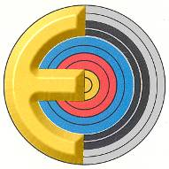

European Club Teams Cup 20___

The Member Association: _____________________________________________________

Verifies that the team of the Club : ___________________________________

Town to which the club belongs: ___________________________________

is in accordance with the rules of the European Club Teams Cup and that the presented athletes are all members of the Federation and of the stated Club for at least a year prior the Club Teams’ registration and they are holders since 2 years of the Minimum Score needed to participate in the event.
.

CLUB –TEAM ATHLETES’ NAME (*)
Men
1.
2.
3.
Captain or Coach:
Women
1.
2.
3.
Captain or Coach:
(*) A club can only present one team of 3 athletes, for each gender.

Name and signature of the President or the Secretary General of the Member Association

………………………………………………………………………………………. …………………………………………………….

Date : ………………………………………………..

