

Rome, 23 June 2013
Ref. n. 18/13 President of European Archery Federations
c.c. WAE Executive Board Members
WAE Committees
WA Secretary General

Dear President,

As you already know the next European Club Team Cup will be held in Kamnik (Slovenia) on 6-8 September 2013.

Thanks to a successful sponsoring campaign, WAE decided to give the following money prizes to the winners of Recurve Women and Recurve Men Club Teams:

1st place: 2000 €
2nd place: 1500 €
3rd place: 1000 €
4th place: 500 €

We are sure that this decision will create more interest among the Club archers who, furthermore, have the possibility to enjoy competing with their club teammates in an international event.

I send you, attached, the Rules for 2013 European Club Teams Cup together with the Invitation Package.
I wish you will publish such a Rule and the Invitation Package on the website of your Federation and distribute it among your Clubs. This is the only way we have to increase the number of the participants and the importance of the competition.

Finally, I would like to inform you that, if a Club of your country wish to organize the 2014
European Club Team Cup, has to send the request to WAE Secretary General (m.pisciotti@emau.org) as soon as possible.

Thank you in advance for your cooperation, best regards

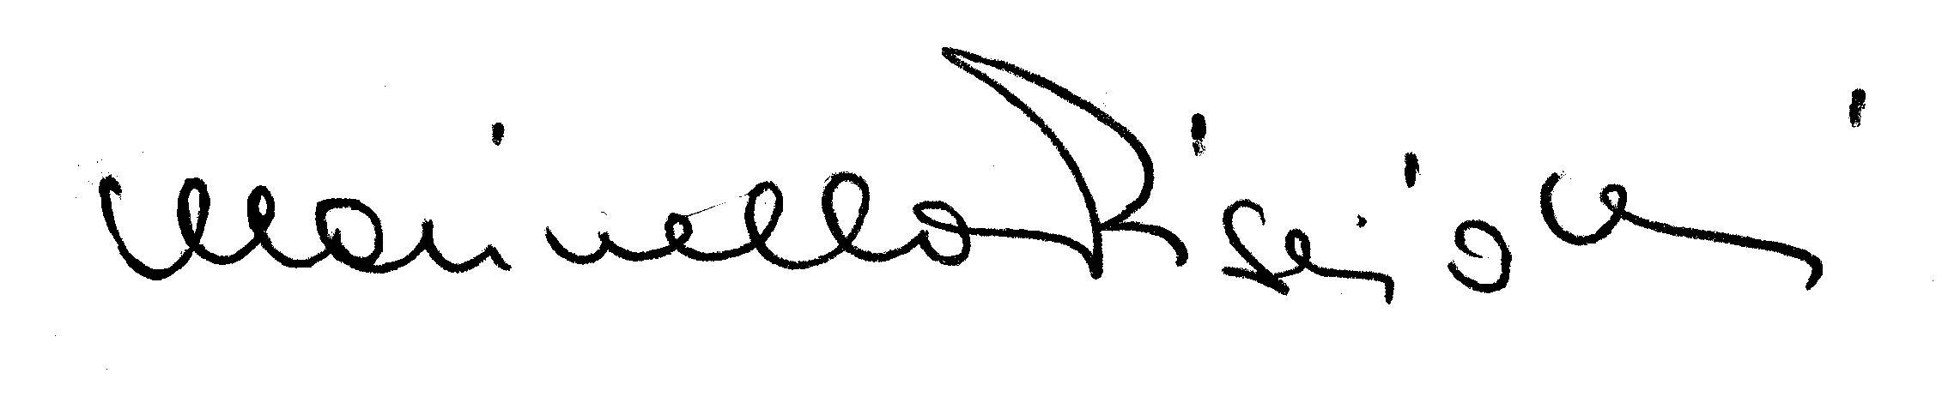
Marinella Pisciotti
Secretary General

Attached: Club Team Cup Rules 2013
Invitation Package

