INVITATION

To All Member Associations 24.11.2010

Dear Member Associates,

On behalf of the Organizing Committee of the Turkish Archery Federation (TAF) we kindly would like to invite you to take part in the 1st leg of the EMAU-Grand Prix, which will be held in 11-16 April, 2011 in Antalya-Turkey. This will be the First Round of the European Circuit for the current year.

This competition will be organized following the FITA rules for the EMAU Grand Prix 1st leg 2011, in both divisions: recurve and compound.

You will find the Turkish hospitality and we hope you and your team will enjoy your stay in Antalya.

Enclosed you will find the Tournament information needed the necessary documents concerning registration and participation in the event.
We will be very happy to meet and warmly welcome you in Antalya.

Sincerely yours,
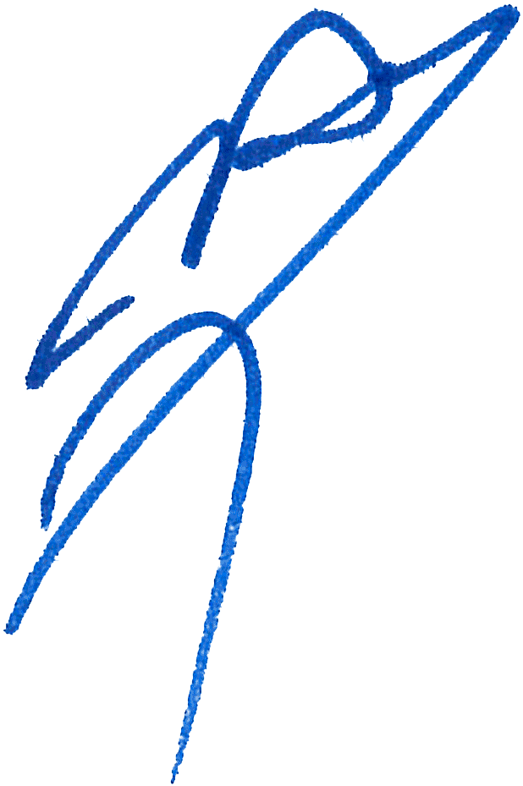
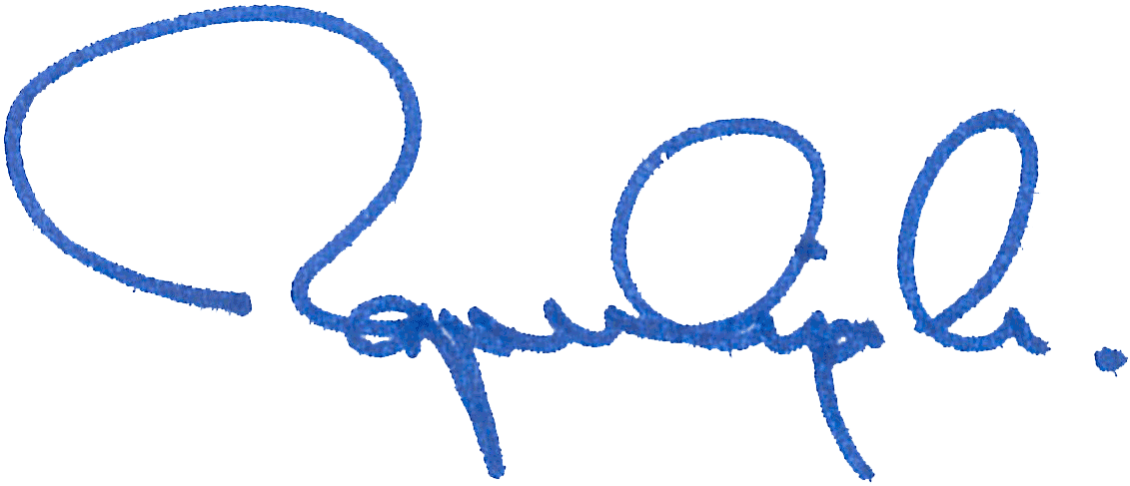

Abdullah TOPALOGLU Husnu KOCAOGLU

President President

Turkish Archery Federation Organizing Committee

Preliminary Programme

 | Sunday, April 10th | Arrival & Registiration of Delegations
Day 1 | Monday, April 11th | Official Practice  Team Captains meeting
Day 2 | Tuesday, April 12 th | Qualification - FITA Round ( 4 distances ) for recurve (Men &Women)
Day 3 | Wednesday, April 13th | Qualification & Individual Elimination1/32 to 1/2, Compound  (Men & Women) 50 m-80 cm 5-10 face
Day 4 | Thursday, April 14th | Individual – Elimination  1/32 to 1/2, Recurve (Men & Women)
Day 5 | Friday, April 15th | Team &Mix Team Eliminations to 1/2 Finals
Day 6 | Saturday, April 16th | Team, Mix Team ,Individuals – Bronze&Gold medal matches in all divisions.  Medals Ceremony
Day 7 | Sunday, April 17th | Departure of Nations

Maximum six (6) archers are allowed to enter the competition per category and per division. A team will consist of the highest three ranked archers in the qualification round, unless the team captain notify in writing his three chosen archers to the Director of Shooting or the Chairman of Judges 1 hour prior to the start of the eliminations.

Please note if you have not finalized on the exact number of the teams and archers yet, then only send the total number of the athletes. The precise names may be updated later. Practice field will be available on 9th of April.

Not only National Team archers can participate in a Grand Prix, but also Club archers. National teams will have priority during the preliminary entry phase. After the preliminary entry deadline all Club members could register. The Club archers can participate only in the individual competition, not in team competition and in mixed team. Registrations must be done through their National Federations and the entries can be accepted by the Organizing Committee until the total capacity of the field has been reached.

The rules for individual registration will be published in January or February

Accommodation
Sea Life Hotel 5 Star
Single Room 90 EURO
Double Room 120 EURO

Hotel’s prices include: Bed, breakfast, lunch, dinner. The rates are in Euro per room and per day.

Hotel’s prices include:
Breakfast Open Buffet Lobby Main Restaurant
Lunch Open Buffet Lobby Main Restaurant
Dinner Open Buffet Lobby Main Restaurant
Midnight Soup Lobby Main Restaurant
Tea, Coffee&Cookie Service
10.00-24.00 All Local Hot and Cold Drinks Without Alcohol

Free transport from the hotel to the competition venue.

Participants who decide to book their accommodation in other hotels (non-official hotel) will have to pay a double entry fee, and the LOC will not be responsible to provide transportation from this Hotel to the venue In addition, no information will be distributed to the non-official hotels.

The deadline for Preliminary Registration must be not later than 60 days before the first day of the competition, while the Final Registration must be not later than 20 days before the first days of the competition.
The Member Associations which send final entries with more than two athletes different from the numbers indicated in the preliminary entries will pay a fine of 100 Euro for per athlete.
Teams , registering after the 20-day deadline will pay a penalty of 100 Euro for each athlete registered.
Entry fees:
Individuals: 125 EURO / Archer
There will be no entry fees for Teams and Officials.

Transportation: 15 EURO /Person
Transportation will be from/to airport and official hotel.

Awards Ceremony:
It is required that each team should bring its Country’s Flag (90cm x 120cm approx).

Prepayment
Booking will only be regarded valid as soon as a 50 % down payment has been received by the Organising Committee, as required. The teams will be asked to present the prepayment receipts before the Committee on check-in. Full payments are to be made by cash only upon arrival while registering at the Tournament venue.
To Contact Us:
Email: organization@antalyaarchery.org
Tel+90-312-4416422
Fax:+90-312-4416423
Mobile phone: +90-532-3938644
Web address: organization@antalyaarchery.org

Could you please return the forms within the deadlines required, as stated below:

Preliminary entry forms: 11 ^{th} Feb 2011
Hotel booking forms: 11th Feb 2011
Hotel accommodation form: 11th Feb 2011
Payment form: 11 ^{th} March 2011
Final entry form: 21 ^{th} March 2011
Transport form: 21 ^{th} March 2011

No entry forms will be available for registering to this event.
All registration process has to be done using the FITA Online Registration System (FORS): www.archery.org/admin

A maximum number of 6 athletes per country (host country 8) are allowed to be registered into each category of the event.

Preliminary entries have to be done using the FORS, V2:
In order to be able to use FORS, please enter this internet address in your web browser www.archery.org/admin and use your Username and Password that FITA had assigned to each Member Association. After entering the FORS, please go to "Online Registration" and register your archers for this event.
A "FORS User Manual" can be downloaded in PDF format (English) from the same website.

For any questions regarding the FORS, please contact jcholgado@archery.org

Hotel Booking Forms

NAME OF MEMBER ASSOCIATION:

Tel: Fax: E – mail:
Return at the latest: 11Th Feb2011

Booking Request

Number of Single Rooms :
Number of Double Rooms :
Total number of persons :

CHECK IN: …………… CHECK OUT: …………… Nbr. Nights:

We require that 50 % of the payment should be done by 21 st March 2011.

Payment must be sent to the following Bank Account:

Bank Transfer
Antalya Okçuluk İhtisas Spor Kulübü
Yapı Kredi Bankası
Mustafabey Şubesi
Alsancak / İzmir
I.B.A.N: TR030006701000000025086669
The copy of the bank transfer must be sent by fax to:

Fax: (+90) 312-4416423

Date: …………………… Signature:
President/Secretary

Transfer Form

NAME OF MEMBER ASSOCIATION:

Tel: Fax: E – mail:
Return at the latest: 21th March 2011

Total number of Archers:

Total number of Officials:

ARRIVAL

Plane:

Flight No …………. From: ………………
Date: ……………… Time: ………………

DEPARTURE

Plane:

Flight No: ………… From: ………………
Date: ……………… Time: ………………

Date: …………………… Signature: ……..……..……………

President / Secretary

Payment Form

NAME OF MEMBER ASSOCIATION:

Tel: Fax: E – mail:

Return at the latest: 11th March 2011
 | Number | Cost | Total
Entry Fee  Transfer Fee | …………….  ................. | 125 €  15 € | ……………. €  ...................€
Total entry and transfer fees ( A ) |  |  | ……………. €
Total Accommodation ( B) |  |  | ……………. €
Grand Total ( A+B) |  |  | ……………. €
Deposit 50% 22 March 2011 |  |  | ……………. €
Balance due (Hotel Accommodation %50 and total entry fees )no later than 4th April, 2011 |  |  | ……………. €

Payment must be sent to the following bank account:

BANK TRANSFER
Antalya Okçuluk İhtisas Spor Kulübü
Yapı Kredi Bankası
Mustafabey Şubesi
Alsancak / İzmir
I.B.A.N: TR030006701000000025086669
The copy of the bank transfer must be sent by fax to:

Fax: (+90) 312-4416423

Date: …………………… Signature: ....……………………..

Accommodation Form

NAME OF MEMBER ASSOCIATION:

Tel: Fax: E – mail:

Return at the latest: 11th Feb. 2011

 | Number of rooms | Cost price | Total
Single Rooms | ……………. | 90€ | ……………. €
Double Rooms | ……………. | 120 € | ……………. €
Total: |  |  | ……………. €

The rates are in Euro per room and per day.
(All inclusive)

Payment must be sent to the following bank account:

BANK TRANSFER
Antalya Okçuluk İhtisas Spor Kulübü
Yapı Kredi Bankası
Mustafabey Şubesi
Alsancak / İZMİR
I.B.A.N: TR030006701000000025086669
The copy of the bank transfer must be sent by fax to:

Fax: (+90) 312-4416423

Date: …………………… Signature: ....……………………..

EMAU PARTICIPATION WAIVER AND COMPETITORS AGREEMENT

EVENT: EUROPEAN GRAND PRIX 1stLeg,

11-16 April 2011, Antalya-TURKEY

Must be given during the accreditation.

This form needs to be signed by all the athletes before they can be accredited at the event. The event detailed in the document heading will be referred to as “The Event”.

As in any sporting event, athletes always run the risk of injury or worse. Archery is no different. Therefore, the following waiver is currently required for participation.

In consideration of my involvement in The Event, I acknowledge and agree that:
- I understand that participation in archery competition may involve risk of bodily injury, including but not limited to paralysis, dismemberment or even death, as well as loss of or damage to property.
- I fully understand such dangers and knowingly and freely assume all such risk, and
- I for myself and on behalf of my heirs, assigns and next of kin, hereby release, hold harmless and promise not to sue EMAU, their Officers, Officials, Organisers, Agents, Sponsors and/or Employees and/or other representatives ("The EMAU Agents"), with respect to any and all such injury, paralysis, dismemberment, death and/or loss or damage arising from my participation in the except that which is resultant of gross negligence and/or wilful or wanton misconduct by EMAU and/or EMAU agent
- I promise to abide by all EMAU rules, regulations, decisions and rulings, including without limitation all those relating to doping or use of drugs. I agree to submit all disputes or claims of any nature relating to the Event (including without limitation its conduct, sponsorship and my participation therein), EMAU rules, regulations, rulings and decisions on all subjects to binding arbitration before the Court of Arbitration for Sport under its statutes and regulations.
- The sponsors of The Event and EMAU may use my photograph, image, name or nick name for the promotion of the Event, EMAU or archery events. EMAU Sponsors or Partners may use my name and likeness to describe any prizes given by Sponsors or Partners without implying any endorsement of their product or service. This use may not include any endorsement by me. I am free to negotiate these endorsements on my own.
- I will accept any prizes or awards given to me by EMAU or the sponsors of The Event for my participation, and I will attend all special award ceremonies at which prizes or awards are presented.
- If I am invited to attend a press conference by the EMAU Press Officer or his representative I will without any delay attend this conference. I acknowledge that by not doing so sanctions may be imposed.

Participant’s name (print) _______________________________

Participant’s signature _______________________________

Date _________________

EMAU PARTICIPATION WAIVER AND COMPETITORS AGREEMENT

EVENT: EUROPEAN GRAND PRIX 1stLeg,

11-16 April 2011, Antalya-TURKEY

FOR ATHLETES OF MINORITY AGE
(under 18 years, or minor in his/her country at time of participation,)

This is to certify as parent/guardian of this participant, I have read, understood and approved the above participation waiver and competitors agreement and consent to his/her release of EMAU from all liabilities to his/her involvement in The Event and will ensure that she/he will respect the signed agreement.

Participant’s name (print) _____________________________

Parent/Guardian name (print) _____________________________

Parent/Guardian signature ______________________________

Date _________________

Hotel Pictures

