25th January 2012

I N V I T A T I O N

To All FITA Member Associations

Dear President,

Subject: European Grand Prix – 1st Leg, 4-9 June 2012 Nicosia – CYPRUS

On behalf of the Organizing Committee of the Cyprus Archery Federation (CAF) we invite you to take part in the 1st leg of the European Grand Prix 2012, which will be held from 4 -9 June 2012 in Nicosia, CYPRUS.

We are sure you and your team will enjoy your stay in Nicosia, the Capital of Cyprus.

Please, find enclosed the necessary documents concerning the registration, organization and participation for your team. We kindly ask you to reply within the stated deadlines:

Preliminary Entries (FORS) | 15th March 2012
Preliminary Hotel Reservation Form (O.C.) | 15th March 2012
Budget Form and payment due | 15th March 2012
Final Hotel Reservation Form (O.C.) | 15th May 2012
Final Entries (FORS) | 15th May 2012
Transportation Form (O.C.) | 15th May 2012

We are looking forward to welcome you in Nicosia, CYPRUS.

Yours sincerely,

Kourounas Charalambos Matsoukari Tonia
President Secretary

http://www.nicosiaGP2012.com.cy

PRELIMINARY PROGRAM

 | Sunday  3rd June 2012 | Arrival of participants.  Practice field and local transport available.
Day 1 | Monday  4th June 2012 | Official practice,  Equipment inspection,  Team captains meeting,  Opening Ceremony.
Day 2 | Tuesday  5th June 2012 | Qualification  70m Round Recurve and 50m Compound.
Day 3 | Wednesday  6th June 2012 | Elimination Individual Round till semi finals,  Recurve divisions.
Day 4 | Thursday  7th June 2012 | Elimination Individual Round till semi finals,  Compound divisions.
Day 5 | Friday  8th June 2012 | Team and Mixed Teams Elimination Round All divisions  Team and Mixed Teams Finals – Medal matches  Award Ceremony for Teams and Mixed Teams.
Day 6 | Saturday  9th June 2012 | Individual Finals - Medal matches  Award Ceremony for Individual.
 |  | Closing Party.
 | Sunday  10th June 2012 | Departure of teams.

NOTE:
This preliminary program may change according to the number of participants and TV requirements. All changes of the program will be published and all the participants will be informed.

The practice field will be available from the 2nd June 2012.

PRELIMINARY & FINAL REGISTRATION

No entry forms will be available for registering in this event.
The registration process has to be done using the FITA Online Registration System (FORS, V.2) www.archery.org/admin
A maximum number of 6 athletes per country are allowed to be registered into each category of the event (the host country is allowed to register 8 archers).

Preliminary entries have to be done using the FORS, V.2:
In order to be able to use FORS, please enter this address in your web browser (www.archery.org/admin) and use the Username and Password that FITA has assigned to each Member Association. After entering the FORS, please go to “Online Registration” and register your archers for this event.
A “FORS User Manual” can be downloaded in PDF (English and Russian) from the same website. For any question or doubts regarding the use of FORS, please contact Mr. Matteo Pisani email: pisani@net-tech.it .

Starting date for online-registration with FORS is: | 25th January 2012
End of Preliminary registration with FORS is: | 15th March 2012
End of Final registration with FORS is: | 15th May 2012

Please pay attention to the stated deadlines. After passing the deadlines, MAs would not be able to enter or update their data in FORS anymore, as the system will be blocked. In this case, if any MA would like to change or proceed with the Final Registrations process or change their Final entry, it is required to contact Mr. Matteo Pisani at email: pisani@net-tech.it with a copy to Organizing Committee email cafkotox@cytanet.com.cy

Final registration that will differ for more than 2 archers according to preliminary registration will have a penalty fee of €100 to be paid to the OC at the moment of arriving at the event.

Teams that enter after 15th May 2012 will pay a penalty of €100 per athlete to be paid to the OC on arrival for the tournament (article 3.3 EMAU agreement).

A Member Association that has made final entries in FORS and does not participate will be invoiced for the number of entries entered in the system, unless the MA informs the OC by email cafkotox@cytanet.com.cy at latest one week prior to the event that they are not be able to attend.

Since entries are through the FORS only, Member Associations declare that their athletes and officials are aware of the participation waiver and anti doping agreement. We recommend Member Associations to advise their athletes on this matter. However, accepting the conditions of the athlete participation waiver and the anti doping are eligible to participate in the event.

Only Member Associations in good standing will be eligible to compete. This also means that any penalty fee for 2011 and/or 2012 FITA fee will have to be paid prior to this Grand Prix.

ADDITIONAL INFORMATION

Entry fees:

Individuals: €120 per Archer.
Teams: free of charge.
Officials: free of charge.

Participation in the Mixed Teams event is free of charge.

The entry fee includes daily transport to and from fields/hotel. Transport timetable will be available.

Participants who decide to book their accommodation in other hotels (non-official) will have to pay a double entry fee, and the OC will not be responsible for providing transportation from those hotels to the venue. Furthermore they have to register at accreditation at the latest the day before the official practice; if they do not register the day before, no changes will be made to the entry list. It is likely that they will not be allowed to compete if registration was not completed on time.

Transportation:

Larnaca Airport and Nicosia – Larnaca airpot: € 30 per Person
Larnaca airport is approximately 55 km, 45 minutes drive from Nicosia.

Awards Ceremony:
You are requested to bring your National anthem (on a CD) and your Country’s Flag (90cm x 120cm approx).

Club Archers Participation
Not only National Team archers can participate in a Grand Prix, but also Club archers. National teams will have priority during the preliminary entry phase. After the preliminary entry deadline all Club members could register. The Club archers can participate only in the individual competition, not in team competition and in mixed team. Registrations must be done through their National Federations and the entries can be accepted by the Organizing Committee until the total capacity of the field has been reached.

Field, hotel and buses will be available for disable persons.

Prepayment:
Booking will be considered valid as soon as a minimum 50% payment has been received by the Organising Committee. You will be asked to present the prepayment receipts at the check-in. Full payments have to be made at the registration of the Tournament.

VISA
Application for obtaining entry visas (for the countries that need such a visa) is the responsibility of the participating teams. The process for obtaining a visa requires each individual to submit an application through a Cyprus Embassy or Cyprus Consulate. This is a process that MUST be done by the applicant – the organizing committee cannot do it for you! It cannot be emphasized enough to start the application process early.

LETTER OF INVITATION
All countries that need Letter of Invitation by the Cyprus Archery Federation for use in their application process are requested to ask this in time. Please fill out the Visa Support / Official Invitation Form as soon as possible and send it in.
As long as the Organizing Committee gets no different information, the Letter of Invitation will be send by fax and/or email.

OPENING CEREMONY
Opening ceremony will be held on Monday, 4th June 2012.
FITA dress code will be required.

PARTY
There will be a party held at Saturday evening, 9th June 2012.
The participation fee is €15 per person and has to be paid to the Organizers in advance.

WATER

Water will be available on the competition field free of charge.

The ELECTRICITY PLUG that you can use in Cyprus is triple UK standard.
DRIVING in Cyprus is on the left side of the road.

To Contact Us:

Email: cafkotox@cytanet.com.cy

Telephone: +357-22-449896

Fax: +357-22-449897

Mobile phone: +357-99-689103 Mr. Kourounas Charalambos
+357-99-496999 Ms. Matsoukari Tonia

Website: http://www.nicosiaGP2012.com.cy

ACCOMMODATION

The official hotel is Hilton Park Nicosia (4* Hotel):

Hilton Park Nicosia is only 10 minute drive from the city centre and 50 minutes from Larnaca International Airport.
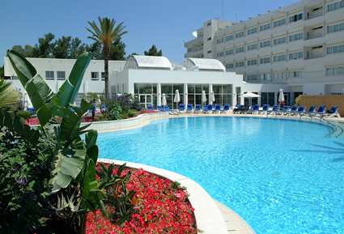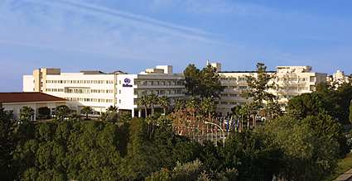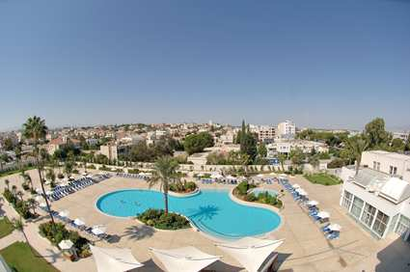
 | Price per person
Single Room | €100
Double Room | €75
Triple Room | €65
Quad triple Room | €60

Hotel prices include: Breakfast, lunch and dinner.

Free water and juice will be provider to Breakfast, lunch and dinner.
50% Discount by the hotel to all bar drink to the Grand Prix participants.
Free use of outdoor tennis courts and outdoor swimming pool.
Free use of gym.
Internet will be available free of charge in lobby and FoP.

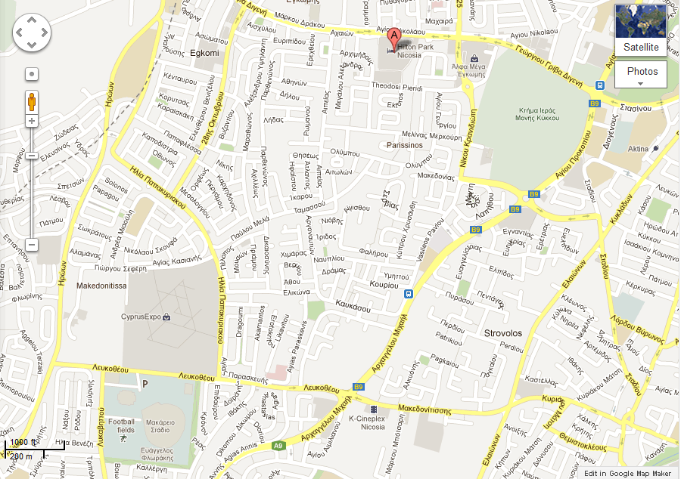

PRELIMINARY HOTEL RESERVATION FORM

Please complete and return this document as soon as possible by fax no:
+357 22449897 or E-mail: cafkotox@cytanet.com.cy before the 15th March 2012.
Name of Federation: |  | ………………………………………………………………………
Telephone No.: | ………………………… |  |  | Fax No: | ……………..…………………..
Email: | ………………………………………………………………………………
Contact Person: | ………………………………………………………………………………

Number of | Single Room |  |  | ……………………………..
Number of | Double Room |  |  | ……………………………..
Number of | Triple Room |  |  | ……………………………..
Number of | Quad triple Room |  |  | ……………………………..
Total number of persons: |  |  |  | ……………………………..
CHECK IN: …………… |  | CHECK OUT: …………… | No. Nights: ……………

It is necessary that 50% of the payment should be done by 15th March 2012.

All payments must be in Euro.

Please transfer all payments to: CYPRUS ARCHERY FEDERATION

Payment must be sent to the following bank account:

Bank Transfer to CYPRUS ARCHERY FEDERATION:
Marfin Popular Bank Public Co Ltd Account Number: 011-08-061496
IBAN: CY82 0030 0011 0000 0011 0806 1496
SWIFT code (BIC) of Marfin Popular Bank Public Co Ltd is LIKICY2N
A copy of the bank transfer must be sent to the OC by fax to +357-22449897 or by email to: cafkotox@cytanet.com.cy

Date: …………………… Signature: ……………………………………
President/Secretary
FINAL HOTEL RESERVATION FORM

Please complete and return this document as soon as possible by fax no:
+357 22449897 or E-mail: cafkotox@cytanet.com.cy before the 15th May 2012.
Name of Federation: |  | ………………………………………………………………………
Telephone No.: | ………………………… |  |  | Fax No: | ……………..…………………..
Email: | ………………………………………………………………………………
Contact Person: | ………………………………………………………………………………

 | Number of rooms | Number of Persons | Number of Nights | Cost price | Total Cost
Single Room | ………… | ………… | ………… | €100 | €……….……...
Double Room | ………… | ………… | ………… | €75 | €……….……...
Triple Room | ………… | ………… | ………… | €65 | €……….……...
Quad triple Room | ………… | ………… | ………… | €60 | €……….……...
 |  |  |  | Total (2): | €……….……...
The rates are in Euro per person, per day, full board.
Payment must be sent to the following bank account:

Bank Transfer to CYPRUS ARCHERY FEDERATION:
Marfin Popular Bank Public Co Ltd Account Number: 011-08-061496
IBAN: CY82 0030 0011 0000 0011 0806 1496
SWIFT code (BIC) of Marfin Popular Bank Public Co Ltd is LIKICY2N
A copy of the bank transfer must be sent to the OC by fax to +357-22449897 or by email to: cafkotox@cytanet.com.cy

Date: …………………… Signature: ………………………………………
President/Secretary
NOTE:
All payments are required to be done in EURO by BANK TRANSFER or IN CASH upon arrival
Bank transfer fees are the responsibility of the sender.
NO CREDIT CARDS, NO TRAVELLERS CHEQUES, NO FOREIGN CURRENCIES
BUDGET FORM
Please complete and return this document as soon as possible by fax no:
+357 22449897 or E-mail: cafkotox@cytanet.com.cy before the 15th May 2012.
Name of Federation: |  |  |  | ………………………………………………………………………
Contact Person: |  | ………………………………………………………………………………
(1) | ENTRY FEE |  |  |  |  | No of Persons |  | Cost |  | Total Cost
 | Athlete |  |  |  |  | ………… |  | €120 |  | €……………………
 | Team |  |  |  |  | ………… |  | Free |  | €……………………
 | Official |  |  |  |  | ………… |  | Free |  | €……………………
 | Total of Entry Fees (1) |  |  |  |  |  |  |  |  | €……………………
(2) | HOTEL RESERVATION FORM
 |  |  | Number of rooms |  | Number of Persons |  | Number of Nights |  | Cost price | Total Cost
 | Single Room |  | ………… |  | ………… |  | ………… |  | €100 | €……………………
 | Double Room |  | ………… |  | ………… |  | ………… |  | €75 | €……………………
 | Triple Room |  | ………… |  | ………… |  | ………… |  | €65 | €……………………
 | Quad triple Room |  | ………… |  | ………… |  | ………… |  | €60 | €……………………
 | Total of Hotel Reservation Fees (2) |  |  |  |  |  |  |  |  | €……………………
(3) | TRANSPORTATION FEE |  |  |  |  | No of Persons |  | Cost |  | Total Cost
 | Larnaca Airport |  |  |  |  | ………… |  | €30 |  | €……………………
 | Total of Transportation Fees (3) |  |  |  |  |  |  |  |  | €……………………
(4) | CLOSING PARTY FEE |  |  |  |  | No of Persons |  | Cost |  | Total Entry Cost
 | Saturday 9/6/2012 |  |  |  |  | ………… |  | €15 |  | €……………………
 | Total of Closing Party Fees (4) |  |  |  |  |  |  |  |  | €……………………
 | GRAND TOTAL (1+2+3+4) |  |  |  |  |  |  |  |  | €……………………
 | Deposit 50% Date: 15th March 2012 |  |  |  |  |  |  |  |  | €……………………
 | All payments must be settle up upon arrival |  |  |  |  |  |  |  |  | €……………………
Payment must be sent to the following bank account:
Bank Transfer to CYPRUS ARCHERY FEDERATION:
Marfin Popular Bank Public Co Ltd Account Number: 011-08-061496
IBAN: CY82 0030 0011 0000 0011 0806 1496
SWIFT code (BIC) of Marfin Popular Bank Public Co Ltd is LIKICY2N
A copy of the bank transfer must be sent to the OC by fax to +357-22449897 or by email to: cafkotox@cytanet.com.cy
Date: …………………… Signature: ………………………………………
President/Secretary
NOTE:
All payments are required to be done in EURO by BANK TRANSFER or IN CASH upon arrival
Bank transfer fees are the responsibility of the sender.
NO CREDIT CARDS, NO TRAVELLERS CHEQUES, NO FOREIGN CURRENCIES
TRANSPORTATION FORM

Please complete and return this document as soon as possible by fax no:
+357 22449897 or E-mail: cafkotox@cytanet.com.cy before the 15th May 2012.
Name of Federation: |  | ………………………………………………………………………
Telephone No.: | ………………………… |  |  | Fax No: | ……………..…………………..
Email: | ………………………………………………………………………………
Contact Person: | ………………………………………………………………………………

Return before: 15th May 2012

Total number of Archers: …………………………………………….…………………………

Total number of Officials: ………………………………………………………………………

ARRIVAL
Airline:
Flight No.: | ………………………. | From: | ……………………….
Date: | ………………………. | Time: | ……………………….
DEPARTURE

Airline:
Flight No.: | ………………………. | From: | ……………………….
Date: | ………………………. | Time: | ……………………….

Date: …………………… Signature: ……..……..……………
President / Secretary

