16th February 2012

TO ALL WORLD ARCHERY MEMBER ASSOCIATIONS

Dear President,

On behalf of the Organizing Committee and Croatian Archery Association I am pleased to invite you to the first leg of the ‘EUROPEAN JUNIOR CUP 2012’ competition that will be held in city of Porec from 7th – 12th May 2012.
This event will be organised following the EMAU ‘EUROPEAN JUNIOR CUP COMPETITION 2012’ rules for Junior Women, Junior Men, Cadet Women and Cadet Men classes in divisions of recurve and compound bow, in the discipline of Outdoor Target Archery.

Hereby you will find enclosed the necessary documents concerning the registration, organisation and participation in this event. We kindly ask you for your response within the stated deadlines:

Preliminary Entries 17th March 2012
Final Entries 17th April 2012
Hotel Reservation Form 1st April 2012
Transportation Form 17th April 2012
Visa Invitation Letter Form 17th March 2012
Budget Form 17th April 2012
Hotel Reservation Form (Final) 17th April 2012

I am looking forward to welcoming you in Porec, Croatia.

Yours sincerely,

Mr Alen KIDEMET
Organizing Committee President
Croatian Archery Association President

PRELIMINARY PROGRAMME

Saturday May 5th, 2012 Arrival of Delegations
Practice field and local transportation available

Sunday May 6th, 2012 Arrival of Delegations
Practice field and local transportation available

Monday May 7th, 2012 Official practice and Equipment inspection
Team Captains Meeting

Tuesday May 8th, 2012 Qualification round group 1
1/48 and 1/24 elimination
Qualification round group 2
1/48 and 1/24 elimination

Wednesday May 9h^{th} 2012 Mixed Team from 1/8 Eliminations to all Medal Matches group 1
Mixed Team from 1/8 Eliminations to all Medal Matches group 2
Mixed Team Awarding

Thursday May 10th, 2012 Individual Eliminations group 1
(1/16, 1/8, 1/4, 1/2) and bronze match
Individual Eliminations group 2
(1/16, 1/8, 1/4, 1/2) and bronze match

Friday May 11th, 2012 Team Eliminations group 1
(1/8, 1/4, 1/2) and bronze match
Team Eliminations group 2
(1/8, 1/4, 1/2) and bronze match

Saturday May 12th, 2012 Team Gold Medal Matches
Individual Gold Medal Matches
Award Ceremony
Brief Closing Ceremony
Disco party

Sunday May 13th, 2012 Departure of Delegations

Note: This preliminary programme might be changed in accordance with the number of participants. All changes in the programme will be published and informed to all participants in good time.

PRELIMINARY & FINAL REGISTRATION

No entry forms will be available for registering to this event. The registration process has to be done using the World Archery Online Registration System (FORS, V.2)
The number of athletes that may be entered by a Member Association is limited to four (4) in each category.
All World Archery MAs are eligible to compete in European Junior Cup competitions, but only the results of the athletes from EMAU MA’s will be taken in consideration for Junior Cup Circuit.
In order to use FORS, please enter this address in your internet browser (www.archery.org/admin) and use the Username and Password that World Archery has assigned to your Member Association. After entering the FORS, please go to “Online Registration” and register your archers for this event.
A “FORS User Manual” can be downloaded in PDF format (English and Russian) from the same website.
For any question regarding FORS, please contact Mr. Matteo Pisani at pisani@net-tech.it

Starting date of online-registration with FORS is: 16th February 2012
End of Preliminary registration: 17th March 2012
End of Final registration: 17th April 2012

Please pay attention to the stated deadlines. After the deadlines have passed, MAs will not be able to enter or update data in FORS anymore, as the system will be blocked. In this case, if any MA would like to change or proceed with the Final registration process after the deadline, it is required to contact the Organizing Committee at archery@archery.hr or World Archery at pisani@net-tech.it (with the OC in Cc of that email).

The Member Association that will process her Final entry in FORS after the 20 day prior the start of competition date (Final registration deadline), will have a penalty fee of 100 Euros per athlete registered, to be paid to the OC upon arrival at the event.

The Member Association with Final registration in FORS that will differ by more than 4 athletes from the preliminary registration, will have a penalty fee of 100 Euros, to be paid to the OC upon arrival at the event.

A Member Association that has made Final entry in FORS and does not participate will be invoiced for the number of entries entered in the system, unless the Member Association has informed the OC in writing at least one week prior to the event that they are unable to attend.

Since entries will be made through FORS only, MAs declare that their athletes and officials are aware of the participation waiver and anti doping agreement, and we recommend MAs to advise their athletes on this matter.
However, accepting the conditions of the athlete participation waiver and antidoping agreement are an eligibility requirement to participate in the event.

As a final note, only member Associations in good standing will be eligible to compete. This also means that any penalty fee for 2011 will have to be paid prior to participation.

ACCOMMODATION & GENERAL INFORMATION

The official hotel is Hotel "Zorna". Hotel is 3*** stars category hotel.

The room rate is per person per night.
The room rate includes full board accommodation, taxes and VAT.

Reservations should be made before 1st April 2012.
Reservations after this date will be subjected to availability.
Please be aware that we have limited number of single rooms and they will be served on a "first come - first get" base. After filling the contingent of single rooms, single room will be possible to get only on a "double room/single use" base, with the price that will be app 50% higher in relation to the price for double room per person per night.

To confirm your reservation you are required for 50% deposit before 1st April 2012.!

HOTEL | Category | Single room  Price per room per night | Double room  Price per person per night | Double room/single use  Price per room  per night
Hotel "Zorna" | 3*** | € 79,00 | € 65,00 | € 98,00

The rooms will be distributed by the organizer.

Note:
Please refer to the Accommodation pages below for detailed hotel information. Ensure that you complete all the necessary forms by the specified dates and make full payment for the accommodation at the time of booking. See detailed payment instructions below.

Participants who decide to book their accommodation in non-official hotel will not have local transportation from these hotels to the venue provided by OC (transportation will be provided just to and from the official hotel). In addition, no information will be distributed to the non-official hotels.
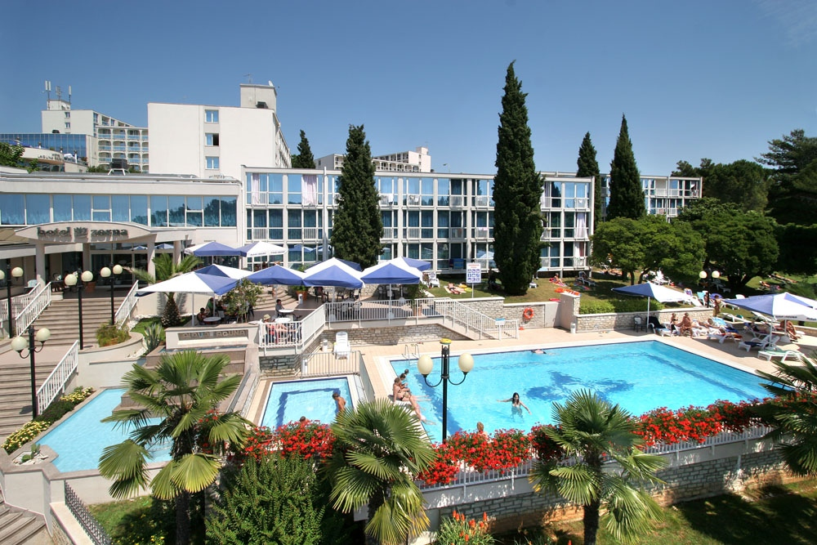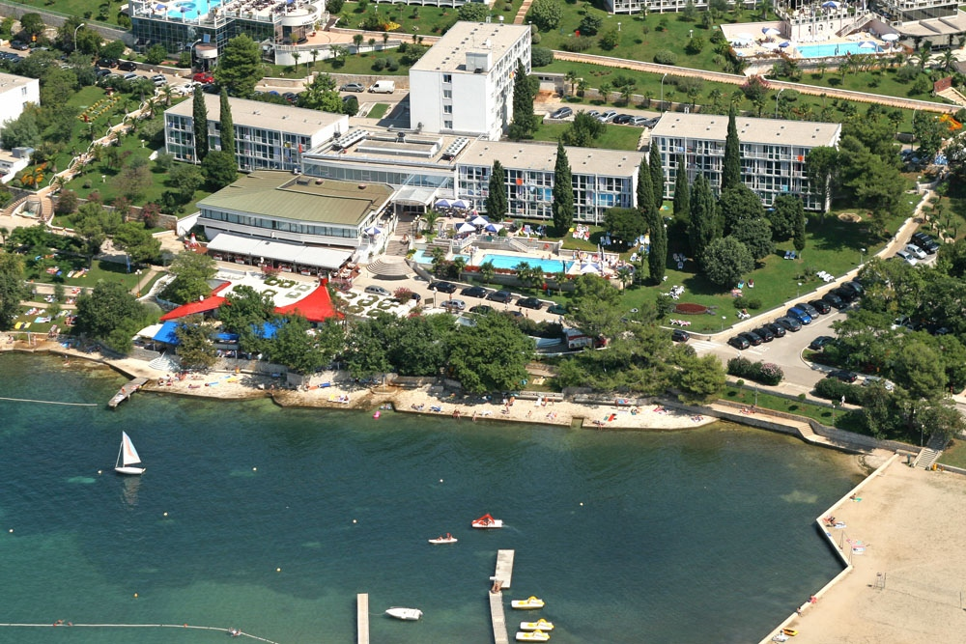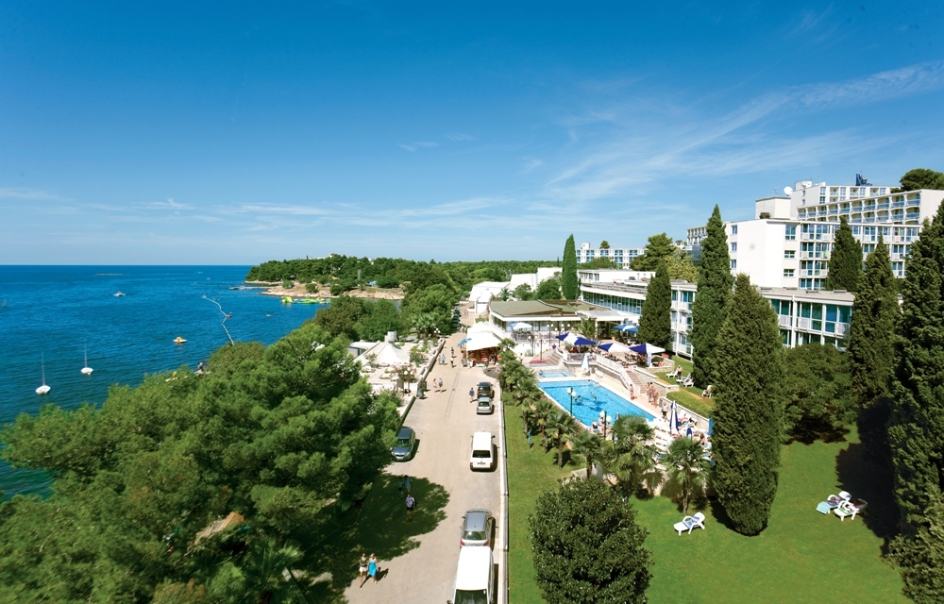

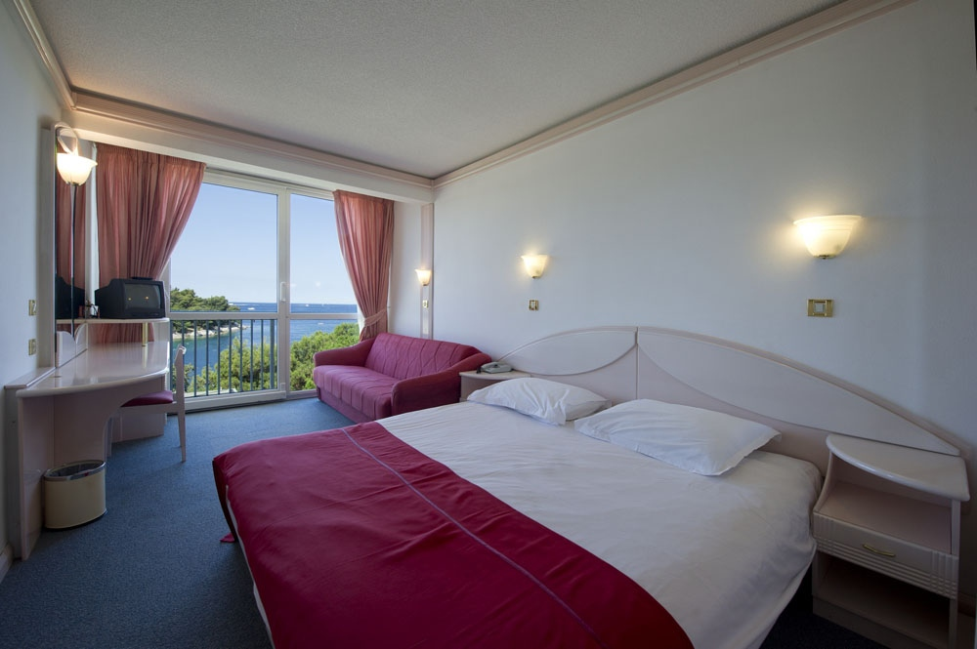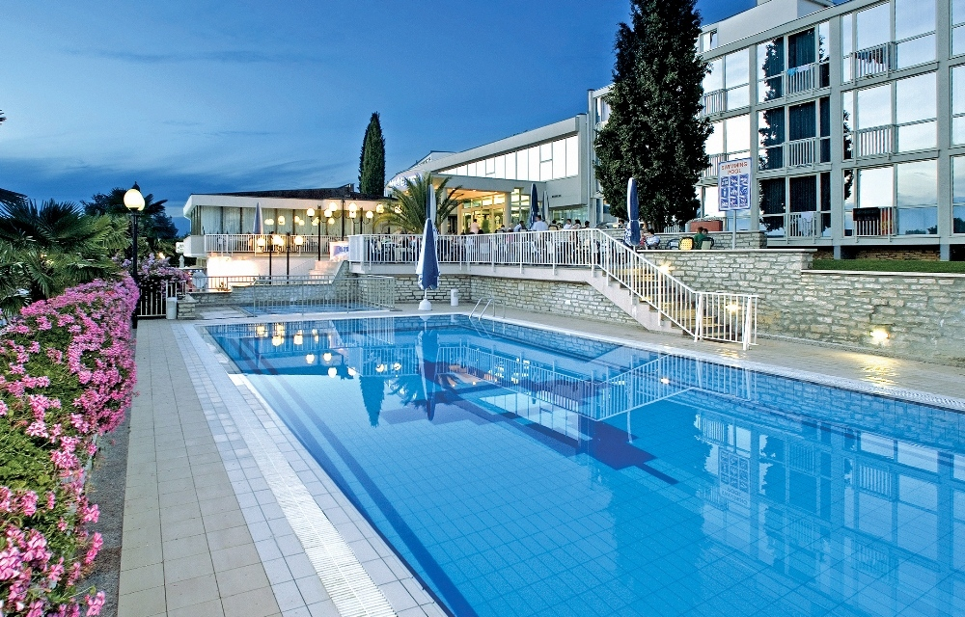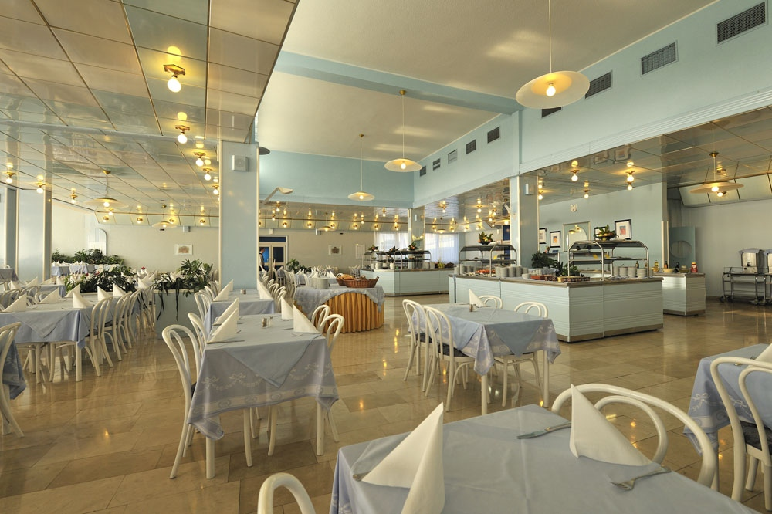

ADDITIONAL INFORMATION

Entry fees:
Individual: 50 Euros per athlete
Officials: -
Teams: -

There is no entry fee for officials and/or teams.

Your entry fee includes daily local transportation to and from practice and competition field to the event official hotel and venues during the qualification, elimination and finals (transportation timetable has to be confirmed).

Transportation fees from/to the airports:
The OC will collect the teams from the two airports. You have to pay the transportation fee (including arrival and departure) as follows:

ZAGREB International Airport (280 km) 110 Euros/person
TRIESTE International Airport (ITA) (150 km) 90 Euros/person

The last date for the payment of the transportation fee is 27th April 2012.

From the airports to the hotel (return trip), the organiser will use buses (Hoch Decker), small buses, vans and cars, what will depend of number of persons scheduled for transportation.

Transportation from the airports will start two days before the official practice day and will end two days after the closing day.

Local transportation will be available between hotel and practice and competition venues. Exact transport timetables will be confirmed. Buses and/or vans will be used.
Official hotel is very near the venues (~300m).

Cancellations & Changes:
Cancellation must be in writing by email to archery@archery.hr or by
FAX to +385 1 2981 768.

Following conditions will apply:
- cancellation received before and included 17th March 2012 for full refund of the deposit
- cancellation received between and included 18th March 2012 and 17th April 2012 for 50%
refund of the deposit
- cancellation received after 17th April 2012 - there will be no refund of the deposit payment.

All rates for payments after deadlines are subject to additional changes without prior notice.

All refunds, if any, will be processed after the event.

Name change (the same category and division) will be accepted up to 72 hours before the event without any additional charge.

OC has to be informed about changes in the travel programme 72 hours prior arrival. If your arrival is later then your original schedule, the room charges are starting from the original date indicated by the Member Association in their Accommodation form.

Meals at the venue:
Lunch will be served in the restaurant of the hotel. There will be possibility to order lunch boxes instead of having real lunch in hotel, but it has to be done one day before (and for each day you need it) on the reception of hotel, using the "Lunch boxes form" provided below in this Invitation package.
Bottled drinking water will be available on the competition field free of charge.
All other costs made in cafeteria at the archery venue or in the hotel (snacks, drinks, small meals) are not included in the entry fee and hotel payment and must be paid on consumptions.

Porec

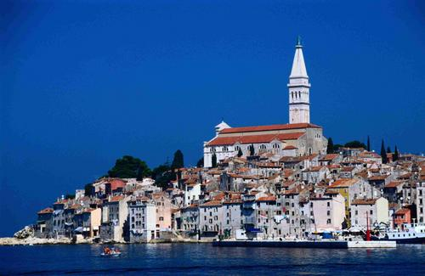
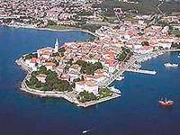
Porec is a city of culture and fun, pleasant sun and warm sea. It is situated on the west coast of Istria, the biggest Croatian peninsula. Porec has 37 km of coastline that extends from the valley of river Mirna on the north to the deep Lim Fjord on the south. Clean beaches and bays and numerous islands are a symbol of Porec.

Weather
The city of Porec is placed on the Mediterranean coast. Porec enjoys mild temperatures during the autumn and spring months. During April and May you can expect the temperature in Porec to stay around 22°C with around ten hours of sunshine per day. Nights can be colder. The spring and autumn months are a comfortable time of the year to explore the region.
Most of the time it is sunny but we suggest you to have some heavier piece of clothes. The rain is not unusual in this time of the year.
Accreditation and Team Captains Meeting
Accreditation will take place upon arrival of teams, in the official Hotel "Zorna" on 6th and 7th May 2012.
The address of hotel is:
Hotel "Zorna", Zelena laguna - 52440 Porec (Parenzo), Croatia
GPS: N: 45° 11' 57.924", E: 13° 35' 26.256"
It would be of great help, if you would email us a picture of your participating archers and officials.
Please use the format: name_of_archer.jpg Example: Goran_Ahel.jpg
For all Ceremonies World Archery dress code is obligatoy.
More details will be provided at the Team Captains’ Meeting.
Team Captains Meeting will be held in the accreditation center, in the same place.
National flags and anthem: The OC suggests all teams to bring 2 of their national flags dimensions 2x1m, and a CD with national anthem.
Training
There will be a training field available starting from 5th May 2012. It is separate part of official competition field for the qualification – all about 300m from the official hotel.
Visas
Please apply for your visa as soon as possible, if you need any additional information regarding visa, please let us know.
Please be aware that Croatia is still not part of the European Union and if you come to Trieste airport in Italy and you need visa for Croatia, most possibly you will need visa for the European Union too.
Please check if your team member is foreigner and if he/she needs visa for entering Croatia and European Union.
Application for and obtaining travel visas are completely and solely the responsibility of the participating teams. The process for obtaining a visa requires each individual to submit an application through a Croatian Embassy or Croatian Consulate. This is a process that MUST be done by the applicant – the Organizing Committee cannot do it for you. It cannot be emphasized enough to start the application process early. Please note that the application and interview process in your country may very well be in advance of the team selection date, so in many cases, you will need to start the application process prior to confirming your final team.
Visa Invitation Letter – All countries that will need letter of invitation by the Organizing Committee to use it in their application process, are requested to order these in time. Please fill out the Visa Invitation Letter Form as soon as possible and send it in.
As long as the Organizing Committee gets no different information, the letter of Invitation will be sent by email. If an express service should be desired, this service will be charged to the MA and must be paid to the Organizing Committee upon arrival.

Disco party
On final day (Saturday, 12th May 2012) standard meal dinner will be served in the restaurant of the hotel. After the dinner, music and dancing will take place from 21:00 till 24:00h.
For the disco party there is no any fee, but all consumed must be paid on consumption.
Place of disco party will be confirmed.
Internet
Facilities in the hotel.
Internet is available in the hotel lobby but with charges – you must get the username and password at the reception of hotel.
OC contacts
- Phone for assistance when traveling
Mr Mladen Cica: +385 98 834 173 (24 hours – English)
- For all matters
Mr Goran Ahel (24 hours – English)
Phone +385 1 2981 766
Fax +385 1 2981 768
Mobile +385 91 4343 463
E-mail: archery@archery.hr

HOTEL RESERVATION FORM

Country/Team from: ___________________________________________

HOTEL: "Zorna" 3*** Hotel

Number of Rooms:

Single room:
Double room:
Double room/single use:

Please check this box if you need facilities for persons with disabilities.

Team Arrival Date: _____________________

Team Departure Date: __________________

Date: ____________

Signature of President/Secretary General: ______________________________

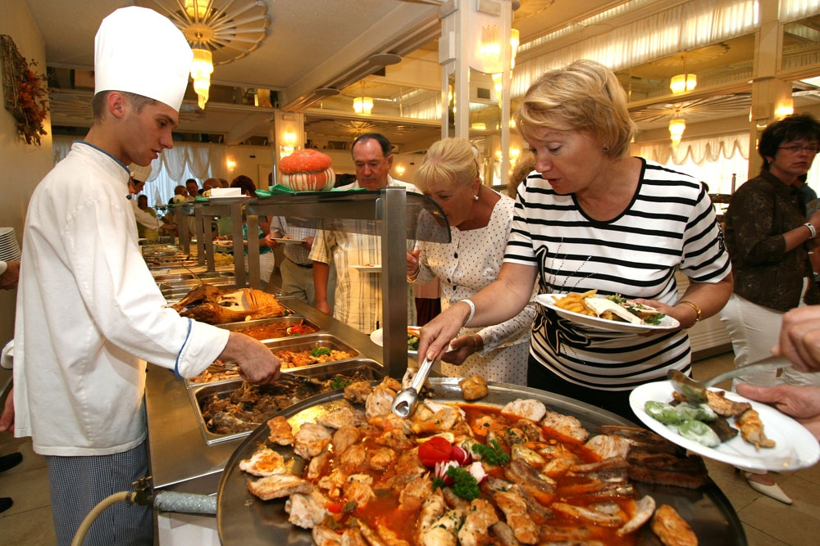

PLEASE RETURN THIS HOTEL RESERVATION FORM TO THE ORGANISER
BEFORE 1st April 2012
by e-mail to archery@archery.hr or by FAX to +385 1 2981 768

FINAL HOTEL RESERVATION FORM

Country/Team from: ___________________________________________

HOTEL: "Zorna" 3*** Hotel

Number of Rooms:

Single room:
Double room:
Double room/single use:

Please check this box if you need facilities for persons with disabilities.

Team Arrival Date: _____________________

Team Departure Date: __________________

Date: ____________

Signature of President/Secretary General: ______________________________

ONLY IF YOU CHANGE NUMBER OR TYPE OF ORDERED ROOMS STATED IN PRELIMINARY HOTEL REERVATION FORM
PLEASE RETURN THIS HOTEL RESERVATION FORM TO THE ORGANISER
BEFORE 17th April 2012
by e-mail to archery@archery.hr or by FAX to +385 1 2981 768

LUNCH BOXES ORDERING FORM

Country/Team from: ___________________________________________

Hereby orders __________________ lunch boxes (number of lunch boxes)

to be ready for __________________ (date).

of which _______________ needs to be vegetarian ones (number).

Date: _______________

Signature of the delegation official: ______________________________

PLEASE RETURN THIS FORM TO THE RECEPTION OF HOTEL 1 DAY BEFORE YOU NEED LUNCH BOXES (AND FOR EACH DAY YOU NEED IT).

TRANSPORTATION FORM

Country/Team from: __________________________

Number of passengers: ________ person/s

Arrival information

We will arrive by plane:

Airport: __________________ Flight Nr: _____________

Date: ______________ Arrival Time: ___________

We will arrive to Porec by: _______________________________________

____________________________________________________________

Departure information

We will depart by plane:

Airport: __________________ Flight Nr: _____________

Date: ______________ Arrival Time: ___________

We will departe Porec by: _______________________________________

____________________________________________________________

Date: _________

President/Secretary General MA: ______________________________

PLEASE RETURN THIS TRANSPORTATION FORM TO THE ORGANISER
BEFORE 17th April 2012
by email to archery@archery.hr or by FAX to +385 1 2981 768
VISA INVITATION LETTER FORM
Country/Team from: ___________________________________

Contact person: _______________________________________

Given name/ | Family name/ | Date and place of birth/ | Citizenship  (Country)/ | Passport number/ | Expiration date of passport/ | Adress of residence

Date: ______________
President/Secretary General MA: _______________________________

PLEASE RETURN THIS VISA INVITATION LETTER FORM TO THE ORGANISER AS SOON AS POSSIBLE (latest by 17th March 2012)
by email to archery@archery.hr or by FAX to +385 1 2981 768
BUDGET FORM

Member Association: ____________________________________________
Contact person: ________________________________________________
Telephone: ____________________________________________________
Mobile: _______________________________________________________
E-mail: _______________________________________________________

1) Entry Fees
Position Cost Number of persons Total
Athlete € 50 x ___ € ____

Total 1 ................................................................................. € ____

2) Accommodation
Hotel "Zorna" 3*** hotel - Full Board
Room Cost Nr of Persons Nr of nights Total
Single room € 79 x ___ x __ € ____
Double room € 65 x ___ x __ € ____
Double room/
single use € 98 x ___ x __ € ____

Total 2 .................................................................................. € ____

3) Transportation
Airport Cost Number of Persons Total
Zagreb € 110 x ______ € ____
Trieste € 90 x ______ € ____

Total 3 .................................................................................. € ____

TOTAL (1+2+3) € ____

Date, ___________

President/Secretary General MA: _____________________________

PLEASE RETURN THIS BUDGET FORM TO THE ORGANISER
BEFORE 17th April 2012
by e-mail to archery@archery.hr or by FAX to +385 1 2981 768

PAYMENT INSTRUCTIONS:

BANK TRANSFER FOR ENTRY FEES

BANK: PRIVREDNA BANKA ZAGREB d.d.
Address: Rackoga 6
ZAGREB
CROATIA

A/C NAME HRVATSKI STRELICARSKI SAVEZ
Address: Hrvatskog proljeca 34
ZAGREB
CROATIA

SWIFT CODE (BIC): PBZGHR2X
IBAN: HR66 2340 0091 1100 3920 2

BANK TRANSFER FOR THE ACCOMMODATION AND TRANSPORTATION

BANK: PRIVREDNA BANKA ZAGREB d.d.
Address: Rackoga 6
ZAGREB
CROATIA

A/C NAME STRELICARSKI TRENING CENTAR D.O.O.
za usluge, turizam i trgovinu, turisticka agencija
Address: Hrvatskog proljeca 34
ZAGREB
CROATIA

SWIFT CODE (BIC): PBZGHR2X
IBAN: HR14 2340 0091 1104 6907 2

NOTE:

ALL PAYMENTS ARE REQUIRED TO BE DONE IN EUROS BY BANK TRANSFER LATEST 27th APRIL 2012!
ALL BANK TRANSFER FEES HAVE TO BE PAID BY PARTICIPATING MAs (you need to state OUR option when paying).
IN CASE OF NOT PAYING THE BANK TRANSFER FEES, YOU WILL BE CHARGED FOR THE DIFFERENCE UPON ARRIVAL, AT THE ACCREDITATION.

- NO CREDIT CARDS
- NO TRAVEL CHECKS

PLEASE SEND THE COPY OF THE BANK TRANSFER TO THE ORGANISER
by email to archery@archery.hr or by FAX to +385 1 2981 768

