To all European Member Associations,

Dear President,

On behalf of the Organizing Committee of the Archers Riomois Association, we would like to invite you to take part in the 1st leg of the European Grand Prix, wich will be held in Riom 2013.

This event will be organized following the WA and World Archery Europe rules, in both divisions: recurve and compound.

You will find enclosed the necessary documents concerning the registration, organization and participation in this event. We kindly ask you to return within the stated deadlines:

- Preliminary entries: January 25th 2013
- Final entries: March 25th 2013
- Hotel reservation form: March 3rd 2013
- Transportation form: March 3rd 2013

We will be very happy to meet and warmly welcome you in Riom.

Sincerely yours,
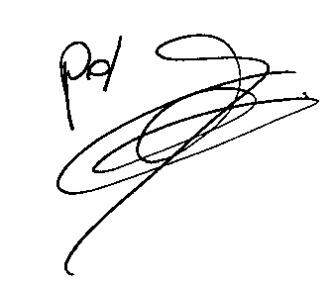
René DEQAIRE
President of Archers Riomois

PRELIMINARY PROGRAM

- APRIL ,15th 2013 Teams arrivals

- APRIL, 16th, 2013 Official practice
Team Captain meeting
Opening Ceremony

- APRIL, 17th, 2013 Qualifications – FITA Round (4 distances)
for recurve, 50 mt round for Compound
Rhythm AB/CD – Recurve and compound – Men and Women

- APRIL, 18th ,2013 Individual Elimination
1/32 to ¼ finals
Recurve and compound – Men and Women
Mixed team

- APRIL, 19th, 2013 Teams Finals

- APRIL, 20th ,2013 Individual finals (alternate shooting)
½ finals –Bronze and Gold medal matches
Recurve and compound – Men and Women
Closing Ceremony

- APRIL, 21st,2013 Departures of the teams

PRELIMINARY & FINAL REGISTRATION

No entry forms will be available for registering in this event.
The registration process has to be done using the WA Registration & Entries Online System (WAREOS) www.archery.org/admin
A maximum number of 6 athletes per country are allowed to be registered into each category of the event (the host country is allowed to register 8 archers).

Preliminary entries have to be done using the WAREOS:
In order to be able to use WAREOS (World Archery Registration & Entries Online System), please enter this address in your web browser (www.archery.org/admin) and use the Username and Password that WA has assigned to each Member Association. After entering the WAREOS, please go to “Online Registration” and register your archers for this event.
A “WAREOS User Manual” can be downloaded in PDF (English) from the same website. For any question or doubts regarding the use of WAREOS, please contactMr. Matteo Pisani email: matteo@pisani.eu

Starting date for online-registration with WAREOS is: | 8. January 2013
End of Preliminary registration with WAREOS is: | 25. January 2013
End of Final registration with WAREOS is: | 25. March 2013

Please pay attention to the stated deadlines. After passing the deadlines, MAs would not be able to enter or update their data in WAREOS anymore, as the system will be blocked. In this case, if any MA would like to change or proceed with the Final Registrations process or change their Final entry, it is required to contact Mr. Matteo Pisani at email: matteo@pisani.eu with a copy to Organizing Committee email megcaroju@gmail.com.

Final registration that will differ for more than 2 archers according to preliminary registration will have a penalty fee of €100 to be paid to the OC at the moment of arriving at the event.
Teams that enter after March 25 th will pay a penalty of €100 per athlete to be paid to the OC on arrival for the tournament (article 3.3 WAE agreement).
A Member Association which made entries in WAREOS and does not participate will be invoiced for the number of entries entered in the system, unless the MA inform WAE and the OC to email megcaroju@gmail.com at latest one week prior to the event that they are not be able to participate.

Since entries are through the WAREOS only, Member Associations declare that their athletes and officials are aware of the participation waiver and anti doping agreement. We recommend Member Associations to advise their athletes on this matter. However, accepting the conditions of the athlete participation waiver and the anti doping are eligible to participate in the event.

Only Member Associations in good standing will be eligible to compete. This also means that any penalty fee for 2013 World Archery fee will have to be paid prior to this Grand Prix.

ACCOMMODATION AND GENERAL INFORMATION

 Hotel’s prices include: breakfast, lunch on the field of play, dinner in the hotel and transportation from the hotel to the field of play.
 The room rate is per person and per night.
 Reservations should be made before FEBRUARY, 28th 2013.
 30% of the payment is required before FEBRUARY, 28th, 2013. Full payment is due upon arrival on APRIL 15th, 2013.

 | Hotels | Price single room  (€) | Price double room  (€)
Category A  2 & 3 stars | « Anémotel »  « Campanile » | 120 € | 90 €
Category B  1 & 2 stars | « A.C.E. »  « Etap’ Hôtel »  « La Caravelle » | 95 € | 80 €

ENTRY FEES

- Individuals: 140 € / archer
- Teams: 65 € / team
- Officials: 40 € /officials

TRANSPORTATION
- From official Airport or Railway Station to the Hotel – (arrival and departure)
: 25 € / person

TRANSPORTATION FORM

 The competition field is:

Centre Départemental et Régional de Tir à l’Arc
Place de l’Europe
63200 RIOM
France

 Country name: ……….……….……….……….……….……….……….……….
 Quantity of people: ……….……….……….……….……….……….……….……….

ARRIVAL

 We will arrive at Clermont-Ferrand International Airport 
- Flight Nr: ………………..………………..
- Date : ………………..………………..
- Arrival time : ………………..………………..

 We will arrive at Riom / Châtel-Guyon Railway Station. 
- Train Nr: ………………..………………..
- Date: ………………..………………..
- Arrivaltime : ………………..………………..

 We will arrive by car or coach. 
The access to the competition field will be signalized on the main roads at the entrances of the town of Riom.
- Date: ………………..………………..
- Arrival time: ………………..………………..

DEPARTURE

 You will leave at Clermont-Ferrand International Airport. 
- Flight Nr: ………………..………………..
- Date: ………………..………………..
- Departure time: ………………..………………..

 You will leave by train from Riom/Châtel-Guyon Railway Station. 
- Train Nr: ………………..………………..
- Date: ………………..………………..
- Departure time: ………………..………………..

 You will leave with your own car or other transportation. 
- Date: ………………..………………..
- Departure time: ………………..………………..

The lunch and dinner on Sunday April the 21st are not included.

Keep in Mind: There are many possibilities to come to Riom.
The official International Airport is Clermont-Ferrand.
The official Railway Station is Riom /Châtel-Guyon.

Date: ………………..………………..

Name and Signature of the President:

ACCOMMODATION FORM

 Hotel’s prices include: accommodation, breakfast, lunch on the field of play, dinner at the hotel and transportation from the hotel to the field of play.

 The room rate is per person and per night.

 Reservations should be made before FEBRUARY, 28th 2013.

 30% of the payment is required before FEBRUARY, 28th, 2013. The rest is due upon arrival on APRIL 15th, 2013.

Category A 2 &3 stars | Number of rooms | Cost | Total
Single Rooms | ……………. | * 120 € | ……………. €
Double Rooms | ……………. | * 90 € | ……………. €
TOTAL CATEGORY A |  |  | ……………. €
Category B 1&2 stars | Number of rooms | Cost | Total
Single Rooms | ……………. | * 95 € | ……………. €
Double Rooms | ……………. | * 80 € | ……………. €
TOTAL CATEGORY B |  |  | ……………. €
TOTAL HOTEL ACCOMODATION B |  |  | ……………. €

PAYMENT FORM

Return before FEBRUARY, 28th 2013 to:

René DEQUAIRE
26, rue du Couriat
63200 RIOM France
Tél. / Fax. : (33) 473.387.443
@: megcaroju@gmail.com

 | Number | Cost | Total
Individuals  Teams | …………….  ……………. | * 140 €  * 65 € | ……………. €  ……………. €
Officials | ……………. | * 40 € | ……………. €
Total entry fees (a) |  |  | ……………. €
Total transportations Airport/Railway station – Hotels (b) | ……………. | * 25 € | ……………. €
Total accommodation (c) |  |  | ……………. €
Grand Total (a+b+c) |  |  | ……………. €
Deposit 30% FEBRUARY, 28th, 2013 |  |  | ……………. €
Balance due no later than APRIL, 15th, 2013 |  |  | ……………. €

Date: ………………..………………..

BANK AND PAYMENT CONDITIONS

 Etablissement bancaire : Crédit Agricole Centre France

 International Banking Account Number (IBAN) :
FR76 1680 6017 0029 9914 3900 177

 Bank Identification Code (BIC) :
AGRIFRPP868

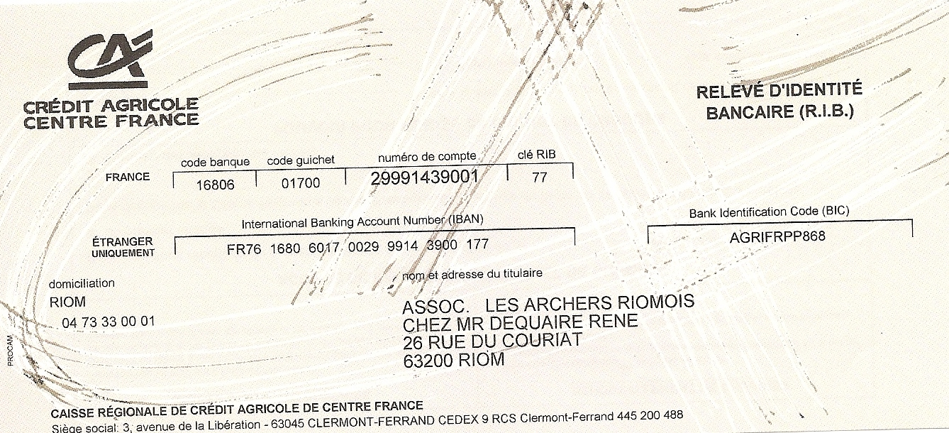

GENERAL INFORMATIONS

 We kindly ask you to return the following documents within the stated deadlines :

- Preliminary entries: January 25th 2013
- Final entries: March 25th 2013
- Hotel reservation form: February 28th 2013
- Transportation form : February 28th 2013

 Maximum six archers per category and division per country.

 Cancellations and reimbursement:

- Entry fees received before February 28th, 2013: total reimbursement of deposit.
- Entry fees received after February 28th, 2013: reimbursement of 50% of deposit.

 Weather in Auvergne:
In April the weather is generally rather good, but the temperature is not very high.
It is recommended to have clothes for rain and cold.

TO CONTACT US

 President:
René DEQUAIRE
26, rue du Couriat
63200 RIOM
France
Phone : Fax : + 33. 473.387.443

 All informations:
Caroline DUPORT-MEGRET
Phone.: + 33. 662.141.189
@: megcaroju@gmail.com

 postal address office:
Mr René DEQUAIRE
26, rue du Couriat
63200 RIOM
France

 Fax address:
+ 33. 473.387.443

 E-mail address:
megcaroju@gmail.com

