TO ALL WORLD ARCHERY MEMBER ASSOCIATIONS 26th January 2013

Dear President,

On behalf of the Organizing Committee and Archers Association of Slovenia I am pleased to invite you to the first leg of the “EUROPEAN JUNIOR CUP 2013” competition that will be held in Slovenia capital city, Ljubljana, from 13th – 18th May 2013.
This event will be organised following the WORLD ARCHERY EUROPE “EUROPEAN JUNIOR CUP COMPETITION 2013” rules for Junior Women, Junior Men, Cadet Women and Cadet Men classes in divisions of recurve and compound bow, in the discipline of Outdoor Target Archery.

Hereby you will find enclosed all the necessary documents concerning the registration, organisation and participation in this event. We kindly ask you for your response within the stated deadlines:

Preliminary Entries 19th February 2013
Final Entries 22nd April 2013
Hotel Reservation Form 31st March 2013
Transportation Form 22nd April 2013
Visa Invitation Letter Form 31st March 2013
Budget Form 22nd April 2013
Hotel Reservation Form (Final) 22nd April 2013

I am looking forward to welcoming you in Ljubljana, Slovenia.

Yours sincerely,

Mr. Tomaž Urlep
Organizing Committee President
Archers Association of Slovenia President

PRELIMINARY PROGRAMME

Saturday May 11th, 2013 Arrival of Delegations
Practice field and local transportation available

Sunday May 12th, 2013 Arrival of Delegations
Practice field and local transportation available

Monday May 13th, 2013 Official practice and Equipment inspection
Team Captains Meeting

Tuesday May 14th, 2013 Qualification round COMPOUND
Qualification round RECURVE - long distances

Wednesday May 15th, 2013 Qualification round RECURVE - short distances
Mixed Teams

Thursday May 16th, 2013 Individual Eliminations - up to the bronze medal matches

Friday May 17th, 2013 Team Eliminations and Finals

Saturday May 18th, 2013 Individual Gold Medal Matches
Award Ceremony
Closing Ceremony
Disco party

Sunday May 19th, 2013 Departure of Delegations

Note:
This preliminary program could be changed slightly according to the number of participants.
All changes will be published and distributed to all participants in good time.

PRELIMINARY & FINAL REGISTRATION

No entry forms will be available for registering to this event. The registration process has to be done using the World Archery Online Registration System (WAREOS, V.2)
The number of athletes that may be entered by a Member Association is limited to four (4) in each category.
All World Archery MAs are eligible to compete in European Junior Cup competitions, but only the results of the athletes from WORLD ARCHERY EUROPE MA’s will be taken in consideration for Junior Cup Circuit.
In order to use WAREOS, please enter this address in your internet browser www.archery.org/admin and use the Username and Password that World Archery has assigned to your Member Association. After entering the WAREOS, please go to “Online Registration” and register your archers for this event.
A “WAREOS User Manual” can be downloaded in PDF format (English and Russian) from the same website.
For any question regarding WAREOS, please contact Mr. Matteo Pisani at matteo@pisani.eu

Starting date of online-registration with WAREOS is: 28th January 2013
End of Preliminary registration: 19th February 2013
End of Final registration: 22nd April 2013

Please pay attention to the stated deadlines. After the deadlines have passed, MAs will not be able to enter or update data in WAREOS anymore, as the system will be blocked. In this case, if any MA would like to change or proceed with the Final registration process after the deadline, it is required to contact the Organizing Committee at president@archery-si.org or Mr. Matteo Pisani at matteo@pisani.eu (with the OC in Cc of that email).

The Member Association that will process her Final entry in WAREOS after the 20 day prior the start of competition date (Final registration deadline), will have a penalty fee of 100 Euros per athlete registered, to be paid to the OC upon arrival at the event.

The Member Association with Final registration in WAREOS that will differ by more than 4 athletes from the preliminary registration, will have a penalty fee of 100 Euros, to be paid to the OC upon arrival at the event.

A Member Association that has made Final entry in WAREOS and does not participate will be invoiced for the number of entries entered in the system, unless the Member Association has informed the OC in writing at least one week prior to the event that they are unable to attend.

Since entries will be made through WAREOS only, MAs declare that their athletes and officials are aware of the participation waiver and anti-doping agreement, and we recommend MAs to advise their athletes on this matter.
However, accepting the conditions of the athlete participation waiver and anti-doping agreement are an eligibility requirement to participate in the event.

As a final note, only member Associations in good standing will be eligible to compete. This also means that any penalty fee for 2012 will have to be paid prior to participation.

ACCOMMODATION & GENERAL INFORMATION

The official hotel is PLAZA HOTEL. Hotel is 4* stars category hotel.

The room rate:
- is per person per night,
- includes full board accommodation, taxes and VAT,
- does NOT include private parking fee (8 €/day) in front of the hotel or in the hotel’s
garage (max. height 2,20m),
- does NOT include use of the swimming pool.

Reservations should be made before 31st March 2013.

To confirm the reservation, a 50% deposit of the total amount is required to be bank transferred to the OC before 31st March 2013. Reservations after this date will be considered only according to availability, the room rate can change and we can not guarantee rooms in PLAZA HOTEL.

HOTEL | Category | Single room  Price per room per night | Double room  Price per person per night
PLAZA HOTEL  http://www.plazahotel.si/eng/ | 4* | € 80,00 | € 65,00

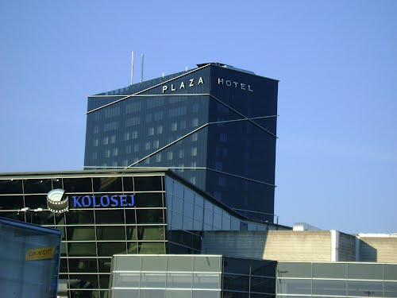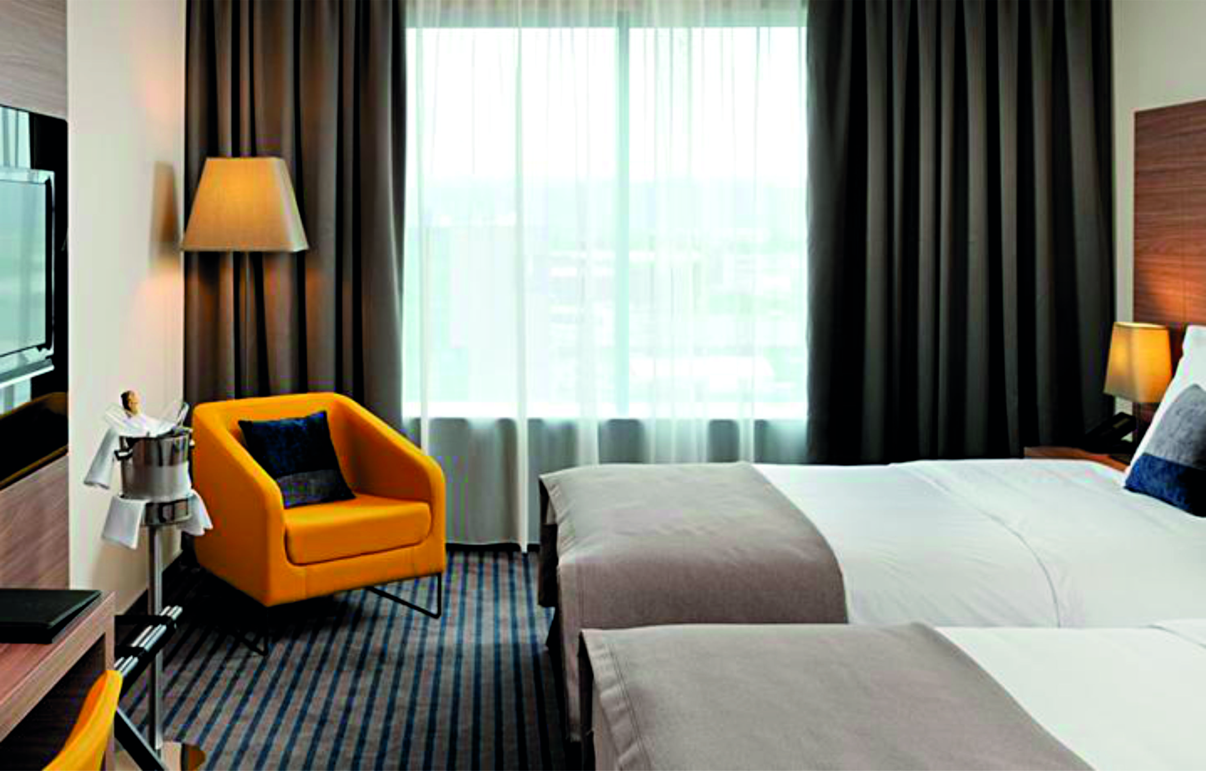

Note:
Please refer to the Accommodation pages below for detailed hotel information. Ensure that you complete all the necessary forms by the specified dates and make full payment for the accommodation at the time of booking. See detailed payment instructions below.

Participants who will decide to book their accommodation in other hotels (non-official hotel) will have to pay a double entry fee, and the LOC will not be responsible to provide transportation from that Hotel to the venue (transport for these teams will be provided only to and from airport). Also, it is not possible to distribute any information at the non-official hotels.
ADDITIONAL INFORMATION

Entry fees:
Individual: 50 € per athlete
Officials: Free
Teams: Free

Your entry fee includes daily local transportation to and from practice and competition field to the event official hotel and venues during the qualification, elimination and finals (transportation timetable has to be confirmed).

Transportation fees from/to the airports:
The OC will collect the teams from the two airports. You have to pay the transportation fee (including arrival and departure) as follows:

LJUBLJANA International Airport (SLO) (30 km) 30 €/person
TRIESTE International Airport (ITA) (130 km) 70 €/person

The last date for the payment of the transportation fee is 22nd April 2013.

From the airports to the hotel (return trip), the organiser will use buses, small buses, vans and cars, what will depend of number of persons scheduled for transportation.

Transportation from the airports will start two days before the official practice day and will end two days after the closing day.

Local transportation will be available between hotel and practice and competition venues. Exact transportation timetables will be confirmed. Buses and/or vans will be used.

Cancellations & Changes:
Cancellation must be in writing by email to president@archery-si.org.

Following conditions will apply:
- cancellation received before and included 31st March 2013 for full refund of the deposit,
- cancellation received between and included 1st April 2013 and 22nd April 2013 for 50% refund of the deposit,
- cancellation received after 22nd April 2013 - there will be no refund of the deposit payment.

All rates for payments after deadlines are subject to additional charges without prior notice.

All refunds, if any, will be processed after the event.

Name change (the same category and division) will be accepted up to 72 hours before the event without any additional charge.

OC has to be informed about changes in the travel programme 72 hours prior arrival. If your arrival is later then your original schedule, the room charges are starting from the original date indicated by the Member Association in their Accommodation form.

Meals at the venue:
Lunch will be served in the restaurant of the hotel. There will be possibility to order lunch boxes instead of having real lunch in hotel, but it has to be done one day before (and for each day you need it) on the reception of hotel, using the "Lunch boxes form" provided below in this Invitation package.

Drinking water will be available on the competition field free of charge.

All other costs made in cafeteria at the archery venue or in the hotel (snacks, drinks, small meals) are not included in the entry fee and hotel payment and must be paid on consumptions.

LJUBLJANA
Besides having everything that all the other modern capitals have, Ljubljana succeeded in maintaining the relaxed atmosphere of a small city. This picturesque and very vibrant city is full of surprises. The region that besides Ljubljana comprises 25 other municipalities is noted for its traditional hospitality, diverse nature, nice towns, castles, quality traditional restaurants and village churches with their rich artistic legacy.

The Central Slovenia is the place where the alpine and karst landscapes meet. Thus, various unique natural and cultural particularities were created. Some of these are the Ljubljana Marshes, an area of wetlands and peat bogs known for its prehistoric pile dwellers and for its rare animal and vegetal species, the high mountain plateau Velika planina situated in the Kamnik Alps, noted for its ski centre and for being the oldest dairy herdsmen’s settlement in Europe, interesting subterranean caves, karstic fields and the mysterious forests of the Polhov Gradec and Posavje hills that abound with tourist farms.

Weather
In May you can expect in Ljubljana the temperature 20–25°C with around ten hours of sunshine per day. Nights can be colder.
Most of the time it is sunny, but we suggest you to have some heavier piece of clothes. The rain or colder day is not unusual in this time of the year.

Accreditation and Team Captains Meeting
Accreditation will take place upon arrival of the teams, in the lobby of the PLAZA HOTEL
(on the right side of the entrance) on 11th and 12th May 2013.

The address of hotel is:
PLAZA HOTEL Ljubljana, Bratislavska cesta 8, 1000 Ljubljana, Slovenia.
At check in, every national team (or Team Captain) is required to give credit card information to the hotel reception.
For all Ceremonies WA dress code is obligatory.
More details will be provided at the Team Captains’ Meeting.
Team Captains Meeting will be held in the conference room on the 15th floor of the PLAZA HOTEL, on Monday, May 13th 2013, at 11:00.
The OC suggests all teams to bring 2 of their national flags dimensions 2x1m.

Training
The practice field will be available starting from 11th May 2013. The practice field is beside the competition field and is 4 km from the hotel.

Visas
Please apply for your visa as soon as possible, if you need any additional information regarding visa, please let us know.

Application for and obtaining travel visas are completely and solely the responsibility of the participating teams. The process for obtaining a visa requires each individual to submit an application through a Slovenian Embassy or Slovenia Consulate. This is a process that MUST be done by the applicant – the Organizing Committee cannot do it for you. It cannot be emphasized enough to start the application process early. Please note that the application and interview process in your country may very well be in advance of the team selection date, so in many cases, you will need to start the application process prior to confirming your final team.

Visa Invitation Letter – All countries that will need letter of invitation by the Organizing Committee to use it in their application process, are requested to order these in time. Please fill out the Visa Invitation Letter Form as soon as possible and send it in.

As long as the Organizing Committee gets no different information, the Invitation Letter will be sent by email. If an express service should be desired, this service will be charged to the MA and must be paid to the Organizing Committee upon arrival.

Disco party
On the final day (Saturday, 18th May 2013) standard meal dinner will be served in the restaurant of the hotel. After the dinner, music and dancing will take place from 21:00 till 24:00h.
Entry fee for the disco party is 15 € (soft drinks included).
Place of disco party will be confirmed.

Internet
Free of charge in the hotel and on the competition field.

OC contacts
- Phone for assistance when traveling
Mr. Tone Cezar: +386 (0)31 621 372 - 24 hours English
- For all matters
Mr. Tomaž Urlep - 24 hours English
Mobile +386 (0)31 682 647
E-mail: president@archery-si.org

HOTEL RESERVATION FORM

Country/Team from: ___________________________________________

HOTEL: PLAZA HOTEL

Number of Rooms:

Single room:
Double room:

Please check this box if you need facilities for persons with disabilities.

Team Arrival Date: _____________________

Team Departure Date: __________________

Date: ____________

Signature of President/Secretary General: ______________________________

PLEASE RETURN THIS HOTEL RESERVATION FORM TO THE ORGANISER BEFORE 31st March 2013 by e-mail to president@archery-si.org

FINAL HOTEL RESERVATION FORM

Country/Team from: ___________________________________________
Team Captain: _________________________________
Mobile: _________________________________
e-mail: _________________________________

HOTEL: PLAZA HOTEL

Number of Rooms:

Single room:
Double room:

Please check this box if you need facilities for persons with disabilities.

Team Arrival Date: _____________________

Team Departure Date: __________________

Date: ____________

Signature of President/Secretary General: ______________________________

ONLY IF YOU CHANGE NUMBER OR TYPE OF ORDERED ROOMS STATED IN PRELIMINARY HOTEL REERVATION FORM
PLEASE RETURN THIS HOTEL RESERVATION FORM TO THE ORGANISER BEFORE 22nd April 2013 by e-mail to president@archery-si.org

LUNCH BOXES ORDERING FORM

Country/Team from: ___________________________________________

Hereby orders __________________ lunch boxes (number of lunch boxes)

to be ready for __________________ (date).

of which _______________ needs to be vegetarian ones (number).

Date: _______________

Signature of the delegation official: ______________________________

PLEASE RETURN THIS FORM TO THE RECEPTION OF HOTEL 1 DAY BEFORE YOU NEED LUNCH BOXES (AND FOR EACH DAY YOU NEED IT).

TRANSPORTATION FORM

Country/Team from: __________________________

Number of passengers: ________ person/s

Arrival information

We will arrive by plane:

Airport: __________________ Flight Nr: _____________

Date: ______________ Arrival Time: ___________

We will arrive to LJUBLJANA by: _______________________________________

____________________________________________________________

Departure information

We will depart by plane:

Airport: __________________ Flight Nr: _____________

Date: ______________ Arrival Time: ___________

We will departe LJUBLJANA by: _______________________________________

____________________________________________________________

Date: _________

President/Secretary General MA: ______________________________

PLEASE RETURN THIS TRANSPORTATION FORM TO THE ORGANISER BEFORE 22nd April 2013 by email to president@archery-si.org
VISA INVITATION LETTER FORM
Country/Team from: ___________________________________

Contact person: _______________________________________

Given name | Family name | Date and place of birth | Citizenship  (Country) | Passport number | Expiration date of passport | Adress of residence

Date: ______________

President/Secretary General MA: _______________________________
PLEASE RETURN THIS VISA INVITATION LETTER FORM TO THE ORGANISER AS SOON AS POSSIBLE (latest by 31st March 2013) by email to president@archery-si.org
BUDGET FORM

Member Association: ____________________________________________
Contact person: ________________________________________________
Telephone: ____________________________________________________
Mobile: _______________________________________________________
E-mail: _______________________________________________________

1) Entry Fees
Position Cost Number of persons Total
Athlete € 50 x ___ € ____

Total 1 ................................................................................. € ____

2) Accommodation
PLAZA HOTEL - Full Board
Room Cost Nr of Persons Nr of nights Total
Single room € 80 x ___ x __ € ____
Double room € 65 x ___ x __ € ____

Total 2 .................................................................................. € ____

3) Transportation + DISCO PARTY
Airport Cost Number of Persons Total
LJUBLJANA € 30 x ______ € ____
TRIESTE € 70 x ______ € ____

DISCO PARTY € 15 x ______ € ____

Total 3 .................................................................................. € ____

TOTAL (1+2+3) € ____

Date, ___________

President/Secretary General MA: _____________________________

PLEASE RETURN THIS BUDGET FORM TO THE ORGANISER BEFORE 22nd April 2013 by e-mail to president@archery-si.org

PAYMENT INSTRUCTIONS:

BANK: NOVA LJUBLJANSKA BANKA d.d.
Address: Trg republike 2
1000 Ljubljana
Slovenia

A/C NAME LOKOSTRELSKA ZVEZA SLOVENIJE
Address: Dolenjska cesta 11
1000 Ljubljana
Slovenia

SWIFT CODE (BIC): LJBASI2X
IBAN: SI56 0201 3001 7204 321

NOTE:

ALL PAYMENTS ARE REQUIRED TO BE DONE IN EUROS BY BANK TRANSFER LATEST 27th APRIL 2013!
ALL BANK TRANSFER FEES HAVE TO BE PAID BY PARTICIPATING MAS (you need to state OUR option when paying).
IN CASE OF NOT PAYING THE BANK TRANSFER FEES, YOU WILL BE CHARGED FOR THE DIFFERENCE UPON ARRIVAL, AT THE ACCREDITATION.

- NO CREDIT CARDS
- NO TRAVEL CHECKS

PLEASE SEND THE COPY OF THE BANK TRANSFER TO THE ORGANISER by email to president@archery-si.org.

