Echmiadzin, 30/01/2014

TO EUROPEAN MEMBER ASSOCIATIONS

Dear President,

On behalf of the Organising Committee of the European Outdoor Championship and of the Archery Federation of Armenia, I would like to invite you to the European Outdoor Championships 2014, which will be held from 21 – 26 July in Echmiadzin, Armenia.

To register participation, please find enclosed the necessary documents and return your completed forms within the deadlines listed below:

Summary of deadlines:

- Preliminary Entries 21 April 2014
- Hotel Reservation Form & Deposit 21 April 2014
- Final Entries 1 July 2014
- Transportation Form 1 July 2014
- Visa Support Form 1 May 2014
- Final Hotel Reservation Form 1 July 2014
& Remaining Payment

Looking forward to welcoming you and your teams to Echmiadzin, Armenia.

Sincerely yours,

Nazik Amiryan
President of Archery Federation of Armenia
PROGRAMME
Day Date |  |  |  | Description
 | Saturday  19 July |  | Arrival of participants  Practice field and local transport available
 | Sunday  20 July |  | Arrival of participants  Practice field and local transport available  WAE Congress (Congress Hotel)  Registration of participants – 02:00 pm  Start- 03:00 pm
DAY 1 | Monday  21 July |  | Official Practice (Recurve Women and Men)  Official Practice (Compound Women and Men)  Equipment Inspection  Team Managers Meeting 20:00 hrs in Metropol Hotel (Shuttle bus service available).  Opening Ceremony 14:30 hrs (In the field)
DAY 2 | Tuesday  22 July |  | Qualification Rounds  Morning Section;  Recurve (Women, Men; 70m, 72 Arrows)  Afternoon Section;  Compound (Women, Men; 50m, 72 Arrows)
DAY 3 | Wednesday  23 July |  | Team Eliminations  - Recurve (Women, Men)  - Compound – (Women, Men)  Mixed Team Eleminations  - Recurve  - Compound  All matches 1/8th and Semifinals  - Excursion
DAY 4 | Thursday  24 July |  | Individual Eliminations  Morning Section;  - Recurve (Women and Men)  - 1/48th and Quarterfinals  Afternoon Section;  - Compound (Women and Men)  - 1/48th and Quarterfinals
DAY 5 | Friday  25 July |  | Semi Final&Finals – Compound & Recurve  - Team  - Mixed Team  - Awards Ceremony  - Excursion
DAY 6 | Saturday  26 July |  | Semi Final&Finals – Compound&Recurve  - Individual  - Awards Ceremony  - Banquet
DAY 7 | Sunday  27 July |  | Departure of teams

NOTE: This is a preliminary programme and subject to change according to the number of participants in each division and TV requirements. All changes will be published and distributed to all participants in advance.
PRELIMINARY & FINAL REGISTRATION
No entry forms will be available for registering to this event. The registration process has to be done using the World Archery Online Registration System (WAREOS, V.2)
The number of athletes that may be entered by a Member Association is limited to three (3) in each category.
In order to use WAREOS, please enter this address in your internet browser http://register.worldarchery.org/login.asp and use the Username and Password that World Archery has assigned to your Member Association. After entering the WAREOS, please go to “Online Registration” and register your archers for this event.
A “WAREOS User Manual” can be downloaded in PDF format (English and Russian) from the same website.
For any question regarding WAREOS, please contact Mr. Matteo Pisani at matteo@pisani.eu
Starting date of online-registration with WAREOS is: 03 February 2014
End of Preliminary registration: 21 April 2014
End of Final registration: 1 July 2014
Please pay attention to the stated deadlines. After the deadlines have passed, MAs will not be able to enter or update data in WAREOS anymore, as the system will be blocked. In this case, if any MA would like to change or proceed with the Final registration process after the deadline, it is required to contact the Organizing Committee at nune200707@rambler.ru or rsarg@mail.com and Mr. Matteo Pisani at matteo@pisani.eu (with the OC in Cc of that email).

The Member Association that will cancel Final entry in WAREOS after the 20 day prior the start of competition date (Final registration deadline), will have a penalty fee of 100 Euros per athlete registered, to be paid to the LOC upon arrival at the event.

The Member Association with Final registration in WAREOS that will differ by more than 4 athletes from the preliminary registration, will have a penalty fee of 100 Euros, to be paid to the LOC upon arrival at the event.

A Member Association that has made Final entry in WAREOS and does not participate will be invoiced for the number of entries entered in the system, unless the Member Association has informed the OC in writing at least one week prior to the event that they are unable to attend.

Since entries will be made through WAREOS only, MAs declare that their athletes and officials are aware of the participation waiver and anti-doping agreement, and we recommend MAs to advise their athletes on this matter.
However, accepting the conditions of the athlete participation waiver and anti-doping agreement are an eligibility requirement to participate in the event.

As a final note, only member Associations in good standing will be eligible to compete. This also means that any penalty fee for 2013 and World Archery fee 2014 must have been paid prior to participation.

ACCOMMODATION & GENERAL INFORMATION
The official hotels are:
Metropol
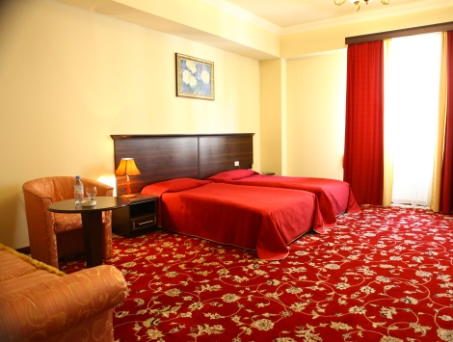

Imperial
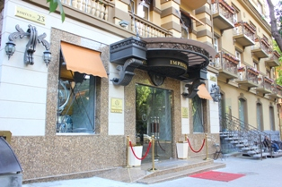
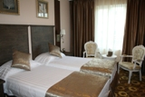

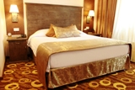

Ararat
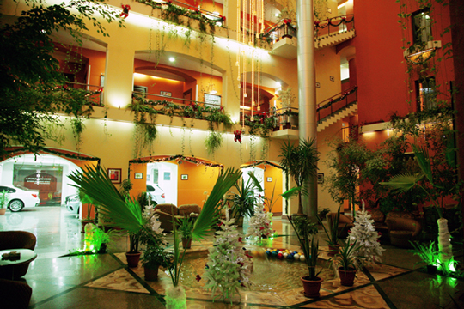
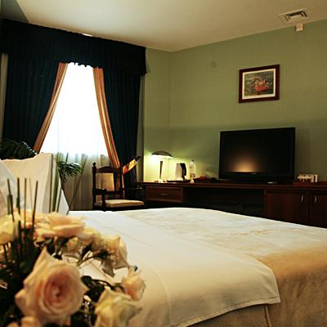
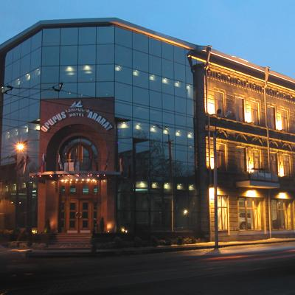
The hotel room rates are per room, per night, including full board (hot/cold, open buffet breakfast, lunch and dinner with non–alcoholic drinks).
Teams who do not book their accommodation through the LOC will be charged a double entry fee.

- Reservations should be made before: 1 April 2014
- Final Hotel Reservation & Transportation Forms: 1 July 2014

To confirm your hotel reservations, a 50% deposit, of the total amount, is required to be transferred, to the OC before 1 June 2014, via a bank transfer, using the details provided on page 12. Reservations received after this date will be considered according to availability.

1. Metropol hotel (5 Stars)
Single Room 120 Euro
Twin Room 180 Euro
Triple Room 225 Euro

2. Imperial hotel (4 Stars)
Single Room 110 Euro
Twin Room 160 Euro

3. Ararat Hotel (4 Stars)
Single Room 110 Euro
Twin Room 160 Euro
Superior single 130 Euro
Superior double room 260 Euro (4 beds)

Important Note:
Please complete all the necessary forms by the deadlines given and arrange full payment for accommodation before arrival. No credit cards or travel checks will be accepted on site.
All participants should book their accommodation through the LOC. Participants that do not book their accommodation through the LOC, will have to pay double entry fees and will not be entitled to any event information or transportation.
Teams will also need to register for their accreditation, at the latest, the day before official practice. If participants do not register the day before, no changes will be made to the entry list. Participants will not be allowed to compete if registration is not completed in time and will not be allocated to a target.
Internet:
Free Internet is available in all hotels (guest rooms and hotel lobby) and the archery field area.

HOTEL RESERVATION FORM

Country/Team from: ___________________________________________

Hotel: ____________________________________

Number of Rooms:

Single:

Double:

Do you require a room for a disabled team member? Yes No

If yes, please specify: ______________________________________________

Do any of your team members have dietary requirements or allergies such as, vegetarian, nut allergies or gluten free etc. Yes No

If yes, please specify: ______________________________________________

Date: ______________________

Signature of President / Secretary General: ______________________________

PLEASE RETURN THIS HOTEL RESERVATION FORM TO LOC BEFORE
1 July 2013 by email to nune200707@rambler.ru
TRANSPORTATION FORM

Country/Team from: ___________________________________________

Number of passengers: ___________ person/s

Arrival information

We will arrive by plane:

Airport: ___________________________ Flight Nr: ______________________

Date: _____________________ (DD/MM/YY) Arrival Time: ________________

We will arrive in Yerevan International Airport (EVN) by: ____________________

Departure information

We will depart by plane:

Airport: _________________________ Flight Nr: _______________

Date: ____________________ (DD/MM/YY) Departure Time: _______________

We will depart from Yerevan International Airport (EVN) by: _________________

Date: ____________________ (DD/MM/YY)

Signature: ______________________________

President / Secretary General MA: _______________________________
Note:
The entry fee INCLUDES transportation between hotels and archery venues.
For transportation from other airports please contact LOC for fee quotation.
PLEASE RETURN THIS TRAVEL FORM TO THE LOC ASAP, by email to: nune200707@rambler.ru

ENTRY FEE

Entry fee:
Individual: 150 Euro per athlete
Officials: 40 Euro per person
Entry fee for teams 75 Euro
There is no entry fee for mix teams.

Entry fee in NON official hotels:
Individual: 300 Euro per athlete
Officials: 80 Euro per person

For participants using official hotels, entry fees include daily local transport to and from the practice field to official hotels during the qualification, elimination and finals venues (timetable to be confirmed). All participants should book their accommodation through the LOC. Participants who decide to book their accommodation in other hotels (non official) will have to pay a double entry fee and the OC will not be responsible for providing transportation from those hotels to the venue.

VISAS
All participants who need an entry visa to Armenia, are kindly requested to address to the LOC for support letters, but no later than 1 May 2014.
Participants can obtain their visas on the board of entry to Armenia just at the airport.

All participating countries are requested to bring two national flags (1mx2m) and national anthem.

WAE Congress:
The WAE Congress will be held on Sunday 20 July. All participants are expected to be present in the hall of the hotel at 13:45 hours, for transport to the Congress Venue.
Participants of the Congress who are coming to Echmiadzin only for the Congress will be lodged in the hotel “Congress”, that has 35 single and 13 twin rooms. Prices include full board.

“Congress” hotel (5 Star)
Single Room 120 Euro
Twin Room 180 Euro

Continental Qualifying Tournament:
This European Championship will serve also as Qualifying Event for EUROPEAN GAMES-BAKU, 17-22 June 2015.
There will be no special Quota Tournament.
After final position
8 teams Men and 8 teams Women = 24 M + 24 W
16 Individuals Men and 16 Individuals Women = 16 M + 16 W
will achieve quota places for their countries.

FINAL HOTEL RESERVATION & ENTRY FEE FORM

Personal Details Women Men
Name of Member Association:_________________________________________ Country / Region: _____________________
Contact Name: ________________________________
Telephone: __________________ E-mail: _____________________

Hotel Accommodation:
Metropol Hotel (5 Star)
Single room, (per room per night) 120 Euro; Twin room 180 Euro; Triple 225 Euro.
Congress Hotel (5 Star) (Only for congress)
Single room, (per room per night) 120 Euro; Twin room 180 Euro.
Ararat Hotel (4 Star)
Single room, (per room per night) 110 Euro; Twin room 160 Euro; Superior single 130 Euro; Superior double 260 Euro.
Imperial Hotel (4 Star)
Single room, (per room per night) 110 Euro; Twin room 160 Euro.
Please reserve the following:
_______ SINGLE ROOM(s) From ________________ to _______________ 2014
_______ TWIN ROOM(s) From ________________ to _______________ 2014
___________________ TOTAL ROOMS REQUIRED
Flight Details:
We will arrive/departure to/from __________________________________ International Airport Or We will arrive/depart to/from Yerevan International Airport (EVN) by other means. Please indicate _______________________________________

Date of Arrival __________________________ (DD/MM/YY)
Time __________________________ Flight __________________________
Date of Departure __________________________ (DD/MM/YY)
Time __________________________ Flight __________________________
Accommodation Payment:
ROOM TYPE AMOUNT OF ROOMS NIGHT RATE P/N TOTAL RATE
_____________ _____________________ _________________ ________________

Single __________________ x ___________ x = _______________
Twin __________________ x ___________ x = _______________
TOTAL ACCOMMODATION AMOUNT _____________________________

Entry Fee Payment:
The entry fees should be paid in full BEFORE arrival.

Participants who decide to book their own accommodation, not through the LOC, will have to pay double entry fee (this is the case for both official and non-official hotels).

NUMBER OF PERSONS ENTRY FEE (EURO) TOTAL (EURO)
Athletes ___________________ x Euro 150 = ________________________
Officials ___________________ x Euro 40 = ________________________
Team _____________________ x Euro 75 =__________________________

TOTAL ENTRY FEE __________________________

Airport Transportation Fee: (Round trip)

NUMBER OF PERSONS FEE (EURO) TOTAL (EURO)

______________________ x Euro 20 = __________________________

To Guarantee Reservations:
For the payment of accommodation, a 50% deposit of the total amount payable
is required to be paid with preliminary entry by 21 April 2014. The remaining payment for accommodation should be paid with the final entry by 1 July 2014. Accommodation cannot be guaranteed after this deadline.

A balance invoice will be provided via email or on arrival, as required, after payment.

Please send this form to the LOC BEFORE 1 July 2014 by email to nune200707@rambler.ru; rsarg@mail.com

PAYMENT CONDITIONS:

For the payment of accommodation, a 50% deposit of the total amount payable is required to be paid with preliminary entry by 21 April 2014. The remaining payment for accommodation should be paid with the final entry by 1 July 2014. Accommodation cannot be guaranteed after this deadline. A balance invoice will be provided via email or on arrival, as required, after payment.

BANK TRANSFER:
Payment must be sent to the following bank account:

INTERMEDIARY BANK:  DEUTSCHE BANK A.G., FRANKFURT AM MAIN,  GERMANY  SWIFT: DEUTDEFF  BENEFICIARY BANK:  CONVERSE BANK CJSC, YEREVAN, ARMENIA  SWIFT: COVBAM22  BENEFICIARY CUSTOMER:  NAME: The ARCHERY FEDERATION OF THE REPUBLIC OF ARMENIA  A/C No. or ID  No.: 19300 02187950104 | Main Details:  CONVERSE BANK CJSC  26/1 Vazgen Sargsyan Str.,  Republic Square, 0010 Yerevan, Armenia  SWIFT: COVBAM22  Phone: (37410) 511200, 511211  Tel: (37410)511212  E-mail: post@conversebank.am  www..conversebank.am

NOTE: Please indicate in the reference/notes section the team or reservation name that corresponds to the payment.

ALL PAYMENTS SHALL BE MADE IN EURO
By BANK TRANSFER

All bank charges/fees are the responsibilities of the sender.
CREDIT CARDS or TRAVEL CHECKS will not be accepted.
Archery Venues:
The archery qualification and competition venues are located in Echmiadzin, “Ara and Aytsemnik” Complex.
The length of the field is 100 m and width is 160m. The field has a good drainage system. There is a spectator tribune with a capacity of 400 seats at the venue. The venue is surrounded by and well protected tall fencing system. Inside the venue, there will be archery exhibition stands, shops, catering and an athlete equipment repair booth.

Transportation:
- Transportation will be provided from “Zvartnots” International Airport to the official hotels, on 19 & 20 July 2014.
- Transportation will be provided from the official hotels to “Zvartnots” International Airport, 27 July 2014.

Local transportation will be available between official hotels and practice and competition venues. Transport timetables will be confirmed. Buses and/or vans will be provided.

Cancellations & Changes:
Written Cancellations must be:
- Received before 29 May 2014 for full refund of the deposit payment.
- Received after 29 May 2014, no refund will be awarded.

All refunds, if any, will be processed after the event.

Name change (the same category and division) will be accepted up to 72 hours before the event, without any additional charge. The LOC should be informed about any changes immediately in the travel programme 72 hours prior arrivals. If your arrival is later than originally scheduled, the room charges will start from the original date indicated by the accommodation forms received from the Member Association.

Training:
There is a training field that will be available to use from 19 July 2014. The training field is walking distance to the competition field and is about 25 km from the hotels.

Weather:
July (Average):
Temperature 35º C (95 F)
Low Temperature 30º C (86 F)
High Temperature 40º C (104 F)
Sunshine Hours- 15 Hours
Rainfall 0 mm
Rainfall days- 0 days

Ceremonies:
There will be an opening and closing ceremony. Further details will be given on arrival.
Banquet (free of charge)

Water on the Venue:
Water will be provided on the field during competition for accredited people.

Media Registration:
Media representatives can apply for registration by emailing nune200707@rambler.ru; rsarg@mail.com

Internet Connection:
Hot Spot WiFi will be available in official hotels and in the archery venue free of charge for accredited persons.

LOC Contact:
Name: Ms Ruzanna Sargsyan
Ph. +374 93 88 10 66
Email: rsarg@mail.com
Language: English
Official website: www.armarchery.am

