TO ALL WORLD ARCHERY EUROPE MEMBER ASSOCIATIONS 13th January 2014

Dear President,

On behalf of the Organizing Committee and Archers Association of Slovenia I am pleased to invite you to the 14th European Outdoor Youth Championships and CQT for Youth Olympic Games that will be held in Slovenia capital city, Ljubljana, from 19th – 24th May 2014.

Hereby you will find enclosed all the necessary documents concerning the registration, organisation and participation in this event. We are kindly asking you for your response within the stated deadlines:

Preliminary Entries 17th February 2014
Final Entries 28th April 2014
Hotel Reservation Form 31st March 2014
Transportation Form 28th April 2014
Visa Invitation Letter Form 31st March 2014
Budget Form 28th April 2014
Hotel Reservation Form (Final) 28th April 2014

I am looking forward to welcoming you in Ljubljana, Slovenia.

Yours sincerely,

Mr. Leon Uratnik
Organizing Committee President
Archers Association of Slovenia President

PRELIMINARY PROGRAMME

Saturday May 17th, 2014 Arrival of Delegations
Practice field and local transportation available

Sunday May 18th, 2014 Arrival of Delegations
Practice field and local transportation available

Monday May 19th, 2014 Opening Ceremony
Official practice and Equipment inspection
Team Managers Meeting

Tuesday May 20th, 2014 Qualification round Recurve & 1/48 ER
Qualification round Compound & 1/48 ER

Wednesday May 21st, 2014 Individual Eliminations, ¼ and ½ Finals

Thursday May 22nd, 2014 CQT for Youth Olympic Games
Mixed Teams

Friday May 23rd, 2014 Team Eliminations and Finals

Saturday May 24th, 2014 Individual Bronze and Gold Medal Matches
Award Ceremony
Closing Ceremony
Disco party

Sunday May 25th, 2014 Departure of Delegations

Note:
This is a preliminary program and could be changed slightly according to the number
of participants. All changes will be published and distributed to all participants in good time.

Website: http://www.eyc-ljubljana2014.si/

PRELIMINARY & FINAL REGISTRATION

No entry forms will be available for registering to this event. The registration process has to be done using the World Archery Online Registration System (WAREOS, V.2)
The number of athletes that may be entered by a Member Association is limited to three (3) in each category.
In order to use WAREOS, please enter this address in your internet browser http://register.worldarchery.org/ and use the Username and Password that World Archery has assigned to your Member Association. After entering the WAREOS, please go to “Online Registration” and register your archers for this event. Pay attention: every archer can be registered in the system only once. The date of birth is mandatory.
A “WAREOS User Manual” can be downloaded in PDF format (English and Russian) from the same website.
For any question regarding WAREOS, please contact Mr. Matteo Pisani at matteo@pisani.eu

Starting date of online-registration with WAREOS is: 17th January 2014
End of Preliminary registration: 17th February 2014
End of Final registration: 28th April 2014

Please pay attention to the stated deadlines. After the deadlines have passed, MAs will not be able to enter or update data in WAREOS anymore, as the system will be blocked. In this case, if any MA would like to change or proceed with the Final registration process after the deadline, it is required to contact the Organizing Committee at president@archery-si.org and Mr. Matteo Pisani at matteo@pisani.eu (with the OC in Cc of that email).

Final entries processed in WAREOS after the 20 day prior the start of competition date (Final registration deadline), will have a penalty fee of 100 Euros per athlete registered, to be paid to the OC upon arrival at the event.

The Member Association with Final registration in WAREOS that will differ by more than 4 athletes from the preliminary registration will have a penalty fee of 100 Euros, to be paid to the OC upon arrival at the event.

A Member Association that has made Final entry in WAREOS and does not participate will be invoiced for the number of entries entered in the system, unless the Member Association has informed the OC in writing at least one week prior to the event that they are unable to attend.

Since entries will be made through WAREOS only, MAs declare that their athletes and officials are aware of the participation waiver and anti-doping agreement, and we recommend MAs to advise their athletes on this matter.
However, accepting the conditions of the athlete participation waiver and anti-doping agreement are an eligibility requirement to participate in the event.

As a final note, only member Associations in good standing will be eligible to compete. This also means that any penalty fee for 2014 and World Archery fee 2014 must have been paid prior to participation.

ACCOMMODATION & GENERAL INFORMATION

The official hotels are PLAZA HOTEL and AMBIENT HOTEL. PLAZA is 4* stars category hotel, AMBIENT is 3* stars category hotel.

The room rates for both hotels:
- are per person per night,
- include full board accommodation, taxes and VAT.
The room rate for PLAZA hotel:
- does NOT include private parking fee (8 €/day) in front of the hotel or in the hotel’s
garage (max. height 2,20m),
- does NOT include use of the swimming pool.

HOTEL | Category | Single room  Price per person per night (full board) | Double room  Price per person per night (full board)
PLAZA HOTEL  http://www.plazahotel.si/eng/ | 4* | € 120,00 | € 85,00
AMBIENT HOTEL  http://www.ambienthotel.si/ | 3* | € 85,00 | € 60,00

There are just some triple rooms available in both hotels and few 4 bed rooms and apartments for 4 or 5 in Ambient hotel. Please contact us if you are interested.

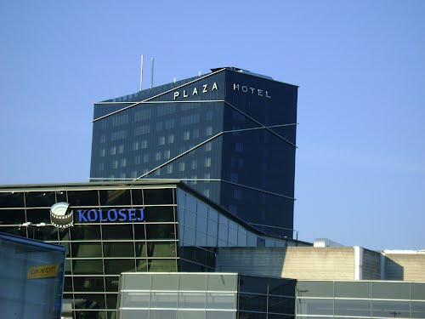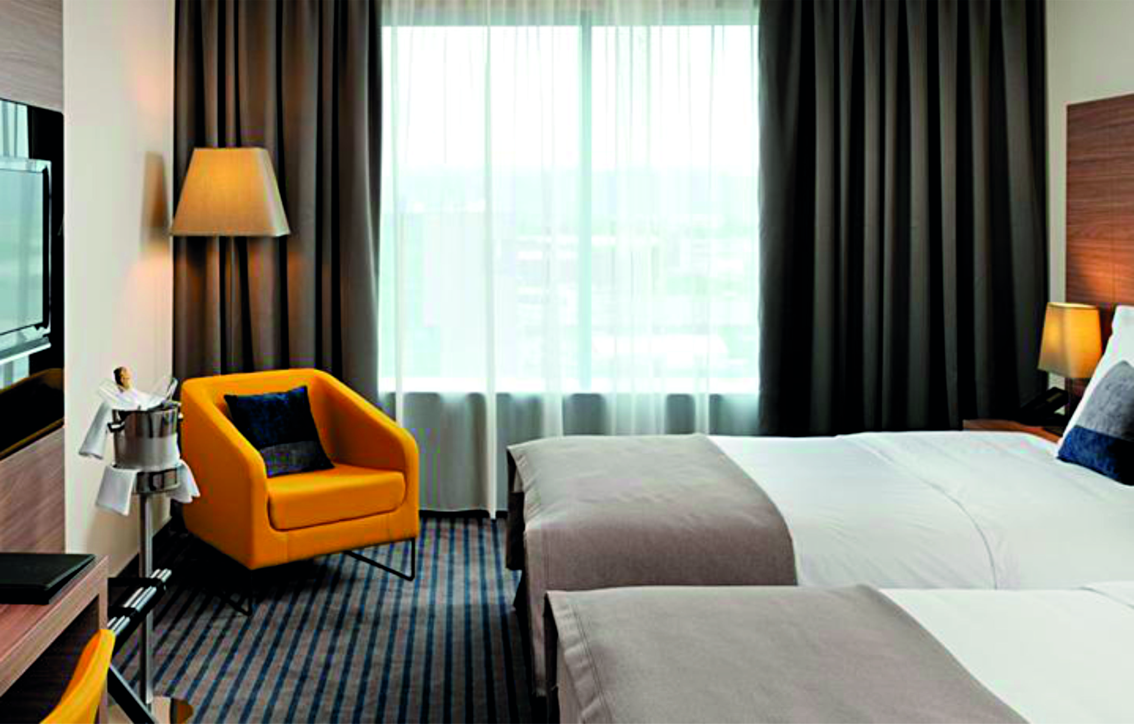

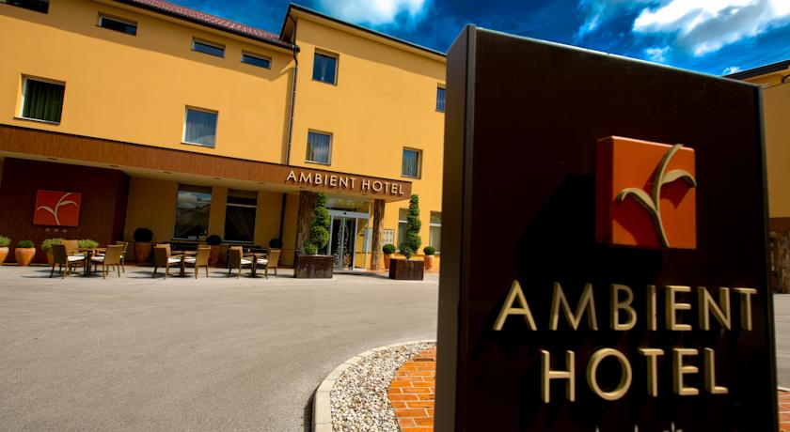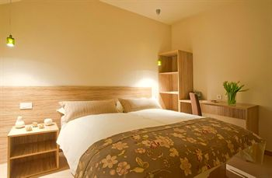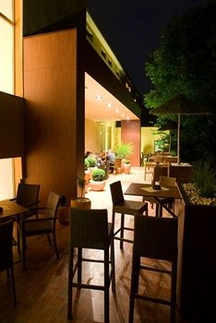

There are different double rooms:
- king room - with one big bed
- twin room - with 2 separate beds
Please specify your requirements on the reservation form.

In both hotels there are few rooms with extra long beds (220 cm).

Reservations should be made before 31st March 2014.

To confirm the reservation, a 50% deposit of the total amount is required to be bank transferred to the OC before 31st March 2014. Reservations after this date will be considered only according to availability, the room rate can change and we can not guarantee rooms in both official hotels.

Note:
Please refer to the Accommodation pages below for detailed hotel information. Ensure that you complete all the necessary forms by the specified dates and make full payment for the accommodation at the time of booking. See detailed payment instructions below.

Participants who will decide to book their accommodation in other hotels (non-official hotels) will have to pay a double entry fee, and the LOC will not be responsible to provide transportation from that Hotel to the venue (transport for these teams will be provided only to and from the airport). Also, it will not be possible to distribute any information at the non-official hotels.

ADDITIONAL INFORMATION

Entry fees:
Individual: 150 € per athlete
Officials: 50 € per official
Teams: 75 € per team

Your entry fee includes daily local transportation to and from practice and competition field to the event official hotel and venues during the qualification, elimination and finals (transportation timetable has to be confirmed).

Continental Quota Tournament for Youth Olympic Games:
The Continental Qualifying Event for the Youth Olympic Games in Nanjing, China will be held on Thursday, May 22nd. This special competition will be held for athletes eligible to compete in the 2014 Youth Olympic Games. For the Qualifying event, athletes must have been born between 1 January 1997 and 31 December 1999. Furthermore, they must have achieved the following Minimum Qualification Standard (MQS)
Men 60m Round 610
Women 60m Round 600
The MQS must be achieved in the qualifying period starting 1 September 2013 to 1 July 2014.

There will be no extra entry fee for this event. There will be no extra qualification round for this competition. Ranking for the purpose of pairing for the elimination round will be done according the results from the qualification round of the European Youth Championships. Archers who have previously won a qualification place for their NOC at the WAYC, cannot compete at the CQT. The competition format will be an Olympic Round with 1/64th Elimination Round and all athletes will shoot at 60 m.

For Europe, 3 places per gender will be allocated to the National Olympic Committees of the highest ranked athletes, with a maximum of one (1) per NOC.

List of the Qualification Places earned at the World Archery Youth Championships

GIRLS BOYS
Belarus Belgium
Spain Belarus
France France Great Britain Great Britain
Israel Germany
Italy Netherlands
Poland Poland
Russia Slovenia
Turkey Slovakia
Ukraine Turkey

Transportation fees from/to the airports:
The OC will collect the teams from the two airports. You have to pay the transportation fee (including arrival and departure) as follows:
LJUBLJANA International Airport (SLO) (30 km) 30 €/person
TRIESTE International Airport (ITA) (130 km) 70 €/person

The last date for the payment of the transportation fee is 28th April 2014.

From the airports to the hotel (return trip), the organiser will use buses, small buses, vans and cars, what will depend of number of persons scheduled for transportation.

Transportation from the airports will start two days before the official practice day and will end two days after the closing day.

Local transportation will be available between hotel and practice and competition venues. Exact transportation timetables will be confirmed. Buses and/or vans will be used.

Cancellations & Changes:
Cancellation must be in writing by email to president@archery-si.org.

Following conditions will apply:
- cancellation received before and included 31st March 2014 for full refund of the deposit,
- cancellation received between and included 1st April 2014 and 28th April 2014 for 50% refund of the deposit,
- cancellation received after 28th April 2014 - there will be no refund of the deposit payment.

All rates for payments after deadlines are subject to additional charges without prior notice.

All refunds, if any, will be processed after the event.

Name change (the same category and division) will be accepted up to 72 hours before the event without any additional charge.

OC has to be informed about changes in the travel programme 72 hours prior arrival. If your arrival is later then your original schedule, the room charges are starting from the original date indicated by the Member Association in their Accommodation form.

Meals at the venue:
Lunch will be served in the restaurant of the hotel. There will be possibility to order lunch boxes instead of having real lunch in hotel, but it has to be done one day before (and for each day you need it) on the reception of hotel, using the "Lunch boxes form" provided below in this Invitation package.

Drinking water will be available on the competition field free of charge.

All other costs made in cafeteria at the archery venue or in the hotel (snacks, drinks, small meals) are not included in the entry fee and hotel payment and must be paid on consumptions.

LJUBLJANA
Besides having everything that all the other modern capitals have, Ljubljana succeeded in maintaining the relaxed atmosphere of a small city. This picturesque and very vibrant city is full of surprises. The region that besides Ljubljana comprises 25 other municipalities is noted for its traditional hospitality, diverse nature, nice towns, castles, quality traditional restaurants and village churches with their rich artistic legacy.

The Central Slovenia is the place where the alpine and karst landscapes meet. Thus, various unique natural and cultural particularities were created. Some of these are the Ljubljana Marshes, an area of wetlands and peat bogs known for its prehistoric pile dwellers and for its rare animal and vegetal species, the high mountain plateau Velika planina situated in the Kamnik Alps, noted for its ski centre and for being the oldest dairy herdsmen’s settlement in Europe, interesting subterranean caves, karstic fields and the mysterious forests of the Polhov Gradec and Posavje hills that abound with tourist farms.

Weather
In May you can expect in Ljubljana the temperature 20–25°C with around ten hours of sunshine per day. Nights can be colder.
Most of the time it is sunny, but we suggest you to have some heavier piece of clothes.
The rain or colder day is not unusual in this time of the year.

Accreditation and Team Managers Meeting
Accreditation will take place upon arrival of the teams, in the lobby of the PLAZA HOTEL
(on the right side of the entrance) on 17th and 18th May 2014.

The address of hotel is:
PLAZA HOTEL, Bratislavska cesta 8, 1000 Ljubljana, Slovenia
AMBIENT HOTEL, Askerceva 6A, 1230 Domzale, Slovenia
At check in, every national team (or Team Captain) is required to give credit card information to the hotel reception.
For all Ceremonies WA dress code is obligatory.
More details will be provided at the Team Manager’ Meeting.
Team Managers Meeting will be held in the conference room on the 15th floor of the PLAZA HOTEL, on Monday, May 19th 2014, at 12:00.
The OC suggests all teams to bring 2 of their national flags dimensions 2x1m.

Training and Competition Field
The practice field will be available starting from 17th May 2014. The practice field is beside the competition field and is 4 km from the hotel Plaza and 17 km from the hotel Ambient.
The address of the Training and Competition Field is
Hipodrom Stozice, Stozice 22, 1000 Ljubljana, Slovenia
Coordinates: 46°5´8” N 14°31´30” E
Visas
Please apply for your visa as soon as possible, if you need any additional information regarding visa, please let us know.

Application for and obtaining travel visas are completely and solely the responsibility of the participating teams. The process for obtaining a visa requires each individual to submit an application through a Slovenian Embassy or Slovenia Consulate. This is a process that MUST be done by the applicant – the Organizing Committee cannot do it for you. It cannot be emphasized enough to start the application process early. Please note that the application and interview process in your country may very well be in advance of the team selection date, so in many cases, you will need to start the application process prior to confirming your final team.

Visa Invitation Letter – All countries that will need letter of invitation by the Organizing Committee to use it in their application process are requested to order these in time. Please fill out the Visa Invitation Letter Form as soon as possible and send it in.

As long as the Organizing Committee gets no different information, the Invitation Letter will be sent by email. If an express service should be desired, this service will be charged to the MA and must be paid to the Organizing Committee upon arrival.

Please note: the deadline for Visa Invitation Letter Form is 31st March 2014.

Disco party
On the final day (Saturday, 24th May 2014) standard meal dinner will be served in the restaurant of the hotel. After the dinner, music and dancing will take place from 20:30 till 24:00h.
Entry fee for the disco party is 15 € (soft drinks included).
Place of disco party will be confirmed.

Internet
Free of charge in the hotel lobby and rooms and on the competition field.

Website
The official website of the competition is http://www.eyc-ljubljana2014.si/

OC contacts

- Phone for assistance when travelling
Mr. Tone Cezar: +386 (0)31 621 372 - 24 hours English

- For all matters
Mr. Leon Uratnik - 24 hours English
Mobile +386 (0)31 765 888
E-mail: president@archery-si.org

Mrs. Irena Rosa – 24 hours English
Mobile +386 (0)31 633 851
E-mail: irena.rosa@guest.arnes.si and cc to: president@archery-si.org

- For questions about accommodation and visa support
Mr. Tomaz Urlep – 24 hours English
Mobile +386 (0)31 682 647
E-mail: tomaz.urlep@t-1.si and cc to: president@archery-si.org

HOTEL RESERVATION FORM

Country/Team from: ___________________________________________
Team Manager: _________________________________
Mobile: _________________________________
e-mail: _________________________________

HOTEL: PLAZA HOTEL HOTEL: AMBIENT HOTEL

Number of Rooms:

Single room:
Double room:

Special requirements:

Please check this box if you need facilities for persons with disabilities.

Team Arrival Date: _____________________

Team Departure Date: __________________

Date: ____________

Signature of President/Secretary General: ______________________________

PLEASE RETURN THIS HOTEL RESERVATION FORM TO THE ORGANISER BEFORE 31st March 2014 by e-mail to president@archery-si.org

FINAL HOTEL RESERVATION FORM

Country/Team from: ___________________________________________
Team Manager: _________________________________
Mobile: _________________________________
e-mail: _________________________________

HOTEL: PLAZA HOTEL HOTEL: AMBIENT HOTEL

Number of Rooms:

Single room:
Double room:

Special requirements for beds:

Special requirements for food:

Please check this box if you need facilities for persons with disabilities.

Team Arrival Date: _____________________

Team Departure Date: __________________

Date: ____________

Signature of President/Secretary General: ______________________________

ONLY IF YOU CHANGE NUMBER OR TYPE OF ORDERED ROOMS STATED IN PRELIMINARY HOTEL REERVATION FORM

PLEASE RETURN THIS HOTEL RESERVATION FORM TO THE ORGANISER BEFORE 28th April 2014 by e-mail to president@archery-si.org

ACCOMODATION TABLE - ROOMING LIST

We would like to have accreditation process as smooth as possible. Therefore we prepared accomodation table for you to fill out with the following data: mark te tipe of the room (single/double/triple) and write names of persons to be in that room.
PLEASE RETURN TILL MONDAY, MAY 5th

room | single/double  room | king/twin  bed | person 1  (Name) | person 2  (Name)
room 1
room 2
room 3
room 4
room 5
room 6
room 7
room 8
room 9
room 10
room 11
room 12
room 13
room 14

Note:
- There are few triple rooms available in both hotels and few 4 bed rooms and apartments for 4 or 5 in Ambient hotel. Please contact us if you are interested.
- Please specify the tipe of the room - in both hotels there are diferent double rooms:
- King – double room with one big bed
- Twin – double room with two separate beds
- In both hotels there are few rooms with extra long bed (220 cm).
- The booking of rooms will be the subject of the system "first come – first get".
Furthermore we would like to remind you about some important information:
- Acreditation office will be open on Saturday, May 17th, from 16:00 - 21:00
and on Sunday, May 18th, from 08:00 - 21:00.
- Team Managers meeting is scheduled for Monday, May 19th, at 12:00,
on the top floor of PLAZA HOTEL (the conference room on the 15th floor).

PLEASE RETURN THIS ACCOMODATION TABLE TO THE ORGANISER BEFORE 5th May 2014 by e-mail to president@archery-si.org

LUNCH BOXES ORDERING FORM

Country/Team from: ___________________________________________

Hereby orders __________________ lunch boxes (number of lunch boxes)

to be ready for __________________ (date).

of which _______________ needs to be vegetarian ones (number).

Date: _______________

Signature of the delegation official: ______________________________

PLEASE RETURN THIS FORM TO THE RECEPTION OF HOTEL 1 DAY BEFORE YOU NEED LUNCH BOXES (AND FOR EACH DAY YOU NEED IT).

TRANSPORTATION FORM

Country/Team from: __________________________

Number of passengers: ________ person/s

Arrival information

We will arrive by plane:

Airport: __________________ Flight Nr: _____________

Date: ______________ Arrival Time: ___________

We will arrive to LJUBLJANA by: _______________________________________

____________________________________________________________

Departure information

We will depart by plane:

Airport: __________________ Flight Nr: _____________

Date: ______________ Arrival Time: ___________

We will departe LJUBLJANA by: _______________________________________

____________________________________________________________

Date: _________

President/Secretary General MA: ______________________________

PLEASE RETURN THIS TRANSPORTATION FORM TO THE ORGANISER BEFORE 28th April 2014 by email to president@archery-si.org

VISA INVITATION LETTER FORM
Country/Team from: ___________________________________

Contact person: _______________________________________

Given name | Family name | Date and place of birth | Citizenship  (Country) | Passport number | Expiration date of passport | Adress of residence

Date: ______________

President/Secretary General MA: _______________________________
PLEASE RETURN THIS VISA INVITATION LETTER FORM TO THE ORGANISER AS SOON AS POSSIBLE (latest by 31st March 2014) by email to president@archery-si.org

BUDGET FORM

Member Association: ____________________________________________
Contact person: ________________________________________________
Mobile: _______________________________________________________
E-mail: _______________________________________________________

1) Entry Fees
Position Cost Number of persons/teams Total
Athlete € 150 x ___ € ____
Official € 50 x ___ € ____
Team € 75 x ___ € ____

Total 1 ................................................................................. € ____

2) Accommodation
PLAZA HOTEL and AMBIENT HOTEL - Full Board
Room Cost Nr of Persons Nr of nights Total
PLAZA - Single room € 120 x ___ x __ € ____
PLAZA - Double room € 85 x ___ x __ € ____
AMBIENT - Single room € 85 x ___ x __ € ____
AMBIENT - Double room € 60 x ___ x __ € ____

Total 2 .................................................................................. € ____

3) Transportation + DISCO PARTY
Airport Cost Number of Persons Total
LJUBLJANA € 30 x ______ € ____
TRIESTE € 70 x ______ € ____
DISCO PARTY € 15 x ______ € ____

Total 3 .................................................................................. € ____

Date, ___________ TOTAL (1+2+3) € ____

President/Secretary General MA: _____________________________

PLEASE RETURN THIS BUDGET FORM TO THE ORGANISER BEFORE 28th April 2014 by e-mail to president@archery-si.org

PAYMENT INSTRUCTIONS:

BANK: NOVA LJUBLJANSKA BANKA d.d.
Address: Trg republike 2
1000 Ljubljana
Slovenia

A/C NAME LOKOSTRELSKA ZVEZA SLOVENIJE
Address: Dolenjska cesta 11
1000 Ljubljana
Slovenia

SWIFT CODE (BIC): LJBASI2X
IBAN: SI56 0201 3001 7204 321

NOTE:

ALL PAYMENTS ARE REQUIRED TO BE DONE IN EUROS BY BANK TRANSFER LATEST 28th APRIL 2014!
ALL BANK TRANSFER FEES HAVE TO BE PAID BY PARTICIPATING MAS (you need to state OUR option when paying).
IN CASE OF NOT PAYING THE BANK TRANSFER FEES, YOU WILL BE CHARGED FOR THE DIFFERENCE UPON ARRIVAL, AT THE ACCREDITATION.

- NO CREDIT CARDS
- NO TRAVEL CHECKS

PLEASE SEND THE COPY OF THE BANK TRANSFER TO THE ORGANISER by email to president@archery-si.org.

