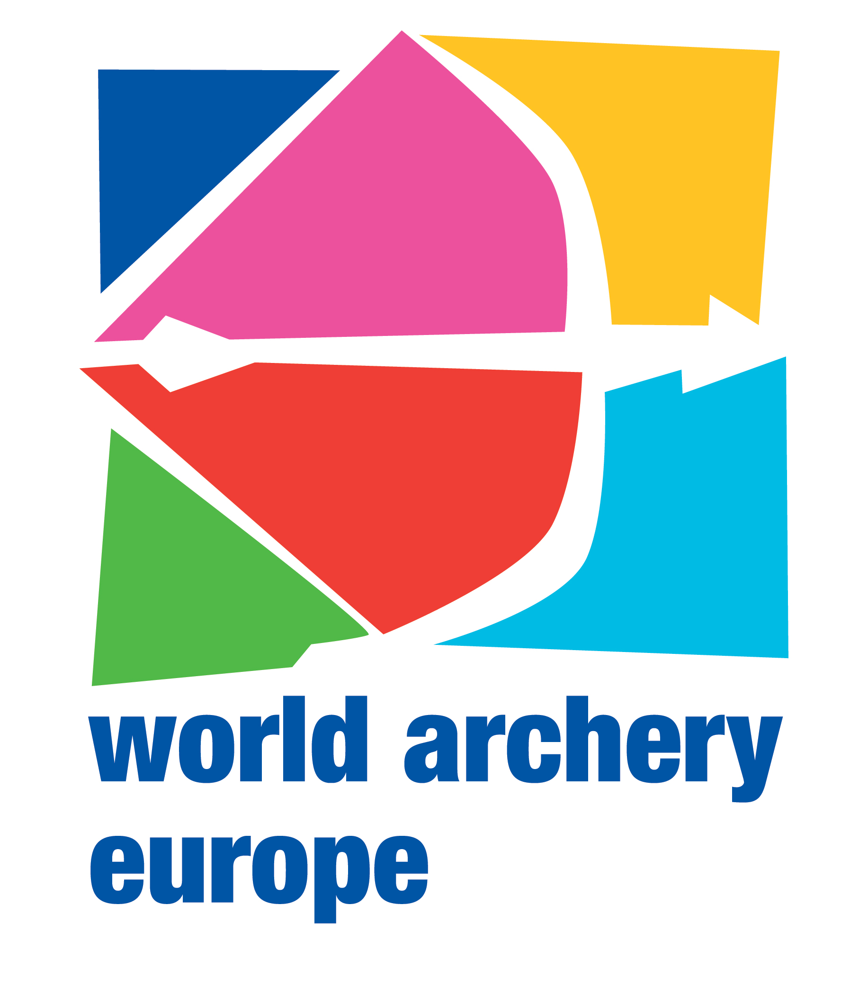

Ref. n. 69/14
Rome, 11 August 2014 President of European Archery Federations
c.c. WAE Board Members
WAE Committees
WA Secretary General

Dear President,

I would like to inform you about some decisions taken by the WAE Board during the last meeting held on 19 July 2014 in Yerevan (Armenia).

European Championships
The Board allocated the European Championships as it follows:
- European Indoor Championships 2015 to the Archery Federation of Slovenia. The Championships will be held in Koper on 24- 28 February 2015.
- European Field Championships 2015 to the Polish Archery Federation. The Championships will be held in Rzeszow on 6-10 October 2015. - European Para Archery Championships 2016 to the French Archery Federation. The Championships will be held in Saint Jean de Monts – Challans on 2-10 April 2016 and it will be valid as Continental Quota Tournament for the Para Olympic Games in Rio 2016.

European Grand Prix
The Grand Prix , which will be organized by the Greek Federation on 24-28 March 2015, will take place in Marathon and not in Olympia, as already communicated.
This Grand Prix will be valid as second Qualification Tournament for the European Games in Baku.

Best regards

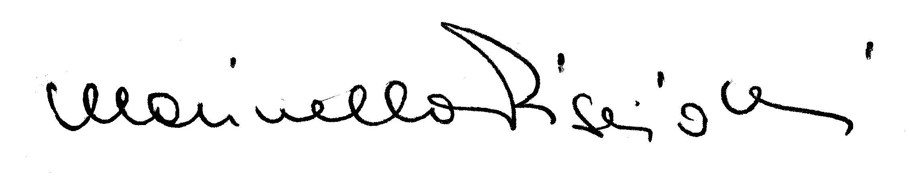
Marinella Pisciotti
WAE Secretary General

