6th October 2014

TO ALL WORLD ARCHERY EUROPE MEMBER ASSOCIATIONS

Dear President,

On behalf of the Organizing Committee and Archers Association of Slovenia we are pleased to invite you to the 15th European Archery Indoor Championships that will be held in Koper, Slovenia, from 24th – 28th February 2015 for women and men, junior women and junior men categories in Recurve and Compound division.

Hereby you will find enclosed all the necessary documents concerning the registration, organisation and participation in this event. We are kindly asking you for your response within the stated deadlines:

Preliminary Entries 27th November 2014
Final Entries 4th February 2015
Hotel Reservation Form 31st December 2014
Transportation Form 4th February 2015
Visa Invitation Letter Form 31st December 2014
Budget Form 4th February 2015
Hotel Reservation Form (Final) 4th February 2015

We are looking forward to welcoming you in Koper, Slovenia.

Yours sincerely,

Mrs. Irena Rosa
Organizing Committee President

Mr. Leon Uratnik
Archers Association of Slovenia President

PRELIMINARY PROGRAMME

Sunday February 22nd, 2015 Arrival of Delegations
Practice field and local transportation available

Monday February 23rd, 2015 Arrival of Delegations
Practice field and local transportation available

Tuesday February 24th, 2015 Opening Ceremony
Team Managers Meeting
Official practice and Equipment inspection

Wednesday February 25th, 2015 Qualification round

Thursday February 26th, 2015 Individual Eliminations, ¼ and ½ Finals

Friday February 27th, 2015 Team Eliminations and Finals
Award Ceremony

Saturday February 28th, 2015 Individual Bronze and Gold Medal Matches
Award Ceremony
Closing Ceremony
Party

Sunday March 1st, 2015 Departure of Delegations

Note:
This is a preliminary program and could be changed slightly according to the number
of participants. All changes will be published and distributed to all participants in good time.

Website: http://www.eaic-koper2015.si

PRELIMINARY & FINAL REGISTRATION

No entry forms will be available for registering to this event. The registration process has to be done using the World Archery Online Registration System (WAREOS).
The number of athletes that may be entered by a Member Association is limited to three (3) in each category.
In order to use WAREOS, please enter this address in your internet browser http://register.worldarchery.org/ and use the Username and Password that World Archery has assigned to your Member Association. After entering the WAREOS, please go to “Online Registration” and register your archers for this event. Pay attention: every archer can be registered in the system only once. The date of birth is mandatory for juniors.
A “WAREOS User Manual” can be downloaded in PDF format (English and Russian) from the same website.
For any question regarding WAREOS, please contact Mr. Matteo Pisani at matteo@pisani.eu

Starting date of online-registration with WAREOS is: 15th October 2014
End of Preliminary registration: 27th November 2014
End of Final registration: 4th February 2015

Please pay attention to the stated deadlines.

The Member Associations which send final entries with more than two (four for Youth) athletes difference from the numbers entered at the time of the preliminary WAREOS entry, will pay a fine of 100 Euro, to be paid to the OC upon arrival at the event.

Teams that enter athletes through WAREOS after the 20 day final deadline will pay a penalty of 100 Euro per athlete registered, to be paid to the OC upon arrival at the event.

Name change (the same category and division) will be accepted up to 72 hours before the event without any additional charge.

All modification after final deadline must be approved by the Organizing Committee and must be communicated by email to both, the Organizing Committee at oc-koper@archery-si.org and Mr. Matteo Pisani at matteo@pisani.eu.

Since entries will be made through WAREOS only, MAs declare that their athletes and officials are aware of the participation waiver and anti-doping agreement, and we recommend MAs to advise their athletes on this matter.
However, accepting the conditions of the athlete participation waiver and anti-doping agreement are an eligibility requirement to participate in the event.

As a final note, only member Associations in good standing will be eligible to compete. This also means that any penalty fee for 2014 and World Archery fee 2014 must have been paid prior to participation.

ACCOMMODATION & GENERAL INFORMATION

The official hotel is 4* stars category HISTRION HOTEL in Portorož.

The room rate:
- is per person per night,
- include full board accommodation, taxes and VAT,
- include use of the swimming pool,
- include parking in front of the hotel.

HOTEL | Category | Single room  Price per person per night (full board) | Double room  Price per person per night (full board)
HISTRION HOTEL  http://www.bernardingroup.si/si/bernardin-resort/hoteli/hotel-histrion | 4* | € 120,00 | € 85,00
Lunch will be served in the restaurant of the School sport hall.

St. Bernardin Resort
Hotel Histrion
Obala 2
6320 Portorož
GPS coordinates
E 13° 34' 20"
N 45° 30' 51"

Hotel Histrion
Category

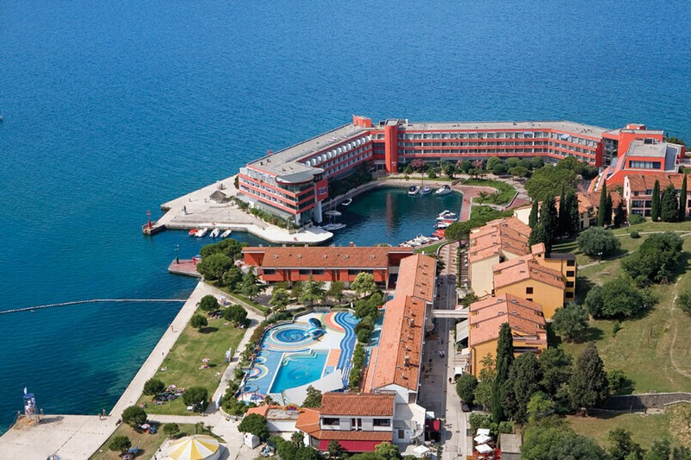

Location: at the former monastery church St. Bernardin, after which the village was named.
Beach: rocky, sandy and grassy; rental of sun loungers, parasols
Accommodation: Hotel, which from the beginning of 2002 is a four-star hotel, offers 276 comfortably appointed guest rooms and suites with balconies overlooking the sea or lagoon. From the hotel there is direct access to the marine park Laguna Bernardin, Wellness Histrion and Casino Bernardin.

Standard room: telephone, satellite TV and radio, mini bar, air conditioning, WI-FI
Hotel facilities : restaurant Sacred and the Mediterranean Taverna, Café San Bernardino, fish restaurant Barka Wellness Histrion, Laguna Bernardin - Marine Park, near the beach, conference room Asteria and meeting room, online playground, safes at reception, car park and parking garage with car wash.
Pool: Water Park Laguna Bernardin's largest pool complex with heated sea water on the Slovenian coast. It occupies 1,000 m² of water surface and is divided into two inter-related work, east and west. In the summer, the complex with a terrace connected to the beach by the sea.
In the marine park are also available: Finnish and Turkish saunas, solarium, massages

Reservations should be made before 31st December 2014.

To confirm the reservation, a 50% deposit of the total amount is required to be bank transferred to the OC before 31st December 2014. Reservations after this date will be considered only according to availability, the room rate can change and we can not guarantee rooms in the official hotel.

Note:
Please refer to the Accommodation pages below for detailed hotel information. Ensure that you complete all the necessary forms by the specified dates and make full payment for the accommodation at the time of booking. See detailed payment instructions below.

Local transportation will be available between hotel and practice and competition venues. Exact transportation timetables will be confirmed. Buses and/or vans will be used.

Participants who will decide to book their accommodation in other hotels (non-official hotels) will have to pay a double entry fee, and the LOC will not be responsible to provide transportation from that Hotel to the venue (transport for these teams will be provided only to and from the airport). Also, it will not be possible to distribute any information at the non-official hotels.

ADDITIONAL INFORMATION

Entry fees:
Individual: 150 € per athlete
Officials: 50 € per official
Teams: 75 € per team

Your entry fee includes daily local transportation to and from practice and competition field to the event official hotel and venues during the qualification, elimination and finals (transportation timetable has to be confirmed).

Transportation fees from/to the airports:
The OC will collect the teams from the two airports. You have to pay the transportation fee (including arrival and departure) as follows:
TRIESTE International Airport (ITA) (65 km) 40 €/person
LJUBLJANA International Airport (SLO) (130 km) 70 €/person
Be aware that Trieste is in Italy and some countries might need visa for Italy.

The last date for the payment of the transportation fee is 10th February 2015.

From the airports to the hotel (return trip), the organiser will use buses, small buses, vans and cars, what will depend of number of persons scheduled for transportation.

Transportation from the airports will start two days before the official practice day and will end two days after the closing day.

Cancellations & Changes:
Cancellation must be in writing by email to oc-koper@archery-si.org.

Following conditions will apply:
- cancellation received before and included 31st December 2014 for full refund of the deposit,
- cancellation received between and included 1st January and 10th February 2015 for 50% refund of the deposit,
- cancellation received after 10th February 2015 - there will be no refund of the deposit payment.

All rates for payments after deadlines are subject to additional charges without prior notice.

All refunds, if any, will be processed after the event.

Name change (the same category and division) will be accepted up to 72 hours before the event without any additional charge.

OC has to be informed about changes in the travel programme 72 hours prior arrival. If your arrival is later then your original schedule, the room charges are starting from the original date indicated by the Member Association in their Accommodation form.

Meals at the venue:
Lunch will be served in the restaurant of the School sport hall.

Drinking water will be available on the competition field free of charge.
All other costs made in cafeteria at the archery venue or in the hotel (snacks, drinks, small meals) are not included in the entry fee and must be paid on consumptions.

Please inform us if you have special requirements for food and specify it.

KOPER - CAPODISTRIA

Koper was founded on a rocky island with the Roman name Capris.
Insu-la Capraria (“goat island”), Insula Capritana, Iustinopolis, Caput Histriae (‘head of Istria’), Capo d’Istria are the names used through its rich history.
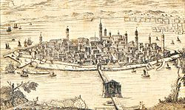

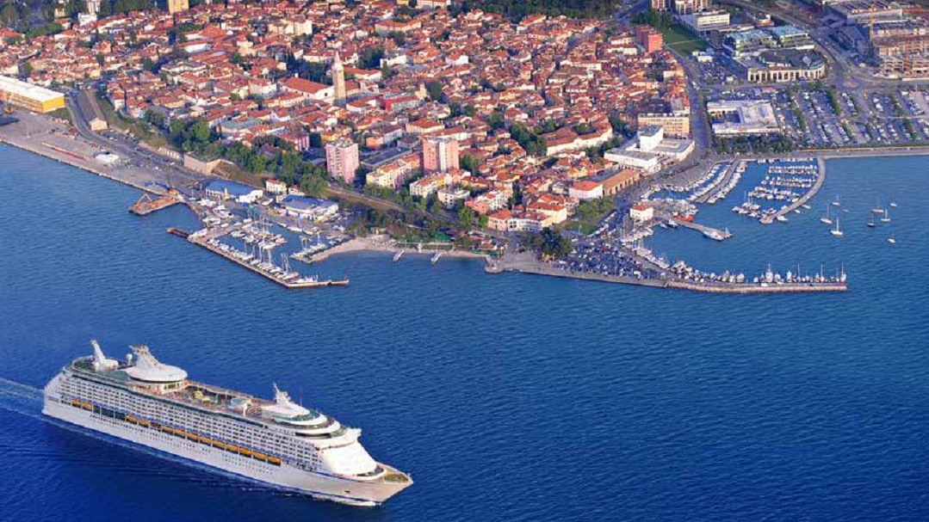
Koper, presents as a hidden Mediterranean city, surrounded by sea and hills, which hold its remarkable rich thousand-year history.
The walk through the old streets and squares, narrates about transitions and effects that have left their mark on the city.
Koper also offers active, sporting holidays, adding his inspiration with traditional cultural events.

Weather
The average temperature in Koper in February is 9°. The minimum average temperature in February is 2°.

Accreditation and Team Managers Meeting
Accreditation will take place upon arrival of the teams, in the lobby of the Histrion hotel 22nd and 23rd February 2015.

For all Ceremonies WA dress code is obligatory.
More details will be provided at the Team Manager’s Meeting.
Team Managers Meeting will be held in the conference room of the Elementary School Koper (the conference room on the 1st floor) on Tuesday, February 24th 2015, at 12:00.

Training and Competition Field
For European Indoor Archery Championships two sport halls will be used:
- Sport hall of the Elementary School
- Arena Bonifika

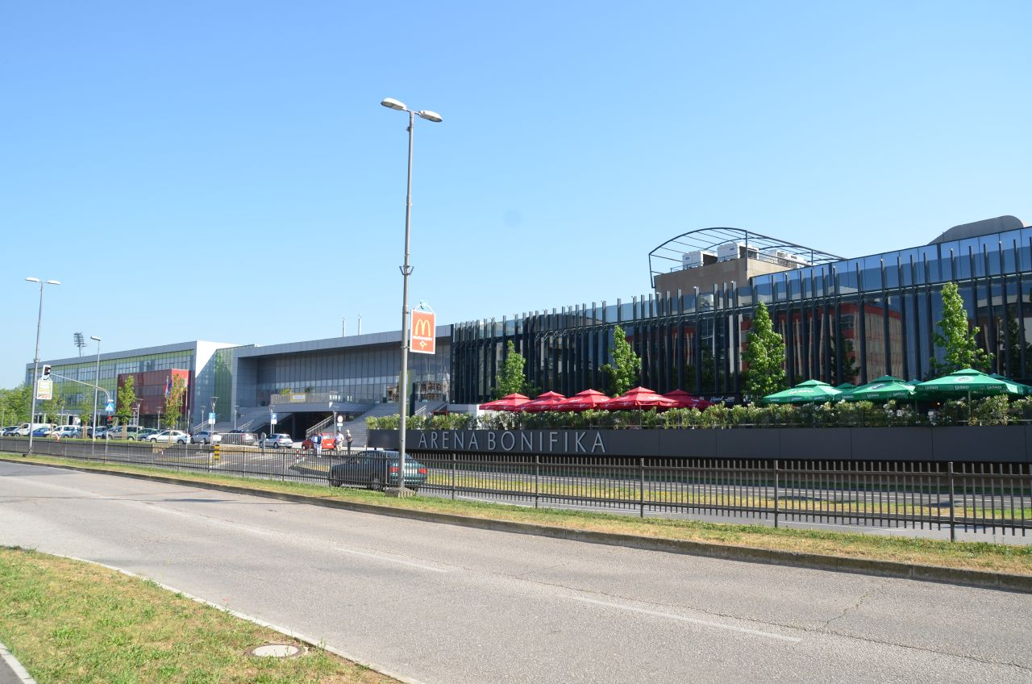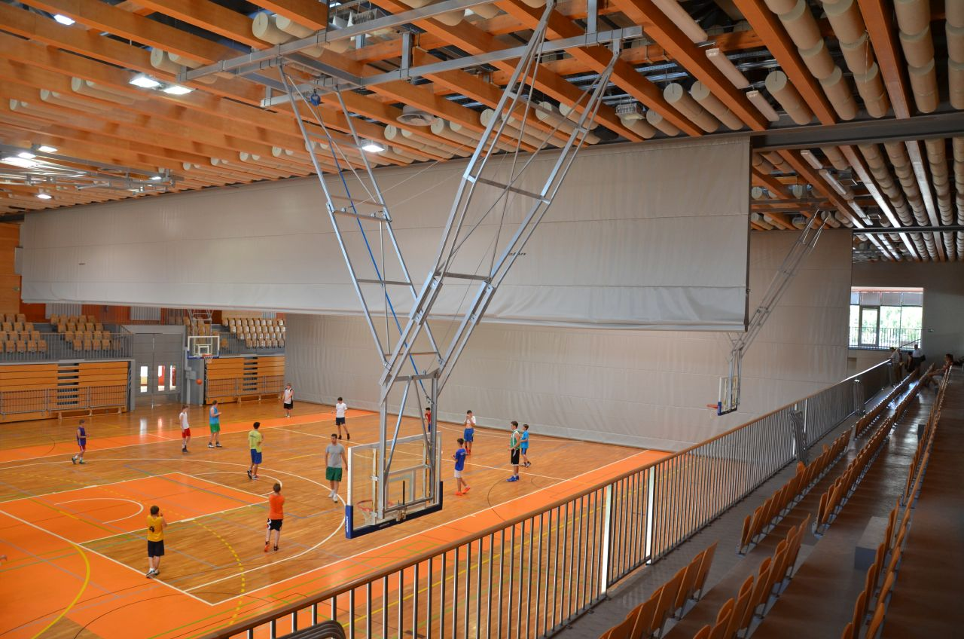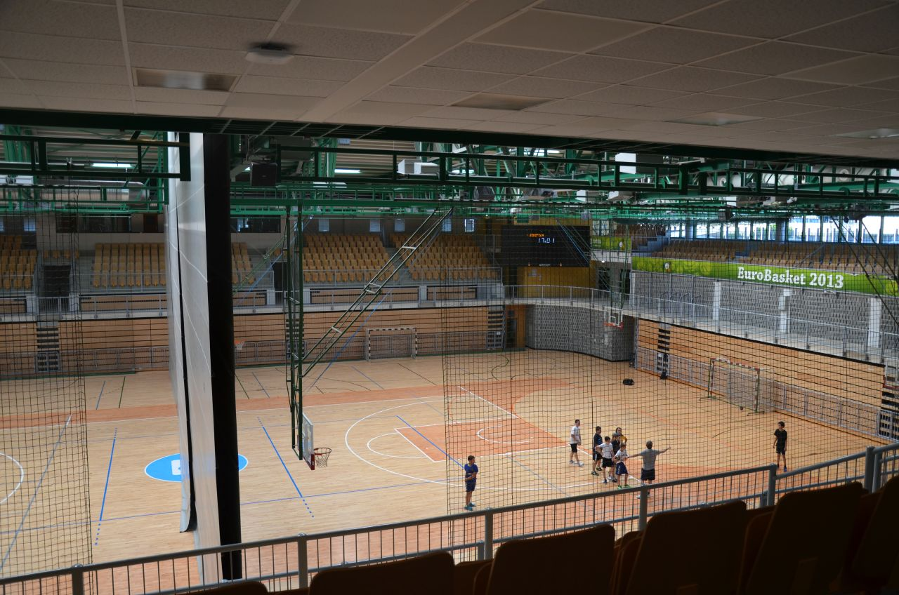

The distance between the two sport halls is 20m.
The practice will be available starting from 22nd February 2015 in one of the two sport halls.

The address of the Sport Halls are:
Cesta Zore Perello Godina 1, 6000 Koper
Cesta Zore Perello Godina 3, 6000 Koper
Coordinates: 45°32´35,4” N 13°43´42,9” E
45,543161 13,728580
Visas
Please apply for your visa as soon as possible, if you need any additional information regarding visa, please let us know.

Application for and obtaining travel visas are completely and solely the responsibility of the participating teams. The process for obtaining a visa requires each individual to submit an application through a Slovenian Embassy or Slovenia Consulate. This is a process that MUST be done by the applicant – the Organizing Committee cannot do it for you. It cannot be emphasized enough to start the application process early. Please note that the application and
interview process in your country may very well be in advance of the team selection date, so in many cases, you will need to start the application process prior to confirming your final team.

Visa Invitation Letter – All countries that will need letter of invitation by the Organizing Committee or local authorities to use it in their application process are requested to order these in time. Please fill out the Visa Invitation Letter Form as soon as possible and send it in.

As long as the Organizing Committee gets no different information, the Invitation Letter will be sent by email. If an express service should be desired, this service will be charged to the MA and must be paid to the Organizing Committee upon arrival.

Those teams that want to land in Trieste airport must be aware that they might need visa for Italy. In this case we might not be able to help you.

Please note: the deadline for Visa Invitation Letter Form is 31st December 2014.

Banquet
On the final day (Saturday, 28th February 2015) the gala dinner will be served in the restaurant of the hotel Histrion instead of the normal dinner in the hotel. After the dinner, music and dancing will take place from 20:30 till 24:00^{h}.
The extra cost for participants at this party is 15 € per person (drinks included).
For participants who will not book the party, the normal dinner will be served in the hotel.

Internet
Free of charge in the hotel lobby and rooms.

Website
The official website of the competition is http://www.eaic-koper2015.si

HOTEL RESERVATION FORM

Country/Team from: ___________________________________________
Team Manager: _________________________________
Mobile: _________________________________
e-mail: _________________________________

HOTEL: HISTRION PORTOROŽ

Number of Rooms:

Single room:
Double room:

Special requirements:

Please mark this box if you need facilities for persons with disabilities.

Please mark this box if you have special requirements for food and specify it:

__________________________________________________________________________

___________________________________________________________________________

Team Arrival Date: _____________________

Team Departure Date: __________________

Date: ____________

Signature of President/Secretary General: ______________________________

PLEASE RETURN THIS HOTEL RESERVATION FORM TO THE ORGANIZER BEFORE
31st December 2014 by e-mail to oc-koper@archery-si.org

FINAL HOTEL RESERVATION FORM

Country/Team from: ___________________________________________
Team Manager: _________________________________
Mobile: _________________________________
e-mail: _________________________________

HOTEL: HISTRION PORTOROŽ

Number of Rooms:

Single room:
Double room:

Special requirements:

Please mark this box if you need facilities for persons with disabilities.

Special requirements for beds:

Special requirements for food:

Please mark this box if you have special requirements for food and specify it:

__________________________________________________________________________

___________________________________________________________________________

Team Arrival Date: _____________________

Team Departure Date: __________________

Date: ____________

Signature of President/Secretary General: ______________________________

ONLY IF YOU CHANGE NUMBER OR TYPE OF ORDERED ROOMS STATED IN PRELIMINARY HOTEL REERVATION FORM

PLEASE RETURN THIS HOTEL RESERVATION FORM TO THE ORGANIZER BEFORE
4th February 2015 by e-mail to oc-koper@archery-si.org

ACCOMMODATION TABLE - ROOMING LIST

For the accreditation process to be as smooth as possible we prepared accommodation table. We need the following data: type of the room, type of the bed and names of persons.
PLEASE RETURN TILL TUESDAY, FEBRUARY 10th

Room | Single/Double | King/Twin  Bed | Person 1  (Name) | Person 2  (Name)
1
2
3
4
5
6
7
8
9
10
11
12
13
14
15

Note:
- In case you specified double room please specify type of bed:
- King – double room with one big bed
- Twin – double room with two separate beds
- The booking of rooms will be done according to the rule "first come – first get".
Furthermore we would like to remind you about some important information:
- Acreditation office will be opened on Sunday, February 22nd, from 16:00 - 21:00
and on Monday, February 23rd, from 08:00 - 18:00 in Histrion Hotel.
- Team Managers meeting is scheduled for Tuesday, February 24th, at 12:00,
in the Elementary School Koper (the conference room on the 1st floor).
PLEASE RETURN THIS ACCOMODATION TABLE TO THE ORGANIZER BEFORE
10th February 2015 by e-mail to oc-koper@archery-si.org

TRANSPORTATION FORM

Country/Team from: __________________________

Number of passengers: ________ person/s

Arrival information

We will arrive by plane:

Airport: __________________ Flight Nr: _____________

Date: ______________ Arrival Time: ___________

We will arrive to KOPER by: _____________________________________

____________________________________________________________

Departure information

We will depart by plane:

Airport: __________________ Flight Nr: _____________

Date: ______________ Departure Time: ___________

We will depart from KOPER by: _______________________________________

____________________________________________________________

Date: _________

President/Secretary General MA: ______________________________

PLEASE RETURN THIS TRANSPORTATION FORM TO THE ORGANIZER BEFORE
4th February 2015 by email to oc-koper@archery-si.org

VISA INVITATION LETTER FORM
Country/Team from: ___________________________________

Contact person: _______________________________________

No | First name | Family name | Date and place of birth | Citizenship (Country)
No | Address of residence |  |  | Passport
No |  |  |  | Number | Expiration
1
2
3
4
5
6
7
8
9
10
11
12
13
14

Date: ______________

President/Secretary General MA: _______________________________
PLEASE RETURN THIS VISA INVITATION LETTER FORM TO THE ORGANIZER AS SOON AS POSSIBLE (latest by 31st December 2014) by email to oc-koper@archery-si.org

BUDGET FORM

Member Association: ____________________________________________
Contact person: ________________________________________________
Mobile: _______________________________________________________
E-mail: _______________________________________________________

1) Entry Fees
Position Cost Number of persons/teams Total
Athlete € 150 x ___ € ____
Official € 50 x ___ € ____
Team € 75 x ___ € ____

Total 1 ................................................................................. € ____

2) Accommodation
HOTEL HISTRION - Full Board
Room Cost Nr of Persons Nr of nights Total
HISTRION - Single room € 120 x ___ x __ € ____
HISTRION - Double room € 85 x ___ x __ € ____

Total 2 .................................................................................. € ____

3) Transportation + PARTY
Airport Cost Number of Persons Total
LJUBLJANA € 70 x ______ € ____
TRIESTE € 40 x ______ € ____
PARTY € 15 x ______ € ____

Total 3 .................................................................................. € ____

Date, ___________ TOTAL (1+2+3) € ____

President/Secretary General MA: _____________________________
PLEASE RETURN THIS BUDGET FORM TO THE ORGANIZER BEFORE
4th February 2015 by e-mail to oc-koper@archery-si.org

PAYMENT INSTRUCTIONS

BANK: NOVA LJUBLJANSKA BANKA d.d.
Address: Trg republike 2
1000 Ljubljana
Slovenia
A/C NAME LOKOSTRELSKA ZVEZA SLOVENIJE
Address: Dolenjska cesta 11
1000 Ljubljana
Slovenia

SWIFT CODE (BIC): LJBASI2X
IBAN: SI56 0201 3001 7204 321

NOTE:

ALL PAYMENTS ARE REQUIRED TO BE DONE IN EUROS BY BANK TRANSFER LATEST 10th FEBRUARY 2015!
ALL BANK TRANSFER FEES HAVE TO BE PAID BY PARTICIPATING MAS (you need to state OUR option when paying).
IN CASE OF NOT PAYING THE BANK TRANSFER FEES, YOU WILL BE CHARGED FOR THE DIFFERENCE UPON ARRIVAL, AT THE ACCREDITATION.

- NO CREDIT CARDS
- NO TRAVEL CHECKS

IN CASE YOU WILL BRING CASH, YOU WILL BE CHARGED FOR EXTRA BANK COSTS FOR DEPOSIT (1% OF THE DEPOSIT).

PLEASE SEND THE COPY OF THE BANK TRANSFER TO THE ORGANIZER by email to
oc-koper@archery-si.org

OC contacts

- Phone for assistance when travelling
Mr. Tone Cezar - 24 hours English
Mobile +386 (0)31 621 372
E-mail: oc-koper@archery-si.org

- For all matters
Mrs. Irena Rosa - 24 hours English
Mobile +386 (0)31 633 851
E-mail: oc-koper@archery-si.org

- For questions about accommodation and visa support
Mr. Tomaz Urlep - 24 hours English
Mobile +386 (0)31 682 647
E-mail: oc-koper@archery-si.org

