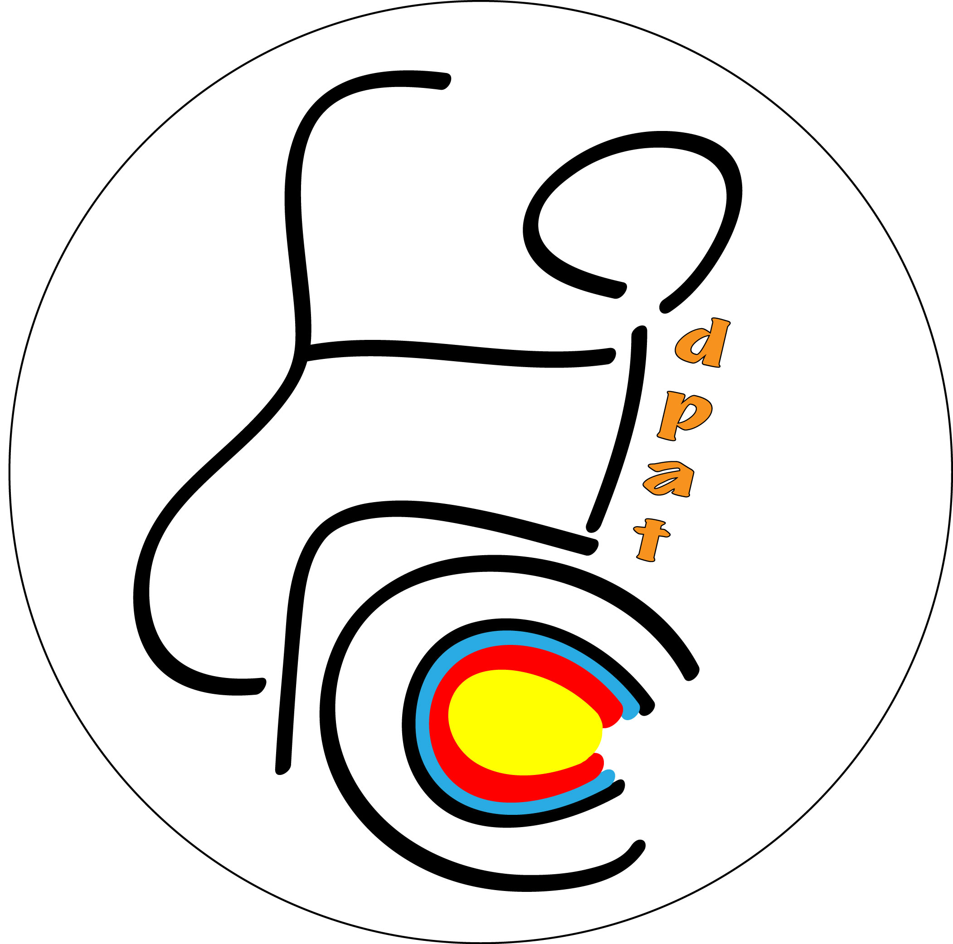

Invitation Package
for the

Dutch Para Archery Tournament 2015

World Ranking Event

Archery Association of the Netherlands
in cooperation with
HBS Almere [NED]

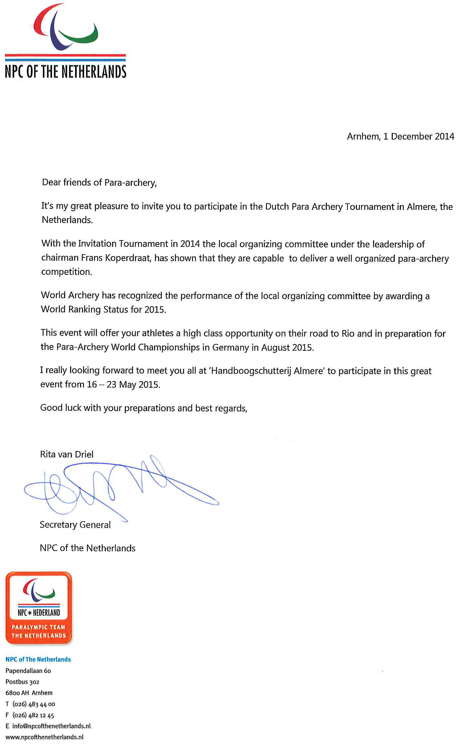

Entry Information
Dutch Para Archery Tournament 2015
World Ranking Status

Organizing Committee

President Frans Koperdraat
E-mail frans.koperdraat@dpat.nl
Phone +31 (0)6 2254 9936
Secretary Carel Deden
E-mail carel.deden@dpat.nl
Phone +31 (0)6 5192 1420

Administration (Archery Association of the Netherlands)
Name: José Bruntink
E-mail: josebruntink@handboogsport.nl
Phone: +31 (0)73 5280064

WA Technical Delegate
Name Dominique Ohlmann
E-mail ohlmann.dominique@gmail.com

Event

Dutch Para Archery Tournament world ranking tournament
Saturday 16 May 2015 – Saturday 23 May 2015 in Almere, Netherlands

Events List

Individual (4 entries per nation per class)
Recurve Open Men
Recurve Open Women
Compound Open Men
Compound Open Women
Recurve/Compound W1 (minimal participation is 4 archers, in case of less participants, they will be combined in an unique category without gender distinction)

Team
Recurve Open Men
Recurve Open Women
Compound Open Men

Compound Open Women

Mixed team
Recurve Open
Compound Open
Recurve/Compound W1

Entries

- The Preliminary Entry Deadline (with 30% deposit) is: 14 February 2015
- All registrations must be done using the World Archery Online Registration System WAREOS: http://register.worldarchery.org. No entry forms will be accepted for registration to this event.

- A maximum number of 4 athletes per class per country (host country included) are allowed to be registered into each category of the event. Entries have to be done by WAREOS.

- In order to use WAREOS, please login on http://register.worldarchery.org with your Username and Password assigned by World Archery. After entering the WAREOS, please go to "Online Registration" and register your athletes for this event. A "WAREOS User Manual" can be downloaded in PDF format (English) using the same website link. Pay attention: every archer can be registered in the system only once.

- For any questions regarding the WAREOS, please contact Mr. Matteo Pisani (matteo@pisani.eu)

- Start date for online registration using WAREOS: 29 December 2014
- End of Preliminary registration using WAREOS: 1 March 2015
- End of Final registration using WAREOS: 27 April 2015
- All modifications after final deadline must be approved by the Organizing Committee and must be communicated by email to both, the Organizing Committee at carel.deden@dpat.nl and Mr. Matteo Pisani at matteo@pisani.eu.

- Final entries processed after the after the FINAL deadline will result in a penalty fee of € 50,00 per athlete to be paid to the OC upon arrival at the field.

- Final registrations that differ by more than 4 athletes from the preliminary registration or have been submitted after the preliminary deadline will result in a penalty fee of € 100,00 to be paid to the OC upon arrival at the field.

- Member Associations that have penalty fees outstanding from previous years, have to pay these penalty fees at accreditation before being eligible to participate.

- Nations will be registered and accepted after the Organizing Committee has entered the entries in the WAREOS and has received the 30% deposit.

Entry Fee

The entry fee (incl. lunch from 17-22 May)
Athletes: € 200,00
Officials : € 100,00
Teams: No fee.

Payment Information

Account name/Beneficiary | Nederlandse Handboog Bond, Netherlands
Bank name | ING bank
Bank address | Rosmalen, Netherlands
Bank account number(IBAN) | NL30 INGB 068 1514 205
SWIFT/BIC | INGBNL2A
- Please use applicant name as reference, add the following description: DPAT 2015 - >Nation<

Competition & Training Venue

Handboogschutterij Almere
Trekweg 2
1339GA Almere
www.hbsa.nl

https://maps.google.nl/maps?q=trekweg+2,+almere&hl=nl&sll=52.548336,5.566507&sspn=1.372918,2.469177&t=h&hnear=Trekweg+2,+1338+GA+Almere-Buiten,+Almere,+Flevoland&z=16

Telephone: +31 (0) 36 532 3549

Accommodation

The LOC will offer no accommodation.

We recommend
Bastion Almere
http://www.bastionhotels.nl/nl/onzehotels/almere
Audioweg 1
1322 AT Almere
Tel +31 (0)36 5367 755

This hotel offers special prices for the participants of the DPAT. Please contact carel.deden@dpat.nl for more information and log-in codes for direct registration at the hotel.

For additional hotel information, see page 13
.

Meals

The entry fee includes lunch from 17 May 2015 – 22 May 2015

For participants who book accommodation in Bastion Hotel by using their login code, breakfast and dinner is included in the tournament arrangement.

There are additional food facilities at the competition area at own cost. Free water for members of teams will be available.

Transportation Bastion hotel to competition venue v.v.
The LOC offers the athletes and the officials transport between the Bastion Hotel and the competition venue. The costs are € 50,00 per person (17-22 May).
Contact the LOC if you want more information.

Airport Pick Up
We can offer transport from Schiphol Airport to Bastion Hotel Almere v.v. The costs are € 50,00 p.p. This amount covers transport to Bastion hotel Almere on Saturday 16 may 2015 and return to Schiphol Airport on Saturday 23 May 2015. We don’t offer transport to other hotels or on different dates.

Classification

The classification will be held on Sunday 17 May 2015.

Rules

Technical aspects of the event, as well as classifications are subject to the rules of World Archery.

Insurance

Participants/officials will have to provide for their own health, accident and liability insurances. The OC cannot be held responsible for damage, loss or theft of equipment or personal belongings during the entire tournament.

Doping Control

Doping tests will be conducted during the competitions.

Internet Connection

Free Hot Spot WiFi will be available in the venue(s) for accredited people.

Cancellation and Refund Policy

Any cancellation must be submitted to the Organizing Committee eight (8) days before the arrival of the delegation. Refund will be only possible for case of injury and illness upon justification of documents. In case of cancellation of participation of the entire delegation, refund of 70% of the entry fees will be possible after the tournament. The cancellation must be justified.

Preliminary Competition Schedule

Sat, 16 May Arrivals

Sun,17 May Free practice
Classification
Team managers meeting
Opening ceremony

Mon, 18 May Official practice

Tue, 19 May Qualification rounds Gr 1
Qualification rounds Gr 2

Wed, 20 May Individual elimination rounds of all categories till semi finals

Thu, 21 May Team and mixed teams elimination rounds and finals
Team medal ceremonies

Fri, 22 May Individual Medal matches
Individual Medal ceremonies

Sat, 23 May Departures

Detailed schedule will be available after registration process
Schedule subject to change according to media/TV needs.

Budget Form

Only e-mail is accepted to josebruntink@handboogsport.nl

Entry Fees | Number of Persons |  | Total People |  | Cost  (EUR) |  | TOTAL  (EUR)
 | Female | Male
Individual Entry Fee |  |  |  | X | € 200,00 | =
Official Entry Fee |  |  |  | X | € 100,00 | =
Subtotal Entry Fees |  |  |  |  |  | A

Transportation Fees | Number of wheelchairs | Total People |  | Cost  (EUR) |  | TOTAL  (EUR)
Airport <-> Bastion Hotel Almere |  |  | X | € 50,00 | =
Bastion <-> Venue |  |  | X | € 50,00 | =
Subtotal Transportation Fees |  |  |  |  | B

Grand Total | A +B | €
Deposit 30% | Deposit (30% of Grand Total) has to be paid before February 14th , 2015 | €
Final payment 70% | Final payment (balance due) has to be paid before April 30th, 2015

Attention; Nations with outstanding balances at accreditation will not allowed to enter the competition. Payment at accreditation is not possible!!!

Travel Form

Only e-mail is accepted to josebruntink@handboogsport.nl

Country
Contact Person |  | Mobile

Arrival information: We will arrive by plane:

Airport: Schiphol
Flight Nr _________________

Date _________________(DD/MM/YY)
Arrival Time _________________

Departure information: We will depart by plane:

Airport: Schiphol
Flight Nr _________________

Date _________________(DD/MM/YY)
Departure Time _________________

Arrival information: We will arrive by car, mini bus or bus:
Date _________________(DD/MM/YY)
Arrival Time _________________

Departure information: We will depart by car, mini bus or bus::
Date _________________(DD/MM/YY)
Departure Time _________________

Number of
Cars _________________

Mini Buses _________________
(higher than standard cars)

Buses _________________

VISA

All participants who need an entry visa to the Netherlands, are kindly requested to fill in the Visa Support Form below and return completed to the Organizing Committee, as soon as possible, but not later than 25 April 2015.

After the Organizing Committee has received the Visa Support Form, an official invitation from the Archery Association of the Netherlands will be provided for visa application. Participants should obtain their visas before departure to the Netherlands.

NOTE: Please read the Visa Information for Foreigners for applying a Dutch visa. Please make your visa application in person and at least two months before traveling to the Netherlands to avoid any difficulties.

Explanations:

- The term “official passport” covers diplomatic, service, special and official passports.
- Passports should be valid at least 90 days longer than the expiry date of the requested visa.
- Despite the visa regime applied towards the citizens of a country, the travel document holders of that country need to obtain a visa from Dutch missions beforehand.
- All foreigner visitors to the Netherlands, except for those exempt from the visa requirements, should obtain their visas at the Dutch consulate.

For detailed information, please visit the website of the Dutch Ministry of Foreign Affairs
http://www.government.nl/issues/visa-for-the-netherlands-and-the-caribbean-parts-of-the-kingdom/short-stay-visas-for-the-netherlands.

Visa Support Form

All participants/officials who need an entry visa to the Netherlands, are kindly requested to fill in the Visa Support Form and return this, including a Copie of their valid passport. to the Organizing Committee, as soon as possible, but no later than 25 April 2015.

Only e-mail is accepted to josebruntink@handboogsport.nl

Gender  M/F. | Family Name | First Name | Date of Birth DD/MM/YY | Nationality and place of birth | Title  (Athlete/Coach/Official) | Passport No. | Expiration Date of Passport  DD/MM/YY | Location of Visa collection

Hotels (mentioned prices are without breakfast and dinner)

Name (distance to venue) | Total no of available rooms | Average prices per room (2 beds)
Bastion (5KM) | 155 | € 75
Apollo Hotel (Almere 5KM) | 117 | € 103
Van der Valk (Almere 3KM) | 180 | € 105
Apollo Hotel (Lelystad 26KM) | 86 | € 90
Lelystad Airport (26KM) | 24 | € 85

