INVITATION

Dear President,

On behalf of the Organizing Committee and the Romanian Archery Federation, I am pleased to invite and welcome your Federation to participate to the WAE GRAND PRIX 2nd leg 2015, which will be held in Bucharest/Romania, on July7th- 11th, 2015.

This competition will be organized following the WORLD ARCHERY rules and WAE GRAND PRIX rules, in both divisions: Recurve and Compound, for Men and Women. National teams from all continents are welcome, as well as club archers.

This event is the Second Round of the European Grand Prix Circuit for the year 2015 and a World Ranking Event. Also, it is the last major international tournament before the World Archery Championships, and it is a great opportunity to prepare your teams before going to Copenhagen (DEN).

Special prizes will be awarded by the OC to the winners in the individual competition, recurve and compound: Gold – 500 Euro, Silver – 300 Euro, Bronze – 100 Euro.

We are happy to welcome national teams from all continents and also club archers and we hope that you will enjoy a great tournament and a wonderful week in Bucharest.

Please find enclosed the necessary documents concerning the organization, registration and participation to this event.

We kindly ask you to reply within the stated deadlines:

- Preliminary Entries 15 april2015
- Preliminary Hotel Reservation Form 15 april 2015
- Visa Invitation Letter Form 7 may2015
- Transportation Form 7 may 2015
- Final Hotel Reservation Form 7 may 2015
- Budget Form 7 may 2015
- Final Entries 15 june 2015
- Club Archers Registration Form 15 june 2015

We are looking forward to welcoming you in Bucharest!

Sincerely yours,
Mr. Aurelian Florin Bacinschi
President
Romanian Archery Federation
PRELIMINARY PROGRAM
Sunday  5 July | Arrival of participants. Practice field and  local transport available
Monday  6 July | Arrival of participants.  Accreditation.  Practice field and local transport available
Day 1  Tuesday  7 July | Official practice, Equipment Inspection  Team Managers’ Meeting  Opening Ceremony
Day 2  Wednesday  8 July | Qualification Round–70 m Recurve& 50 m Compound  Men and Women  (Practice Field open)
Day 3  Thursday  9 July | Individual Eliminations up to semifinals  (Practice Field open)
Day 4  Friday  10 July | Team and Mix teams eliminations up to semifinals  (Practice Field open)
Day 5  Saturday  11 July | Individual,Teams & Mixed Teams Finals & Medal Matches (alternate shooting)  Award Ceremony  Closing Party
Sunday  12 July | Departures of participants

Each Member Association may enter a maximum of six (6) archers to the competition per category and per division, as national team members.

NOTE:
This preliminary program could change slightly according to the number of participants.
All changes to this program will be published and informed to all participants in good time.

PRELIMINARY AND FINAL REGISTRATION

No entry forms will be available for registering in this event.
The registration process has to be done using the WA Online Registration System (WAREOS, V.2)(http://register.worldarchery.org/)
A maximum number of 6 athletes per country are allowed to be registered into each category of the event (the host country is allowed to register 8 archers).

Preliminary entries have to be done using the WAREOS, V.2:
In order to be able to use WAREOS, please enter this address in your web browser (http://register.worldarchery.org/) and use the Username and Password that WA has assigned to each Member Association. After entering the WAREOS, please go to “Online Registration” and register your archers for this event.
A “WAREOS User Manual” can be downloaded in PDF (English and Russian) from the same website. For any question or doubts regarding the use of WAREOS, please contact Mr. MatteoPisani email: matteo@pisani.eu.

Starting date for online-registration with WAREOS is: | 11 march2015
End of Preliminary registration with WAREOS is: | 15 april2015
End of Final registration with WAREOS is: | 15 june2015

Please pay attention to the stated deadlines. After passing the deadlines, MAs will be able to enter or update their data in WAREOS, but late fees will automatically apply.
Getting close to the event, in order to finalize detailed schedule and start working on the accreditation process, the system will be blocked. Ather that moment,if any MA would like to change or proceed with the Final Registrations process or change their Final entry, it is required to contact Mr. Matteo Pisani at email: matteo@pisani.eu with a copy to Organizing Committee email office@frta.ro
Final registration that will differ for more than 2 archers according to preliminary registration will have a penalty fee of €100 to be paid to the OC at the moment of arriving at the event.

Teams that enter after 15 June 2015 will pay a penalty of €100 per athlete to be paid to the OC on arrival for the tournament.
Only after having paid the penalty fees to the OC, a Member Association can register the athletes in order to participate at the competition.

A Member Association which made entries in WAREOS and does not participate will be invoiced for the number of entries entered in the system, unless the MA inform WAE and the OC to email office@frta.ro before 15th June 2015, that they are not be able to participate.

Since entries are through the WAREOS only, Member Associations declare that their athletes and officials are aware of the participation waiver and anti doping agreement. We recommend Member Associations to advise their athletes on this matter. However, accepting the conditions of the athlete participation waiver and the anti doping are eligible to participate in the event.

Only Member Associations in good standing will be eligible to compete. This also means that any penalty fee for 2014 and/or 2015 World Archery fee will have to be paid prior to this Grand Prix.

ACCOMMODATION AND GENERAL INFORMATION

The Official Hotels are 2 hotels less than 700m away from each other:
CROWNE PLAZA BUCHAREST 4*
PULLMAN BUCHAREST 4*

Rooms | Category | Pullman  Price/person/night | Crowne Plaza  Price/person/night
Single Room | ⬇⬇⬇⬇ | 91 Euro | 95 Euro
Double Room | ⬇⬇⬇⬇ | 71 Euro | 75 Euro

The room prices are in Euro (€) per person and per night.
It is offered on a “Fully Board” basis including bed, breakfast, lunch and dinner.
In the room price is also included service charge and VAT and the local transportation from/to Hotel/Venue & Practice field
Free Wi-Fi will be available in the hotel lobby and rooms.

There is a limit of availability in both hotels. Therefore the rooms will be allocated based on first come – first served principle.

Crowne Plaza - Photos

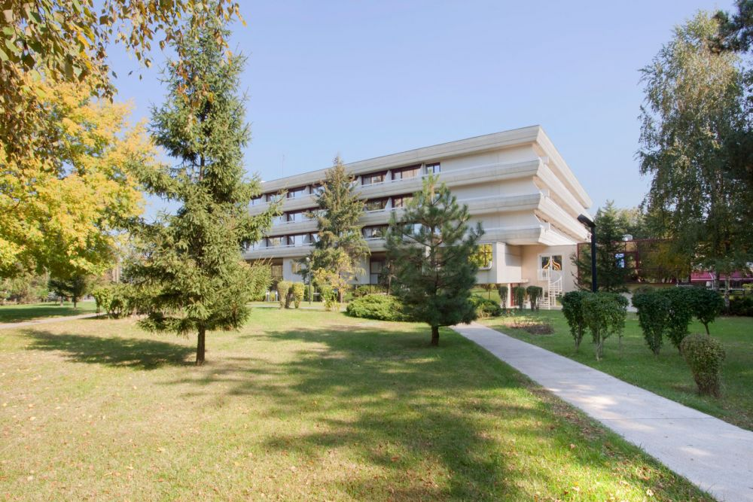
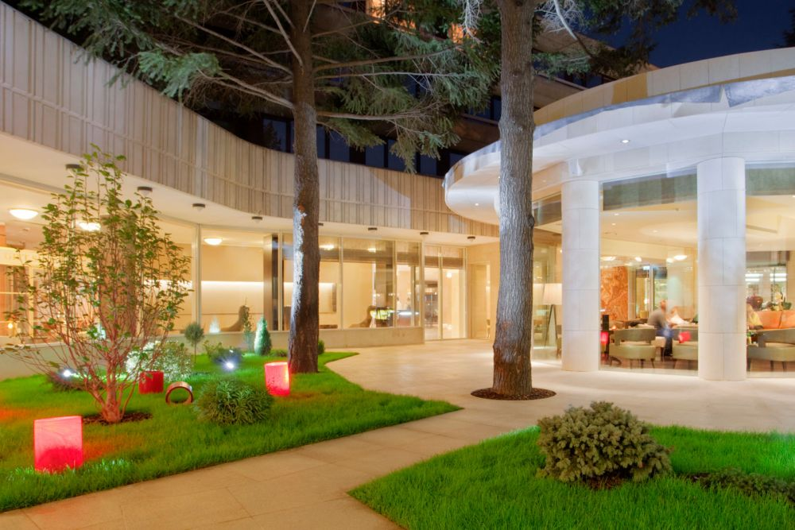


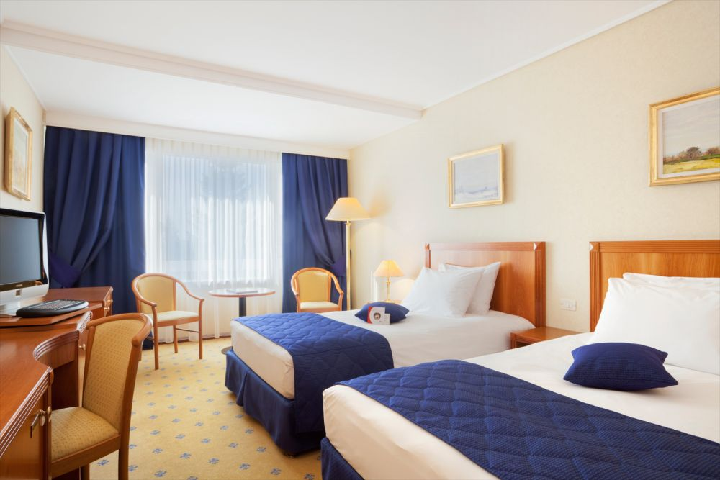

Pullman Bucharest - Photos

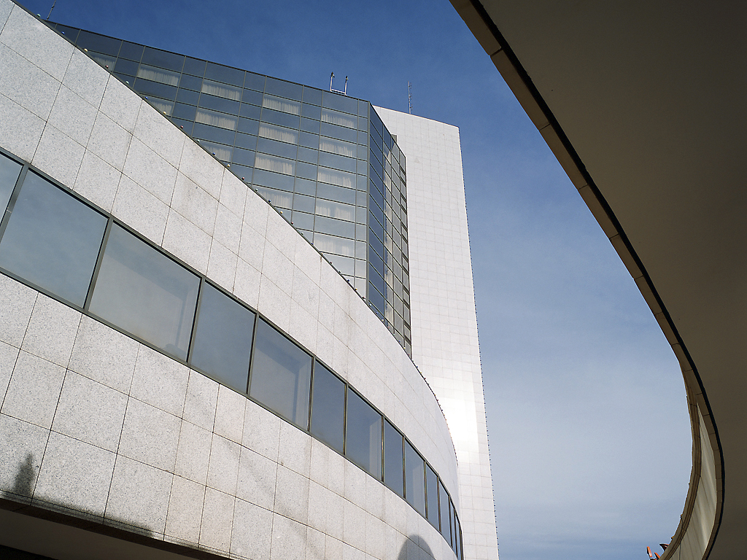
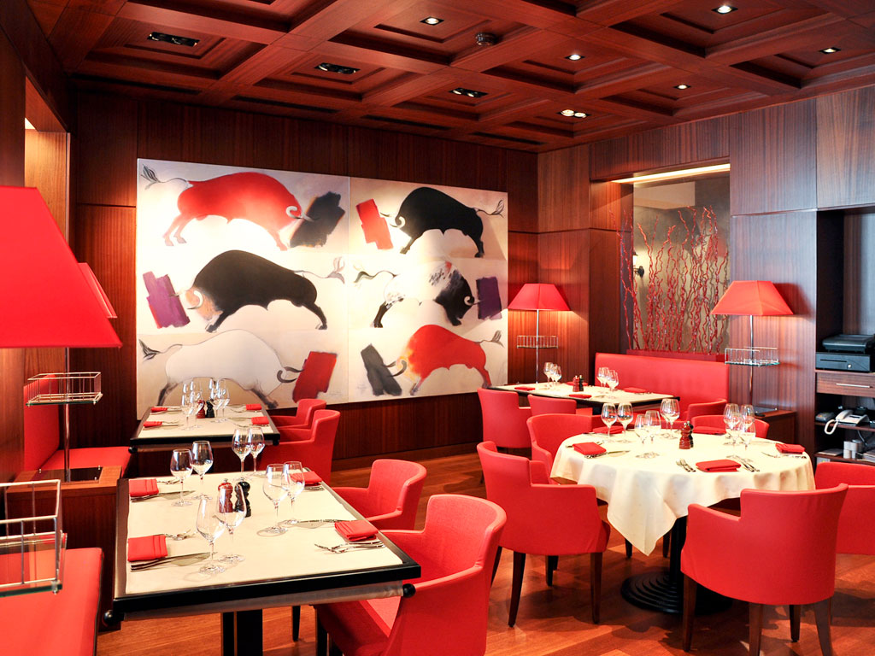

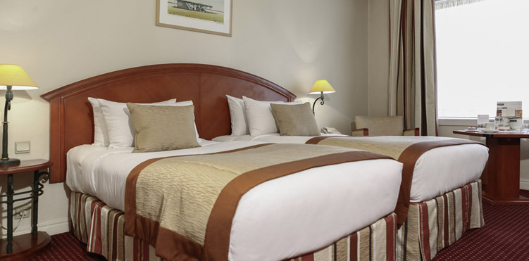
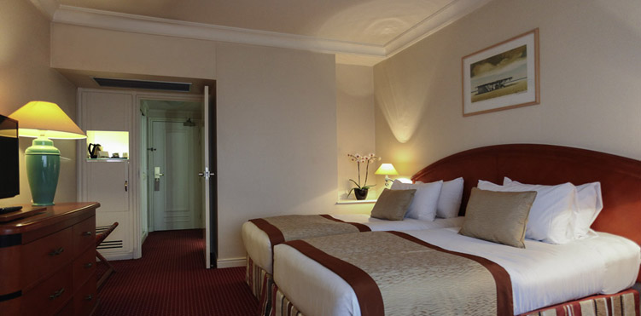

Final Reservations should be made before 7th May 2015

Preliminary Hotel Reservations should be made before: 15th of April 2015.
Reservations after this date shall be subject to availability.

A 50% deposit of the Accommodation payment is required before: 15th of April 2015.
The rest 50% of Accommodation payment is to be made, before: 7th of May 2015.

Accommodation cannot be guaranteed, nor at the above quoted prices beyond each deadline.

Entry fees:
Individuals: 110 Euro per athlete
Team: 50 Euro per team *Participation in the Mixed Team event is free
Officials: 30 Euro per person

Transportation:
Bucharest International Airport (OTP) &Bucharest Central Railway Station
From/To Airport& Train Station–to/from Hotel (arrival and departure): 20 Euro/person

Weather for Bucharest:

Bucharest has a transitional climate, with both continental and subtropical influences (Köppen climate classificationCfa/Dfa/Cfb/Dfb). In summer, the average temperature is 23 °C (73 °F) (the average for July and August) Temperatures frequently reach 35 °C (95 °F) to 40 °C (104 °F) in mid-summer in the city centre. Although average precipitation and humidity during summer are low, there are occasional heavy storms.

Water:
Water will be available on the fields free of charge.

Visa:

Please apply for your visa as soon as possible, if you need any additional information regarding visa, please let us know.

Application for and obtaining travel visas are completely and solely the responsibility of the participating teams. The process for obtaining a visa requires each individual to submit an application through a Romanian Embassy or Romanian Consulate. This is a process that MUST be done by the applicant – the Organizing Committee cannot do it for you. It cannot be emphasized enough to start the application process early. Please note that the application and interview process in your country may very well be in advance of the team selection date, so in many cases, you will need to start the application process prior to confirming your final team.

Visa Invitation Letter – All countries that will need letter of invitation by the Organizing Committee to use it in their application process are requested to order these in time. Please fill out the Visa Invitation Letter Form as soon as possible and send it in.

As long as the Organizing Committee gets no different information, the Invitation Letter will be sent by email. If an express service should be desired, this service will be charged to the MA and must be paid to the Organizing Committee upon arrival.

If our help is needed you may contact us immediately: frtirarc.rou@gmail.com / office@frta.ro / contact@romanian-archery.rono later than 20th of June2015, for we could send an official invitation over to the Romanian Embassy or Consulate for further cooperation.

Closing Party: Saturday, 11 July 2015
On the final day (Saturday, 11thJuly 2015) a special dinner with music and dancing will take place from 20:00.Entry fee for the banquet is 15 € per person.
Everyone is invited to join the Party!

Dress Regulations:
WA & WAE dress regulations do apply.

Awards Ceremony:
It is required that each team should bring a country’s Flag (90cm x 120cm approx).

Pre-payments:
Hotel booking will only be regarded valid as soon as a 50 % down payment has been received by the Organizing Committee, before 15th of April 2015.
The balance of full payments is to be made, before 7th of May 2015.

Booking non official hotel:
Participants who may decide to book their accommodation at or with other hotels, i.e. non-official hotels, and not through the Local Organizing Committee (LOC), shall have to pay a double entry fee, and the LOC will not be responsible for providing transportation from those hotels to the venue (transport for these teams will be provided only to and from airport& train station). It is not possible to distribute any information at the non-official hotels, also.

Meals at the venue:
All meals will be served at the Hotel, during the official days.
For replacing lunch with lunch-box, please inform the OC one day before.
Lunch-box will contain 2 sandwiches, 1 juice and fruits.

ADDITIONAL INFORMATION
The teams interested in training before and after the days of official competition schedule, are invited to contact the OC for details.

CLUB ARCHERS PARTICIPATION
Not only National Team archers can participate in the Grand Prix, but also Club archers. National teams will have priority during the preliminary entry phase. After the Preliminary Entry deadline (15th of April 2015) all Club members could register. The Club archers can participate only in the individual competition, not in team competition and in mixed team. Registrations must be done through their National Federations and the entries can be accepted by the Organizing Committee until the total capacity of the field has been reached.

Please also refer to the Club Archers Registration Form at the last pages of the Invitation.

Please note that Hotel Reservations will be made in priority of receiving the 50% payment of Accommodation payment, no later than: 7th of May 2015.

Please also refer to the detailed Payment Policy below.

PAYMENT POLICY

- For the payment of Accommodation, a 50% deposit of the total amount payment is required before 15th of April 2015.
- A balance invoice will be issued after payment.
- The Entry Fees should be paid in full before 7th of May2015.
- The Transportation Fee should be paid in full before 7th of May2015.
- The balance of full payments is due by 7th of May2015.
- An Invoice will be issued after payment.
- All prices for payments after the stated deadlinesare subject to additionalcharges.

Payments must be sent to the following Bank Account:
BANK: BancaComercialaRomana.
Address: Lipscani Street no. 18-20, Sector 3
Bucharest
Romania

A/C NAME Romanian Archery Federation
Fiscal code: 4204135
Address: VasileConta Street, no. 16, Sector 2
Bucharest
Romania

SWIFT CODE: RNCBROBU
IBAN: RO57 RNCB 0090 0005 0853 0013

NOTE:

ALL PAYMENTS ARE REQUIRED TO BE DONE IN EURO BY BANK TRANSFER LATEST 7th of May 2015!
ALL BANK TRANSFER FEES HAVE TO BE PAID BY PARTICIPATING MAS (you need to state OUR option when paying).
IN CASE OF NOT PAYING THE BANK TRANSFER FEES, YOU WILL BE CHARGED FOR THE DIFFERENCE UPON ARRIVAL, AT THE ACCREDITATION.

- NO CREDIT CARDS
- NO TRAVEL CHECKS

PLEASE SEND THE COPY OF THE BANK TRANSFER TO THE ORGANISER by email to contact@romanian-archery.ro / office@frta.ro / frtirarc.rou@gmail.com

Cancellations & Changes:
Cancellations must be in writing to theRomanian Archery Federation, by email to aurelian.bacinschi@yahoo.com / office@frta.ro
and:

- received until 7th of May 2015,for full refund of the deposit payment

- received until 15th of June 2015, for 50% refund of the deposit payment

- received later than 15th of June 2015 , no refund

- late arrivals or early departures will be charged according to the Final Hotel Reservation Form(s).

All refunds, if any, will be processed after the end of the event.

PRELIMINARY HOTEL RESERVATION FORM

Return at the latest: 15th April 2015

Member Association: __________________________________________

Email address: ___________________________

Telephone: ___________________ and Fax: ___________________

Hotel Name :___________________________

Arrival Date :

Departure Date :

Number of Nights : ________

Number of Rooms

Single:
Double:

Please check this box if you need facilities for persons with disabilities.

We require that 50% of the accommodation payment should be made before 15th of April 2015

Date: __________ Signature President / Secretary General: ____

Please return Preliminary Hotel Reservation Form to:Romanian Archery Federation,
Before 15th April 2015, by e-mail:contact@romanian-archery.ro / office@frta.ro

TRANSPORTATION FORM
Return at the latest: 7th May 2015

Member Association: ________________________________________

Email address: ___________________________

Telephone: ___________________ and Fax: ___________________

Total number of Persons: | ………. | X 20 € = | TOTAL (B): ………… €
Arrival information
By plane:
Airport:Bucharest International Airport (OTP) Flight Nr: ______________

Date: _______________ Arrival Time: ___________

By Train:
Train Station:Bucharest Central Train Station Train Nr: _______________

Date: _______________ Arrival Time: ____________

Departure information
By plane:
Airport:Bucharest International Airport (OTP): Flight Nr: ______________

Date: _______________ Arrival Time: ___________

By Train:
Train Station:Bucharest Central Train Station Train Nr: _______________

Date: _______________ Arrival Time: ____________

Please check this box if you need facilities for persons with disabilities.

Date: ____________ Signature President / Secretary General: ____________________

Note:
OC should be informed in writing about changes in the Teams’ travel program before15th of May2015. If your arrival is later than your original schedule, the room charges are starting from the original date indicated in the Member Association’s Final Hotel Reservation Form.

Please return Transportation Form to:Romanian Archery Federation,
Before 7th of May2015, by e-mail: contact@romanian-archery.ro / office@frta.ro

FINAL HOTEL RESERVATION FORM
Return at the latest: 7th of May 2015

Member Association: ________________________________________

Arrival Date: _________________ Departure date: _________________
- OC should be informed in writing about changes in the Teams’ travel program until 7th of May 2015 (full refund) or until 15th of June 2015 (50% refund). If your arrival is later or departure is earlier than your original schedule, the rooms will be chargedaccording to the original dates indicated in the Member Association’s Final Hotel Reservation Form (s).
Please refer to the Cancellations & Changes at the PAYMENT POLICY page.

CROWNE PLAZA 4* | Number of  rooms | Number of persons | Nights | Price/person | Total in Euro  €
Single room |  |  |  | 95 €
Double room |  |  |  | 75 €
 |  |  |  | TOTAL (1)
The rates are in Euro (€) per person, per day, full board.

PULLMAN  4* | Number of  rooms | Number of persons | Nights | Price/person | Total in Euro  €
Single room |  |  |  | 91 €
Double room |  |  |  | 71 €
 |  |  |  | TOTAL (2)
The rates are in Euro (€) per person, per day, full board.

TOTALHOTEL COST (1) + (2): ____________ Euro

Please check this box if you need facilities for persons with disabilities.

We require that balance of full Accommodation payment should be made before 7th of May 2015

Date:____________ Signature President / Secretary General: ____________________

BUDGET FORM
Return at the latest: 7th May 2015

Member Association: ____________________________
Telephone: ________________ Fax: _______________ Mobile: _______________
E-mail: _______________________________________
 | Number | Price | Total
AthletesEntry Fee |  | 110 € | €
Teams Entry Fee |  | 50 € | €
Officials Entry Fee |  | 25 € | €
TOTAL ENTRY FEES ( A ) |  |  | €
Transportation Fee |  | 20 € | €
TOTAL TRANSPORTATION FEES (B) |  |  | €
TOTAL ACCOMMODATION (C) |  |  | €
Grand Total ( A+B+C ) |  |  | €
Deposit 50% of Accommodation payment before ______ 2015 |  |  | €
Balance of full payments due on _____ 2015 |  |  | €

Payments must be made according to the details presented previously in the Payment Policy

Date: _______________ President/SecretaryGeneral:___________________________

VISA INVITATION LETTER FORM
Return at the latest: 7th May 2015

Country/Team:_________________________ Contact:_______________________

Email: _______________________________

Phone:_______________________________ Fax: __________________________
№ | Given Name | Family Name | Date of Birth | Passport Number | Date of issue | Validity | Indicate Athlete or Official
1
2
3
4
5
6
7
8
9
10
11
12
13
14

Date: _____________ President/SecretaryGeneral:_______________________

CLUB ARCHER REGISTRATION FORM

EVENT: European Grand Prix – 2nd leg

PLACE: Bucharest, (Romania)
DATE: 07-11/07/2015

Country:
Family Name:
Name: |  |  |  |  |  |  |  |  | WA ID #  (if any)
Date of birth: |  |  |  |  |  | DIVISION |  |  |  | Rec. men
Club name: |  |  |  |  |  |  |  |  |  | Rec. women
 |  |  |  |  |  |  |  |  |  | Comp. men
 |  |  |  |  |  |  |  |  |  | Comp. women
Email address:
Postal address | Street:
 | City:
 | Postal code:
 | Phone #:
 | ALL cells must be completed
To be completed ONLY by THE LOC  Date the Form was received: |  |  |  | Day |  |  | Month |  |  |  | Year

Please send this form completed to the Local Organizing Committee and to your National Archery Federation / Association:

- The Local Organizing Committee (LOC) will contact you to coordinate final registration, payment and any other information needed to complete your registration to the event.
- Your Federation will need to register your data in WAREOS (WA Registration & Entry Online System) in order to include you into the results system and WA WAREOS data base.

REGULATION for CLUB ARCHERS participating in European GRAND PRIX

- The Club Archer is responsible to send the completed form to the LOC and his/her Federation. Sending the form does not guarantee his/her participation. The process of registration and inclusion must respect the Club Archers’ regulations and procedures in order to be able to participate to this event.

- As soon as the Club Archer will be registered in WAREOS (by his/her Federation) and the LOC has accepted his/her registration, the Club Archer will be informed by the LOC that he/she can officially take part in the event.

- Club Archers participating in WAE events must be members of a WA Member Association (therefore official members of the Archery Federation of his/her country).

- The LOC will work on a “first come, first serve” basis, to take into consideration the forms they will be receiving. However, in order to participate, the Club Archer must also fulfill all the requirements requested in terms of booking, payments and other information requested by the LOC.

- Club archers cannot have coaches or guest accredited to access the FoP (blue area). If guest or coaches will accompany a Club Archer he will be treated as a spectator.

- DRESS REGULATIONS: Club Archers must respect WA rules (Book 1, point 3.22) in terms of uniform for the WA events. Club Archers cannot use any National Team uniform (neither of his country nor any other).

- Club Archer must be present in the Official Practice day when he will pick up his/her accreditation, confirm name and data given and pass the equipment inspection. The Club Archer is not allowed to miss the official practice and arrive directly to the qualification day. Travel plan should be arranged according to the schedule.

- Club archers could be Junior or Senior Categories. Cadet’s archers are not allowed to participate in the event as Club Archer.

CLUB ARCHER REGISTRATION PROCEDURE

- The Club Archer interested in participating in a Grand Prix competition, has to read Invitation Package and study cost and conditions to participate.

- After the end of the Preliminary Registration, the LOC (Local Organizing Committee) will calculate the available spaces for Club Arches per Division and inform WAE , which will advertise and publish the spots available for Club Archer on WAE Website.

- Max 30% of spots of the spots available (for Division) are for Club Archers from the host country, 70% are for International Club Archers.

- The Club Archer will visit the WAE Website and as soon as she/he knows the places available, completes the “Club Archer Registration Form” and sends it to the LOC and to her/his National Archery Federation.

- The belonging Federation, receiving the Club Archer Registration Form, has to check:
- if she/he is a member of the Federation

- If all is OK, the Federation will register the data of the archer in WAREOS (WA Registration & Online System) in order to include her/him into the result system and WA WAREOS data base. If Club Archer is included in WAREOS, the Federation has to inform LOC that the archer is eligible for the event.

- The LOC will prepare a list of Club Archers forms ordered by date of arrival and inform the Club Archer that her/his form has been received and she/he is included in the Club Archers list. The LOC requests to start room booking and fees-cost payment as indicated in the Invitation Package.

- The Club Archer contacts LOC to arrange room booking, arranges payments and informs about travel plan.

INFORMATION ABOUT BUCHAREST


Bucharest is the primary entry point into Romania. Bucharest is a booming city with many large infrastructure projects changing the old face of the city. Known in the past as "The Little Paris," Bucharest has changed a lot lately, and today it has become a very interesting mix of old and new that has little to do with its initial reputation. Finding a 300 year old church near a steel-and-glass building that both sit next to a communist style building is commonplace in Bucharest. Bucharest offers some excellent attractions, and has, in recent years, cultivated a sophisticated, trendy, and modern sensibility that many have come to expect from a European capital. Those who knew Bucharest in the past but have not visited it after 2010 will be surprised by the scale of the changes that are taking place. Ambitious projects are quite common in Bucharest. The largest project finished at this time is the impressive Basarab Bridge, which is Europe's widest cable-stayed bridge.
Bucharest has landmark buildings and monuments, like the Palace of the Parliament - the largest building in Europe and the second-largest in the world. Other important landmarks are: The Triumphal Arch - modeled after the Arc de Triomphe in Paris, The Romanian Athenaeum, The CEC Palace etc.

More info at:
http://wikitravel.org/en/Bucharest

To Contact the Organizing Committee:
- Mr.Aurelian Florin Bacinschi(for All matters)
E-mail: aurelian.bacinschi@yahoo.com
Phone: +40 744433 723

- Mrs.Adriana Hoppe(for forms, accommodation, transport, payments)
E-mail: frtirarc.rou@gmail.com
Phone: +40 722 473 051

