INVITATION

Dear Member Associates,

On behalf of the Organizing Committee of the BULGARIAN ARCHERY FEDERATION I would like to kindly invite you to take part in the WAE-Grand Prix, which is to be held on April 12 – 16, 2016, in Sofia – Bulgaria.
The tournament will be organized following the WORLD ARCHERY rules and the WAE GRAND PRIX rules in both divisions: Recurve and Compound.

Please find enclosed the necessary documents concerning the registration, organization and participation to this event. We kindly ask you to reply within the stated deadlines:

Preliminary Entries | 12 January’2016
Final Entries | 22 March’2016
Hotel Reservation Form | 12 January’2016
Transportation Form | 12 February’2016
Budget Form | 12 February’2016
Visa Invitation Letter Form | 12 February’2016

You will certainly be able to sense the Bulgarian hospitality. We also hope that you and your team will enjoy your stay in Sofia.
We are looking forward to seeing you in Sofia.

Sincerely yours,
Daniel Pavlov
President
Bulgarian Archery Federation

PRELIMINARY PROGRAM

 | Sunday  10 April’2016 | Arrival of participants.  Practice field and local transport available.
 | Monday  11 April’2016 | Arrival of participants.  Practice field and local transport available.
Day 1 | Tuesday  12 April’2016 | Official practice, Equipment inspection,  Team Managers’ Meeting.
Day 2 | Wednesday  13 April’2016 | Qualifications 70m Round Recurve and 50m Compound.
Day 3 | Thursday  14 April’2016 | Elimination Individual Round till semi finals, Mixed Team Eliminations and finals.  ALL divisions.
Day 4 | Friday  15 April’2016 | Teams Elimination Round and finals.  ALL divisions.
Day 5 | Saturday  16 April’2016 | Individual Finals - Medal matches  Award Ceremony for Individual, Teams and Mixed Teams.  Closing Party.
 | Sunday  17 April’2016 | Departure of teams.

Maximum six (6) archers are allowed to enter the competition per category and per division.

NOTE:
This preliminary program could change slightly according to the number of participants and TV requirements. All changes to the program will be published and informed to all participants in good time.

PRELIMINARY & FINAL REGISTRATION
No entry forms will be available for registering in this event.
The registration process has to be done using the WA Online Registration System (WAREOS, V.2) (http://register.worldarchery.org/)
A maximum number of 6 athletes per country are allowed to be registered into each category of the event (the host country is allowed to register 8 archers).
Preliminary entries have to be done using the WAREOS,, V.2:
In order to be able to use WAREOS, please enter this address in your web browser (http://register.worldarchery.org/) and use the Username and Password that WA has assigned to each Member Association. After entering the WAREOS, please go to “Online Registration” and register your archers for this event.
A “WAREOS User Manual” can be downloaded in PDF (English and Russian) from the same website. For any question or doubts regarding the use of WAREOS, please contact Mr. Matteo Pisani email: matteo@pisani.eu.
Starting date for online-registration with WAREOS is: | 01 December’2016
End of Preliminary registration with WAREOS is: | 12 January’2016
End of Final registration with WAREOS is: | 22 March’2016

Please pay attention to the stated deadlines. After passing the deadlines, MAs would not be able to enter or update their data in WAREOS anymore, as the system will be blocked. In this case, if any MA would like to change or proceed with the Final Registrations process or change their Final entry, it is required to contact Mr. Matteo Pisani at email: matteo@pisani.eu with a copy to Organizing Committee email: egpsofia_2016@abv.bg .

Final registration that will differ for more than 2 archers according to preliminary registration will have a penalty fee of €100 to be paid to the OC at the moment of arriving at the event.

Teams that enter after 22 March’2016 will pay a penalty of €100 per athlete to be paid to the OC on arrival for the tournament.
A Member Association which made entries in WAREOS and does not participate will be invoiced for the number of entries entered in the system, unless the MA inform WAE and the OC to email: egpsofia_2016@abv.bg at latest one week prior to the event that they are not be able to participate.

Since entries are through the WAREOS only, Member Associations declare that their athletes and officials are aware of the participation waiver and anti doping agreement. We recommend Member Associations to advise their athletes on this matter. However, accepting the conditions of the athlete participation waiver and the anti doping are eligible to participate in the event.

Only Member Associations in good standing will be eligible to compete. This also means that any penalty fee for 2015 and/or 2016 World Archery fee will have to be paid prior to this Grand Prix.

ACCOMMODATION & GENERAL INFORMATION

The Official Hotel is “Tsarsko selo” Spa Centre. The hotel is offered on a “Full board” base.
Reservation should be made before 12 January’2016.

Hotel | Category | Single room | Double room
Hotel “Tsarsko selo”  Spa Centre | 4**** | 85.00 € | 65.00€

Hotel’s prices include: bed, breakfast, lunch, dinner on the spot. The rates are in Euro (€) per person and per day.

The tournament will be organized and held in the stadiums of the “Tsarsko selo” - Spa Centre 4**** hotel itself. A free parking place is provided to each hotel guest. Free Wi-Fi.

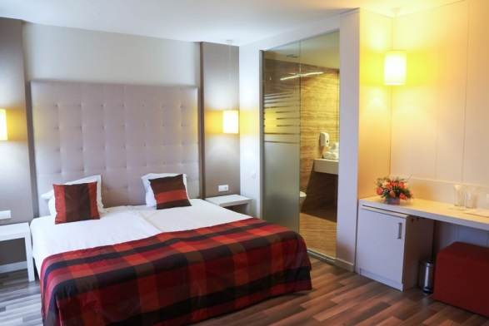 | 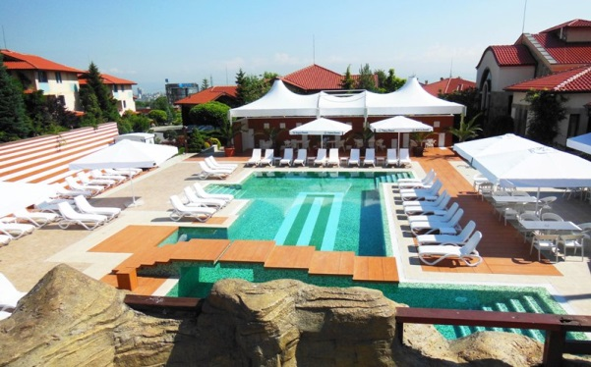
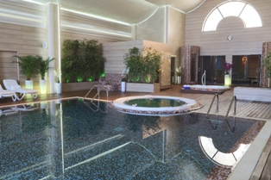 | 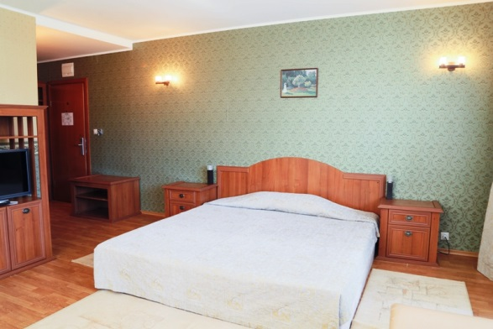

Entry fees:
Individuals: 120 € / Archer
Officials: 40 € / Official
*The Entry fee includes the Closing Party meal.
*Participation in the Mixed Team and Teams event is free of charge.

Transportation:
Sofia Airport
Sofia Central Railway Station
Sofia Central Bus Station
From Sofia airport, bus or railway station to the hotels – (arrival and departure): 20€/person
* Field, hotel and buses will be available for disable persons.

Water:
Water will be available on the fields free of charge.

Visa:
For all nations that will need visa permits, please make sure to apply for such as early as possible in your country of origin before leaving. If our help is needed you may contact us immediately: egpsofia_2016@abv.bg, for we could send an official invitation over to the Bulgarian Embassy for further cooperation.

Closing Party: Saturday, April 16’2016
Opening: 20:00 p.m. till the end...
Everyone is awaited at the dinner - join the Party!

Awards Ceremony:
It is required that each team should bring its National Anthem
(on a CD or on a pen-drive) and a country’s Flag (90cm x 120cm approx).

Pre-payments:
Hotel booking will only be regarded valid as soon as a 50 % down payment has been received by the Organizing Committee, before 12 January’2016.
The balance of full payments is to be made, before 12 February’2016.

Participants who may decide to book their accommodation at or with other hotels, i.e. non-official hotels, and not through the Local Organizing Committee (LOC), shall have to pay a double entry fee, and the LOC will not be responsible for providing transportation from those hotels to the venue (transport for these teams will be provided only to and from airport). It is not possible to distribute any information at the non-official hotels, also.

To contact us:
Email: egpsofia_2016@abv.bg
Tel / Fax: + 359 2 9300 625;
Mobile phone: + 359 886 697 615;
Web address: www.archery.bg

ADDITIONAL INFORMATION
Training field will be available a week before and after competition for teams who want to practice. Teams are welcome at this time.

CLUB ARCHERS PARTICIPATION
Not only National Team archers can participate in the Grand Prix, but also Club archers. National teams will have priority during the preliminary entry phase. After the preliminary entry deadline (22 March’2016) all Club members could register. The Club archers can participate only in the individual competition, not in team competition and in mixed team. Registrations must be done through their National Federations and the entries can be accepted by the Organizing Committee until the total capacity of the field has been reached.

TRANSPORTATION FORM
Return at the latest: 12 February’2016

Country/Team:________________________ Email: ______________________________
Team Manager: _______________________ Phone:_______________________________

Total number of Persons: |  | X 20 € = | Total (B): €

ARRIVAL
Plane:
Sofia Airport Flight No _________ From: _________
Date: ______________ Time: _____________________
Train: Train No: _________ Arriving from: _____________
Date: ______________ Time: _____________________
Car/Bus: Date: ______________ Time: _____________________

DEPARTURE
Plane:
Sofia Airport Flight No _________
Date: ______________ Time: _____________________
Train: Train No: _________
Date: ______________ Time: _____________________
Car/Bus: Date: ______________ Time: _____________________

If you are not arriving or departing in one group, please specify in the tables below.
Arrivals:
No. of persons | Flight No. /From | Date | Time
Departures:
No. of persons | Flight No. | Date | Time

Please check this box if you need facilities for persons with disabilities.

Date: _______________ President/SecretaryGeneral:___________________________

HOTEL RESERVATION FORM
Return at the latest: 12 January’2016

Country/Team:________________________ Email: ______________________________

Contact person: _______________________ Phone/Fax:__________________________________

ACCOMMODATION

4**** hotel  Tsarsko selo  Spa Centre | Number of Rooms | Number of Persons | Number of Nights | Cost price | Total Cost
Single Room |  |  |  | 85 € | €
Double Room |  |  |  | 65 € | €
 |  |  |  | Total (C) | €

The rates are in Euro (€) per person, per day, full board.
Please check this box if you need facilities for persons with disabilities.

We require that 50 % of the payment should be done before 12 January’2016.

Payment must be sent to the following bank account:

Bank Name: FIRST INVESTMENT BANK
International Banking Account Number (IBAN): BG13FINV91501203792590
Bank Identification Code (BIC): FINVBGSF
Bank address: 3, Narodno sabranie Sq. 1000 Sofia, Bulgaria
Bank account nominee: Bulgarian Archery Federation
NOTE:
All payments are required to be done in EURO:
- By BANK TRANSFER: 50% of total payment, before 12 January’2016
- By BANK TRANSFER: The rest of total payment (50%), before 12 February’2016
Bank transfer fees are the responsibility of the sender.
NO CREDIT CARDS, NO TRAVELLERS CHEQUES, NO FOREIGN CURRENCIES

Date: _______________ President/SecretaryGeneral:___________________________

BUDGET FORM
Return at the latest: 12 February’2016

Country/Team:________________________ Email: ______________________________

Contact person: _______________________ Phone/Fax:__________________________________

 | Number | Cost | Total
Individuals Entry fee |  | 120 € | €
Officials Entry fee |  | 40 € | €
Total entry fees ( A ) |  |  | €
Transportation Total ( B ) |  | 20 € | €
Total Accommodation ( C ) |  |  | €
Grand Total ( A+B+C ) |  |  | €
Deposit 50% before 12 January’2016 |  |  | €
Balance of full payments due on 12 February’2016 |  |  | €

Payment must be sent to the following bank account:
Bank Name: FIRST INVESTMENT BANK
International Banking Account Number (IBAN): BG13FINV91501203792590
Bank Identification Code (BIC): FINVBGSF
Bank address: 3, Narodno sabranie Sq. 1000 Sofia, Bulgaria
Bank account nominee: Bulgarian Archery Federation
NOTE:
All payments are required to be done in EURO:
- By BANK TRANSFER: 50% of total payment before 12 January’2016
- By BANK TRANSFER: The rest of total payment (50%), before 12 February’2016
Bank transfer fees are the responsibility of the sender.
NO CREDIT CARDS, NO TRAVELLERS CHEQUES, NO FOREIGN CURRENCIES

Date: _______________ President/SecretaryGeneral:___________________________

VISA INVITATION LETTER FORM
Return at the latest: 12 February’2016

Country/Team:________________________ Email: ______________________________

Contact person: __________________________ Phone/Fax:__________________________________

№ | Family Name | Given Name | Date of Birth  DD/MM/YY | Passport Number | Date of issue  DD/MM/YY | Validity  DD/MM/YY | Indicate Athlete, Coach or Official
1
2
3
4
5
6
7
8
9
10
11
12
13
14

Date: _______________ President/SecretaryGeneral:___________________________

CLUB ARCHER REGISTRATION FORM

Event: European Grand Prix – 1st leg

PLACE: Sofia (Bulgaria)
DATE: 12-16.04.2016

Country:
Family Name:
Name: |  |  |  |  |  |  |  |  | FITA ID # (if any)
Date of birth: |  |  |  |  |  | DIVISION |  |  |  | Rec. men
Club name: |  |  |  |  |  |  |  |  |  | Rec. women
 |  |  |  |  |  |  |  |  |  | Comp. men
 |  |  |  |  |  |  |  |  |  | Comp. women
Email address:
Postal address | Street:
 | City:
 | Postal code:
 | Phone #:
 | ALL cells must be completed
To complete ONLY by THE LOC  Date the Form was received: |  |  |  | Day |  |  | Month |  |  |  | Year

Please send this form completed to the Local Organizing Committee and to your National Archery Federation / Association:

- The Local Organizing Committee(LOC) will contact you to coordinate final registration, payment and any other information needed to complete your registration to the event.
- Your Federation will need to register your data in WAREOS (WA Registration & Entry Online System) in order to include you into the results system and WA WAREOS data base.

REGULATION for CLUB ARCHERS participating in European GRAND PRIX
- The Club Archer is responsible to send the completed form to the LOC and his/her Federation. Sending the form does not guarantee his/her participation. The process of registration and inclusion must respect the Club Archers’ regulations and procedures in order to be able to participate to this event.

- As soon as the Club Archer will be registered in WAREOS (by his/her Federation) and the LOC has accepted his/her registration, the Club Archer will be informed by the LOC that he/she can officially take part in the event.

- Club Archers participating in WAE events must be members of a WA Member Association (therefore official members of the Archery Federation of his/her country).

- The LOC will work on a “first come, first serve” basis, to take into consideration the forms they will be receiving. However, in order to participate, the Club Archer must also fulfill all the requirements requested in terms of booking, payments and other information requested by the LOC.

- Club archers cannot have coaches or guest accredited to access the FoP (blue area). If guest or coaches will accompany a Club Archer he will be treated as a spectator.

- DRESS REGULATIONS: Club Archers must respect WA rules (Book 1, point 3.22) in terms of uniform for the WA events. Club Archers cannot use any National Team uniform (neither of his country nor any other).

- Club Archer must be present in the Official Practice day when he will pick up his/her accreditation, confirm name and data given and pass the equipment inspection. The Club Archer is not allowed to miss the official practice and arrive directly to the qualification day. Travel plan should be arranged according to the schedule.
- Club archers could be Junior or Senior Categories. Cadet’s archers are not allowed to participate in the event as Club Archer.

CLUB ARCHER REGISTRATION PROCEDURE

- The Club Archer interested in participating in a Grand Prix competition, has to read Invitation Package and study cost and conditions to participate.

- After the end of the Preliminary Registration, the LOC (Local Organizing Committee) will calculate the available spaces for Club Arches per Division and inform WAE , which will advertise and publish the spots available for Club Archer on WAE Website.

- Max 30% of spots of the spots available (for Division) are for Club Archers from the host country, 70% are for International Club Archers.

- The Club Archer will visit the WAE Website and as soon as she/he knows the places available, completes the “Club Archer Registration Form” and sends it to the LOC and to her/his National Archery Federation.

- The belonging Federation, receiving the Club Archer Registration Form, has to check:
- if she/he is a member of the Federation

- If all is OK, the Federation will register the data of the archer in WAREOS (WA Registration & Online System) in order to include her/him into the result system and WA WAREOS data base. If Club Archer is included in WAREOS, the Federation has to inform LOC that the archer is eligible for the event.

- The LOC will prepare a list of Club Archers forms ordered by date of arrival and inform the Club Archer that her/his form has been received and she/he is included in the Club Archers list. The LOC requests to start room booking and fees-cost payment as indicated in the Invitation Package.

- The Club Archer contacts LOC to arrange room booking, arranges payments and informs about travel plan.

Official Hotel is “Tsarsko selo” Spa Centre

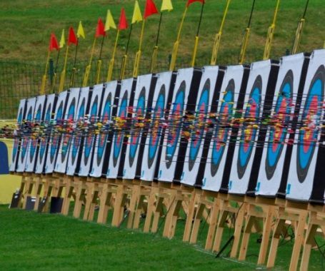 | 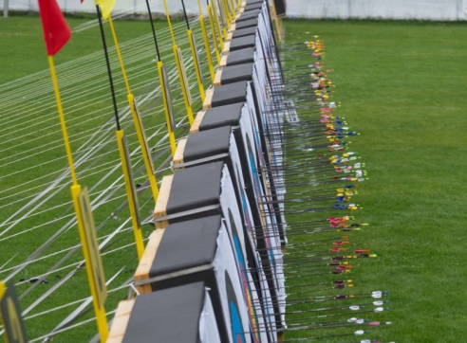
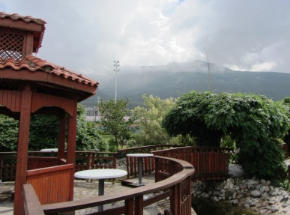 | 
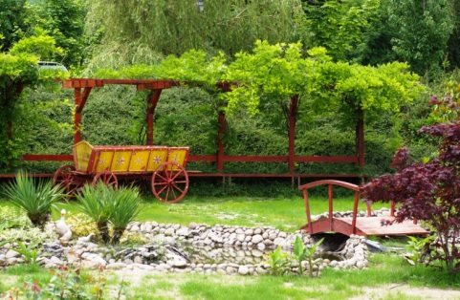 | 
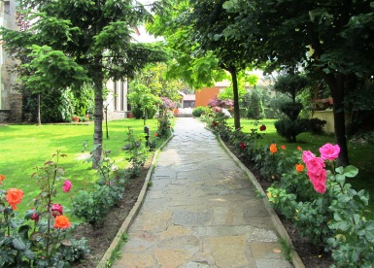 | 

