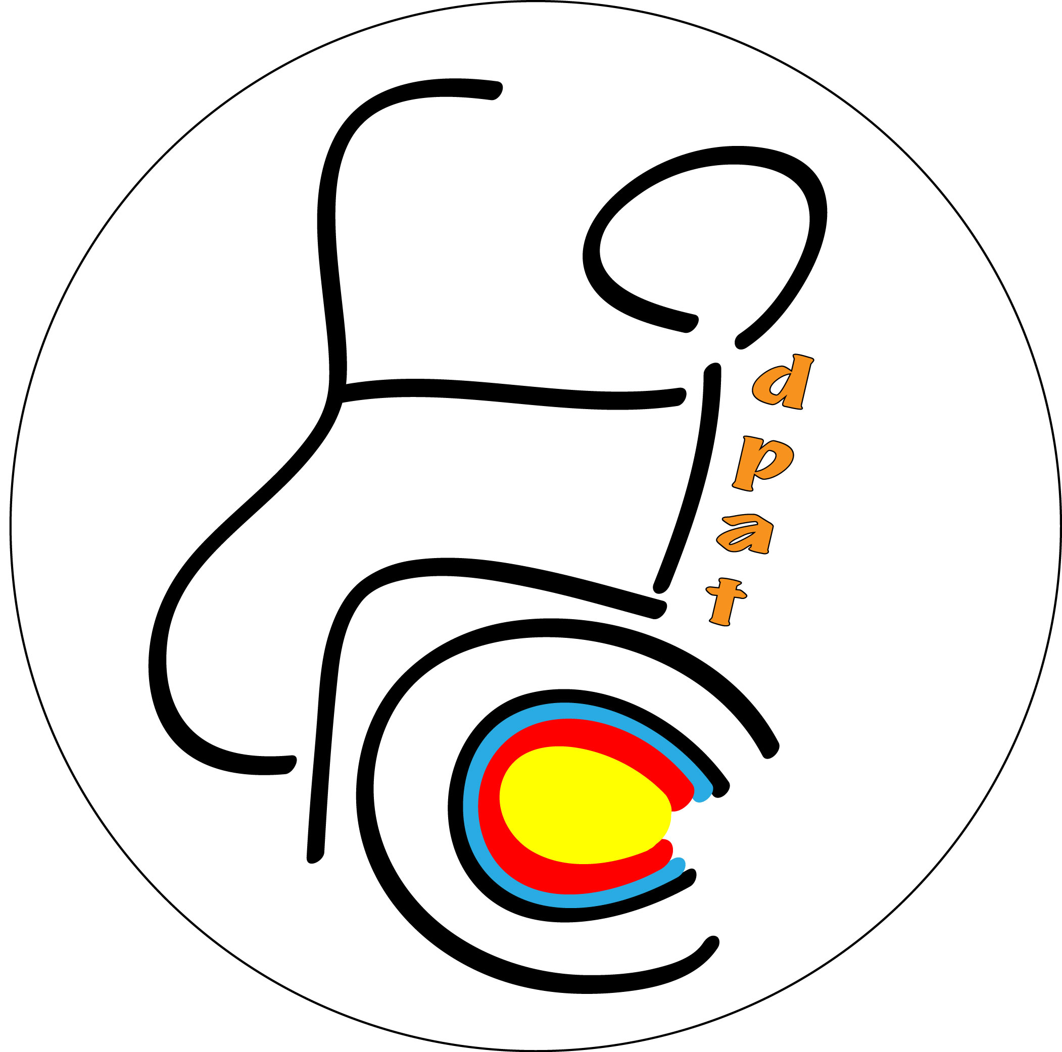

Invitation Package
for the

Dutch Para Archery Tournament 2016

World Ranking Event

Archery Association of the Netherlands
in cooperation with
HBS Almere [NED]

Entry Information

Organizing Committee Secretariat

Contact Person Mr. Carel Deden
E-mail carel.deden@dpat.nl
Phone number +31 (0)6 5192 1420
Postal address Paletlaan 79
1339 GA Almere
The Netherlands

Website www.dpat.nl
Facebook Dutch Para Archery Tournament

Event

Dutch Para Archery Tournament

Friday 6 May 2016 – Saturday 14 May 2016

Location: Handboogschutterij Almere
Trekweg 2
1339 GA Almere
The Netherlands

https://maps.google.nl/maps?q=trekweg+2,+almere&hl=nl&sll=52.548336,5.566507&sspn=1.372918,2.469177&t=h&hnear=Trekweg+2,+1338+GA+Almere-Buiten,+Almere,+Flevoland&z=16

Events List

 | Individuals* |  | Teams*
 | Women | Men | Women | Men | Mixed
W1 | X | X | X | X | X
Compound Open | X | X | X | X | X
Recurve Open | X | X | X | X | X
VI 1 | Combined
VI 2-3 | Combined

(*) No finals will be shot if fewer than 2 individuals and 2 teams are participating. In these cases the individuals or teams will be ranked according the Qualification Round and the Organizer will award them the gold medal for the first individual or team.

Competition Schedule (Draft)

6 May 2016 Arrivals

7 May 2016 Classification

8 May 2016 Official practice
Equipment Inspection
Team Managers Meeting

9 May 2016 Qualification rounds Gr 1
Qualification rounds Gr 2

10 May 2016 Qualification round Gr 3
1/24 individual eliminations

11 May 2016 Individual eliminations (to semi-finals)

12 May 2016 Team eliminations
Team Medal matches
Team Medal Ceremony

13 May 2016 Individual Medal matches
Individual Medal ceremonies
Closing ceremony

May14 Departures

Note: this program is subject to change. All changes to the program will be published and communicated to the participants in advance.

Classification

The classification will be held on Saturday 7 May, 09h:00 to 17h:00.

It is the responsibility of the teams that archers who have to be classified arrive in time for the classification session. That means that they have to arrive at the latest the day before the date of classification, so on Friday 6 May.
Classifiers will not change the classification schedule due to teams who arrive at the classification day itself.

For athletes that need to be classified, a medical intake form, translated in English, is mandatory. It must be sent by email to the chief classifier of the tournament at least 20 days before the start of classification, 16 April 2016 to archeryclassification@yahoo.com

If this information has not be submitted by email before this date, the athlete will not be classified and therefore, will not be eligible to participate in the event.

For physically impaired archers classification will be held on the same location as the field of play.

There will be only one panel for PI classification. In case of protest, a new classification will not be possible on place and should be done on a future event with a classification session.

There will be no VI classification on this tournament.
Archers who are already classified on a WA tournament are allowed to shoot in their respective category.

Preliminary & final registration

- The Preliminary Entry Deadline (with 30% deposit) is: 6 February 2016
- All registrations must be done using the World Archery Online Registration System (WAREOS V.2.): www.archery.org/admin. No entry forms will be available to register for this event.

- A maximum number of 3 athletes per country (host country included) are allowed to be registered into each category of the event. In order to use WAREOS, please login on www.archery.org/admin with your Username and Password assigned by World Archery. After entering the WAREOS, please go to "Online Registration" and register your athletes for this event. A "WAREOS User Manual" can be downloaded in PDF format (English) using the same website link.

- For any questions regarding the WAREOS, please contact the World Archery office, Mr Jae Kyung LEE (jklee@archery.org).

- Starting date of online registration using WAREOS: 7 January 2016
- End of preliminary registration using WAREOS: 6 February 2016
- End of final registration using WAREOS: 16 April 2016
- Final date of sending medical form (in English) to the chief classifier 16 April 2016

- Please pay attention to the stated deadlines. Teams will not be able to enter or update their data in WAREOS, after the deadlines as the system will be blocked. If teams wish to make any changes to their final registration after the deadline, you need to contact Mr Jae Kyung LEE, World Archery Member Services Coordinator (jklee@archery.org) and the local organizing committee.

- Any Member Association sending final registrations that differ by more than 4 athletes from the preliminary registration will result in a penalty fee of € 100,00 to be paid in cash to the LOC upon arrival at the field (WAE agreement art. 3.2.)
- Teams that enter after the final deadline will pay a penalty fee of € 100,00 per athlete to be paid in cash to the LOC upon arrival at the field (WAE agreement art. 3.3.).
- Any Member Association that has made final entries in the WAREOS system and does not participate with the number of entries entered in the system has to inform the OC by email carel.deden@dpat.nl at least one week prior to the event that they are unable to attend.
- Since entries are through WAREOS only, Member Associations declare that their athletes and officials are aware of the participation waiver and anti-doping agreement. We recommend MA advise their athletes on this matter. However, accepting the conditions of athletes participation waiver and the anti-doping agreement are an eligibility requirement to participate in the event.
- Any entries received less than 3 days before the team managers meeting of this event will be refused if no preliminary entry and/or final entries were made beforehand. This decision cannot be appealed by teams and is fully compliant with the current World Archery rules, article 3.7.1.2. Entries received after the deadlines, are subject to penalties as clearly stated in the rule book and the invitation documents of the event. A Member Association that has made final entries in WAREOS and does not participate will be invoiced for the number of entries entered in the system, unless they have informed the OC in writing at least one week prior to the event that they are unable to attend.
- Only Member Associations in good standing will be eligible to compete. This also means that any World Archery penalty fees owed for 2015 must have been paid prior to competition.
- Nations will be registered and accepted after the Organizing Committee has confirmed the entries made in WAREOS and confirmed receipt of the 30% deposit.

Entry Fees

The entry fees for this World Ranking Event are:

Full package/official hotel:
- Individual € 150,= per archer
- Official € 50,= per official
- Team Participation in (mixed) team is free of charge
- Accommodation for 8 nights (full board)
- in twin room / person : € 900,00
- in single room / person : € 1.220,00
- meals from lunch on 6 May to breakfast on 14 May (Departure)
- local transport (Hotel – Venue – Hotel) and from/to Amsterdam Schiphol Airport

Non-official hotels:
Participants who decide to book their accommodation in other (non-official) hotels, will have to pay a double entry fee, and the OC will not be responsible for providing transport from these hotels to the venue. Furthermore they have to register at accreditation at the latest one day before official practice; if they don’t register the day before, no changes will be made to the entry list. It is likely that they will not be allowed to compete if registration was not completed on time.
- lunches on the field € 70,00 per person (8 days; from 6 May up till and including 13 May)
Competition & Training Venue

Location HBS Almere, Trekweg 2, 1339 GA Almere, The Netherlands
Internet: www. hbsa.nl

GPS: N 52° 22.643' E 005° 16.928'

Free water for accredited officials and members of teams will be available

Accreditation
Accreditation collection will take place at the Bastion Hotel on 6/7 May (see address below).

Accomodation

The full package includes accommodation in the official hotel:
Bastion Hotel Almere
Pleisterplaats 1
1322 Almere
The Netherlands

This hotel is less than 15 minutes by bus from the field of play. Reservations will be allocated on the order of registration and will be subject to availability and the payments received (see entry fee). Room rates are based on a full board package per person, including related service charge and VAT and transport. All Member Associations are required to submit the preliminary hotel reservation form before 6 February 2016. Booking will only be valid once a 30% deposit has been received by the LOC before 6 February 2016. Full payments are to be made before 16 April 2016. Reservations after these dates will be subject to availability. Please ensure all the necessary forms are completed by the specified dates. All payments are to be made within the given dates.

Transportation
Transportation to and from the venue will only be provided for participants within the official hotel and booked through the LOC. No information will be distributed outside the official hotel.

Transportation to and from the venue and the hotel (included in full package entry fee)
Transportation to and from Schiphol Airport (included in full package entry fee), is available on Friday 6 May and Saturday 14 May. Please contact the LOC if you need transport on other dates.

Rules

Technical aspects of the event, as well as classifications are subject to the rules of World Archery.
In particular please also note the special rules in chapter 21 of book 3.

Insurance

Teams are expected to have their own personal travel, equipment and belongings insurance. Event insurance will be in accordance with World Archery rules and regulations.

Cancellation & Changes

Cancellation must be made by email to carel.deden@dpat.nl and be received before 28 April 2016 for a complete refund of the deposit paid.
Any cancellations received after this date will not be eligible for a refund. All rates for payments after deadlines are subject to additional changes without prior notice. Refunds will be processed after the event.

VISA
For all nations needing visa permits, please make sure that you apply for as early as possible in your country of origin before leaving. If our help is needed, you may contact us immediately on josebruntink@handboogsport.nl. For official invitations please apply before 16 April 2016 on the form provided with copies of passports attached.

Awards Ceremony
Each country is requested to bring their national flag (at least 200 x 100cm) and a CD of their country’s national anthem. For all ceremonies dress code is obligatory.

Dress Regulations
World Archery and World Archery Europe dress regulations apply for this event.

Weather
According to weather information, the average daily temperature for May is 7 to 13 Celsius. Please note that the temperature will drop in the evening and rain is possible.

Bank Account Details

Account name/Beneficiary | St. Dutch Para Archery Tournament
Bank name | ING Bank
Bank address | Amsterdam
SWIFT/BIC | INGBNL2A
IBAN | NL33 INGB 0006 9707 29

- Please add the following description: DPAT2016 XXX (where XXX is your NOC code)

Preliminary Hotel & Budget Form

Country |  |  | Date (DD/MM/AA):
Contact Person
Mobile phone |  | E-mail :

□ Full package with booking in official hotel
 | Entry fee + Accommodation full board  + local transport |  |  |  | Number | Amount
Athletes | Twin room / person |  |  | 1050,00 € |  | €
Athletes | Single room / person |  |  | 1370,00 € |  | €
Officials | Twin room / person |  |  | 950,00 € |  | €
Officials | Single room / person |  |  | 1270,00 € |  | €
  Transport Airport - Hotel - Airport |  |  |  | Included in full package |  | €
 |  |  |  | TOTAL |  | €
To be paid before 6 Feb 2016: 30% = |  |  |  |  |  | €

□ Non-official hotels entry fee
 | Entry fee + lunches 6/5 to 13/5 |  |  |  | Number | Amount
Athletes | 370,00 € |  |  |  |  | €
Officials | 170,00 € |  |  |  |  | €
 |  |  |  | TOTAL |  | €
To be paid before 6 Feb 2016: 30% = |  |  |  |  |  | €

Expected composition of the team (indicate the maximum persons by type of wheelchair used)
  Electrical  wheelchair : …… |   no possible  transfer : …… |   possible  transfer : …….

Any special instructions:

Please return the form to the OC before 6 February 2016 by email to Backoffice@dpat.nl

Signature of President / Secretary General:

Travel Form

Country |  |  | Date (DD/MM/AA):
Contact Person
Mobile phone |  | E-mail :

BY PLANE

ARRIVAL |  |  | Passengers
Date | Flight Nr. | Arrival time  24:00 format | Total |  |  |  | 

DEPARTURE |  |  | Passengers
Date | Flight Nr. | Arrival time  24:00 format | Total


BY OWN TRANSPORT

Date | Arrival time  24:00 format | Need of local  Transport* |  | Passengers
Date | Arrival time  24:00 format | NO | YES, details → | Total
(*) only for teams with full package (rooms in official hotels)

 Electrical wheelchair  Wheelchair without transfer  Wheelchair with possible transfer Standing

Please return the form to the OC before 6 February 2016 by email to Backoffice@dpat.nl
Rooms booking form

Country |  |  | Date (DD/MM/AA):
Contact Person
Mobile phone |  | E-mail :

Number of rooms: Twin: _____ (with 2 separate beds) Single: _____

Types of rooms required The Local Organizing Committe will try to do the best for the comfort of all athletes with the accessible rooms at disposal. Please declare the real necessity to permit to everyone to be served as well as possible.

 | Single | Twin |  |  |  |  |  |  | Single | Twin
1 |  |  |  |  |  |  |  | 11
2 |  |  |  |  |  |  |  | 12
3 |  |  |  |  |  |  |  | 13
4 |  |  |  |  |  |  |  | 14
5 |  |  |  |  |  |  |  | 15
6 |  |  |  |  |  |  |  | 16
7 |  |  |  |  |  |  |  | 17
8 |  |  |  |  |  |  |  | 18
9 |  |  |  |  |  |  |  | 19
10 |  |  |  |  |  |  |  | 20

Electrical wheelchair Wheelchair without transfer Wheelchair with possible transfer Standing

Please return the form to the OC before 6 February 2016 by email to Backoffice@dpat.nl
Final Entry Fee Form

Country |  |  | Date (DD/MM/AA):
Contact Person
Mobile phone |  | E-mail :

□ Full package with booking in official hotel
 | Entry fee + Accommodation full board  + local transport |  |  |  | Number | Amount
Athletes | Twin room / person |  |  | 1050,00 € |  | €
Athletes | Single room / person |  |  | 1370,00 € |  | €
Officials | Twin room / person |  |  | 950,00 € |  | €
Officials | Single room / person |  |  | 1270,00 € |  | €
Transport Airport - Hotel – Airport |  |  |  | Included in full package |  | €
 |  |  |  | TOTAL |  | €
paid at the preliminary entry |  |  |  |  |  | - €
To be paid = |  |  |  |  |  | €

□ Non-official hotels entry fee
 | Entry fee + lunches 6/5 to 13/5 |  |  |  | Number | Amount
Athletes | 370,00 € |  |  |  |  | €
Officials | 170,00 € |  |  |  |  | €
 |  |  |  | TOTAL |  | €
paid at the preliminary entry |  |  |  |  |  | - €
To be paid = |  |  |  |  |  | €

Please return the form to the OC before 16 April 2016 by email to Backoffice@dpat.nl
Rooming list

Country |  |  | Date (DD/MM/AA):
Contact Person
Mobile phone |  | E-mail :

No. | Room type | Name guest no. 1 |  |  |  | Name guest no. 2
1.

No. | Room type | Name guest no. 1 |  |  |  | Name guest no. 2
2.

No. | Room type | Name guest no. 1 |  |  |  | Name guest no. 2
3.

Use more copies if needed.

Please return this form by 16 April 2016 by email to: Backoffice@dpat.nl

Visa Support Form

All Member Associations who need an entry visa, are kindly asked to fill in the Visa Support Form and return this form - including copies of passports - to the Organizing Committee, as soon as possible, but no later than 16 April 2016

Only e-mail is accepted to josebruntink@handboogsport.nl

Gender  M/F. | Family Name | First Name | Date of Birth DD/MM/YY | Nationality and place of birth | Title  (Athlete/Coach/Official) | Passport No. | Expiration Date of Passport  DD/MM/YY | Location of Visa collection
M | Latinov | Vitaly | 27/07/1974 | Russian, Sochi | Athlete | 2857362 | 08/06/2016 | Moscow

