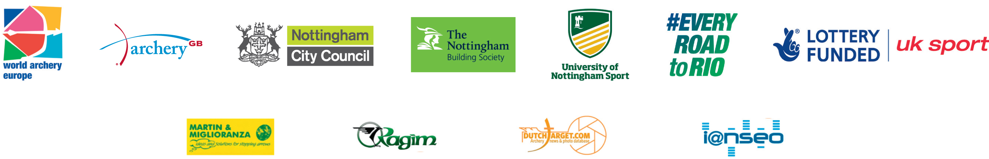

Invitation package to
World Archery Europe Congress 2016
Nottingham UK May 22 2016

Invitation
TO ALL THE WORLD ARCHERY EUROPE MEMBER ASSOCIATIONS
Dear Member Associations, Dear Congress Delegates;
This document has been created for those persons not part of the National Team participating in the World Championships, but who will participate in the World Archery Europe Congress taking place on Sunday 22 May. These persons will need to book their accommodation and transport using the Congress forms following and not using the National Teams invitation package.
Delegates:
- Preliminary Hotel Reservation form and 70% deposit 1 March 2016
- Preliminary Transportation Form 1 March 2016
- Visa Support Form 1 March 2016
- Final Hotel & Transport Form with Remaining Balance 15 April 2016
Nottingham is situated in the heart of England, and renowned throughout the world as the legendary home of Robin Hood. From the sleepy market towns and golden fields of the countryside, to the shops and clubs of the cosmopolitan Nottingham city, ours is a county of contrasts and surprises. Welcome to this amazing city. We look forward to embracing you and making your visit an unforgettable experience.

Please find enclosed the necessary documentation concerning organisation, registration and participation to this event.

We look forward to welcoming you to Nottingham.
Sincerely Yours
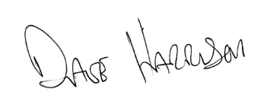
Mr David Harrison
Chairman
Archery GB

Website: www.euroarchery2016.org Contact Email: congress2016@archerygb.org

World Archery Europe Congress:
Preliminary & Final Registration
For the World Archery Europe 2016 Congress the maximum number of Member Association deletes that may attend is: Three (3)
Weekend Delegate rate includes:
Saturday 21 May
Pick up from Airport and taken to Congress Hotel (The Orchard, Nottingham)
Evening meal booked at the Congress Hotel for 20.00
Overnight Accommodation at the Congress Hotel including breakfast
Sunday 22 May
Congress: registration at 08.00 at the East Midlands Conference (next to the Congress Hotel)
Congress: 09.00 – 13.00
Buffet Lunch: 13.00
Guided Coach Tour of Nottingham: 14.30 – 17.00 (optional)
Drinks reception: 19.00
Congress Evening Meal: 20.00
Overnight Accommodation at the Congress Hotel
Return Transport to Airport
If you require accommodation for more than 2 nights’ accommodation included at The Orchard, then please indicate this on the Accommodation Form. This will be at an additional cost.
- Preliminary reservations need to be made before: 1 March 2016
- Final reservations need to be made before: 15 April 2016
Please ensure that you complete all the necessary forms by the specified dates and make all your payments within the timescales given.
Weekend Delegate rate

Accommodation at The Orchard. Congress at East Midlands Conference Centre
Single Room | €420.00
Twin/Double Room (PER PERSON based on 2 people sharing) | €320.00
Nottingham: City Information
Social Programme Ideas
Once you have arrived, Nottingham will provide you with a limitless choice of social and leisure activities. A compact city centre means you will never have far to walk between venues and will find their way around with ease. Nottingham is also one of just a handful of cities that have been accredited with a Purple Flag award for the variety, safety and cleanliness of our after dark offering.

At the heart of the city is Old Market Square, dominated by the Council House and its formidable stone lions. It is the second largest public square in Europe after Trafalgar Square and a focal point for visitors and locals alike.

We offer a vibrant night scene with an eclectic mix of entertainment options including continental style piazza venues with al fresco dining, lively nightclubs and laugh-a-minute comedy clubs plus an abundance of real ale pubs such as the oldest pub in England ‘Ye Olde Trip to Jerusalem,’ the ghostly ‘Ye Old Salutation’ dating back to 1240, and the Bell Inn that was the favoured watering hole of Lord Byron himself!

You won’t be short of places to eat in Nottingham with over 300 restaurants in the city centre alone offering a mouth-watering mix of international cuisines to suit all tastes and budgets. Nottingham is not only known for its fantastic nightlife, it is consistently ranked as a top UK destination for shopping, perfect for a spot of retail therapy. The city is home to international fashion designer Paul Smith, along with several other major labels all nestled alongside the well-known high-street stores and unique fashion outlets on offer.
If you don’t fancy a spot of shopping then why not sample a slice of Nottingham’s sporting life. The city has a long history of producing and developing sporting icons who have performed in some of the local iconic venues including Trent Bridge Cricket Ground, the City Ground home to Nottingham Forest FC, Holme Pierrpont Water Sports Centre and the National Ice Centre, home to Olympic Champions Torvill and Dean.
The Orchard Hotel East Midlands Conference Centre & Orchard Hotel
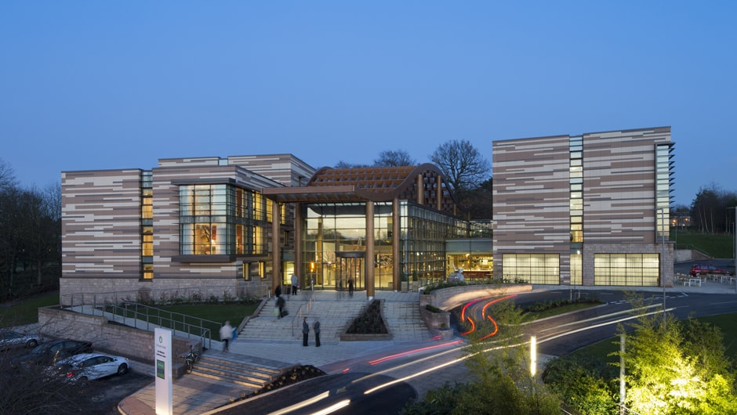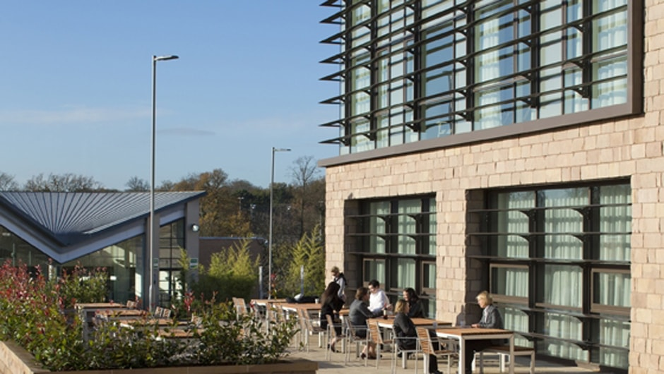

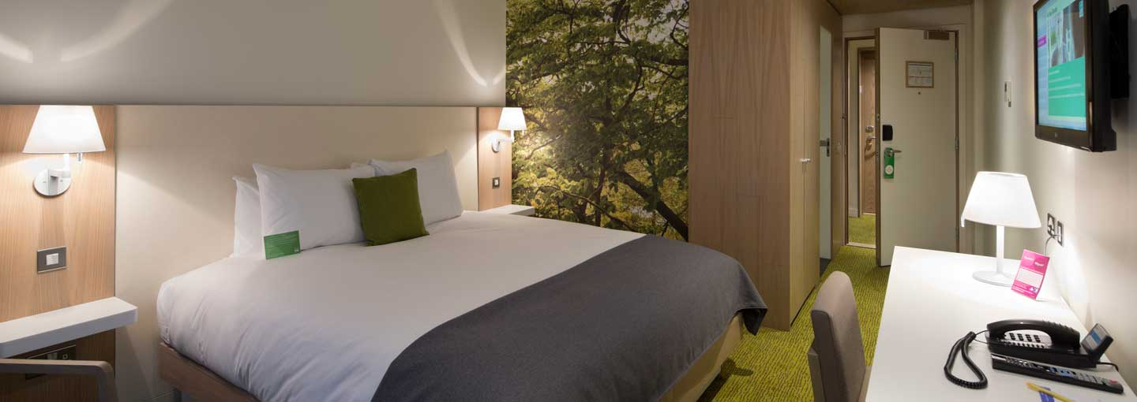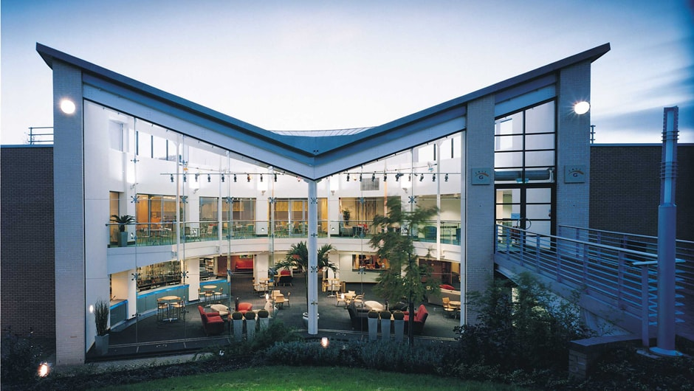
East Midlands Conference Centre
Internet:
Free Wifi throughout the Hotel and Conference Centre
Transportation for Congress:
Transportation to and from the East Midlands or Birmingham Airports will be only be provided for delegates accommodated at the Congress Hotel and booked in advance.
East Midlands Airport (www.eastmidlandsairport.com) to Nottingham approximately 16 miles (26 km) and 35 minute travel time.
Birmingham International Airport (www.birminghamairport.co.uk) to Nottingham approximately 51 miles (82 km) and 65 minute travel time.
Location:
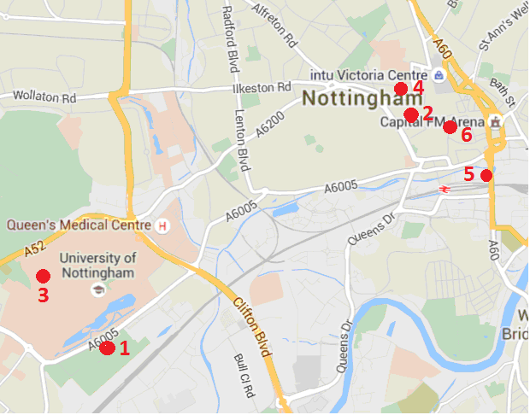
The map below shows the location of the venues and hotels in use at the European Championship (including The Orchard)

- Highfields (Qualification Venue) 2. Old Market Square (Finals Venue)
- De Vere Venues Orchard Hotel (Congress Venue) 4. Crowne Plaza
- Jurys Inn 6. Ibis

Weather:
According to weather information, the average daily temperature for May is 11-16 C. Please note that the temperature will drop in the evening and rain is possible.
Visa:
For all nations that will need visa permits, please make sure that you apply for such as early as possible in your country of origin before leaving. If our help is needed you may contact us immediately on: susan.walford@archerygb.org. For official invitations please apply before 1 March 2016 on the form provided with copies of passports attached.
Please Note: Visas are the responsibility of the individual nations and not the organising committee
Insurance
Teams are expected to have their own personal travel, equipment and belongings insurance. Event insurance will be in accordance with World Archery rules and regulations.
Payment Instructions:
All payments are to be made in Euros by bank transfer to:
Account Name: The Grand National Archery Society T/A Archery GB
Account Address: Lilleshall National Sports Centre, Nr Newport, Shropshire, TF10 9AT
IBAN Number: GB47NWBK60720117529050
Account Number: 17529050
SWIFT / BIC code: NWBKGB2L
Bank Name: Natwest,
Bank Address: 19 High Street, Newport, Shropshire, TF10-7NE

- We regret that credit cards and travellers’ cheques will not be accepted.
- Bank Transfer fees are the responsibility of the sender
- Accommodation fees must be paid in full BEFORE arrival
Cancellations & Changes:
Cancellation must be made by email to congress2016@archerygb.org and be received before 1 March 2016 for a complete refund of the deposit paid, less any bank charges incurred.
Any entries received after this date will be as per the cancellation policy.
All rates for payments after deadlines are subject to additional changes without prior notice.
Refunds will be processed after the event.

Preliminary Hotel Form:

Federation/Country:
Contact Name:
Contact Email:
Telephone: | Fax:

Transportation
Arrival by Car Arrival by Airplane

Accommodation

Room Type | Room  (please tick) | Number of Nights (Minimum 2) | Additional accommodation (Number of Nights) | Arrival Date | Departure Date
Single (1 person) |  | 2
Twin / Double (2 people sharing) |  | 2

Any Special Instructions……………………………………………………………………………………………………….
…………………………………………………………………………………………………………………………………………….
Please email this form before 1 March 2016 to congress2016@archerygb.org with 70% deposit

Signature of President/Secretary General: ____________________________________
Name (printed) ____________________________________________
Date:______________________________________

Transportation Form

Federation/Country:
Contact Name:
Contact Email:
Telephone: | Fax:

Arrival by Airplane from East Midlands
Arrival by Airplane from Birmingham Airport

Arrival Flight
Number of Passengers: | Arrival Airport:
Airline: | Flight Number :
Date: | Departure Time:

Departure Flight
Number of Passengers: | Departure Airport:
Airline: | Flight Number :
Date: | Departure Time:

Any Special Instructions………………………………………………………………………………………………………….
……………………………………………………………………………………………………………………………………………….
Please email the form before 1 March 2016 to congress2016@archerygb.org
Signature of President/Secretary General: ____________________________________
Name (Print) ________________________________________
Date:______________________________________

Visa Support Form

Federation/Country:
Contact Name:
Contact Email:
Telephone: | Fax:

Given Name | Family Name | Date of Birth | Passport Number | Date of Issue | Date of Expiry | Country of Issue | Copy of Passport Attached
Signature of President/Secretary General: ____________________________________
Date:______________________________________
Please email this form before 1 March 2016. By email to: congress2016@archerygb.org
Please forward copies of passports

