European 3D Archery Championships
Mokrice - Catez 30 August – 3 September 2016

1 March 2016

Dear President,

On behalf of the Organizing Committee and Archers Association of Slovenia we are pleased to invite you to the 5th European Archery 3D Championships that will be held in Mokrice - Catez, Slovenia, from 30 August – 3 September 2016.

Please, find enclosed the necessary documents concerning the registration, organization and participation in this event. We kindly ask you to return the forms within the stated deadlines:

Preliminary Entries - online WAREOS 1 June 2016
Preliminary Hotel reservation Form and payment 1 June 2016
Final Entries - online WAREOS 10 August 2016
Transportation Form 10 August 2016
Final Budget Form & remaining Payment 10 August 2016
Visa Application Form 1 July 2016

We look forward to welcoming you and we are sure you will enjoy your stay in Mokrice - Catez.

Yours sincerely

Leon Uratnik Irena Rosa
President Competition Manager
Archers Association of Slovenia

Website: http://www.3d-mokrice2016.si
E-mail: oc-mokrice@archery-si.org
Info: +386 (0)31 633 851 Ms. Irena Rosa

……………………………………………………………………………………………………………………………………..……………………………….

PRELIMINARY PROGRAMME

Sunday 28 August 2016 Arrival of Delegations
Practice field and local transportation available
Team Registration

Monday 29 August 2016 Arrival of Delegations
Practice field and local transportation available
Team Registration

Tuesday 30 August 2016 Official practice and equipment inspection
Team Managers' Meeting at the Terme Hotel in Catez
Opening Ceremony

Wednesday 31 August 2016 1st Qualification Round – 24 targets

Thursday 1 September 2016 2nd Qualification Round – 24 targets

Friday 2 September 2016 1st Individual Elimination Round – 12 targets
Team Elimination Round – 8 targets
2nd Individual Elimination Round – 8 targets

Saturday 3 September 2016 Team semi-finals – 4 targets
Individual semi-finals – 4 targets
Team Finals – 4 targets
Individual Finals – 4 targets
Award Ceremony/Closing Ceremony
Gala Dinner and party at the Terme Hotel in Catez

Sunday 4 September 2016 Departure of Delegations

Note: The preliminary programme could change slightly. All changes to the programme will be published and informed to all participants in good time.

Website: http://www.3d-mokrice2016.si

……………………………………………………………………………………………………………………………………………………….………………

PRELIMINARY & FINAL REGISTRATION

All registration process must be done using the World Archery Online Registration System – WAREOS http://register.worldarchery.org. No entry forms will be accepted for registering to this event.

A maximum number of 3 athletes per country /host country included/ are allowed to be registered into each category of the event. Preliminary entries have to be done using the WAREOS system.

In order to use WAREOS, please login on http://register.worldarchery.org with your Username and Password assigned by World Archery. After entering the WAREOS, please go to “Online Registration” and register your athletes for this event. A “WAREOS User Manual” can be downloaded in PDF format /English/ using the same website link.

For any questions regarding the WAREOS, please contact Mr. Matteo Pisani at matteo@pisani.eu

Starting date of online registration using WAREOS: 1 March 2016
End of Preliminary registration using WAREOS: 1 June 2016
End of Final registration using WAREOS: 10 August 2016

Please pay attention to the stated deadlines. Teams will not be able to enter or update their data in WAREOS after the deadlines, as the system will be blocked. Any teams wish to make any changes to their Final Registration after the deadline, must contact the Organizing Committee at oc-mokrice@archery-si.org and Mr. Matteo Pisani at matteo@pisani.eu /with the OC in CC of that email/.

Teams that enter athletes through WAREOS after the 20 day final deadline will pay a penalty of 100,00 Euro per athlete registered /Article 3.3 WAE Agreement/.

The Member Associations which send final entries with more than two athletes difference from the numbers entered at the time of the preliminary WAREOS entry, will pay a fine of 100,00 Euro /Article 3.2 WAE Agreement/.

Only after having paid the penalty fees to the OC, a Member Association can register the athletes in order to participate into the competition /Article 3.4 WAE Agreement/.

Any entries received less than 3 days before the team managers meeting for a European Championships may be refused if no preliminary entry and/or final entry were made prior.

A Member Association that has made final entries in WAREOS and does not participate will be invoiced for the number of entries entered in the system, unless they have informed OC in writing by email
oc-mokrice@archery-si.org at least one week prior to the event that they are unable to attend.

.............................................................................................................................................................................

Since entries are through WAREOS only, Member Associations declare that their athletes and officials are aware of the participation waiver and anti-doping agreement. We recommend Member Associations advise their athletes on this matter. However, accepting the conditions of athlete participation waiver and the anti-doping agreement are an eligibility requirement to participate in the event.

In a European Championship no title will be assigned if the preliminary entries reflect fewer than 12 individuals and 6 teams. If in WAREOS there will be less than 12 individuals and 6 teams, the individuals or teams will be ranked according the Qualification Round and the Organizer will award them with own medals.

As a final note, only Member Associations in good standing will be eligible to compete. This also means that any penalty fee for 2016 and WA fee 2016 must have been paid prior to participation.

We recommend all teams that upon arriving to Catez you first come into the accreditation office. It is not possible to use any facility without being accreditated. Any athlete arriving to the competition on the day of the 1st Qualification Round may be refused or will have to pay a fine of 50,00 Euro.

ACCOMMODATION & GENERAL INFORMATION

The official hotels are 4* stars category hotels TERME HOTEL and TOPLICE HOTEL in Catez, standing next to each other in Catez Spa.

The room rate:
- is per person per night,
- include full board accommodation, taxes and VAT
- include use of the swimming pool
- include use summer thermal riviera – free entrance twice per day
- include free parking in front of the hotel for cars, minivans and busses
- internet in the hotel lobby and rooms

HOTEL | Category | Single room  Price per person per night - full board | Double room  Price per person per night - full board
TERME HOTEL | **** | € 120 | € 85
TOPLICE HOTEL | **** | € 120 | € 85

Lunch during the competition days will be served in the restaurant of the Castle Mokrice - competition field.

.............................................................................................................................................................................

TERME HOTEL Terme Čatež d.d., Topliška 35, SI - 8251 Čatež ob Savi
Coordinates: 45.89192 15.621547

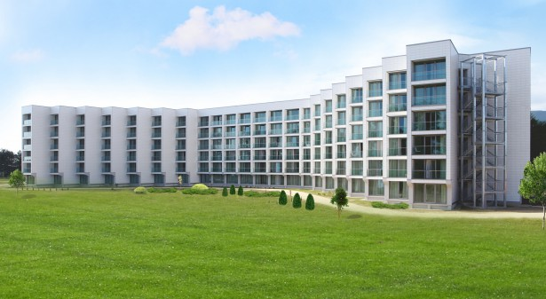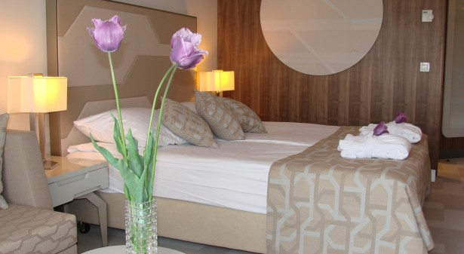

TOPLICE HOTEL Terme Čatež d.d., Topliška 35, SI - 8251 Čatež ob Savi
Coordinates: 45.89192 15.621547

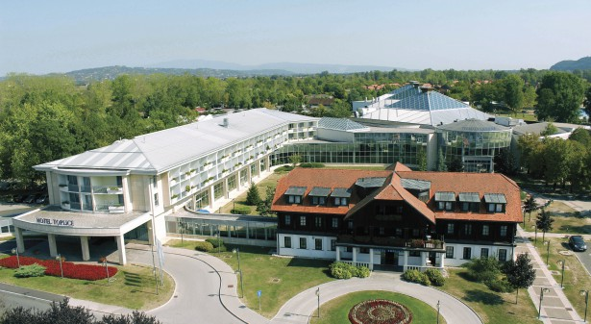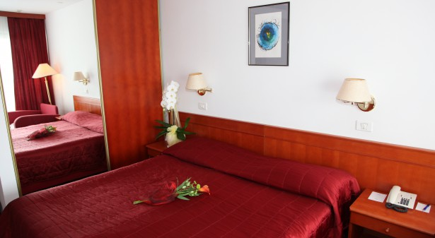

Slovenian health resorts are developed in the middle of natural environment and aside from medical treatments they offer numerous possibilities for sport and recreation in nature, on opened and closed courts. Medicinal offer includes loads of fun, ramblings and exploration of local particularities and sightseeing.
Catez Spa offers the largest pool grandeur in Slovenia. The winter Thermal Riviera with 2200 m² roofed water surfaces and numerous attractions guarantees fun for all ages. There is variety of choice with kiddy pools, pirate ship, asymmetrically shaped pool with whirlpools, waterfalls, massage beds, numerous water slides, raging river, wave pool, attractive wave surfing… From April to October the summer Thermal Riviera enchants the guests with the pirate island, water park for kids, slow river, wave pool, triple water slide and a unique water slide boomerang…

.............................................................................................................................................................................
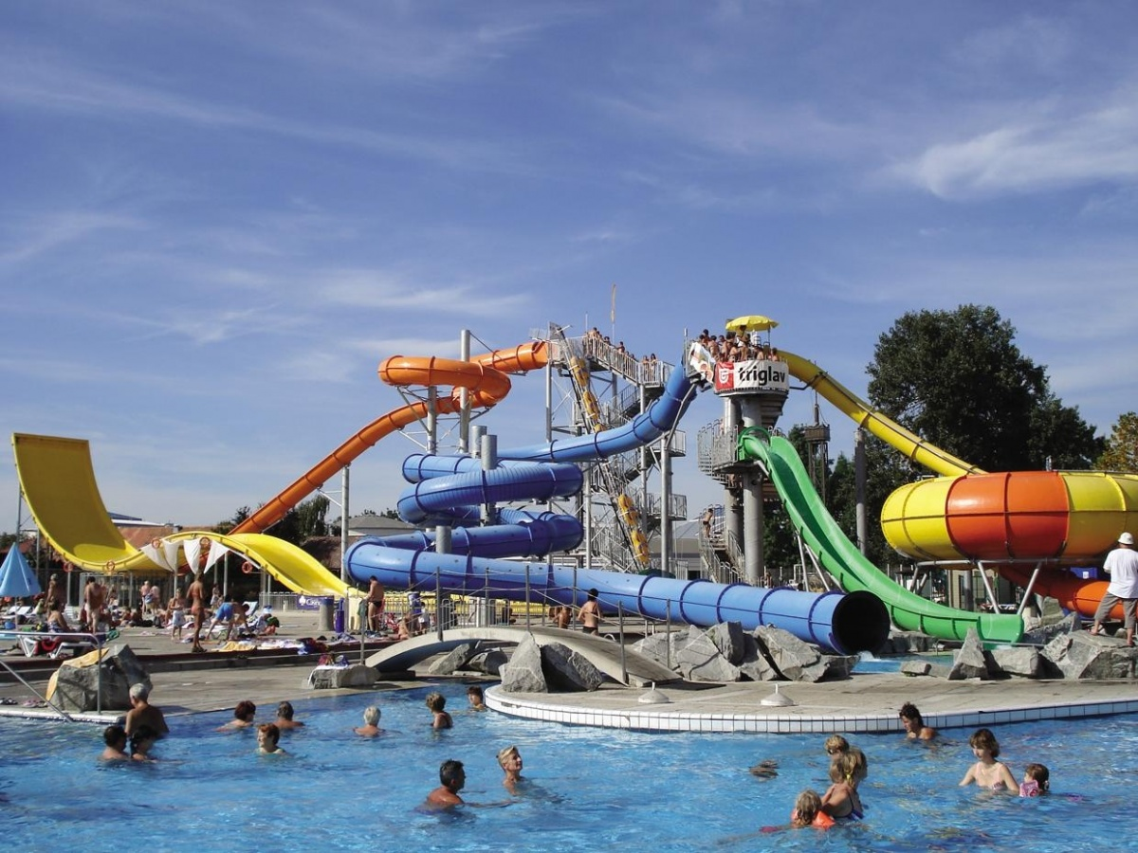
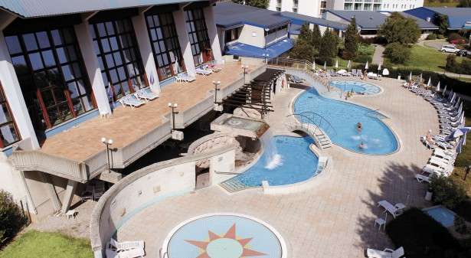
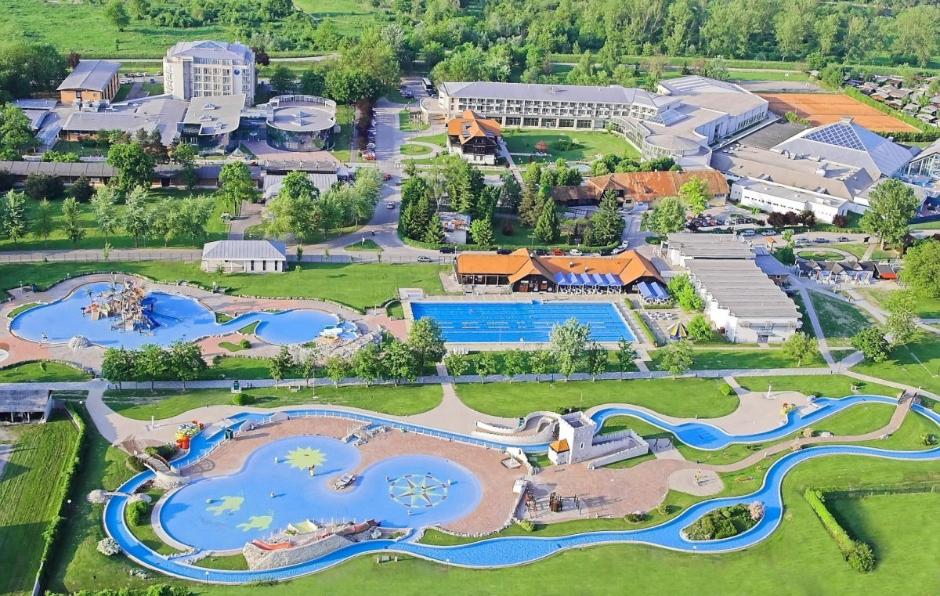
The Terme Hotel and Toplice Hotel are distanced from everyday bustle, located in a quieter part of Terme Catez. It is recommended to everyone who is looking for relaxation and excellent wellness range with available indoor and outdoor pools with thermal water. The hotel comprises the Health & Beauty Centre, where you can let yourself be pampered in unique Roman-Irish baths.
The Summer Thermal Riviera, boasting the largest outdoor pool complex far around, offers entertainment to all generations with more than 10,000 m² of thermal water surface. Visit the water attractions and pools of various shapes with thermal water with a temperature between 26 and 36 °C.
Enjoy thousands water in thousands of forms. Toboggans, Pirate's island, lazy river, pool with waves, children's pools, play structures, whirlpools ... You will have a hard time trying to fit all in one day.

Reservations should be made before 1 June 2016.
To confirm the reservation, a 60% deposit of the total amount is required to be bank transferred to the OC before 1 June 2016. Reservations after this date will be considered only according to availability, the room rate can change and we can not guarantee rooms in the official hotel.

Note:
Please refer to the Accommodation pages below for detailed hotel information. Ensure that you complete all the necessary forms by the specified dates and make full payment for the accommodation at the time of booking. See detailed payment instructions below.

Local transportation will be available between hotel and practice and competition venues. Exact transportation timetables will be confirmed. Buses and/or vans will be used.

Participants who will decide to book their accommodation in other hotels /non-official hotels/ will have to pay a double entry fee, and the LOC will not be responsible to provide transportation from that Hotel to the venue /transport for these teams will be provided only to and from the airport/. Also, it will not be possible to distribute any information at the non-official hotels.

.............................................................................................................................................................................

ADDITIONAL INFORMATION

Entry fees: Individual 150 € per athlete
Officials 50 € per official
Teams 75 € per team

Your entry fee includes daily local transportation to and from practice and competition field to the event official hotel and venues during the qualification, elimination and finals /transportation timetable has to be confirmed/.
Transportation fees from/to the airports:
The OC will collect the teams from the two airports. You have to pay the transportation fee /including arrival and departure/ as follows:
ZAGREB International Airport /CRO/ 50 km 45 € per person
LJUBLJANA International Airport /SLO/ 130 km 80 € per person
Be aware that Zagreb is in Croatia and some countries might need visa for Croatia.

The last date for the payment of the transportation fee is 10 August 2016.

From the airports to the hotel /return trip), the organiser will use buses, small buses, vans and cars, what will depend of number of persons scheduled for transportation.

Transportation from the airports will start two days before the official practice day and will end two days after the closing day.

Cancellations & Changes:
Cancellation must be in writing by email to oc-mokrice@archery-si.org.

Following conditions will apply:
- cancellation received before the final entry: full refund of the paid deposit
- cancellation received after the final entry: no refunds

All rates for payments after deadlines are subject to additional charges without prior notice.
All refunds, if any, will be processed after the event.

Name change /the same category and division/ will be accepted up to 72 hours before the event without any additional charge.

OC has to be informed about changes in the travel programme 72 hours prior arrival. If your arrival is later then your original schedule, the room charges are starting from the original date indicated by the Member Association in their Accommodation form.

.............................................................................................................................................................................

Meals at the venue:
Lunch will be served in the restaurant of the Castle Mokrice.

Drinking water will be available on the competition field free of charge.
All other costs made in cafeteria at the archery venue or in the hotel /snacks, drinks, small meals/ are not included in the entry fee and must be paid on consumptions.

Please inform us if you have special requirements for food and specify it.

MOKRICE CASTLE
The mediaeval Mokrice Castle proudly watches over the centennial forests of Gorjanci. The castle legends and stories speak of turbulent historical events and important routes crossing this area from West towards East already in Roman times. Peasant uprisings left their mark on the castle and the surrounding area as well. In peaceful times the castle was known for luxurious lifestyle of the nobility that occupied it.
Today the castle hosts a high-class hotel. Behind the thick walls, the intertwining hallways lead to period rooms, apartments in towers, halls, premises for social events and a restaurant. Guests enjoy the compete serenity of the castle environment.
When daylight peeks through the window and a view opens as far as to wine-growing hills of Bizeljsko, the sparkling sunny morning invites you to a walk in the 200-year old English park. Play a round of golf with your friends on the diverse course next to the castle or visit the Wellness Centres and numerous pools at the nearby Terme Catez.

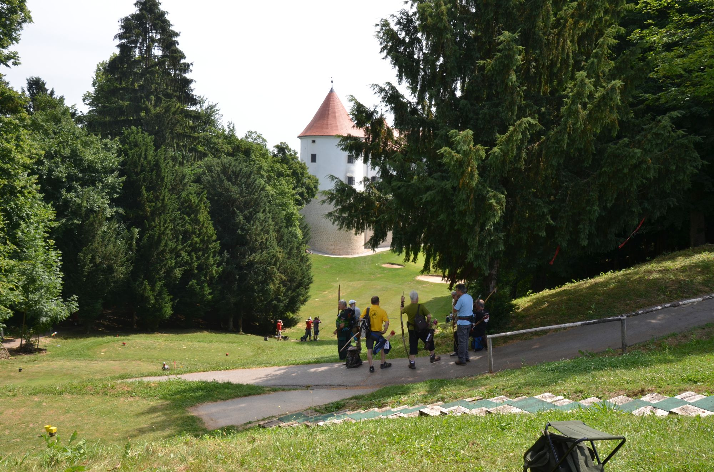
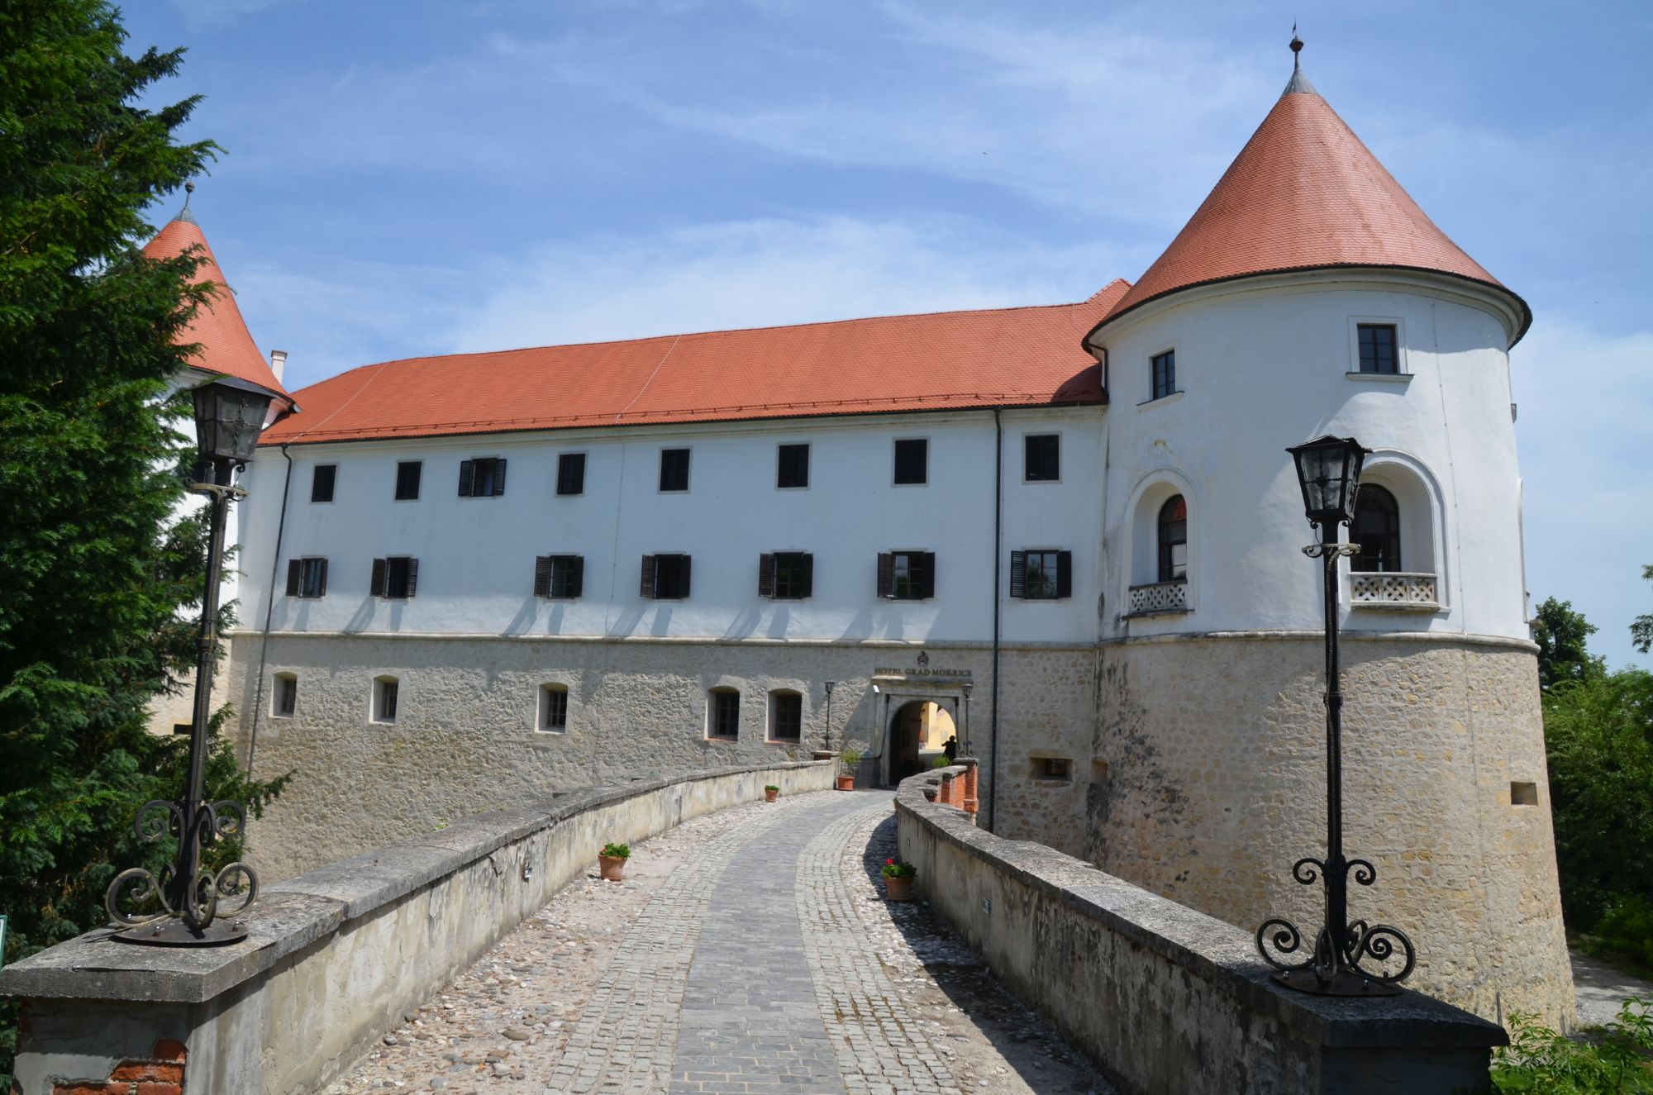

Weather
The average temperature in Mokrice - Catez in September is 27°C. The minimum average temperature in September is 22°C.

.............................................................................................................................................................................

Accreditation and Team Managers Meeting
Accreditation will take place upon arrival of teams in the lobby of the Terme Hotel 28 and 29 September 2016. Accreditation office will be opened on Sunday, 28 August, from 16:00 - 21:00
and on Monday 29 August, from 08:00 - 21:00.

For all Ceremonies WA dress code is obligatory.
More details will be provided at the Team Manager’s Meeting.
Team Managers Meeting will be held in the conference room of the Terme Hotel /the conference room/
on Tuesday, 30 August 2016, starting at 15:00.

Training and Competition Field
For European 3D Archery Championships the golf course at the Castle Mokrice will be used. Entry to the competition areas outside the official schedule is not allowed.

The practice will be available starting from 28 August 2016 in Catez Spa.

The address of the Castle Mokrice:
Castle Mokrice, Rajec 4
8261 Jesenice na Dolenjskem
Coordinates: 45.8586 15.676
Visas
Please apply for your visa as soon as possible. If you need any additional information regarding visa, please let us know.

Application for and obtaining travel visas are completely and solely the responsibility of the participating teams. The process for obtaining a visa requires each individual to submit an application through a Slovenian Embassy or Slovenia Consulate. This is a process that MUST be done by the applicant – the Organizing Committee cannot do it for you. It cannot be emphasized enough to start the application process early. Please note that the application and interview process in your country may very well be in advance of the team selection date, so in many cases, you will need to start the application process prior to confirming your final team.
Visa Invitation Letter – All countries that will need letter of invitation by the Organizing Committee or local authorities to use it in their application process are requested to order these in time. Please fill out the Visa Invitation Letter Form as soon as possible and send it in.

As long as the Organizing Committee gets no different information, the Invitation Letter will be sent by email. If an express service should be desired, this service will be charged to the MA and must be paid to the Organizing Committee upon arrival.

Those teams that want to land in Zagreb airport must be aware that they might need visa for Croatia.
In this case we might not be able to help you.

Please note: the deadline for Visa Invitation Letter Form is 1 July 2016.

.............................................................................................................................................................................

Banquet
On the final day - Saturday, 3 September 2016, the gala dinner will be served in the restaurant of the Terme
Hotel instead of the normal dinner in the hotel. After the dinner, music and dancing will take place from 20:30 till 24:00. The extra cost for participants at this party is 15 € per person /drinks included/.
For participants who will not book the party, the normal dinner will be served in the hotel Toplice.

Internet
Free of charge in all locations of Spa Catez.
Website
The official website of the competition is http://www.3d-mokrice2016.si
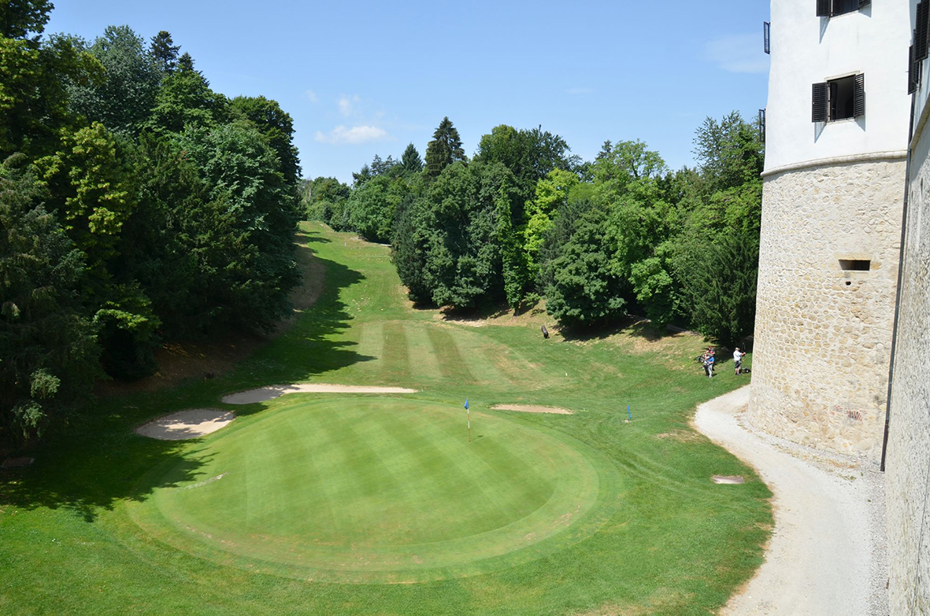

.............................................................................................................................................................................

PRELIMINARY HOTEL RESERVATION FORM

Member Association: ____________________________________________
Contact person: ________________________________________________
Mobile: _______________________________________________________
E-mail: _______________________________________________________

Number of Rooms:
Terme/Toplice Hotel:

Single € 120
Double: € 85

Do you require a room for a disabled team member? Yes No

If yes, please specify: ______________________________________________

Do any of your team members have dietary requirements or allergies such as, vegetarian,
nut allergies or gluten free etc. Yes No

If yes, please specify: ______________________________________________

Accommodation Payment:

ROOM TYPE AMOUNT OF ROOMS NIGHT RATE P/N TOTAL RATE

___________ _____________________ _________________ _____________

Single ______________________x ___________ x = _______________

Double/Twin _____________________ x ___________ x = _______________

TOTAL ACCOMMODATION AMOUNT _____________________________

DEPOSIT 60% OF TOTAL AMOUNT ______________________________

Please pay the deposit before 1 June 2016.

Date: ______________________ Signature of President / Secretary General: ______________________

PLEASE RETURN THIS PRELIMINARY HOTEL RESERVTION FORM TO THE ORGANIZER BEFORE
1 June 2016 by e-mail to oc-mokrice@archery-si.org.
.............................................................................................................................................................................

ACCOMMODATION TABLE - ROOMING LIST

For the accreditation process to be as smooth as possible we prepared accommodation table.
We need the following data: type of the room, type of the bed and names of persons.
PLEASE RETURN TILL TUESDAY, 16 AUGUST 2016

Room | Single/Double | King/Twin  Bed | Person 1  /Name/ | Person 2  /Name/
1
2
3
4
5
6
7
8
9
10
11
12
13
14
15

Note:
In case you specified double room please specify type of bed:
- King – double room with one big bed
- Twin – double room with two separate beds
The booking of rooms will be done according to the rule "first come – first get".
Furthermore we would like to remind you about some important information:
Accreditation office will be opened on Sunday, 28 August, from 16:00 - 21:00
and on Monday, 29 August, from 08:00 - 21:00 in Terme Hotel.
Team Managers meeting is scheduled for Tuesday, 30 August, at 15:00,
in the Terme Hotel /the conference room/.
Date: ______________________ Signature of President / Secretary General: ______________________
PLEASE RETURN THIS ACCOMODATION TABLE TO THE ORGANIZER BEFORE
16 August 2016 by e-mail to oc-mokrice@archery-si.org.
.............................................................................................................................................................................

TRANSPORTATION FORM

Country/Team from: __________________________

Number of passengers: ________ person/s

Arrival information

We will arrive by plane:

Airport: __________________ Flight Nr: _____________

Date: ______________ Arrival Time: ___________

We will arrive to MOKRICE - CATEZ by: _____________________________________

____________________________________________________________

Departure information

We will depart by plane:

Airport: __________________ Flight Nr: _____________

Date: ______________ Departure Time: ___________

We will depart from MOKRICE - CATEZ by: _______________________________________

____________________________________________________________

Date: _________

Signature of President / Secretary General: ______________________________

PLEASE RETURN THIS TRANSPORTATION FORM TO THE ORGANIZER BEFORE
10 August 2016 by email to oc-mokrice@archery-si.org.

.............................................................................................................................................................................
VISA INVITATION LETTER FORM

Country/Team from: ___________________________________

Contact person: _______________________________________

No | First name | Family name | Date and place of birth | Citizenship /Country/
No | Address of residence |  |  | Passport
No |  |  |  | Number | Expiration
1
2
3
4
5
6
7
8
9
10
11
12
13
14

Date: ______________________ Signature of President / Secretary General: ______________________

PLEASE RETURN THIS VISA INVITATION LETTER FORM TO THE ORGANIZER AS SOON AS POSSIBLE.
Latest by 1 July 2016 by email to oc-mokrice@archery-si.org.

.............................................................................................................................................................................

FINAL BUDGET FORM

Member Association: ____________________________________________
Contact person: ________________________________________________
Mobile: _______________________________________________________
E-mail: _______________________________________________________

1) Entry Fees
Position Cost Number of persons/teams Total
Athlete € 150 x ___ € ____
Official € 50 x ___ € ____
Team € 75 x ___ € ____

Total 1 ................................................................................. € ____

2) Accommodation
HOTEL TERME/TOPLICE - Full Board
Room Cost Nr of Persons Nr of nights Total
Terme/Toplice - Single room € 120 x ___ x __ € ____
Terme/Toplice - Double room € 85 x ___ x __ € ____

Total 2 .................................................................................. € ____

3) Transportation + PARTY
Airport Cost Number of Persons Total
LJUBLJANA € 80 x ______ € ____
ZAGREB € 45 x ______ € ____
PARTY € 15 x ______ € ____

Total 3 .................................................................................. € ____

Date, ___________ TOTAL /1+2+3/ € ____

Signature of President / Secretary General: _____________________________
PLEASE RETURN THIS BUDGET FORM TO THE ORGANIZER BEFORE
10 August 2016 by e-mail to oc-mokrice@archery-si.org.
.............................................................................................................................................................................

PAYMENT INSTRUCTIONS

BANK: NOVA LJUBLJANSKA BANKA d.d.
Address: Trg republike 2
1000 Ljubljana
Slovenia
A/C NAME LOKOSTRELSKA ZVEZA SLOVENIJE
Address: Dolenjska cesta 11
1000 Ljubljana
Slovenia

SWIFT CODE /BIC/: LJBASI2X
IBAN: SI56 0201 3001 7204 321

NOTE:
ALL PAYMENTS ARE REQUIRED TO BE DONE IN EUROS BY BANK TRANSFER LATEST 10 AUGUST 2016!
ALL BANK TRANSFER FEES HAVE TO BE PAID BY PARTICIPATING MAs, you need to state OUR option when paying.
IN CASE OF NOT PAYING THE BANK TRANSFER FEES, YOU WILL BE CHARGED FOR THE DIFFERENCE UPON ARRIVAL, AT THE ACCREDITATION.

- NO CREDIT CARDS
- NO TRAVEL CHECKS

IN CASE YOU WILL BRING CASH, YOU WILL BE CHARGED FOR EXTRA BANK COSTS FOR DEPOSIT,
1% OF THE DEPOSIT.

PLEASE SEND THE COPY OF THE BANK TRANSFER TO THE ORGANIZER by email to
oc-mokrice@archery-si.org

OC contacts

For all matters
Ms. Irena Rosa - 24 hours English
Mobile +386 (0)31 633 851
E-mail: oc-mokrice@archery-si.org

For questions about accommodation and visa support
Mr. Tomaz Urlep - 24 hours English
Mobile +386 (0)41 650 015
E-mail: oc-mokrice@archery-si.org

……………………………………………………………………………………………………………………………………………………………………….

