INVITATION

Dear Member Associates,
Dear Friend Archers,
On behalf of the Organizing Committee of the ROMANIAN ARCHERY FEDERATION I would like to kindly invite you to take part in the 10th European Club Teams Cup 2017 which is to be held on September 15th – 17th 2017 in Iasi – Romania.
The competition is reserved only to the recurve division.

Participation is open to female and male club teams. Rules of the WAE European Club Teams Cup apply.

Please find enclosed registration forms and further information on the European Club Teams Cup 2017.
Please find enclosed the necessary documents concerning the registration, organization and participation to this event.

We kindly ask you to reply within the stated deadlines:

Preliminary Entries | 05 /08/2017
Final Entries | 31/08/2017
Hotel Reservation Form | 15/08/2017
Transportation Form | 15/08/2017
Budget Form | 15/08/2017
Visa Invitation Letter Form | 05/08/2017

You will certainly be able to sense the ROMANIAN hospitality.
We also hope that you and your team will enjoy their stay in Iasi.
We are looking forward to seeing you in Iasi.

Sincerely yours,
Mugurel Virgil Ciusca
President
ROMANIAN Archery Federation

PRELIMINARY PROGRAM

Friday, 15th of September, 2017
14:00 Arrival of teams
15:00-19:00 Official practice
18:00-19:00 Team Captains Meeting
20:00-22:00 Teams presentation, banquet, a few hours together, music,
chatter and friendship

Saturday, 16th of September, 2017
09:45 Opening ceremony
10:00 Warm up-Men & Women
10:00 2×36 arrows (A-B-C)
12:00 Lunch break
14:00 1st ranking matches Club teams W&M
14:00 2^{ndd} ranking matches Club teams W&M
15:00 3rdd ranking matches Club teams W&M
Free evening

Sunday, 17th of September, 2017
08:00 Warm - up
09:00 1st ranking group matches Club teams W&M
09:00 2nd ranking group matches Club teams W&M
10:00 Break (30 minutes)
10:30 Bronze medal match Women
11:00 Bronze medal match Men
11:30 Gold medal match Women
12:00 Gold medal match Men
12:30 Awards Ceremony

NOTE:
This preliminary program could change slightly according to the number of participants and TV requirements. All changes to the program will be published and informed to all participants in good time.

GENERAL INFORMATION& ACCOMMODATION

In any case, before being allowed to participate to the European Club Teams Cup, the Member Association must confirm that the club teams-athletes are members of the participating Clubs since the 1st of January 2017.

Maximum number of club teams per country 5 men club teams and 5 women club teams.
Countries with the winning teams in the previous year are allowed to participate with 6 club teams.

Each Club Team is composed of 3 archers.
Mixed teams are not accepted.
Maximum number of teams by Club: 1 per gender.

For Participants who will decide to book their accommodation in other hotels (non-official hotels) the ROMANIAN Archery federation is not responsible for providing transportation from these hotels to the venue (transportation for these persons will only be provided from the official hotels).
In addition, no information will be distributed to the non-official hotels.

The Official Hotel is “MOLDOVA” @ City Center, Iasi. The hotel is offered on a “Full board” base.
Reservation should be made before 15th of August 2017.

Hotel | Category | Single room | Double room
Hotel “MOLDOVA”  @ City Center, Iasi | 3*** | 80.00 € | 65.00€

Hotel’s prices include: bed, breakfast, lunch, dinner on the spot.
The rates are in Euro (€) per person and per day.

A free Wi-Fi place is provided to each hotel guest.

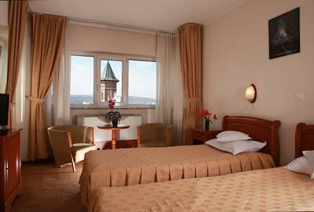 | 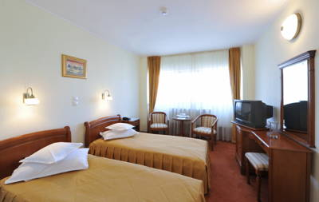
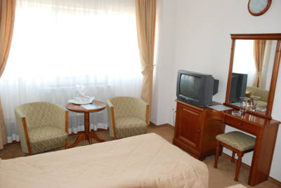 | 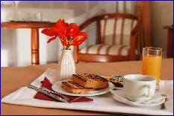

Team Entry fees: 200€ / Team
*The Entry fee includes the Party.

Transportation:
Iasi Airport
Iasi Central Railway Station
Iasi Central Bus Station
From Iasi airport, bus or railway station to the hotels – (arrival and departure): 20€/person
* Field, hotel and buses will be available for disable persons.

Water:
Water will be available on the fields free of charge.

Visa:
For all nations that will need visa permits, please make sure to apply for such as early as possible in your country of origin before leaving. If our help is needed you may contact us immediately: ctc2017@frta.ro, for we could send an official invitation over to the ROMANIAN Embassy for further cooperation.

Pre-payments:
Hotel booking will only be regarded valid as soon as a 50 % down payment has been received by the Organizing Committee, before 1st of September’2017.
The balance of full payments is to be made, before 1st of September 2017.

To contact us:
Email: ctc2017@frta.ro
timico_frai@yahoo.com
csm_iasi@yahoo.com

Mobile phone: +40 73 1339 073 Constantin Frai,
The LOC Administrator for all type of inquiries

+ 40 745 340 526 Ion Pandele, The Secretary General

+40 722 473 051 Mrs. Adriana Hoppe (for payments)

+40 73 2737 825 Ghenadie Iepuri, International Communication

Web address: www.frta.ro
Preliminary Entry Form

Deadline : 15th of August 2017

Member association: …………………………………………...

Club name: ………………………………………………………….

Contact name: ……………………………………………………..

Tel: ………………………….Mobile: ……………………………...

Email: ………………………………………………………………….

Men team
Club name: ………………………………………………………….

Tel: ………………………….Mobile: ……………………………...

Email: ………………………………………………………………….

Number of athletes + official(s): ……………………………

Women team
Club name: ………………………………………………………….

Tel: ………………………….Mobile:………………………………

Email: …………………………………………………………………

Number of athletes + official(s): ……………………………

I hereby declare that our Member Association is in good standing and that for all competitors and officials are covered in case of illness or accident and have signed the WA Anti-Doping Agreement.

Date : / /2017 Signature President or Secretary General:

TRANSPORTATION FORM
Return at the latest: 15th of August’2017

Team: ________________________ Email: ____ _________________________
Team Manager: _______________________ Phone:_______________________________

Total number of Persons: |  | X 20 € = | Total (B): €
ARRIVAL
Plane:
Iasi Airport Flight No _________ From: _ ________
Date: ______________ Time: _____________________
Train: Train No: _________ Arriving from: ____________
Date: ______________ Time: _____________________
Car/Bus: Date: ______________ Time: _____________________
DEPARTURE
Plane:
Iasi Airport Flight No _________
Date: ______________ Time: _____________________
Train: Train No: _________
Date: ______________ Time: _____________________
Car/Bus: Date: ______________ Time: _____________________

If you are not arriving or departing in one group, please specify in the tables below.
Arrivals:
No. of persons | Flight No. /From | Date | Time
Departures:
No. of persons | Flight No. | Date | Time

Please check this box if you need facilities for persons with disabilities.

Date: _______________ President/Secretary General:___________________________

HOTEL RESERVATION FORM
Return at the latest: 15th of August 2017

Team: ________________________ Email: ______________________________

Contact person: _______________________ Phone/Fax:__________________________________

ACCOMMODATION

3*** Hotel  MOLDOVA  @ City Center, Iasi | Number of Rooms | Number of Persons | Number of Nights | Cost price | Total Cost
Single Room |  |  |  | 80 € | €
Double Room |  |  |  | 65 € | €
 |  |  |  | Total (C) | €

The rates are in Euro (€) per person, per day, full board.

Please check this box if you need facilities for persons with disabilities.

We require that 50 % of the payment should be done before 15th of August 2017.

Payment must be sent to the following bank account:

BANK: Banca Comerciala Romana.
Address: Lipscani Street no. 18-20, Sector 3
Bucharest
Romania
A/C NAME Romanian Archery Federation
Fiscal code: 4204135
Address: Vasile Conta Street, no. 16, Sector 2
Bucharest
Romania
SWIFT CODE: RNCBROBU
IBAN: RO46 RNCB 0090 0005 0853 0017

NOTE:
All payments are required to be done in EURO:
- By BANK TRANSFER: 50% of total payment, before 01 September’2017
- By BANK TRANSFER: The rest of total payment (50%), before 15 September’2017
Bank transfer fees are the responsibility of the sender.
NO CREDIT CARDS, NO TRAVELLERS CHEQUES, NO FOREIGN CURRENCIES

Date: _______________ President/Secretary General:___________________________
BUDGET FORM
Return at the latest: 15th August 2017

Country/Team:________________________ Email: ______________________________

Contact person: _______________________ Phone/Fax:__________________________________

 | Number | Cost | Total
Team Entry fee |  | 200 € | €
Total entry fees ( A ) |  |  | €
Transportation Total ( B ) |  | 20 € | €
Total Accommodation ( C ) |  |  | €
Grand Total ( A+B+C ) |  |  | €
Deposit 50% before 15th of August 2017 |  |  | €
Balance of full payments due on 1st of September 2017 |  |  | €

Payment must be sent to the following bank account:

BANK: Banca Comerciala Romana.
Address: Lipscani Street no. 18-20, Sector 3
Bucharest, Romania
A/C NAME Romanian Archery Federation
Fiscal code: 4204135
Address: Vasile Conta Street, no. 16, Sector 2
Bucharest, Romania
SWIFT CODE: RNCBROBU
IBAN: RO46 RNCB 0090 0005 0853 0017

NOTE:
All payments are required to be done in EURO:
- By BANK TRANSFER: 50% of total payment before 15th of August 2017
- By BANK TRANSFER: The rest of total payment (50%), before 1st of September 2017

Bank transfer fees are the responsibility of the sender.
NO CREDIT CARDS, NO TRAVELLERS CHEQUES, NO FOREIGN CURRENCIES

Date: _______________ President/SecretaryGeneral:___________________________

VISA INVITATION LETTER FORM
Return at the latest: 19 August’2017

Country/Team:________________________ Email: ______________________________

Contact person: __________________________ Phone/Fax:__________________________________

№ | Family Name | Given Name | Date of Birth  DD/MM/YY | Passport Number | Date of issue  DD/MM/YY | Validity  DD/MM/YY | Indicate Athlete, Coach or Official
1
2
3
4
5
6
7
8
9
10

Date: _______________ President/SecretaryGeneral:___________________________

FINAL ENTRY FORM

DEAD LINE: 31st of August 2017

Email: ………………………………………………………………..

NAME OF MEMBER ASSOCIATION:…………………………………………...

Name of the Club: ……………………………………………….

Men team (surname/given name)

1:…………………………………………………………………………

2:………………………………………………………………………….

3:………………………………………………………….………………

Officials:……………………………………………………………….

Women team (surname/given name)

1:…………………………………………………………………………

2:………………………………………………………………………….

3:………………………………………………………….………………

Officials:……………………………………………………………….

I hereby declare that our Member Association is in good standing and that for all competitors and officials are covered in case of illness or accident and have signed the WA Anti-Doping Agreement.

Date : / /2017 Signature President or Secretary General:……………………………..

Official Hotel is “MOLDOVA” @ City Center, Iasi

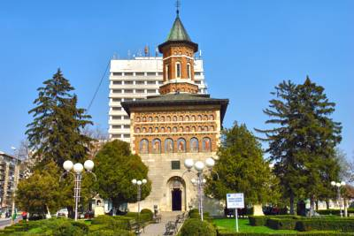 | 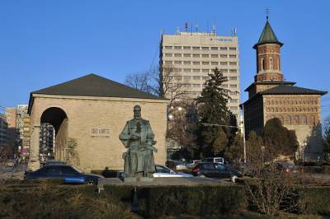
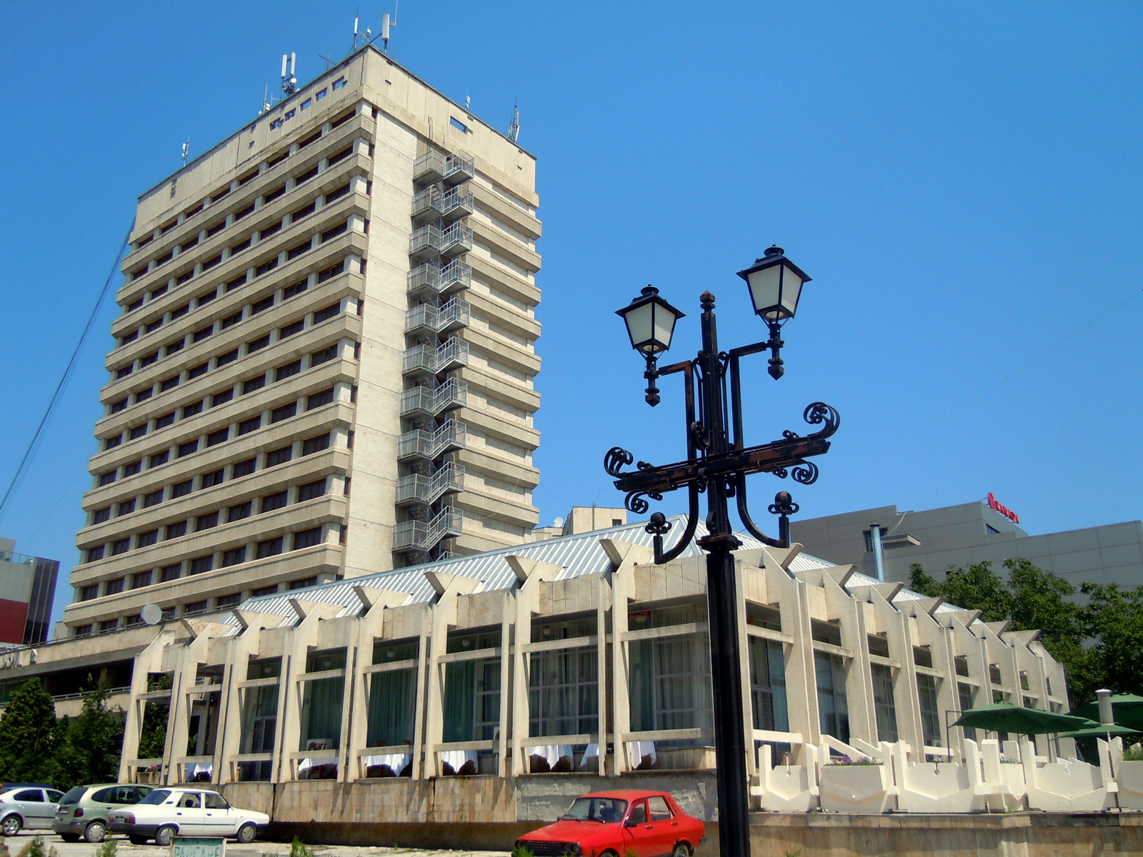 | 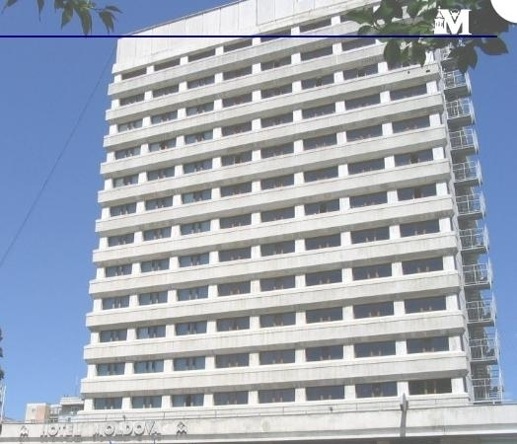
The Premises comprise a 3*** stars Hotel, a 1st Class Restaurant.
All rooms feature air conditioning, cable TV and a minibar.
The bathrooms comprise showers or bathtubs as well as hairdryers.

