INVITATION
Dear President,
On behalf of the Organizing Committee of the HELLENIC ARCHERY FEDERATION, I would like to invite and welcome your Association to participate to the EUROPEAN YOUTH CHAMPIONSHIPS 2018, which will be held in Patras/Greece, on June26th- July 1st 2018.
This event is the quota tournament for Europe for the Youth Olympics 2018.
The European Youth Championships 2018 will be organized following the WORLD ARCHERY rules and WAE Championships rules, in both divisions: Recurve and Compound, for Junior Women, Junior Men, Cadet Women and Cadet Men classes, in the discipline of Outdoor Target Archery.
Participating to this very important event, you will meet the Greek hospitality and we hope you and your delegation will also enjoy staying in the beautiful, historical and touristic place of Patras city.
Please find enclosed the necessary documents concerning the organization, registration and participation to this event.
Please complete all the necessary details in WAREOS before the following deadlines:
PreliminaryEntries 30 March 2018
PreliminaryHotelReservation 30 March 2018
VisaSupport Form 30 March 2018
Transportation 10May 2018
FinalHotelReservation 10May 2018
FinalEntries 06 June 2018

We are looking forward to welcoming you in Patras!

Sincerely yours,
Dr. PetrosSynadinos
President
Hellenic Archery Federation
PRELIMINARY PROGRAM
Sunday  24 June | Arrival of participants.  (Practice Field openand local transport available)
Monday  25 June | Arrival of participants.  (Practice Field open and local transport available)
Day 1  Tuesday  26 June | Official practice, Equipment Inspection  Team Managers’ Meeting  Opening Ceremony
Day 2  Wednesday  27 June | Qualification Round CADETS, Recurve 60m and Compound 50m  Qualification Round JUNIORS,Recurve 70m and Compound 50m  (Practice Field open)
Day 3  Thursday  28 June | Mixed Teams Elimination Rounds up to Semi Finals  Mixed Teams Bronze Medal Matches  (Practice Field open)
Day 4  Friday  29 June | Individual Elimination Rounds up to Semi Finals  (Practice Field open)
Day 5  Saturday  30 June | 2018 Youth Olympic Games Qualifier Tournament  Teams Elimination up to Semi Finals  (Practice Field open)
Day 6  Sunday  01 July | Mixed Teams Gold Medal Matches (alternate shooting)  Team and Individual Bronze & Gold Medal Matches (alternate shooting)  Award Ceremony  Closing Party
Monday  02 July | Departures
NOTE:
This preliminary program could change slightly according to the number of participants and TV requirements.All changes will be published and informed to all participants in good time.
Website: www.eych2018-patras.gr
PRELIMINARY and FINAL REGISTRATION
All entries, accommodation reservations, transport needs, flight arrival/departure information and visa invitation letter requests are to be completed using WAREOS.
The World Archery Online Registration System (WAREOS): http://register.worldarchery.orghas been updated to handle the entire registration process for this event. No Entry, Hotel reservations or Transportation Forms will be accepted as all information must be entered into WAREOS.
In order to use WAREOS, please login on http://register.worldarchery.orgwith your Username and Password assigned by World Archery. After entering WAREOS, please find the event “EUROPEAN YOUTH CHAMPIONSIPS 2018”, in order to register your athletes. Select/press the “Entries” button to see the list of categories in the event. Select/press the “category” to enter the athlete and official numbers/details participating for that event. A "WAREOS User Manual" can be downloaded in PDF format (English) using the same website link.
Pay attention: The date of birth of the registered athletes is mandatory.
For any questions regarding the WAREOS, please contact the World Archery office, Mr. JK LEE (jklee@archery.org).
A maximum number of 3 athletes per country is allowed to be registered into each category per division of the event.
Preliminary and final entries should be completed using WAREOS.

Starting date of online-registration with WAREOS is: | 22 February 2018
End of Preliminary registration with WAREOS is: | 30 March 2018
Please respect the stated deadlines.Entries received after the deadlines are subject to penalties.
Member Associations should only use WAREOS to make any changes/amendments to their entries and will be able to do so at any time. Any changes made in WAREOS, an email will instantly be automatically sent to the Organizing Committee and Member Association with the updated information.
However, for any changes made after the deadlines specified or if entries differ by more than 4 athletes from the preliminary entries, the following penalty fees will automatically be applied.
Final registrations that differ from the preliminary entries by more than 4 athletes/officials will result in a penalty fee of 140,00€ per entry to be paid in cash to the LOC upon arrival at the venue.

Failure to have made preliminary entries before the deadline date but then submitting final entries will result in a penalty fee of 140,00 € per entry to be paid in cash to the LOC upon arrival at the venue.

Penalty fees to be paid to Organizing Committee: | Cost (EUR):
If final entries differ from the preliminary entries by more than 4 athletes/officials | 140 per entry
If no entries before preliminary entries deadline, but then submitting final entries | 140 per entry

Any entries received less than 3 days before the team managers meeting for the European Youth Championships will be refused if no preliminary entry and/or final entry are made prior.

A Member Association that has made final entries in WAREOS and does not participate will be invoiced for the number of entries entered in the system, according to Cancellation and Changes conditions as described below.

Only Member Associations in good standing will be eligible to compete. This also means that World Archery fee 2018 and any penalty fee must have been paid before being eligible to enter and compete.

For European YouthChampionships, no title and no medals will be assigned if less than 4 individuals and 4 teams are registered in the preliminary entries. Anyhow, to assign title and medals, there must be at least 2 teams participating, but with 4 registrations in the preliminary entries.
If in WAREOS there will be less than 4 individuals and 4 teams, the individuals or teams will be ranked according to the Qualification Round and the Organizer will award them with own medals.

Since entries are through WAREOS only, Member Associations declare that their athletes and officials are aware of the participation waiver and anti-doping agreement. We recommend Member Associations to advise their athletes on this matter. However, accepting the conditions of athlete participation waiver and the anti-doping agreement are an eligibility requirement to participate in the event.

ACCOMMODATION AND GENERAL INFORMATION
The official hotels are Porto Rio Hotel(4*) and Astir Patras Hotel (4*).
Hotel allocation will be made on a “first come, first serve basis”.
Accommodation rates are on a “Fully Board” basis including breakfast, lunch and dinner.If official hotels will change, the modification will be reported in WAREOS.
Room rates specified are in Euro, per person and per night, which include service charge, and VAT.
Free Wi-Fi will be available at the hotels reception area and hotels rooms.
- Hotel Reservations should be made before: 30 March 2018
- Final Hotel Reservation & Transportation before: 10 May 2018
To confirm hotel reservations, 50% of the total amount deposit is to be paid by bank transfer to the OC before 30 March 2018. Reservations after this date will be considered only according to availability and the hotel and room rate may change.
Full payments are to be made, before: 10 May 2018
An invoice will be provided via WAREOS.

Room prices in Euro (€),
per person, per night
Full Board
HOTEL | Category | Single | Double | Triple
PORTO RIO HOTEL  http://www.portoriohotel.gr/en/ | 4* | 120 | 95 | ___
ASTIR PATRAS HOTEL  http://www.hotelastirpatras.gr/patras-hotel/index.html | 4* | 110 | 85 | 75

For receiving the best check in service upon your team arrival at the hotel, please fill in theRooming list in WAREOS, no later than 10 May 2018.

Please inform the LOC (info@eych2018-patras.gr) if you need facilities for persons with disabilities.

PORTO RIO HOTEL (Rio beach, Rio 26500-Greece)
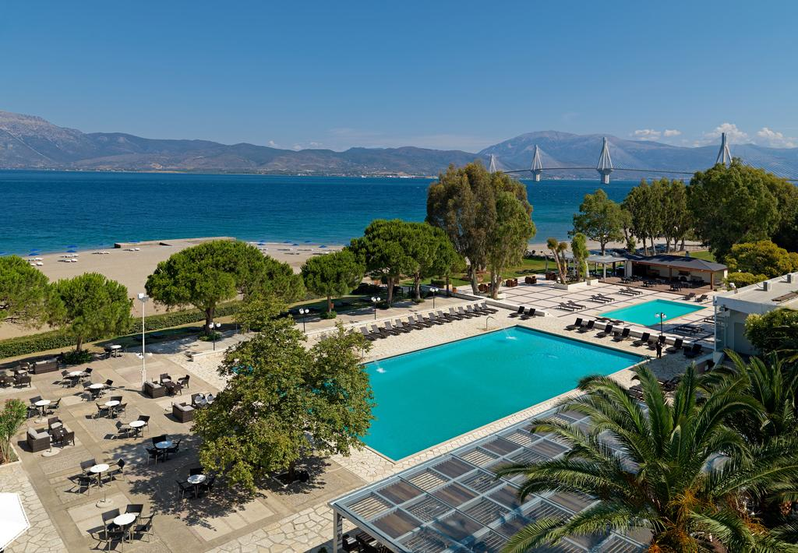

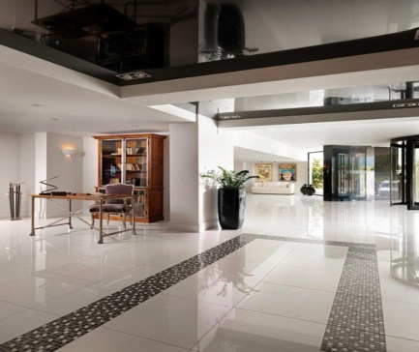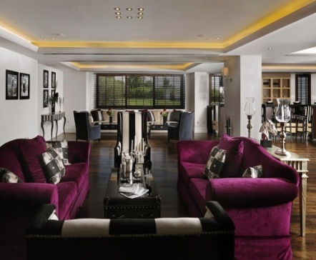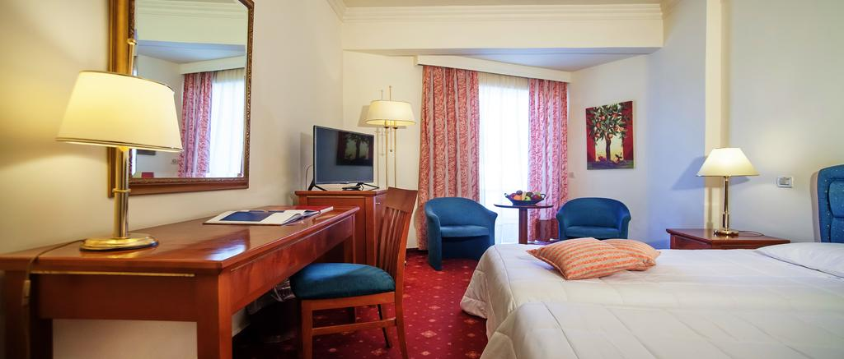

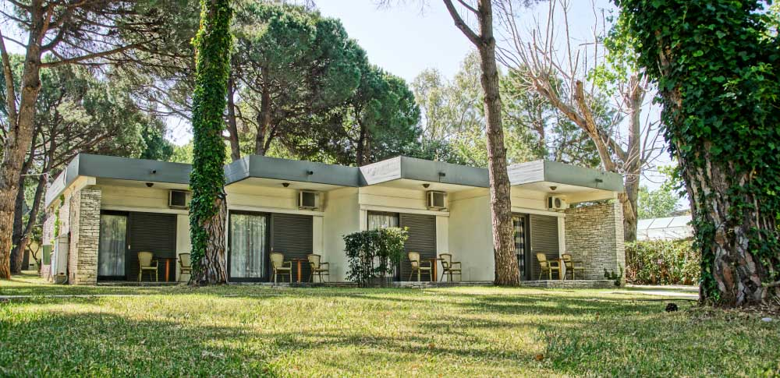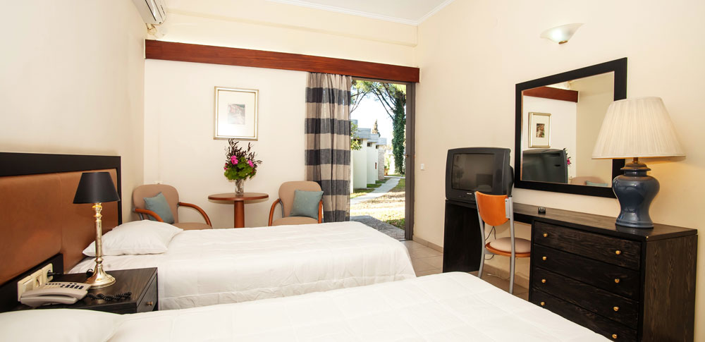

ASTIR PATRAS HOTEL (AgiouAndreou 16 str., Patras 26221-Greece)
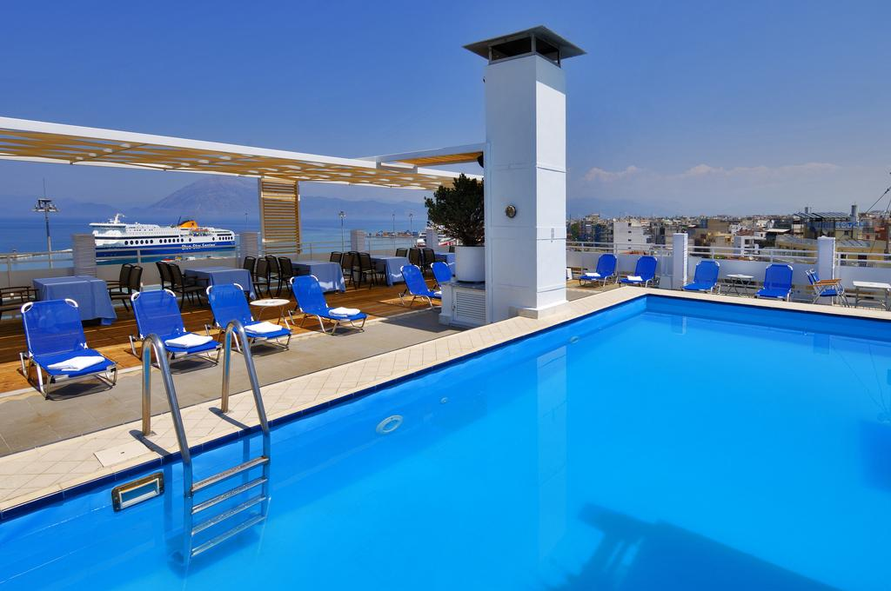
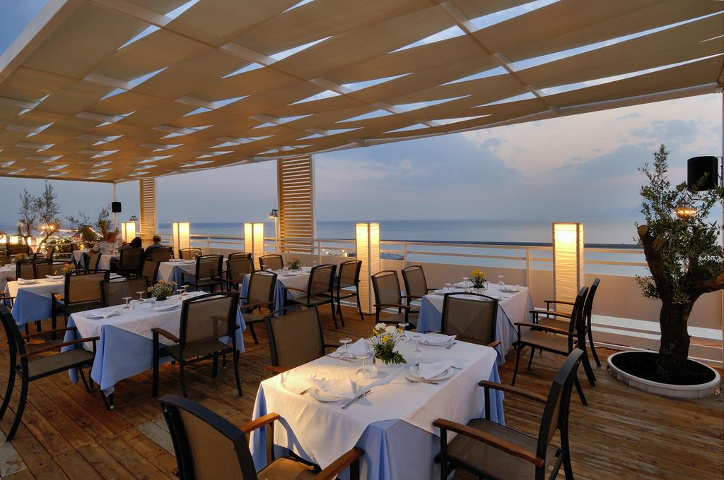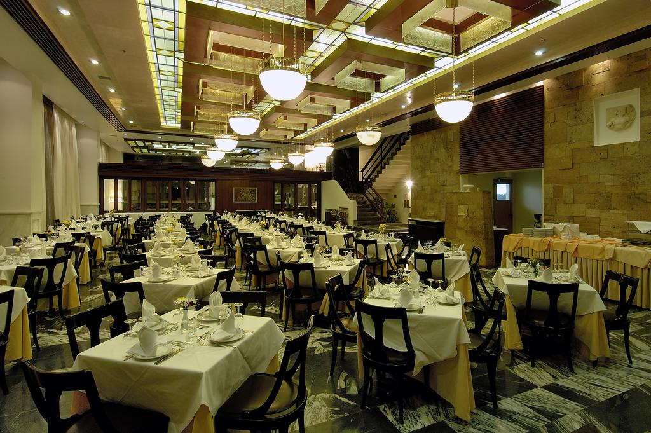
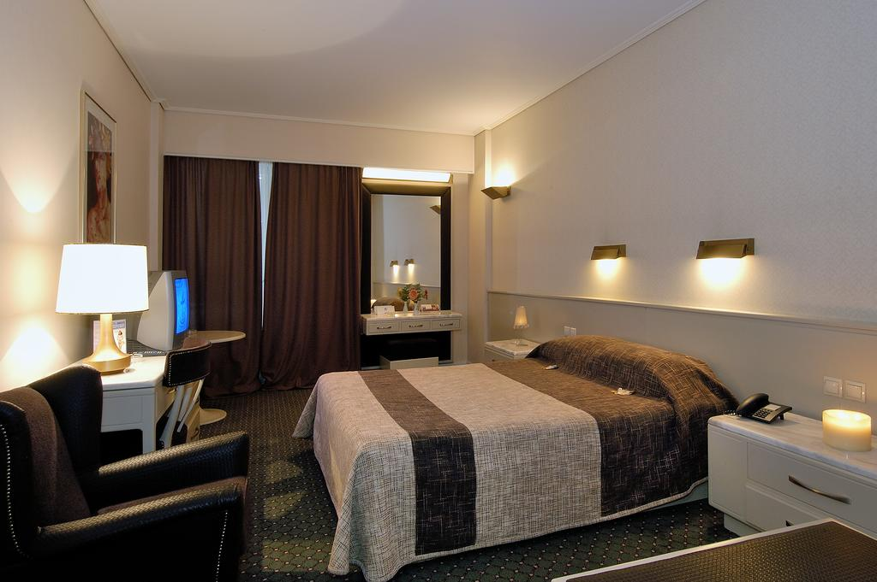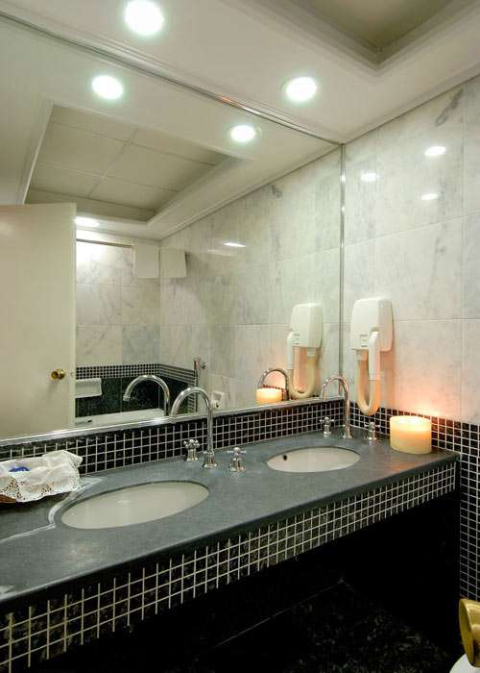
Important Note:
Please refer to the accommodation pages for detailed hotel information. Please complete all necessary sections in WAREOS and make full payment for entries and accommodation by the specified deadlines. Bank transfers only, no credit cards or travel checks will be accepted.

ENTRY FEE:
Individual:  Teams: | 150 Euro per athlete  75 Euro per team
Officials: | 50Europer person

Non-official hotels
Participants who book their accommodation in non-official hotels will have to pay double entry fee, and the LOC is not responsible to provide any transportation or meals from NON-Official Hotels. In addition, no information will be distributed to the nonofficial hotels. Furthermore, they have to register at accreditation no later than the day before the official practice. If they do not register the day before, no changes will be made to the entry list and it is likely that they will not be allowed to compete.
The Entry fee includes the daily local transportation from/to official hotels - venues and Closing Partyonly for participants accommodated at the official hotels. No local transportation will be provided or use of the practice field before 24 June 2018.
Teams that wish to practice before 24 June 2018 should contact the LOC in writing.
Entry fees do not include bus transportation from Athens International Airport El. Venizelos (ATH) to/from official or non-official hotels in Patras.
TRANSPORTATION FEE:
Athens International Airport El. Venizelos (ATH)
Athens International Airport to Patras is approximately 2 hours travel time.
From/to Athens Airport – Official Hotelsin Patras(Round trip): 80 Euro per person.
Transportation will be provided from Athens Airport to the official hotels, two days before the official practice day and two days after the closing day unless otherwise requested by a team to the LOC.
Local transportation will be available between official hotels, practice and competition venues. Buses and/or vans will be provided.
PAYMENT CONDITIONS
- The Entry Fee should be paid in full before 30 March 2018.
- The 50% deposit of the total amount for hotel accommodation should be paid
before 30 March 2018.
- The balance payment of Accommodation and total Transportation should be paid before 10 May 2018.
- An Invoice will be provided via WAREOS.
- All prices for payments after the stated deadlines are subject to additional charges.
Payments must be sent to the following Bank Account:
Bank account nominee:HELLENIC ARCHERY FEDERATION
Bank Name:ATTICA BANK ATE
International Banking Account Number (IBAN):GR96 0160 0690 0000 0008 4951 773
Bank Identification Code (BIC): ATTIGRAA
Bank address:O69 OMIROU 23, ATHENS 10672, GREECE
NOTE:
- ALL PAYMENTS SHOULD BE IN EURO (€), by Bank Transfer
- NO CREDIT CARDS, NO TRAVELLERS CHEQUES, NO FOREIGN CURRENCIES
- BANK TRANSFER FEES ARE THE RESPONSIBILITY OF THE SENDER
- ALL PAYMENTS MUST HAVE BEEN MADE IN FULL BEFORE ARRIVAL

Cancellations & Changes:
All cancellations and changes must be made through WAREOS:
- Received before30 March 2018,for full refund of the deposit payment
- Received before10 May 2018, for 50% refund of the deposit payment
- Received after10 May 2018, no refund
- Refunds, if any, will be processed after the end of the event
- Late arrivals or early departures than the originally scheduled, the room will be charged from the date of the original booking in WAREOS
- Name changes to team officials or athletes (same category and division) will be accepted up to 3 days before the event without any additional charge
- Should flight details change last minute, please contact the Organizing Committee
- An email will automatically notify the Organizing Committee and Member Association of any changes made in WAREOS.
ADDITIONAL INFORMATION
Continental Quota Tournament for Youth Olympic Games:
The Continental Qualifying Event for the Youth Olympic Games in Buenos Aires, Argentina will be held on Saturday, 30 June. This special competition will be held for athletes eligible to compete in the 2018 Youth Olympic Games. For the Qualifying event, athletes must have been born between 1 January 2001 and 31 December 2003. Furthermore, they must have achieved the following Minimum Qualification Standard (MQS)
BOYS 60m Round 610
GIRLS 60m Round 600
The MQS must be achieved in the qualifying period starting 1 October 2017 to 24 July 2018.
There will be no extra entry fee for this event. There will be no extra qualification round for this competition. Ranking for the purpose of pairing for the elimination round will be done according the results from the qualification round of the European Youth Championships. Athletes, who have previously won a qualification place for their NOC at the WAYC, cannot compete at the CQT. The competition format will be an Olympic Round with 1/48 Elimination Round and all athletes will shoot at 60 m.
For Europe, 3 places per gender will be allocated to the National Olympic Committees of the highest ranked athletes, with a maximum of one (1) per NOC.
List of the Qualification Places already earned by European NOCs at the World Archery Youth Championships 2017

GIRLS BOYS
France Estonia
Great Britain Germany
Moldova Italy
Netherlands Russia
Russia Turkey
Spain Ukraine
Ukraine

Accreditation and Team Managers Meeting
Accreditation will take place upon arrival at the OC head office.
More details will be provided at the Team Managers Meeting, on Tuesday 26 June 2018.

Ceremonies
Opening or closing ceremony as per preliminary program.
For all ceremonies dress code is obligatory.

WAE Championship medals individual and team shall be awarded to the first, second and third place. No Diploma shall be awarded for 4th placed individual and teams.

Dress Regulations
World Archery and World Archery Europe dress regulations apply for this event.

Closing Party
The Closing Party is free of charge and will be on 01 June 2018.
For participants accommodated innonofficialhotels, the cost for Closing Party is: 20€ per person.

Meals
All meals will be served at the Hotel.
For replacing lunch with lunch-box, please inform the Hotel reception desk one day before.

Water
Bottled water will be available at the venues free of charge.

Weather
According to weather information, the average daily temperature for June is 18-30 Celsius.

Internet
Will be available in the official hotels for free in hotel rooms and in the lobby. There will also be available for access to results.

Visa
All participants needing visa permits to Greece, will be required to complete the Visa Support sections in WAREOS by no later than 30 March 2018, supplying a copy of their latest/valid passport.Copies of each applicant can be uploaded on WAREOS.
All passport copies and personal details entered/uploaded to WAREOS will be held securely and in the strictest of confidence and not shared with other parties.
It is the applicants’ responsibility for supplying the necessary information, ensuring all details are up to date, correct and submitted by the deadlines specified.
To Contact the Organizing Committee:

President: Dr.Petros SYNADINOS
Technical Delegate: Mr. Hakan CAKIROGLU (hakancakiraga@hotmail.com)
Language: English
Email: info@eych2018-patras.gr
Official website: www.eych2018-patras.gr
For all matters: Mrs Maria KYRILLOPOULOU (Competition Manager)
Mobile: +30 6974 47 40 17

Mrs Evelyn PAPADOPOULOU (Administration Manager)
Mobile: +30 6944 89 80 81

USEFUL TELEPHONE NUMBERS OF PATRAS
- Railwaystation: 1110
- TRAINOSE SuburbanRailway: +30.210.5272000 – 14 511
- Buses: 14 505 & +30.2610.623886/7/8
- Port of Patras: +30.2610.341002
- Port of Rio: +30.2610.991203
- Airport of Araxos: +30.26930.54000
- Bridge of Rio-Antirio: +30.26340.39010
- Athens International Airport El. Venizelos: +30.210.3530000

ABOUT PATRAS AND ACHAIA REGION
For someone visiting the entire region of Peloponnesus the region of Achaia
can be the starting point of enjoying various alternative types of tourism,
that he can discover in close distances! Some of them are:

Sports Tourism
* Kayak & Rafting at the Ladona and Erimantho rivers,http://www.ecoaction.gr
* Sailing at the Sailing Club of Patras, http://www.sailingclub.gr/
* Scuba diving at the surrounding sea area of Patras, http://www.patrasdivingcenter.gr/
* Horse back-riding, http://www.ippocamilos.gr/
* Paragliding at the Paragliding Club of Patras, https://www.facebook.com/groups/111051419019377/
* Ski & Snowboard at the Ski Centre of Helmos, http://www.kalavrita-ski.gr/
* Bird Watching, at the Kalogria lagoon, http://www.ornithologiki.gr/
* Rafting at the Evinosriver, http://www.raftinghouse.gr

Archaeological – Historic Tourism
* The Venetian Castle of Rio, http://www.kastra.eu/castlegr.php?kastro=antirio
* Το Archaeological Museum of Patras, http://www.ampatron.gr/
* The Ancient Conservatory of Patras, www.patrasinfo.com/αρχαίο-ωδείο-πάτρας/
* Ancient Olympia, http://www.odysseus.culture.gr
* The Lighthouse of Drepano, http://www.faroi.com/gr/drepano_rio_gr.htm
* Ancient Delphi, http://www.odysseus.culture.gr
* The Castle of Nafpaktos, http://www.nafpaktos.gr/discover-nafpaktia/alternative-tourism

Religious Tourism
* Monastery of Mega Spileo& Monastery of AgiaLavra, both at Kalavrita, http://www.monastiria.gr/peloponisos/nomos-axaias/iera-moni-megalou-spilaiou/
* Monastery of Resurrection,
http://www.visit-achaia.gr/el/attractions/religion-monuments

