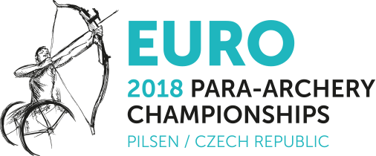

INVITATION PACKAGE

Version V1.2
7th March 2018

Dear President,

On behalf of the Organizing Committee and the Czech Archery Association, I would like to invite your National team to the European Para Archery Championships 2018, which will be held in Pilsen from 11th to 19th August 2018.

Please, find enclosed the necessary documents of the registration, organization and participation for this event. Please, complete the preliminary and final registration in WAREOS and return the completed forms to the OC within the deadlines listed below:

Start date for online registration using WAREOS: 10 March 2018
Preliminary Entries using WAREOS: 14 May 2018
Preliminary Entry Fee Form: 10 May 2018
30% Deposit Entry Fee Payment: 10 May 2018

Visa Support: 30 June 2018

Final Entries using WAREOS: 22 July 2018
Final Entry Fee Form: 11 July 2018
Remaining Entry Fee Payment: 11 July 2018
Rooms booking form: 11 July 2018
Transportation Form and Payment: 11 July 2018

E-mail athlete medical form (in English) to the classification committee 11 July 2018

Looking forward to welcoming you in Pilsen, Czech Republic.
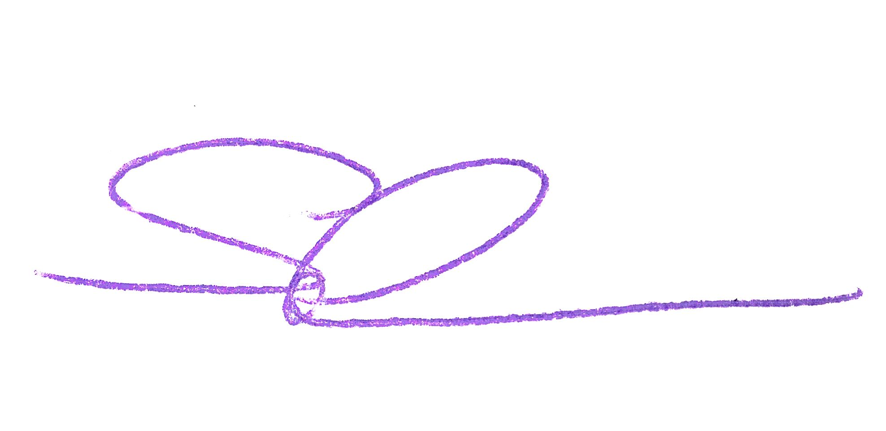
Sincerely yours,

Mr. Roman Suda
President of the Local Organizing Committee
Organizing Committee Contact Details

President of LOC Roman Suda
E -mail suda@centrumzbuch.cz
Phone number +420 724 073 469

General Secretary Hana Majarova
E-mail h.majarova@gmail.com
Phone number +420 733 565 769

Website http://www.pararchery-euro2018.eu

Events List (European Championships)

 | Individuals* |  | Teams*
 | Women | Men | Women | Men | Mixed
W1 | X | X | X | X | X
Compound Open | X | X | X | X | X
Recurve Open | X | X | X | X | X
VI 1 | combined
VI 2-3 | combined

(*) According to World Archery Europe new rules (2.4.4): “[…] no finals will be shot if less than 4 individuals and 4 teams are registered in the preliminary entries. Anyhow, to assign title and medals, there must be at least 2 teams participating.”

Classification
The classification will be held on Sunday 12th August, from 09:00 to 17:00.
It is the responsibility of the teams that archers who have to be classified arrive in time for the classification session. That means that they have to arrive by the 11th August.
Classifiers will not build the classification schedule around teams arriving on classification day.
Classification will only be held for official participants of the Championships.
For athletes who need to be classified, a medical intake form, translated in English, is mandatory. It must be emailed to the chief classifier within 11th July 2018: classification@archery.org
Should this information not be submitted by email before this date, the athlete will not be classified and therefore, will not be eligible to participate to the Championships.
For physically impaired archers classification will be held on the same location as the field of play.
Visually impaired archers classification will be held in Pilsen (Ophta clinic). Transport to this location will be organized by the Organizing Committee for free.
There will be only 1 panel of VI classifiers. In case of protest or automatic reassessment, there will not be possibility to be reassessed on place. It would be done on another event with a VI classification session.

Entries
- Registration must be done using the World Archery Online Registration System (WAREOS): http://register.worldarchery.org . No entry forms will be accepted for registering at this event.
- A maximum number of 3 athletes per country (host country included) are allowed to be registered into each category of the event
- In order to use WAREOS, please login on http://register.worldarchery.org with your Username and Password assigned by World Archery. After entering the WAREOS, please go to "Online Registration" and register your athletes for this event. A "WAREOS User Manual" can be downloaded in PDF format (English) using the same website link.
- For any questions regarding WAREOS, please contact the World Archery office, Mr JK Lee jklee@archery.org
- Preliminary and Final Entries processed after the deadline will result in a penalty fee of 140,00 € per athlete to be paid in cash to the LOC upon arrival at the field.
- Final registrations that differ by more than 4 athletes from the preliminary registration will result in a penalty fee of 140,00 € to be paid in cash to the LOC upon arrival at the field.
- Any entries received less than 3 days before the team managers meeting for a European Championships will be refused, if no preliminary entry and/or final entry have been made beforehand. This decision cannot be appealed by teams and is fully compliant with the current World Archery rules, article 3.7.1.2. Entries received after the deadlines, are subject to penalties as clearly stated in the rule book and the invitation documents of European Championships. A Member Association that has made final entries in WAREOS and does not participate will be invoiced for the number of entries entered in the system, unless they have informed World Archery Europe and the OC in writing at least one week prior to the event that they are unable to attend.
- Member Associations that have penalty fees unpaid from previous years will need to pay these penalty fees before being eligible to enter and compete. Only MAs in good standing are allowed to participate.
- Nations will be registered and accepted by the Organizing Committee afterwards having entered the entries in WAREOS and paid the 30% amount of the Entry Fee

The full package is 1 150,00 € / athlete and 1 100,00 € / official including:
- Entry Fee: 150,00 €/athlete and 100,00 €/official
- World Archery Europe Capitation Fee (30,00 € per person, archers and team officials)
- Accommodation for 9 nights with full board in twin rooms (lunch will be served at the venue)
- Meals from dinner on 11th August to breakfast on 19th August - Free water supply on the field of play.
- Local transportation
- Closing party
Extra cost for single room: + 260,00 €/person (for 9 nights)

Entry fee to be paid: 30% with the first entry, not later than 10th May 2018
Remaining fee with the final registration, not later than 11th July 2018

Accommodation
The full package includes accommodation in one of the official 4* hotels located in Pilsen:

- Courtyard Marriot
http://www.courtyardpilsen.cz
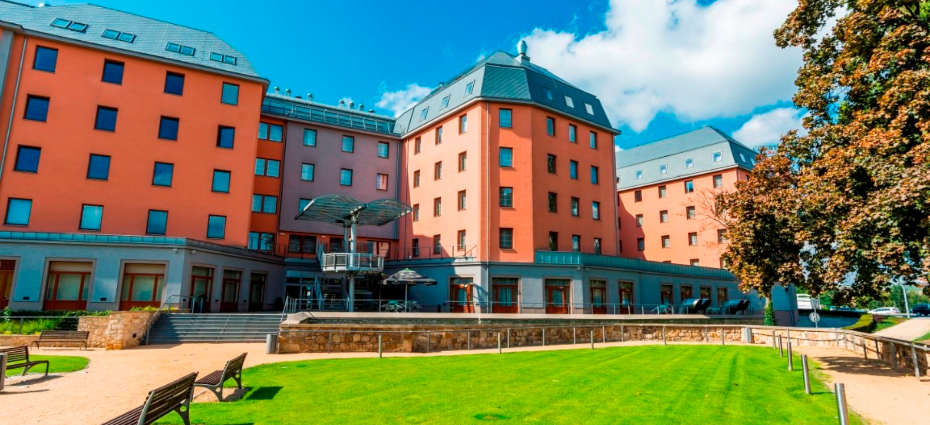

- Vienna House Angelo Pilsen
https://www.viennahouse.com/en/easy-pilsen/the-hotel/overview.html

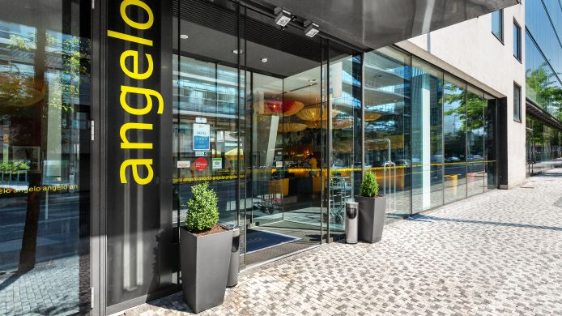

Both hotels are located in the city centre of Pilsen approx. 300 metres straight line from each other.

The Organizing Committee will provide the hotel that best meets your team`s needs. Reservations will be subject to availability and the payments received. Both hotels are in the same class. The Organizing Committee will allocate rooms according to the number of participants of each team and the requirements of accessibility.

Airport Pick Up
Welcome of the delegations will be in Pilsen.
Airport pick-up is available from Vaclav Havel International Airport in Prague at the cost of 40,00 € per person round trip.
Transportation to be paid: within the final registration deadline, not later than 11th July 2018

Rules
Technical aspects of the event, as well as classifications, are subject to World Archery rules. In particular, please also take note of the special rules written in chapter 21 of book 3.

Insurance
Competitors/officials will have to provide for their own health accident and liability insurances. The Organizing Committee will not accept any liability and assume no responsibility for loss or theft of materials or personal belongings during the entire event nor for any health/accident costs to athletes and/or officials.

Cancellation and Refund Policy
Any cancellation must be submitted to the Organizing Committee a minimum of eight (8) days before the notified arrival of the delegation. Refund will be only possible for cases of injury and illness upon production of documents. In case of cancellation of participation of the entire delegation, refund of 70% of the entry fees will be possible after the Championships. The cancellation must be properly justified.

VISA
All participants who need an entry visa are kindly requested to contact Ms. Hana Majarova h.majarova@gmail.com

Competition & Training Venue

Qualification and Training Venue
Location: SK SLOVAN PLZEŇ 1910 new sport facility – Křimická street, Pilsen (it is a new facility since Nov.2016, currently not on google maps)
GPS: 49.7474058N, 13.3390728E

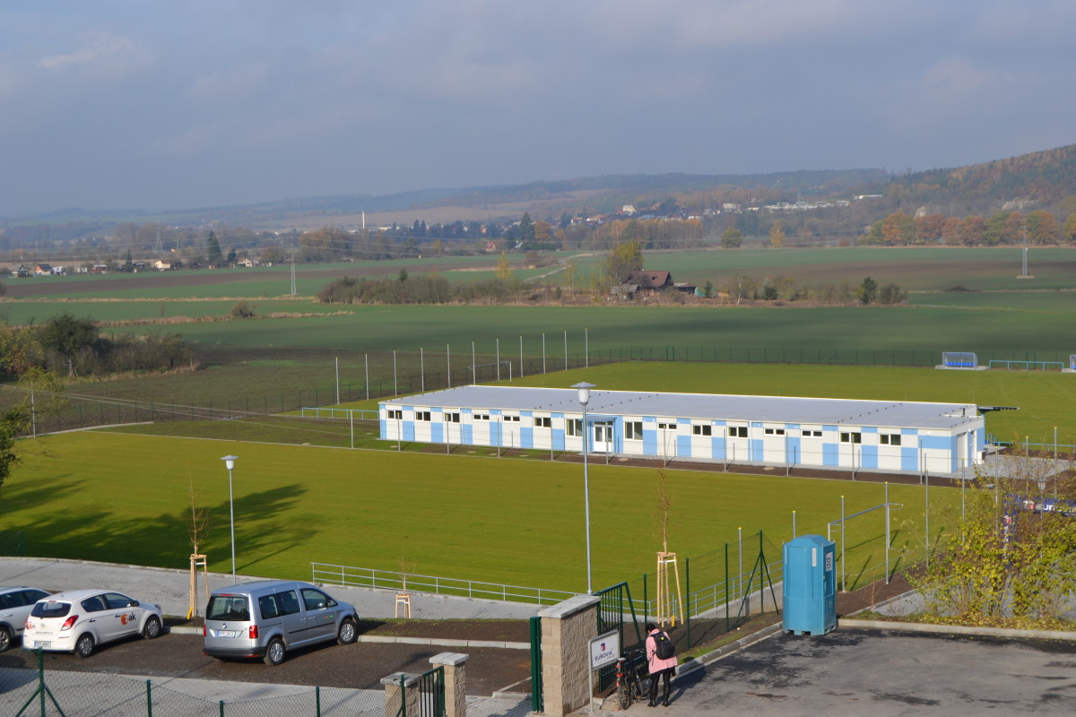

Final Venue
Location: Republic Square of the City of Pilsen http://www.pilsen.eu/tourist/visit/the-best-from-pilsen/republic-square/republic-square.aspx
GPS: 49.7473531N, 13.3767386E

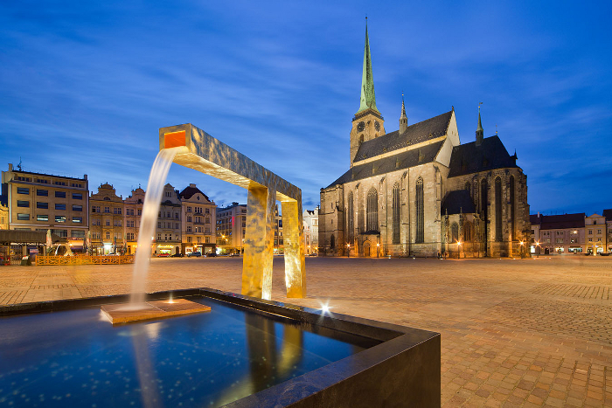
Preliminary Schedule

Sat, 11 August | Arrivals
Sun, 12 August | Free practice
 | Classification
 | Team Managers Meeting
Mon, 13 August | Official practice
 | Equipment Inspection
 | Opening Ceremony
Tue, 14 August | Qualification rounds Gr 1
 | Qualification rounds Gr 2
Wed, 15 August | Qualification rounds Gr 3
 | 1/24e European Championships
 | Elimination rounds Mixed Teams
 | Elimination rounds Teams
Thu, 16 August | Individuals elimination rounds (to semi-finals)
Fri, 17 August | Teams Medal matches
 | Medal ceremonies
Sat, 18 August | Individuals Medal matches
 | Medal ceremonies
 | Closing ceremony
 | Closing party
Sun, 19 August | Departures

Preliminary Budget Form
Completed form to be sent to the email address h.majarova@gmail.com before 10th May 2018
Country |  |  | Date (DD/MM/AA):
Contact Person
Mobile phone |  | E-mail:

Expected composition of the team (indicate the maximum persons by type of wheelchair used)



electrical wheelchair: …….. no possible transfer: ……. possible transfer: ………

 | Entry fee + WAE Fee + Accommodation full board  + local transport + closing party |  |  |  | Number | Amount
Athletes | 1 150,00 € |  |  |  |  | €
Officials | 1 100,00 € |  |  |  |  | €
  Transport Airport - Hotel - Airport |  |  |  | 40,00 € |  | €
  Extra fee for single room |  |  |  | 260,00 € |  | €
 |  |  |  | TOTAL |  | €
To be paid by 10 May 2018: 30% = |  |  |  |  |  | €

Bank Account Details
Account name/Beneficiary | Český lukostřelecký svaz
Bank name | MONETA Money Bank a.s.
Bank address | Vyskočilova 1422/1a, 140 28  Praha 4 Michle
Bank account number | 224963770/0600
SWIFT/BIC | AGBACZPP
IBAN | CZ81 0600 0000 0002 2496 3770
Remind that all transition fees are the responsibility of the sender!
- Please add the following description: ECH2018_Country name

Final Budget Form
Completed form to be sent to the email address h.majarova@gmail.com before 11 July 2018
Country |  |  | Date (DD/MM/AA):
Contact Person
Mobile phone |  | E-mail :

 | Entry fee + WAE Fee + Accommodation full board  + local transport + closing party |  |  |  | Number |  | Amount
Athletes | 1 150,00 € |  |  |  |  |  | €
Officials | 1 100,00 € |  |  |  |  |  | €
Transport Airport - Hotel - Airport |  |  |  | 40,00 € |  |  | €
Extra fee for single room |  |  |  | 260,00 € |  |  | €
 |  |  |  | TOTAL |  |  | €
Amount paid at preliminary entries |  |  |  |  |  |  | - €
to be paid by 11th July 2018 = |  |  |  |  |  |  | €

Bank Account Details
Account name/Beneficiary | Český lukostřelecký svaz
Bank name | MONETA Money Bank a.s.
Bank address | Vyskočilova 1422/1a, 140 28  Praha 4 Michle
Bank account number | 224963770/0600
SWIFT/BIC | AGBACZPP
IBAN | CZ81 0600 0000 0002 2496 3770
Remind that all bank fees are the responsibility of the sender!
Please add the following description: ECH2018_Country name

Travel Form
Completed form to be sent to the email address h.majarova@gmail.com before 11th July 2018
Country |  |  | Date (DD/MM/AA):
Contact Person
Mobile phone |  | E-mail :



BY PLANE or TRAIN
ARRIVAL |  |  |  |  | Passengers
Date |  |  | Flight/Train Nr. | Time  24:00 format | Total |  |  |  | 

DEPARTURE |  |  |  |  | Passengers
Date |  |  | Flight/Train Nr. | Time  24:00 format | Total


BY OWN TRANSPORT
Date | Arrival time  24:00 format | Need of local  Transport |  | Passengers
Date | Arrival time  24:00 format | NO | YES, details → | Total

 Electrical wheelchair  Wheelchair without transfer  Wheelchair with possible transfer Standing
Rooms booking form
Completed form to be sent to the email address h.majarova@gmail.com before 11th July 2018
Country |  |  | Date (DD/MM/AA):
Contact Person
Mobile phone |  | E-mail:

Number of rooms: Twin: ______ (with 2 separate beds) Single: ______

Dispatch wishes

The Organizing Committe will try to do the best for the comfort of all athletes with the accessible rooms at disposal. Please declare the real necessity to permit to everyone to be served as well as possible.

 | Single | Twin |  |  |  |  |  |  | Single | Twin
1 |  |  |  |  |  |  |  | 11
2 |  |  |  |  |  |  |  | 12
3 |  |  |  |  |  |  |  | 13
4 |  |  |  |  |  |  |  | 14
5 |  |  |  |  |  |  |  | 15
6 |  |  |  |  |  |  |  | 16
7 |  |  |  |  |  |  |  | 17
8 |  |  |  |  |  |  |  | 18
9 |  |  |  |  |  |  |  | 19
10 |  |  |  |  |  |  |  | 20

Electrical wheelchair Wheelchair without transfer Wheelchair with possible transfer Standing

