TO ALL World Archery Europe MEMBER ASSOCIATIONS

Dear President,

On behalf of the Organizing Committee (OC) of the European 3D Championships 2018, Gothenburg, we would like to invite your country to the 2018 European 3D Championships, which will be held from 17 – 22 September.

Please find enclosed the necessary documents of registration, organization and participation for this event. Please complete your registration in WAREOS before the deadlines:

Summary of deadlines:

- Preliminary Entries 2018-06-18
- Preliminary Hotel Reservation 2018-06-18
- Preliminary Transportation 2018-06-18
- Visa Support 2018-06-18
- Final Hotel Reservation 2018-08-27
& Payment
- Final Transportation 2018-08-27
- Final Entries 2018-08-27

Looking forward to welcoming you in Gothenburg.

Sincerely yours,

Mr Bo Palm
President
Organizing Committee

PRELIMINARY PROGRAMME:

17-sep-18 | Official practice and equipment control
Monday | Team manager meeting
18-sep-18 | First day of qualification
Tuesday
19-sep-18 | Second day of qualification
Wednesday
20-sep-18 | Individual elimination and semifinal
Thursday
21-sep-18 | Team elimination and semifinal
Friday
22-sep-18 | Team Finals and individual finals and closing party
Saturday
23-sep-18 | Departure
Sunday

NOTE:
This preliminary program is subject to change according to the number of participants and special requirements. All changes will be published and distributed in good time.
PRELIMINARY & FINAL REGISTRATION

No entry forms are available for registering to WAE events. The registration process should be done using the World Archery Online Registration System (WAREOS).
In order to use WAREOS, please login on http://register.worldarchery.org with your Username and Password assigned by World Archery. After entering WAREOS, please find the event, from the list, you wish to register your athletes. Select/press the “Entries” button to see the list of categories in the event. Select/press the “Category” to enter the athlete and official numbers/details participating for that event. A "WAREOS User Manual" can be downloaded in PDF format (English) using the same website link.
For any questions regarding the WAREOS, please contact the World Archery office, Mr. JK LEE (jklee@archery.org).
Starting date of online-registration with WAREOS is: | 2018-04-26
End of Preliminary registration: | 2018-06-18
End of Final registration: | 2018-08-27

Please respect the stated deadlines.
Member Associations should only use WAREOS to make any changes/amendments to their entries and will be able to do so at any time. Any changes made in WAREOS an email will instantly be automatically sent to the Organizing Committee and Member Association with the updated information.
However, any changes that are made after the deadlines specified or if entries differ by more than 4 athletes from the preliminary entries, the following penalty fees will automatically be applied.
Final registrations that differ from the preliminary entries by more than 4 athletes/officials will result in a penalty fee of 140,00 € per entry to be paid in cash to the LOC upon arrival at the venue.
Failure to have made preliminary entries before the deadline date but then submitting final entries will result in a penalty fee of 140,00 € per entry to be paid in cash to the LOC upon arrival at the venue.
Any entries received less than 3 days before the team managers meeting will be refused if no preliminary entry and/or final entry are made prior.
As a final note, only member Associations in good standing will be eligible to compete. This means that World Archery fee 2018 must have been paid prior the participation.

ACCOMMODATION & GENERAL INFORMATION

The official hotel is the Scandic Crown Hotel. Accommodation includes breakfast and dinner with non-alcoholic drinks.

Non-official hotels
Participants who book their accommodation in non-official hotels will have to pay double entry fee, and the LOC is not responsible to provide any transportation or meals from NON-Official Hotels. In addition, no information will be distributed to the nonofficial hotels. Furthermore, they have to register at accreditation no later than the day before the official practice. If they do not register the day before, no changes will be made to the entry list and it is likely that they will not be allowed to compete.

To confirm hotel reservation, a 50% deposit of the total amount is required to be bank transferred to the OC before 18 June 2018. Reservations after this date will be considered only according to availability.

- Scandic Crown Hotel (3 Star)
- Single Room EUR 165
- Double/Twin Room EUR 200
- Three bed Room EUR 245
- Four bed Room EUR 295
- All Rooms (including Breakfast & Dinner Buffet)
- https://www.scandichotels.com/hotels/sweden/gothenburg/scandic-crown

- Hotel
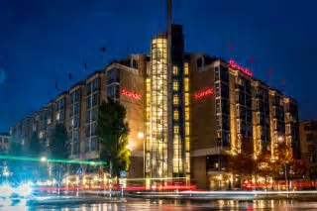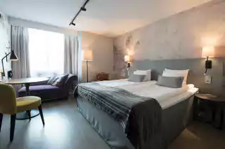
- 2-minute walk from Meeting Point buses and 10-minute walk to the final arena.
- Hotel has Jacuzzi, Gym, Sauna, Free Wi-Fi, Continental breakfast and Full-service restaurant, Bar, Lounge and much more.
All accommodation requests received outside of the LOC negotiated hotel deadline dates, 16 September 2018 through 23 September 2018 are subject to higher hotel rates.

Participants who book their accommodation in non-official hotels will have to pay double entry fee, and the LOC is not responsible to provide any transportation or meals from NON-Official Hotels. Transportation will be provided to and from official hotels only. In addition, no information will be distributed to the nonofficial hotels. Furthermore, they have to register at accreditation no later than the day before the official practice. If they do not register the day before, no changes will be made to the entry list and it is likely that they will not be allowed to compete.

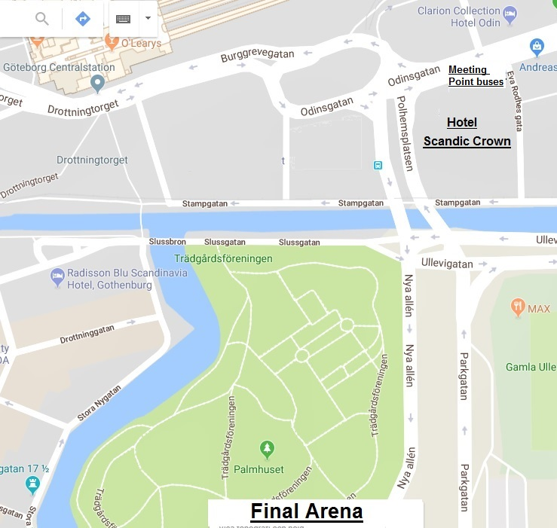

https://www.google.se/maps/@57.707051,11.9764618,17z/data=!5m1!1e4
ENTRY FEE
Entry fee:
Individual: 150 EUR per athlete
Officials: 50 EUR per person
Teams: 75 EUR per person

Entry fees include daily local transport to and from the practice field to/from official hotels during the qualification, elimination and finals venues (timetable to be confirmed on web site www.3dec2018.se .

PAYMENT CONDITIONS:
The entry fees should be paid in full upon arrival.

Payment of accommodation, a minimum deposit of 50% should be made when booking by 18 June 2018. The final outstanding balance shall be made via bank transfer before arrival. Accommodation cannot be guaranteed after this deadline.

NOTE:
- Please indicate in the reference/notes section the team or reservation name that corresponds to the payment
- All payment shall be made in EUR by BANK TRANSFER or CASH upon arrival
- All bank wire charges will be paid by the participant
- CREDIT CARDS or TRAVEL CHECKS will not be accepted as payment

BANK INFORMATION for ACCOMMODATION, TRANSPORTATION and
ENTRY FEES:
BANK: Swedbank AB Göteborg
ADDRESS: Lindholmspiren 9, Göteborg

BANK ACCOUNT HOLDER NAME: Swedbank AB
ACCOUNT NO: SE09 8000 0810 5996 4833 1420
SWIFT CODE: SWEDSESS

TO GUARANTEE RESERVATIONS
The 50% deposit of the accommodation must be paid in advance by
18 June 2018 made by bank transfer. The balance payment is due before arrival and within 27 August 2018.
ADDITIONAL INFORMATION
Transportation
Transportation will be provided from the official arrival airport, Göteborg-Landvetter Airport / GOT, to the official hotel, distance 27 Km. A bus or car will drive you from a meeting place on 15 or 16 September and return trip will be on 23 September, the day after the closing day. Return ticket price 15 EUR.

Cancellations & Changes
- Cancellations received before 18 June 2018 a full refund of the deposit payment will be made.
- Cancellations received after 27 August 2018, no refund will be given.
- Refunds will be processed after the event.
- Name changes to team officials or athletes (same category and division) will be accepted up to 72 hours before the event without any additional charge.
- Should flight arrival details change last minute, please contact the Organizing Committee using the details indicated in the Team Managers’ Booklet.
- If a participant’s arrival is later than the original scheduled arrival date, the room will be charged from the date of the original booking.

Training
A training range will be available starting from 15 September 2018. For teams that wish to arrive and practice earlier than this date, please contact the LOC directly to make arrangements. Travel expenses will be added for training days before 17 September.

Daily lunch
Daily lunch will be served at the competition site from Monday to Friday. Lunch consists of a main course and a meal drink. Cost 18 EUR per lunch and person.

Closing Banquet
The closing Banquet will be held on 22 September 2018 at Hotel Scandic Crown. Mingle buffet including a glass of wine or beer, Cost 29 EUR per person.

Weather
According to weather information, the average temperature in September is expected to be 59 to 68°F / 15 to 20 °C.

Media Registration:
Media representatives can apply for registration by emailing info@3dec2018.se

Internet
Will be available in the official hotels for free (in hotel rooms and in the lobby).

Water
Bottled water will be available at training and competition venues.

LOC Contact:
Name: Registration Manager
Email: OC@3dec2018.se
Language: English or Swedish
Official website: www.3dec2018.se

Visa:
For all nations needing visa permits, please make sure that you apply for it as early as possible in your country of origin before leaving. If our help is needed you may contact us immediately on: visa@3dec2018.se. For official invitations please apply before 27 August 2018 on the form provided with copies of passports attached.

Preliminary Hotel Form:

Federation/Country:
Contact Name:
Contact Email:
Telephone: | Fax: N/A

Transportation
Arrival by Car Arrival by Airplane

Accommodation
Hotel Name: …………………………………………………………….

Room Type | Rate - PPPN | No of Rooms | Arrival Date | Departure Date | Number of Nights
Single

Twin / Double

Three beds
Four beds

Any Special requirements……………………………………………………………………………………………………….
…………………………………………………………………………………………………………………………………………….

PLEASE:
Return the form to the OC before 18 June 2018 email to OC@3dec2018.se

Signature of President/Secretary General: ____________________________________

Date:______________________________________

Transportation Form
Federation/Country:
Contact Name:
Contact Email:
Telephone:

Arrival by Car Date:…………………………… Estimated time of arrival:………………………………

Arrival by Airplane
Arrival Flight
Number of Passengers: | Arrival Airport:
Airline: | Flight Number :
Date: | Arrival Time:
Departure Flight
Number of Passengers: | Arrival Airport:
Airline: | Flight Number :
Date: | Departure Time:

Any Special requirements……………………………………………………………………………………………………….
PLEASE, Return the form to the OC before 27 August 2018 email to OC@3dec2018.se

Signature of President/Secretary General: ____________________________________
Date:______________________________________

Final Entry Forms
Federation/Country:
Contact Name:
Contact Email:
Telephone: | Fax: N/A
Transportation
Arrival by Car Arrival by Airplane
Accommodation
Hotel Name:……………………………………………………..
Room Type | Rate - PPPN | No of Rooms | Arrival Date | Departure Date | Number of Nights
Single

Twin / Double

Three beds
Four beds
Arrival Flight
Number of Passengers: | Arrival Airport:
Airline: | Flight Number:
Date: | Arrival Time:
Departure Flight
Number of Passengers: | Arrival Airport:
Airline: | Flight Number:
Date: | Departure Time:
Any Special or Dietary Requirements
……………………………………………………………………………………………………………………………………………….
PLEASE, Return the form to the OC before 27 August 2018 email to OC@3dec2018.se

Signature of President/Secretary General: ________________________________
Date:___________________

Budget Form
- Entry Fee
Position | No. of persons | No. of persons | Cost | Total
Athlete |  |  | € | €
Official |  |  | € | €
Team |  |  | € | €
 |  |  | Total 1 | €
- Accommodation
Hotel: Scandic Crown
Room | No. of Nights | No. of People | Cost | Total
Single |  |  | € | €
Twin/Double |  |  | € | €
Three beds
Three beds
 |  |  | Total 2 | €
- Transport
Airport | Cost Per Person | No. of Passengers | Total
Landvetter Airport GOT | € 15
 |  | Total 3 | €
- Closing Banquet
Banquet | No. of Persons | Costs | Total
 |  | € 29
 |  | Total 4 | €
- Lunch
Daily Lunch | No. of Persons | Costs | Total
 |  | € 18
 |  | Total 5 | €

Total (1+2+3+4+5) €_____________________

Signature of President/Secretary General: ____________________________________

Date:______________________________________

PLEASE:
Return the form to the OC before 18 June 2018 email to OC@3dec2018.se

Rooming List

Federation/Country:
Contact Name:
Contact Email:
Telephone:

 | Room Type | Guest | Guest
1
2
3
4
5
6
7
8
9
10
11
12
13
14
15
16
17
18
19
20

PLEASE:
Return the form to the OC before 27 August 2018 email to OC@3dec2018.se

Visa Support Form
Federation/Country:
Contact Name:
Contact Email:
Telephone:

Given Name | Family Name | Date of Birth | Passport Number | Date of Issue | Date of Expiry | Country of Issue | Athlete or official

Signature of President/Secretary General: ____________________________________

Date:______________________________________

PLEASE: Return the form to the OC before 18 June 2018 email to visa@3dec2018.se

Please, be sure to forward copies of valid passports

