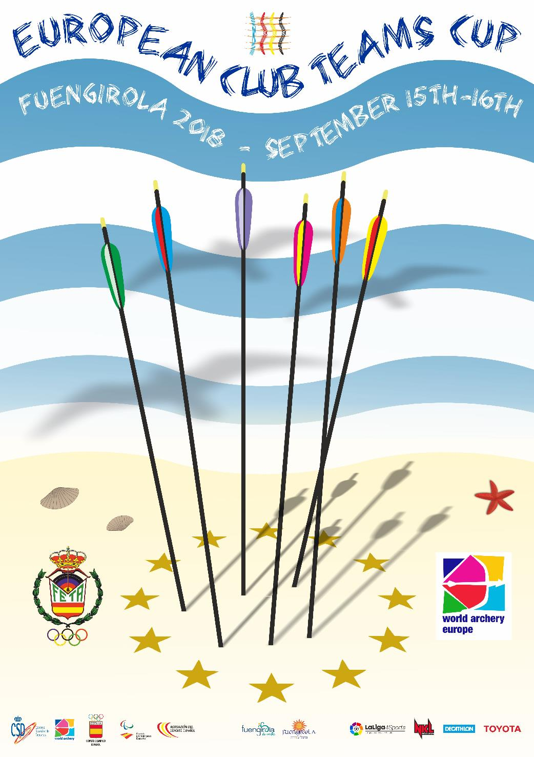

EUROPEAN CLUB TEAMS CUP – FUENGIROLA 2018
INVITATION

Dear Member Associates,

On behalf of the Spanish Archery Federation, I would like to invite you all to take part in the 2018 EUROPEAN CLUB TEAMS CUP, to be held in the sunny city of Fuengirola on September, 15th and 16th.
The competition is open to female and male club teams and it is reserved only to the Recurve Division.
Please find enclosed the necessary documents concerning the registration, organization and participation to this event. We kindly ask you to reply within the stated deadlines:

Participation form | July 22nd
Final Payment&Entries | August 15th
Hotel ReservationForm | July 22nd
Travel information | August 15th
Budget Form | August 15th
Visa InvitationLetter Form | August 15th

The competition is open to female and female club teams, and it is reserved only to the Recurve Division.

The winning Club Teams, men and women, will receive the following prizes:
1st place: 1500€ (Euro)
2nd place 1000€ (Euro)
3rd place 500€ (Euro)

Let the warm weather and the sunny beaches of “Costa del Sol” welcome you in Spain, enjoying a great competition but also a great time by the sea.
I will be glad to personally welcome you all in Fuengirola next September!

Vicente Martínez Orga
Spanish Archery Federation President

OVERALL SCHEDULE

 | Thursday  September 13th | Club teams arrivals
Day 1 | Friday  September 14th | Club teams arrivals and accreditation  Official practice session & Equipment inspection  Team Manager’s meeting  Opening Ceremony
Day 2 | Saturday  September 15th | Qualification round  Pool matches
Day 3 | Sunday  September 16th | Ranking rounds  Medal matches  Awarding & Closing Ceremony  Club teams departures

NOTE: This program could slightly change according to the final number of participants and TV requirements. Detailed competition program will be published and informed to all participants at least 15 days ahead of the Championship.

PARTICIPATION RULES

- A Club can participate with only one Men team and one Women team.
Mixed teams ARE NOT accepted.
- Each Club team is composed of 3 archers.
They should wear the same uniform.
- Maximum number of Club teams by country:
5 Men & 5 Women Club teams.
- The host country may enter a maximum of 8 Men & 8 Women Club teams.
- The countries of the 2017 winning clubs (men and women) are allowed to bring an extra team in the same category they won.
- Archers of the Club team has to belong to the same club, being members of the participating club as per 2018, January 1st.
- To be eligible to participate as members of a Club Team, a written certification from the Club stating that all athletes belong to that Club must be provided.
- The athletes may allow his person, name, pictures or sport performance to be used for advertising purposes.

COMPETITION RULES

- The 16 first men and women Club teams after the qualification round are qualified for the Club team-matches.
- The ranking of the Club teams is obtained by adding the scores of the 3 archers of the Club team at the end of the 70m 2x36 qualification round.
- If less than 16 Club teams take part in a category, byes are allowed when a minimum of 12 Club teams (men or women) are participating .
- If less than 12 Club teams take part in a category, only the first 8 Club teams of the qualification round will qualify for the match-event.
- If there are more than 16 teams (men or women), the teams qualified 16th place onwards can compete in a secondary tournament.
- If a Club has more than 3 archers in a category, theTechnical Delegate must be informed about the 3 archers composing the Club team before the end of the practice Session on Friday.
- The 3 archers of a Club team shooting in the Qualification Round have to shoot the Club team matches.
It is not allowed to change an archer during the competition.
- If a team is missing at the beginning of the competition, it cannot take part in
the competition anymore

POOL MATCHES

Once the individual qualification ranking round is over, the first 16 Club teams (men and women) will compete in the Main competition.
(*) Ties for the 16th place are decided as per WA rules.

These 16 Club teams will be divided in 4 groups of 4 Club teams, according to the
following scheme:

GroupA | GroupB | GroupC | GroupD
1st | 2nd | 3rd | 4th
8th | 7th | 6th | 5th
9th | 10th | 11th | 12th
16th | 15th | 14th | 13th

In this stage, every Club team competes against the three other teams in the group.

In each match 2 “pool points” are allocated based on the outcome of the match:
2 points for the winner / 1 point in case of a tie / 0 points for the loser

At the end of the 3 pool matches, ties in “pool points” are broken by the set points earned during the 3 matches. If the tie still remains, a shoot-off will decide the winner.

After the pool matches, the group teams qualified in the same position will compete among them in ranking elimination matches:

Ranking 1st to 4th A1 vs D1 and B1 vs C1
Ranking 5th to 8th A2 vs D2 and B2 vs C2
Ranking 9th to 12th A3 vs D3 and B3 vs C3
Ranking 13th to 16th A4 vs D4 and B4 vs C4

The 4 final matches (Bronze and Gold Medal Matches – Women & Men) will take place on a separate field of play, in alternate shooting and one after the other.

Secondary Tournament

All the teams that did not make the top 16 cut, will compete in a secondary “just for fun” competition that will take place only on Saturday after the main competition.

TRANSPORTATION

Official arrival points are the following:
- Malaga International Airport
- Maria Zambrano – Malaga main train station
(high speed train connection with Madrid, Barcelona, Seville, Valencia…)

Regional trains connect Malaga train station with Malaga Airport and Fuengirola in 45’ (each way is around 3,00€ per person). Fuengirola train station is 500 meters far from Las Palmeras Hotel.

Private transportation from / to these two points to / from Las Palmeras hotel can be requested to the LOC (50,00€ per Clubteam - way& back).

Prices:
- 50,00€ per Clubteam - way& back
(if team members are travelling together)

- 20,00€ per person – way& back
(if team members are travelling in different flights ( trains)

A free daily shuttle service, connecting the official hotel and the competition field will be provided from Friday to Sunday.

ACCOMMODATION
Official hotel is LAS PALMERAS hotel, a great 4 stars hotel with magnificent facilities just a few meters far from the beach and 1,5km far from the competition venue, providing ensuite private bathroom and and air conditioning.
Free Wi-Fi internet connection is provided for free for all the participants.

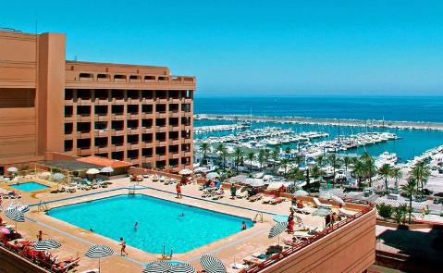
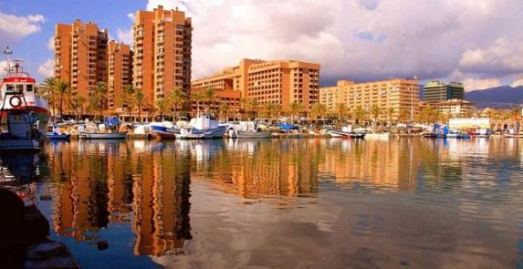
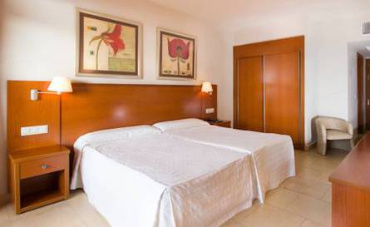
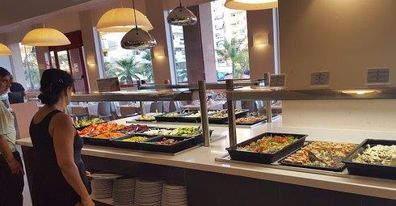
The hotel is offered on a full board base, and all meal services are served on buffet, including limited water and wine.

 | DAILY PRICE (per person) | DAILY ROOM PRICE
SINGLE ROOM | 90,00€ | 90,00€
DOUBLE ROOM | 75,00€ | 150,00€
TRIPLE ROOM | 60,00€ | 180,00€

Rooms should be booked before July 22nd, as it’s still high season in Spain and we might not be able to ensure rooms availability after that date.

Hotel booking will only be valid when50% of the fees are paid to the Organizing Committee.Final payment is to be done on August 15th the latest.

ENTRY FEE

200,00€ each Club team

Teams who book their own accommodation will be charged an entry fee of 300,00€.

Please note that neither transportation nor information services will be provided in any different hotel than the official one.

COMPETITION FIELD

ELOLA FOOTBALL PITCH
Complejo Polideportivo Municipal Elola
Calle Menorca, 2 - 29640 Fuengirola (Spain)
Pitch surface: artificial grass.

Free water will be provided at the competition field during the championship

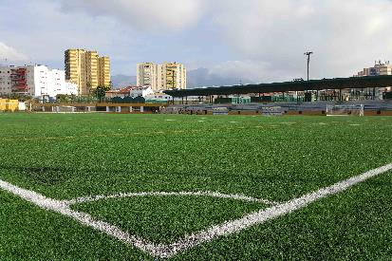
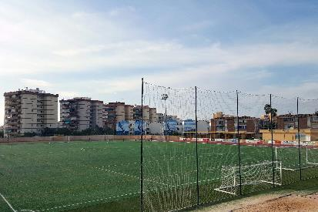

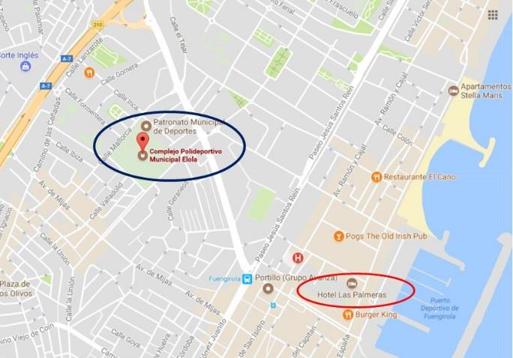

LOC BANK INFO

Account holder | REAL FEDERACIÓN ESPAÑOLA DE TIRO CON ARCO
Account holder’s address | C/ Altamirano, 30 1º derecha  28006 Madrid (Spain)
IBAN | ES64 0081 2341 3100 0101 8811
Bank name | BANCO SABADELL
Bank Address | C/ Núñez de Balboa, 20  28001 Madrid (Spain)
SWIFT/BIC | BSAB ESBB

- All payments are required to be done in EURO.
- Bank transfer fees are the responsibility of the sender.

NO CREDIT CARDS, NO TRAVELLERS CHEQUES, NO FOREIGN CURRENCIES

VISA REQUEST

If visa is needed to travel Spain from your country, please apply for it as soon as possible.

In case a Letter of Invitation is requested, please send us your participants list with their passport number and date of expiry so as we can send it to the related Spanish Embassy.

USEFUL INFORMATION

• Electricity: 220V/50Hz with European 2-pin plug
• Language: Spanish
• Time zone: GMT+1 (CET)
• Phone code: +34 calling code (calls from abroad)
00+ exit code (calls to homeland)
• Emergency phone number: 112
• Police phone number: 091
• Currency: EURO

Organizing Committee: REAL FEDERACIÓN ESPAÑOL DE TIRO CON ARCO
WORLD ARCHERY EUROPE

LOC contact person: Mr. Rifaat Chabouk
Mobile phone : +34696667839
E-mail : comunicacion@federarco.es
Website : https://www.federarco.es/europeanclubteamscup2018


PARTICIPATION FORM
Return at the latest: July 22nd

MEMBER ASSOCIATION:
CLUBNAME:
CONTACT PERSON:
MOBILE PHONE NUMBER:
EMAIL ADDRESS:

MEN’S TEAM
PARTICIPANT | PASSPORT NUMBER | EXPIRY DATE | NAME | SURNAME | DATE OF BIRTH dd/mm/yy | MOBILE PHONE # | E-MAIL ADRESS
OFFICIAL
ARCHER
ARCHER
ARCHER
ARCHER

WOMEN’S TEAM
PARTICIPANT | PASSPORT NUMBER | EXPIRY DATE | NAME | SURNAME | DATE OF BIRTH dd/mm/yy | MOBILE PHONE # | E-MAIL ADRESS
OFFICIAL
ARCHER
ARCHER
ARCHER
ARCHER

TEAMS
ENTRY FEE (1) |  | x200 € each  (official accommodation) | Total (A):€
ENTRY FEE (2) |  | X300 € each  (unofficial ccommodation) | Total (A):€

I hereby declare that:
- Our Member Association is in good standing
- All competitors and officials are covered in case of illness or accident
- We have signed the WA Anti-Doping Agreement.

Date: President / SecretaryGeneral

HOTEL RESERVATION FORM
Return at the latest: July 22nd

Club: Email:

Team Manager: Phone:

ACCOMMODATION

LAS PALMERAS  4**** hotel | ROOMS | PAX | CHECK IN | CHECK OUT | NIGHTS | RATE | TOTAL COST
Single Room |  |  |  |  |  | 90,00€ | €
Double Room |  |  |  |  |  | 75,00€ | €
Triple Room |  |  |  |  |  | 60,00 € | €
 |  |  |  |  |  | Total(B) | €

The rates are in Euro (€) per person, per day, full board.
Please check this box if you need facilities for persons with disabilities.

Date:

President / SecretaryGeneral:

TRAVEL INFORMATION
Return at the latest: August 15th

Club: Email:

Team Manager: Phone:

ARRIVAL

 | FROM | FLIGHT / TRAIN CODE NUMBER | PEOPLE TRAVELLING | ARRIVAL TIME
Malaga
Airport
Malaga
Train Station

DEPARTURE

 | TO | FLIGHT / TRAIN CODE NUMBER | PEOPLE TRAVELLING | DEPARTURE TIME
Malaga
Airport
Malaga
Train Station

In case you are arriving / departing in different flights / trains, please copy-paste and use as many rows as needed.

Please check this box if you need facilities for persons with disabilities.

Teams requesting transportation |  | x50€ each | €
Individual participants requesting transportation |  | x20 € each | €
 |  | TOTAL (C) | €

Date: President / SecretaryGeneral

BUDGET FORM
Return at the latest: August 15th

MEMBER ASSOCIATION:
CLUB NAME:
CONTACT PERSON:
MOBILE PHONE NUMBER:
EMAIL ADDRESS:
INVOICE TO BE BILLED TO:

FINAL BALANCE

A | B | C | TOTAL
ENTRY FEE | ACCOMMODATION FEE | TRANSPORTATION FEE | TOTAL

PLEASE NOTE:

50% of the fees to be paid before: July 22nd
Balance of full payments deadline: August 15th

Date

President / SecretaryGeneral

