……………………………………………………………………………………………………………………………………..……………………………….

INVITATION

TO ALL WORLD ARCHERY MEMBER ASSOCIATIONS 10 December 2018

Dear President,

On behalf of the Organizing Committee and Archers Association of Slovenia we are pleased to invite you to the 2019 European Youth Cup 1st Leg that will be held in Čatež, Slovenia, 13 -18 May 2019.
This event will be organised following the WA and WAE YOUTH CUP RULES for Junior Women, Junior Men, Cadet Women and Cadet Men classes, Recurve and Compound divisions in the Outdoor Target Archery discipline.

THE PARTICIPATION IS OPEN TO ALL WORLD ARCHERY MEMBER ASSOCIATIONS.

Please, find enclosed the necessary documents concerning the registration, organization and participation in this event. To register participation, please complete all the necessary sections in WAREOS within the deadlines listed below:

Registration Opening Date - online WAREOS 17 December 2018
Preliminary Entries Deadline 13 February 2019
Preliminary Hotel reservation and payment 13 February 2019
Final Entries Deadline 23 April 2019
Final Hotel reservation 23 April 2019
Transportation 23 April 2019
Final Payment 23 April 2019
Visa Application 1 April 2019

We are looking forward to welcoming you and we are sure you will enjoy your stay in Čatež.

Yours sincerely

Irena Rosa Leon Uratnik
Competition Manager President of Archers Association of Slovenia
Darja Rožmanec
Project Manager

Website: http://www.eyc-catez2019.si
E-mail: oc-catez@archery-si.org
Info: +386 (0)31 633 851 Ms Irena Rosa

……………………………………………………………………………………………………………………………………..……………………………….
PRELIMINARY PROGRAMME

Saturday 11 May 2019 Arrival of Delegations
Unofficial Practice

Sunday 12 May 2019 Arrival of Delegations
Unofficial Practice
Team Registration

Monday 13 May 2019 Official practice and Equipment inspection
Team Managers' Meeting at the Terme Hotel in Catez
Opening Ceremony

Tuesday 14 May 2019 Qualification round CADETS
Qualification round JUNIORS

Wednesday 15 May 2019 Mixed Teams

Thursday 16 May 2019 Individual Eliminations – up to Semifinals

Friday 17 May 2019 Team Eliminations and Finals
Team & Mixed Team Awarding

Saturday 18 May 2019 Individual Finals
Award Ceremony/Closing Ceremony
Disco party

Sunday 19 May 2019 Departure of Delegations

Note: This preliminary program is subject to change according to the number of participants and special requirements. All changes will be published and distributed in good time.

Website: http://www.eyc-catez2019.si

.............................................................................................................................................................................
PRELIMINARY & FINAL REGISTRATION

No entry forms will be available for registering for this event. The registration process should be done using the World Archery Online Registration System (WAREOS).

The number of athletes that may be entered by a Member Association is limited to four (4) in each category.

All World Archery MA’s are eligible to compete in European Youth Cup competitions, but only the results of the athletes from WORLD ARCHERY EUROPE MA’s will be taken in consideration for the Youth Cup Circuit.

In order to use WAREOS, please login on http://register.worldarchery.org with your Username and Password assigned by World Archery. For any questions regarding the WAREOS, please contact the World Archery office, Mr. JK LEE (jklee@archery.org).

Starting date of online-registration with WAREOS is: | 17 December 2018
End of Preliminary registration: | 13 February 2019
End of Final registration: | 23 April 2019

Please respect the stated deadlines.

Member Associations should only use WAREOS to make any changes/amendments to their entries and will be able to do so at any time. Any changes made in WAREOS an email will instantly be automatically sent to the Organizing Committee and Member Association with the updated information.

However, any changes that are made after the deadlines specified or if entries differ by more than 4 athletes from the preliminary entries, the following penalty fees will automatically be applied:

Penalty fees to be paid to Organizing Committee: | Cost (EURO):
Entries made after the preliminary and/or final entry deadline date. | 45 per entry
If final entries differ from the preliminary entries by more than 4 athletes/officials. | 140 per entry
Failure to have made preliminary entries before the deadline date but then have submitted final entries. | 140 per entry

Any entries received less than 3 days before the team managers meeting will be refused if no preliminary entry and/or final entry are made prior.

As a final note, only Member Associations in good standing will be eligible to compete. This means that World Archery fee must have been paid prior the participation.

.............................................................................................................................................................................
ACCOMMODATION & GENERAL INFORMATION

The official hotels are 4* and 3* stars category hotels TOPLICE HOTEL and ČATEŽ HOTEL in Catez, standing next to each other in Catez Spa.

The room rate:
- is per person per night,
- include full board accommodation, taxes and VAT
- include use of the swimming pool
- include use summer thermal riviera – free entrance twice per day
- include free parking in front of the hotel for cars, minivans and busses
- internet in the hotel lobby and rooms
HOTEL | Category | Single room  Price per person per night - full board | Double room  Price per person per night - full board
TOPLICE | **** | € 140 | € 100
ČATEŽ | *** | € 120 | € 90
Lunch during the competition days will be served in the restaurant of the Hotel.
TOPLICE HOTEL Terme Čatež d.d., Topliška 35, SI - 8251 Čatež ob Savi
Coordinates: 45.89192 15.621547
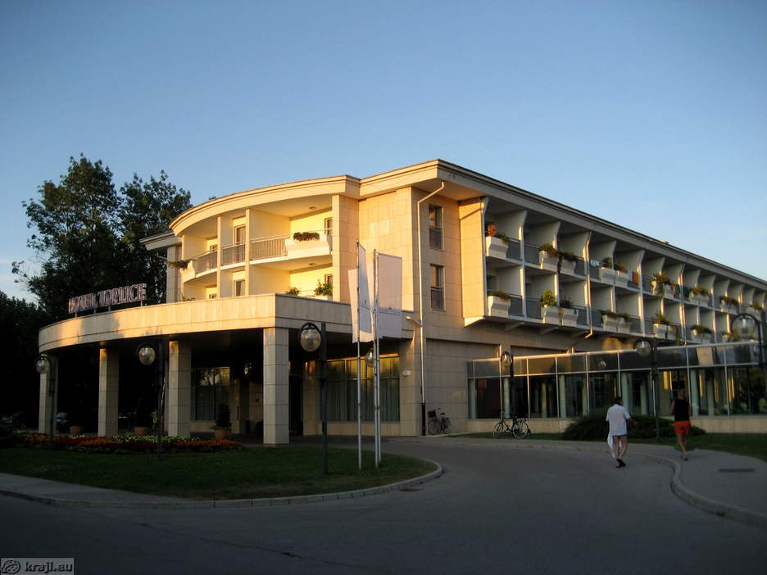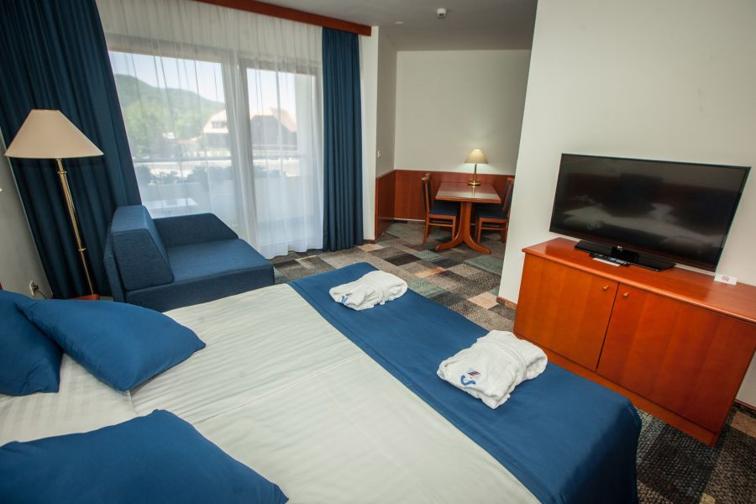

ČATEŽ HOTEL Terme Čatež d.d., Topliška 35, SI - 8251 Čatež ob Savi
Coordinates: 45.89192 15.621547
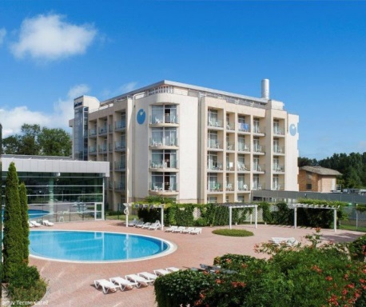
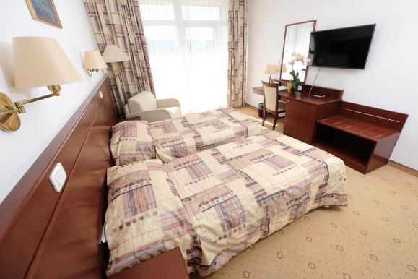

.............................................................................................................................................................................
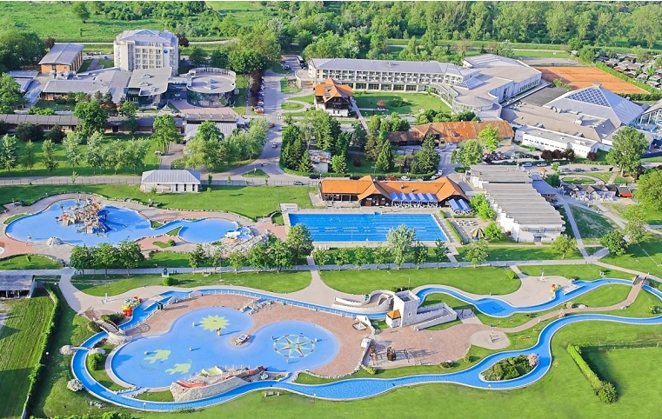
Slovenian health resorts are developed in the middle of natural environment and aside from medical treatments they offer numerous possibilities for sport and recreation in nature, on opened and closed courts. Medicinal offer includes loads of fun, ramblings and exploration of local particularities and sightseeing.
Catez Spa offers the largest pool grandeur in Slovenia. The winter Thermal Riviera with 2200 m² roofed water surfaces and numerous attractions guarantees fun for all ages. There is variety of choice with kiddy pools, pirate ship, asymmetrically shaped pool with whirlpools, waterfalls, massage beds, numerous water slides, raging river, wave pool, attractive wave surfing… From April to October the summer Thermal Riviera enchants the guests with the pirate island, water park for kids, slow river, wave pool, triple water slide and a unique water slide boomerang…
The Terme Hotel and Toplice Hotel are distanced from everyday bustle, located in a quieter part of Terme Catez. It is recommended to everyone who is looking for relaxation and excellent wellness range with available indoor and outdoor pools with thermal water. The hotel comprises the Health & Beauty Centre, where you can let yourself be pampered in unique Roman-Irish baths.
The Summer Thermal Riviera, boasting the largest outdoor pool complex far around, offers entertainment to all generations with more than 10,000 m² of thermal water surface. Visit the water attractions and pools of various shapes with thermal water with a temperature between 26 and 36 °C.
Enjoy thousands water in thousands of forms. Toboggans, Pirate's island, lazy river, pool with waves, children's pools, play structures, whirlpools ... You will have a hard time trying to fit all in one day.

Reservations should be made before 13 February 2019.
To confirm the reservation, a 60% deposit of the total amount is required to be bank transferred to the OC before 13 February 2019. Reservations after this date will be considered only according to availability, the room rate can change and we can not guarantee rooms in the official hotel.

.............................................................................................................................................................................
Final Hotel Reservations and remaining payment should be made before 23 April 2019.

Note: Please ensure that you complete all the necessary forms by the specified dates and make full payment for the accommodation at the time of booking. See detailed payment instructions below.

Participants who book their accommodation in non official hotels will need to pay a entry fee of 300,00 € for each athlete to the LOC. It will not be possible to distribute any information at the non-official hotels.

ADDITIONAL INFORMATION

Entry fees:
Individual: 85 € per athlete
Officials: Free
Teams: Free

Transportation fees from/to the airports:
The OC will collect the teams from the two airports. You have to pay the transportation fee /including arrival and departure/ as follows:
ZAGREB International Airport /CRO/ 50 km 45 € per person
LJUBLJANA International Airport /SLO/ 130 km 80 € per person
Be aware that Zagreb is in Croatia and some countries might need visa for Croatia.

The last date for the payment of the transportation fee is 23 April 2019.

From the airports to the hotel /return trip), the organiser will use buses, small buses, vans and cars, what will depend of number of persons scheduled for transportation.

Transportation from the airports will start two days before the official practice day and will end two days after the closing day.

Cancellations & Changes:
Following conditions will apply:
- cancellation received before the final entry: full refund of the paid deposit
- cancellation received after the final entry: no refunds

All rates for payments after deadlines are subject to additional charges without prior notice.
All refunds, if any, will be processed after the event.

.............................................................................................................................................................................
OC has to be informed about changes in the travel programme 72 hours prior arrival. If your arrival is later then your original schedule, the room charges are starting from the original date indicated by the Member Association.

Meals at the venue:
Lunch will be served in the restaurant of the hotel.

Drinking water will be available at lunch and at dinner and on the competition field free of charge.
All other costs made in cafeteria at the archery venue or in the hotel /snacks, drinks, small meals/ are not included in the entry fee and must be paid on consumptions.

Please inform us if you have special requirements for food and specify it.

Accreditation and Team Managers Meeting
Accreditation will take place upon arrival of teams in the lobby of the Toplice Hotel 12 May 2019. Accreditation office will be open on Sunday 12 May from 08:00 - 21:00.

For all Ceremonies WA dress code is obligatory.
More details will be provided at the Team Manager’s Meeting.
Team Managers Meeting will be held in the conference room of the Terme Hotel /the conference room/
on Monday, 13 May 2019.

Training and Competition Field
For European Youth Cup the football sport fields will be used. Fields are in walking distance from hotels.

The practice will be available starting from 11 May 2018 in Catez Spa.

Visas
All participants who need an entry visa to Slovenia, will be required to complete the Visa Support Form in WAREOS by no later than 1 April 2019.

It is the applicants’ responsibility for supplying the necessary information, ensuring all details are up to date, correct and submitted by the deadlines specified.

In addition, all participants that require a visa are kindly requested to supply a copy of their latest/valid passport. Copies of each applicant can be uploaded on WAREOS. All passport copies and personal details entered/uploaded to WAREOS will be held securely and in the strictest of confidence and not shared with other parties.

Please note that the Organizing Committee can provide invitation for the period of the European Youth Cup in Catez only.

.............................................................................................................................................................................
As long as the Organizing Committee gets no different information, the Invitation Letter will be sent by email. If an express service should be desired, this service will be charged to the MA and must be paid to the Organizing Committee upon arrival.

Those teams that want to land in Zagreb airport must be aware that they might need visa for Croatia.
In this case we might not be able to help you.

Please note: the deadline for Visa Invitation Letter Form is 1 April 2019.

Disco Party
On the final day - Saturday, 18 May 2019, after the dinner the DJ Felix party will be organized free of charge.
Drinks and snacks are not included and must be paid on consumptions.

Internet
Free of charge in all locations of Spa Catez.
Website
The official website of the competition is http://www.eyc-catez2019.si

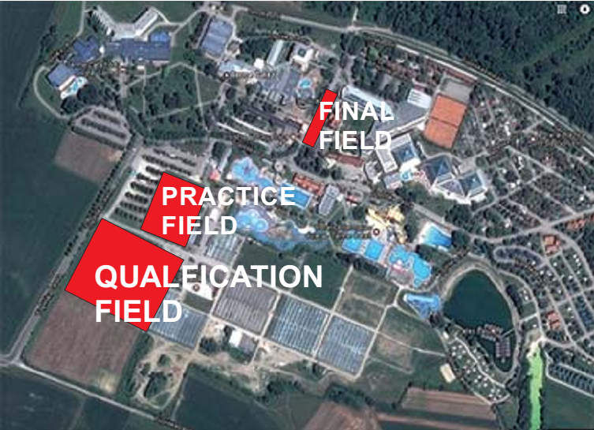

.............................................................................................................................................................................
PAYMENT INSTRUCTIONS

BANK: NOVA LJUBLJANSKA BANKA d.d.
Address: Trg republike 2
1000 Ljubljana
Slovenia
A/C NAME LOKOSTRELSKA ZVEZA SLOVENIJE
Address: Dolenjska cesta 11
1000 Ljubljana
Slovenia

SWIFT CODE /BIC/: LJBASI2X
IBAN: SI56 0201 3001 7204 321

NOTE:
ALL PAYMENTS ARE REQUIRED TO BE DONE IN EUROS BY BANK TRANSFER LATEST 23 APRIL 2019!
ALL BANK TRANSFER FEES HAVE TO BE PAID BY PARTICIPATING MAs, you need to state OUR option when paying.
IN CASE OF NOT PAYING THE BANK TRANSFER FEES, YOU WILL BE CHARGED FOR THE DIFFERENCE UPON ARRIVAL, AT THE ACCREDITATION.

- NO CREDIT CARDS
- NO TRAVEL CHECKS

IN CASE YOU WILL BRING CASH, YOU WILL BE CHARGED FOR EXTRA BANK COSTS FOR DEPOSIT,
1% OF THE DEPOSIT.

PLEASE SEND THE COPY OF THE BANK TRANSFER TO THE ORGANIZER by email to
oc-catez@archery-si.org

OC contacts

For all matters
Ms Irena Rosa - 24 hours English
Mobile +386 (0)31 633 851
E-mail: oc-catez@archery-si.org

For questions about visa support
Mr Tomaz Urlep - 24 hours English
Mobile +386 (0)41 650 015
E-mail: oc-catez@archery-si.org

.............................................................................................................................................................................

