……………………………………………………………………………………………………………………………………..……………………………….

INVITATION

TO ALL WORLD ARCHERY EUROPE MEMBER ASSOCIATIONS 15 June 2019

Dear President,

On behalf of the Organizing Committee and Archers Association of Slovenia we are pleased to invite you to the 2019 European Club Team Cup that will be held in Catez, Slovenia 14 – 15 September 2019.

The competition is open to female and male club teams and it is reserved only to the Recurve Division.

The competition will be organized according European Club Team Cup rules published on WAE web site and sent as the attachment.

Please, find enclosed the necessary documents concerning the registration, organization and participation in this event. To register participation, please complete all the necessary forms within the deadlines listed below:

Preliminary Entries Deadline 1 August 2019
Preliminary Hotel reservation and payment 1 August 2019
Final Entries Deadline 15 August 2019
Final Hotel reservation 15 August 2019
Transportation 15 August 2019
Final Payment 15 August 2019
Visa Application 1 July 2019

We are looking forward to welcoming you and we are sure you will enjoy your stay in Čatež.

Yours sincerely

Irena Rosa Leon Uratnik
Competition Manager President of Archers Association of Slovenia
Darja Rožmanec
Project Manager

Website: http://www.archeryeurope.org
Info: +386 (0)31 633 851 Ms Irena Rosa

…………………………………………………………………………………………………………………………………….……………………………….
PRELIMINARY PROGRAMME

Thursday 12 September 2019 Arrival of the Club teams
Practice field and local transportation available
Team Registration

Friday 13 September 2019 Arrival of the Club teams
Practice field and local transportation available
Team Registration
Team Managers Meeting

Saturday 14 September 2019 Qualification round 2 x 36 arrows
Pool matches Main Event
Pool matches Secondary Tournament

Sunday 15 September 2019 Ranking rounds
Medal matches
Award Ceremony & Closing

ACCOMMODATION & GENERAL INFORMATION

The official hotels are 4* and 3* stars category hotels TOPLICE HOTEL and ČATEŽ HOTEL in Catez,
standing next to each other in Catez Spa.

The room rate:
- is per person per night,
- include full board accommodation, taxes and VAT
- include use of the swimming pool
- include use summer thermal riviera – free entrance twice per day
- include free parking in front of the hotel for cars, minivans and busses
- internet in the hotel lobby and rooms

HOTEL | Category | Single room  Price per person per night - full board | Double room  Price per person per night - full board
TOPLICE | **** | € 140 | € 100
ČATEŽ | *** | € 120 | € 90
Lunch during the competition days will be served in the restaurant of the Hotel.

...........................................................................................................................................................................

TOPLICE HOTEL Terme Čatež d.d., Topliška 35, SI - 8251 Čatež ob Savi Coordinates: 45.89192 15.621547

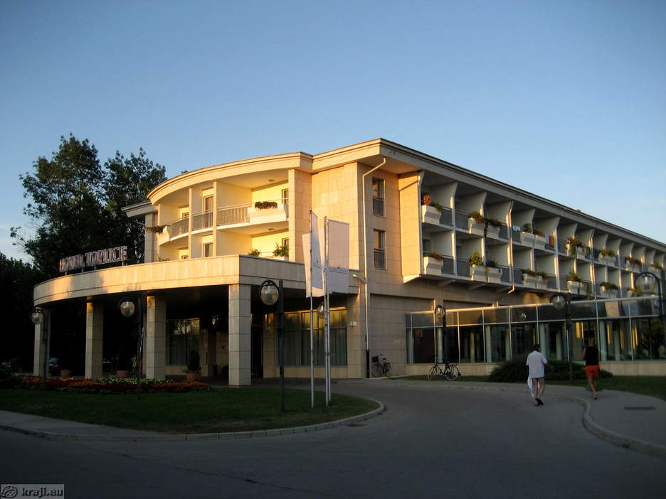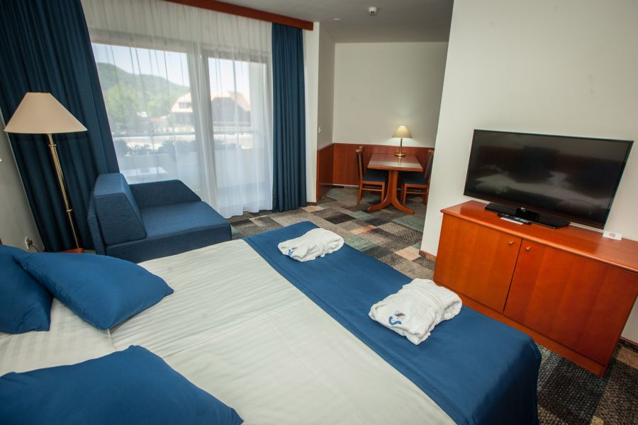

ČATEŽ HOTEL Terme Čatež d.d., Topliška 35, SI - 8251 Čatež ob Savi Coordinates: 45.89192 15.621547
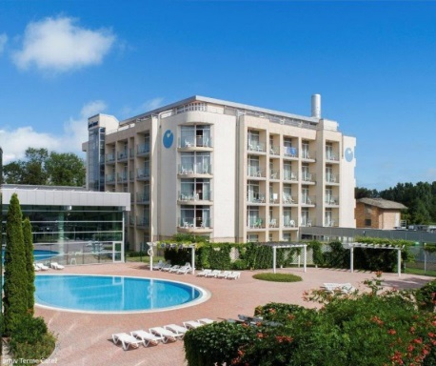
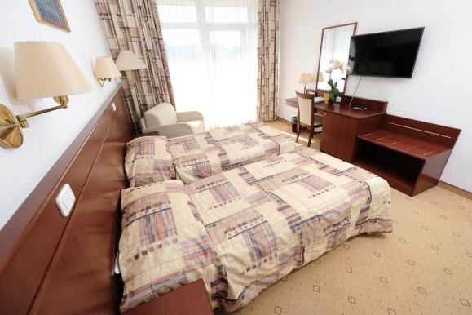

Slovenian health resorts are developed in the middle of natural environment and aside from medical treatments they offer numerous possibilities for sport and recreation in nature, on opened and closed courts. Medicinal offer includes loads of fun, ramblings and exploration of local particularities and sightseeing.
Catez Spa offers the largest pool grandeur in Slovenia. The winter Thermal Riviera with 2200 m² roofed water surfaces and numerous attractions guarantees fun for all ages. There is variety of choice with kiddy pools, pirate ship, asymmetrically shaped pool with whirlpools, waterfalls, massage beds, numerous water slides, raging river, wave pool, attractive wave surfing… From April to October the summer Thermal Riviera enchants the guests with the pirate island, water park for kids, slow river, wave pool, triple water slide and a unique water slide boomerang…
The Terme Hotel and Toplice Hotel are distanced from everyday bustle, located in a quieter part of Terme Catez. It is recommended to everyone who is looking for relaxation and excellent wellness range with available indoor and outdoor pools with thermal water. The hotel comprises the Health & Beauty Centre, where you can let yourself be pampered in unique Roman-Irish baths.
...........................................................................................................................................................................

The Summer Thermal Riviera, boasting the largest outdoor pool complex far around, offers entertainment to all generations with more than 10,000 m² of thermal water surface. Visit the water attractions and pools of various shapes with thermal water with a temperature between 26 and 36 °C.
Enjoy thousands water in thousands of forms. Toboggans, Pirate's island, lazy river, pool with waves, children's pools, play structures, whirlpools ... You will have a hard time trying to fit all in one day.

Reservations should be made before 1 August 2019.
To confirm the reservation, a 60% deposit of the total amount is required to be bank transferred to the OC
before 1 August 2019. Reservations after this date will be considered only according to availability, the room rate can change and we can not guarantee rooms in the official hotel.

Final Hotel Reservations and remaining payment should be made before 15 August 2019.

Note: Please ensure that you complete all the necessary forms by the specified dates and make full payment for the accommodation at the time of booking. See detailed payment instructions below.

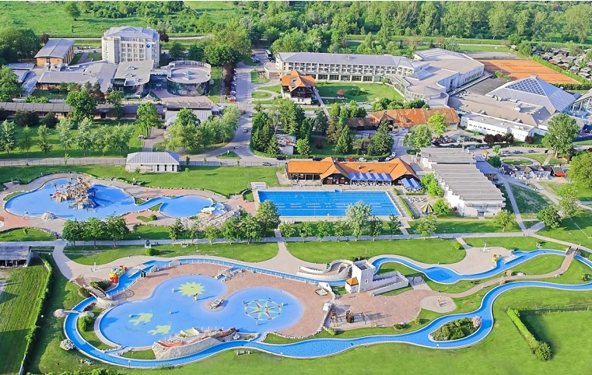

...........................................................................................................................................................................
ADDITIONAL INFORMATION

Entry fees:
Club team: 200 € per Club team

Participants who book their accommodation in non official hotels will need to pay a double entry fee.
It will not be possible to distribute any information at the non-official hotels.

Transportation fees from/to the airports
The OC will collect the teams from the two airports. You have to pay the transportation fee
/including arrival and departure/ as follows:
ZAGREB International Airport /CRO/ 50 km 45 € per person
LJUBLJANA International Airport /SLO/ 130 km 80 € per person
Be aware that Zagreb is in Croatia and some countries might need visa for Croatia.

The last date for the payment of the transportation fee is 1 September 2019.

From the airports to the hotel /return trip/, the organiser will use buses, small buses, vans and cars,
what will depend of number of persons scheduled for transportation.

Cancellations & Changes
Following conditions will apply:
- cancellation received before the final entry: full refund of the paid deposit
- cancellation received after the final entry: no refunds
All refunds, if any, will be processed after the event.

OC has to be informed about changes in the travel programme 72 hours prior arrival. If your arrival is later then your original schedule, the room charges are starting from the original date indicated by the Club.

Prizes
- Prize money: Total amount 6.000 €
- Recurve Women Club teams and Recurve Men Club teams will receive as prize money the following amounts each:
1st place: 1500 €
2nd place: 1000 €
3rd place: 500 €

Meals at the venue
Lunch during the competition days will be served in the restaurant of the Hotel.
Please inform us if you have special requirements for food and specify it.

............................................................................................................................................................................

Drinking water will be available at lunch and at dinner and on the competition field free of charge.
All other costs made in cafeteria at the archery venue or in the hotel /snacks, drinks, small meals/ are not included in the entry fee and must be paid on consumptions.

Accreditation and Team Managers Meeting
Accreditation will take place upon arrival of teams in the lobby of the Čatež Hotel 13 September 2019. Accreditation office will be open on Thursday 13 September from 13:00 - 21:00.
Arrival directly to the FoP and accreditation made on Friday 14 September is possible only with the additional payment of 50 € per athlete.

Each Club team is composed of 3 archers – each archer of the Club team has to belong to the same club. They must be members of the participating club as per the 1st January of 2019. To be eligible to participate as members of a Club team it is necessary to provide a written certification that all athletes belong to that Club.
All members of a Club team have to wear the same uniform.
More details will be provided at the Team Manager’s Meeting.
Team Managers Meeting will be held in the conference room of the Terme Hotel /the conference room/
on Friday, 13 September 2019.

Training and Competition Field
For European Club Teams Cup the football sport fields will be used. Fields are in walking distance from hotels.

The practice will be available starting from 12 September 2019 in Catez Spa.

Visas
All participants who need an entry visa to Slovenia, will be required to complete the Visa Support Form in WAREOS by no later than 1 July 2019.

It is the applicants’ responsibility for supplying the necessary information, ensuring all details are up to date, correct and submitted by the deadlines specified.

In addition, all participants that require a visa are kindly requested to supply a copy of their latest/valid passport. Please note that the Organizing Committee can provide invitation for the period of the European Club Teams Cup in Catez only.

As long as the Organizing Committee gets no different information, the Invitation Letter will be sent by email. If an express service should be desired, this service will be charged to the Club team/MA and must be paid to the Organizing Committee upon arrival.

Those teams that want to land in Zagreb airport must be aware that they might need visa for Croatia.
In this case we might not be able to help you.

Please note: the deadline for Visa Invitation Letter Form is 1 July 2019.

Internet - Free of charge in all locations of Spa Catez.
Website - The official website of the competition is http://www.archeryeurope.org

By signing in the Club team declares that:
- Club team’s Member Association is in good standing
- All competitors and officials are covered in case of illness or accident
- Club team members have signed the WA Anti-Doping Agreement
- All archers of the Club team belong to the same club and are its members at least from 1st January 2019
- All competitors and officials allow his/her person, name, pictures or sport performance to be used for advertising purposes

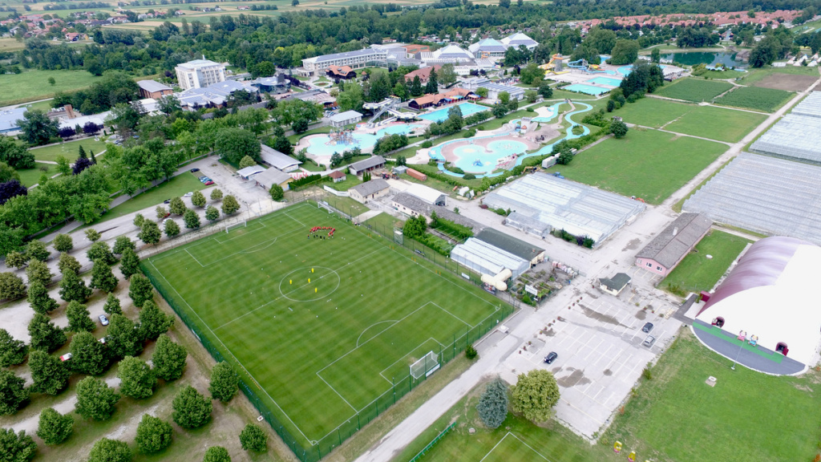

............................................................................................................................................................................
PRELIMINARY HOTEL RESERVATION FORM

Club team and Member Association: ____________________________________________
Contact person: ________________________________________________
Mobile: _______________________________________________________
E-mail: _______________________________________________________

Number of Rooms:
Hotel Catez/*** Hotel Toplice/****
Single € 120 Single € 140

Double: € 90 Double: € 100

Do you require a room for a disabled team member? Yes No

If yes, please specify: ______________________________________________

Do any of your team members have dietary requirements or allergies such as, vegetarian,
nut allergies or gluten free etc. Yes No

If yes, please specify: ______________________________________________

Accommodation Payment:
ROOM TYPE AMOUNT OF ROOMS NIGHT RATE P/N TOTAL RATE

___________ _____________________ _________________ _____________

Single ______________________x ___________ x = _______________

Double/Twin _____________________ x ___________ x = _______________

TOTAL ACCOMMODATION AMOUNT _____________________________

DEPOSIT 60% OF TOTAL AMOUNT ______________________________

PLEASE RETURN THIS PRELIMINARY HOTEL RESERVATION FORM TO THE ORGANIZERS AND PAY THE DEPOSIT BEFORE 1 August 2019 by e-mail to oc-catez@archery-si.org

Date: ______________________ Signature of President / Secretary General: ______________________
.............................................................................................................................................................................
TRANSPORTATION FORM

Club team and Member Association: __________________________

Number of passengers: ________ person/s

Arrival information

We will arrive by plane:

Airport: __________________ Flight Nr: _____________

Date: ______________ Arrival Time: ___________

We will arrive to CATEZ by: _____________________________________

____________________________________________________________

Departure information

We will depart by plane:

Airport: __________________ Flight Nr: _____________

Date: ______________ Departure Time: ___________

We will depart from CATEZ by: _______________________________________

____________________________________________________________

Date: _________

Signature of President / Secretary General: ______________________________

PLEASE RETURN THIS TRANSPORTATION FORM TO THE ORGANIZER BEFORE
1 September 2019 by email to oc-catez@archery-si.org
.............................................................................................................................................................................
VISA INVITATION LETTER FORM

Club team and Member Association: ___________________________________

Contact person: _______________________________________

No | First name | Family name | Date and place of birth | Citizenship /Country/
No | Address of residence |  |  | Passport
No |  |  |  | Number | Expiration
1
2
3
4
5
6
7

Date: ______________________ Signature of President / Secretary General: ______________________

PLEASE RETURN THIS VISA INVITATION LETTER FORM TO THE ORGANIZER AS SOON AS POSSIBLE.
Latest by 1 July 2019 by email to oc-catez@archery-si.org

.............................................................................................................................................................................
FINAL BUDGET FORM

Club team and Member Association: ____________________________________________
Contact person: ________________________________________________
Mobile: _______________________________________________________
E-mail: _______________________________________________________

1) Entry Fees
Posit Cost Number of athletes Total
Club team in official hotel € 200 € ____
Club team in unofficial hotel € 400 x ___ € ____

Total 1 ................................................................................. € ____

2) Accommodation
HOTEL TERME/TOPLICE - Full Board
Room Cost Nr of Persons Nr of nights Total
Hotel Catez/*** - Single room € 120 x ___ x __ € ____
Hotel Catez/*** - Double room € 90 x ___ x __ € ____
Hotel Toplice/****- Single room € 140 x ___ x __ € ____
Hotel Toplice/****- Double room € 100 x ___ x __ € ____

Total 2 .................................................................................. € ____

3) Transportation
Airport Cost Number of Persons Total
LJUBLJANA € 80 x ______ € ____
ZAGREB € 45 x ______ € ____

Total 3 .................................................................................. € ____

Date, ___________ TOTAL /1+2+3/ € ____
Signature of President / Secretary General: _____________________________
PLEASE RETURN THIS BUDGET FORM TO THE ORGANIZER BEFORE 1 September 2019 by e-mail to
oc-catez@archery-si.org

.............................................................................................................................................................................
PAYMENT INSTRUCTIONS

BANK: NOVA LJUBLJANSKA BANKA d.d.
Address: Trg republike 2
1000 Ljubljana
Slovenia
A/C NAME LOKOSTRELSKA ZVEZA SLOVENIJE
Address: Dolenjska cesta 11
1000 Ljubljana
Slovenia

SWIFT CODE /BIC/: LJBASI2X
IBAN: SI56 0201 3001 7204 321

NOTE:
ALL PAYMENTS ARE REQUIRED TO BE DONE IN EUROS BY BANK TRANSFER LATEST 15 AUGUST 2019!
ALL BANK TRANSFER FEES HAVE TO BE PAID BY PARTICIPATING MAs, you need to state OUR option when paying.

IN CASE OF NOT PAYING THE BANK TRANSFER FEES, YOU WILL BE CHARGED FOR THE DIFFERENCE UPON ARRIVAL, AT THE ACCREDITATION.

- NO CREDIT CARDS
- NO TRAVEL CHECKS

IN CASE YOU WILL BRING CASH, YOU WILL BE CHARGED FOR EXTRA BANK COSTS FOR DEPOSIT,
1% OF THE DEPOSIT.

PLEASE SEND THE COPY OF THE BANK TRANSFER TO THE ORGANIZER by email to
oc-catez@archery-si.org

OC contacts
For all matters
Ms Irena Rosa - 24 hours English
Mobile +386 (0)31 633 851
E-mail: oc-catez@archery-si.org

For questions about visa support
Mr Tomaz Urlep - 24 hours English
Mobile +386 (0)41 650 015
E-mail: oc-catez@archery-si.org

