TO ALL World Archery Europe MEMBER ASSOCIATIONS

Dear President,

On behalf of the Organizing Committee (OC) of the European Outdoor Championships 2020, Antalya, we would like to invite your country to the 2020 European Outdoor Championships, which will be held from 20-26 May 2020. This event is also valid as Continental Qualification Tournament for Olympic Games TOKYO 2020.

Registering the participation, please complete all the necessary sections in WAREOS within the deadlines listed below:

Summary of deadlines:

- Preliminary Entries 20/02/2020
- Final Entries and entry payment 29/04/2020
- Preliminary Hotel Reservation 08/03/2020
- Final Hotel Reservation 29/04/2020
- 50% Deposit Hotel Payment 08/03/2020
- Remaining Hotel Payment 29/04/2020
- Visa Support 08/03/2020
- Transportation 29/04/2020

Looking forward to welcoming you in Antalya.

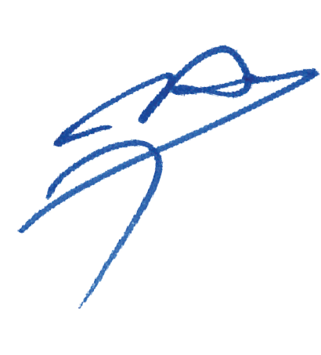
Sincerely yours,

Husnu KOCAOGLU
President of the
Organizing Committee

PRELIMINARY PROGRAMME:

18/05/2020  Monday | Arrival of Participants  Practice Field and Local Transportation is available
19/05/2020  Tuesday | Arrival of Participants  Practice Field and Local Transportation is available  WAE Congress
20/05/2020  Wednesday | Official Practice & Equipment Inspection  Team Managers’ Meeting & Opening Ceremony
21/05/2020  Thursday | Qualification Round & Team Round  Recurve & Compound
22/05/2020  Friday | Individual & Mixed Team Round  Team Round  Recurve & Compound
23/05/2020  Saturday | Individual Eliminations  Mixed Team Round
24/05/2020  Sunday | Continental Quota Tournament
25/05/2020  Monday | Compound Finals
26/05/2020  Tuesday | Recurve Finals
27/05/2020  Wednesday | Departures

NOTE:
This preliminary programme is subject to change according to the number of participants and special requirements. All changes will be published and distributed in good time.

PRELIMINARY & FINAL REGISTRATION

No entry forms will be available to register for this event; the registration process must be completed using WAREOS.

Member Associations can login WAREOS at http://register.worldarchery.org with the username and password assigned by World Archery. After entering WAREOS, selecting the event from list will allow a member association to register their athletes. Select/press “Entries” button to see list of categories in the event. Select/press the “Category” to enter the athlete and official numbers/details participating for that event.

For any questions regarding the WAREOS, please contact the World Archery office, Mr. JK LEE (jklee@archery.org).

A maximum number of three (3) athletes per country can be registered into each category and divisions of the event.

Starting date of online-registration with WAREOS is: | 01 December 2019
End of Preliminary registration: | 20 February 2020
End of Final registration: | 29 April 2020

Please respect the stated deadlines.

Member Associations should only use WAREOS to make any changes/amendments to their entries and will be able to do so at any time. Any changes made in WAREOS an email will be automatically sent to the Organizing Committee and Member Association with the updated information.

However, any changes that are made after the deadlines specified or if entries differ by more than 4 athletes from the preliminary entries, the following penalty fees will automatically be applied:
Penalty fees to be paid to Organising Committee: | Cost (EURO):
Entries made after the preliminary and/or final entry deadline date. | 45 per entry
If final entries differ from the preliminary entries by more than 6 athletes/officials. | 140 per entry
Failure to have made preliminary entries before the deadline date but then have submitted final entries. | 140 per entry

Any entries received less than 3 days before the team managers meeting will be refused if no preliminary entry and/or final entry are made prior.

As a final note, only Member Associations in good standing will be eligible to compete. This means that World Archery fee must have been paid prior the participation.

ACCOMMODATION & GENERAL INFORMATION

The official hotels are the Rixos Hotel Downtown and Porto Bello Hotel Resort & Spa. Hotels are allocated on a first come, first serve basis. Accommodation includes breakfast, lunch and dinner with non-alcoholic drinks.
In order to take part to the Championships, the delegations must choose one of those two proposed hotels. Participants, who book their accommodation in non-official hotels, will not be eligible to compete.

In accordance to the new WAE rule, all the delegations must book their accommodation, through WAREOS, mandatory in one of the official hotels suggested by the LOC.
In case of accommodation in a non-official hotel, the participation will not be allowed.

Confirming of the hotel reservations, a 50% deposit of the total amount is required to be bank transferred to the OC before 08 March 2020. Reservations after this date will be considered only according to availability.

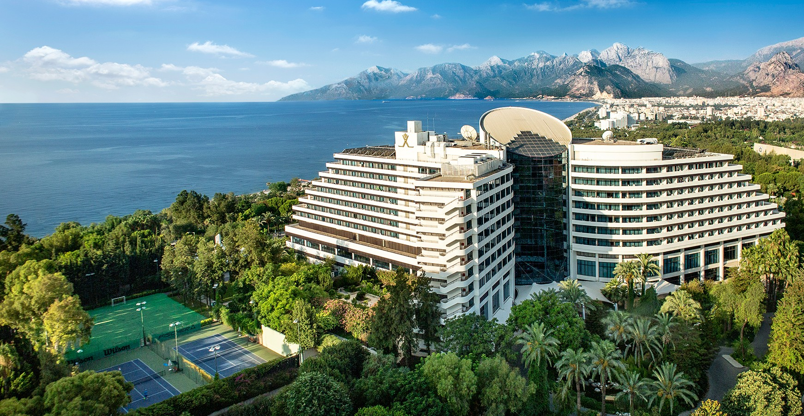
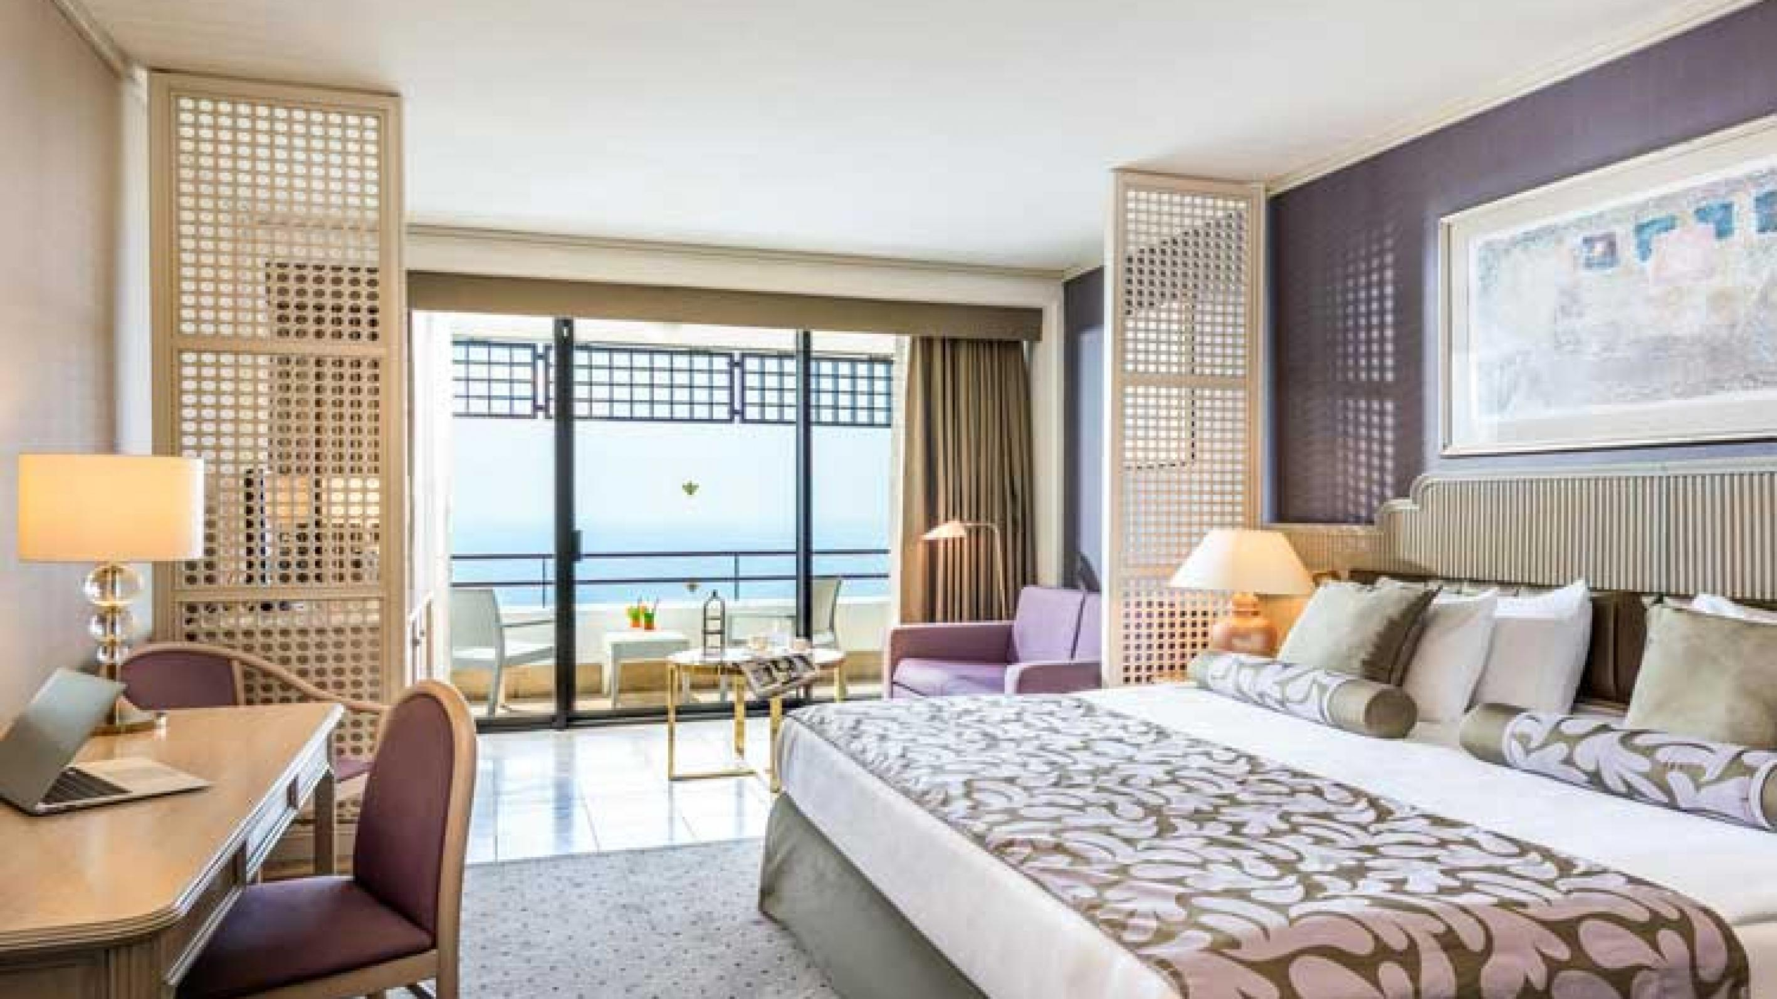
- Rixos Hotel Downtown(5 Star)
- Single Room Euro 190,00€ (Including Breakfast, Lunch & Dinner Buffet)
- Double/Twin Room Euro 285,00€ (Including Breakfast, Lunch & Dinner Buffet)
- 700m walking distance from venue
- Hotel has a pool area, Wi-Fi, continental breakfast, lunch and dinner restaurant.

- Porto Bello Hotel Resort &Spa (5 Star)
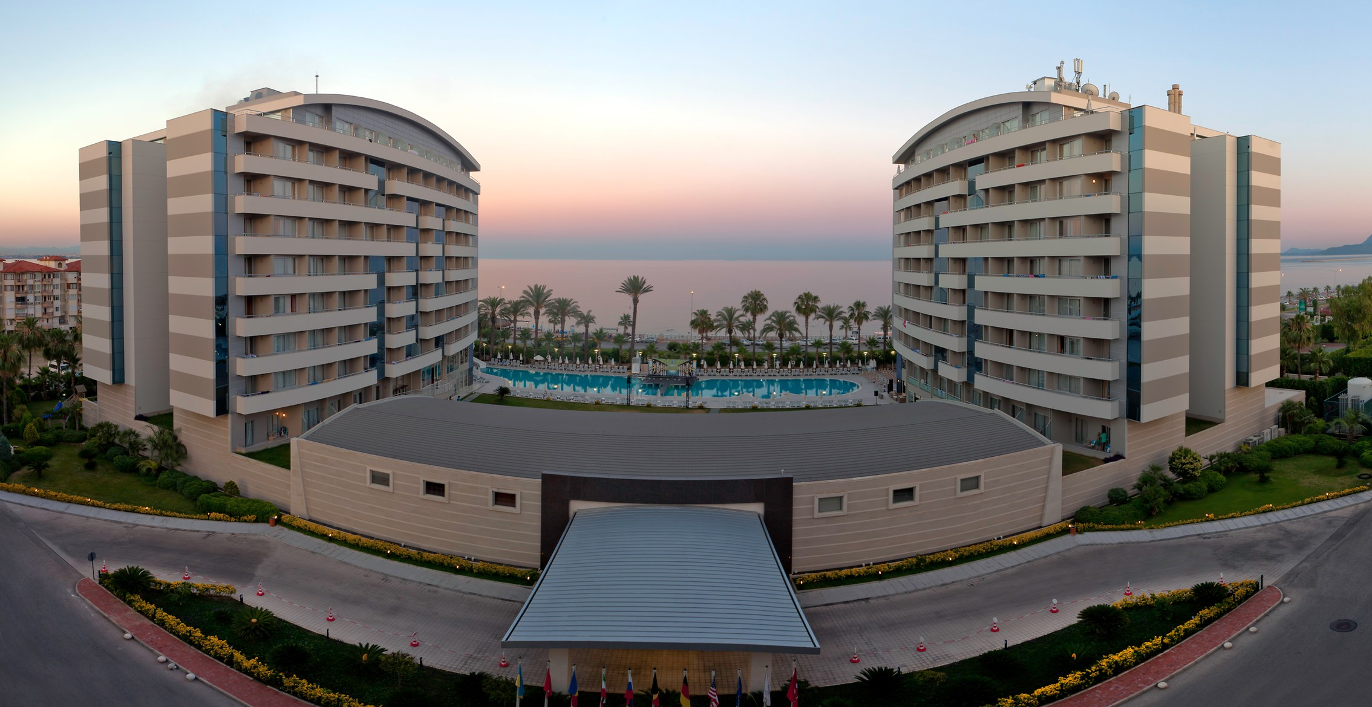
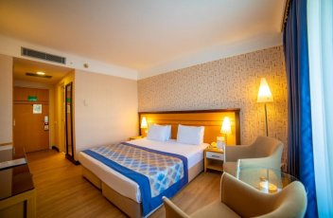
- Single Room Euro 160,00€ (Including Breakfast, Lunch & Dinner Buffet)
- Double/Twin Room Euro 220,00€ Euro (Including Breakfast, Lunch & Dinner Buffet)
- 10 minutes’ drive from the competition venue
- Hotel has a pool area, Wi-Fi, continental breakfast, lunch and dinner restaurant.

ENTRY FEE
Entry fee:
Individual: 150,00€ EUR per athlete
Officials: 75,00€ EUR per person
Teams: 50,00€ EUR per team

Entry fees include(for only the persons who stay in the official hotels )daily local transport to/from the practice field to/from the official hotels during the qualification, elimination and finals venues (timetable to be confirmed on site).

PAYMENT CONDITIONS:
The entry fees should be paid in full upon arrival.

Payment of accommodation, a minimum deposit of 50% should be made when booking by 08 March 2020. The final outstanding balance shall be made via bank transfer before arrival. Accommodation cannot be guaranteed after this deadline.

NOTE:
- Please indicate in the reference/notes section the team or reservation name that corresponds to the payment
- All payment shall be made in EUR0 by BANK TRANSFER.
- All bank wire charges will be paid by the participant
- CREDIT CARDS will not be accepted as payment.

BANK INFORMATION for ACCOMMODATION, TRANSPORTATION and
ENTRY FEES:

BANK ACCOUNT: | ANTALYA OKCULUK IHTISAS SPOR KULÜBÜ
BANK: | YAPI KREDI BANKASI
ACCOUNT NO: | 25086669
SWIFT CODE: | YAPITRIS
IBAN: | TR 03 0006 7010 0000 0025 0866 69

TO GUARANTEE RESERVATIONS
The 50% deposit of the accommodation must be paid in advance via bank transfer by 08 March 2020 . The balance payment is due before arrival and within 29 April 2020.

ADDITIONAL INFORMATION
World Archery Europe Congress
World Archery Europe Congress will be held on 19 May 2020. All information will be provided in advance to the Member Associations.

Continental Quota Tournament for TOKYO 2020
The CQT will take place on 24 May 2020 at the special place in the competition field and all matches will be one by one and running by alternate shooting.

Transportation
Transport from/to Antalya Airport is 30 Euros per person. A daily shuttle service is free of charge (only for those persons accommodated in the Rixos Hotel Downtown and Porto Bello Hotel Resort & Spa. Shuttle services will be available from the Rixos Hotel Downtown, Porto Bello Resort Hotel & Spa, competition venue/practice venue/final venue.

Cancellations & Changes
- Cancellations received before 30 April 2020 a full refund of the deposit payment will be made.
- Cancellations received after 30 April 2020 no refund will be given.
- Refunds will be processed after the event.
- Name changes to team officials or athletes (same category and division) will be accepted up to 72 hours before the event without any additional charge.
- Should flight arrival details change last minute, please contact the Organizing Committee using the details indicated in the Team Managers’ Booklet.
- If a participant’s arrival is later than the original scheduled arrival date, the room will be charged from the date of the original booking.

Training
A training field will be available starting on 18 May 2019 at the Antalyaspor Club’s field located approximately 10 minutes from the official hotels. Transport to training field will be made available at no additional cost on April 18 and 19.

Weather
Temperatures in May are expected to range between 20 and 28 degrees Celsius. The average in the last few years has been 25 degrees Celsius.

Media Registration:
Media representatives can apply for registration by emailing info@archery.org

Internet
Will be available in the official hotels for free (in hotel rooms and in the lobby). There will also be Wi-Fi available at the venue.

Water
Bottled water will be available at the venue.

LOC Contact:
Name: Mr. Sirer AYDIN, Registration Manager
Email: sireraydin@gmail.com
Language: English
Official website:

Visa:
It is your responsibility to establish with your respective foreign office if your team requires a visa for the Turkey. You can find additional information on www.evisa.gov.tr, where it is also possible to apply for the e-visa.

For participants who need a formal visa and invitation letter for entry to Turkey, will be required to complete the Visa Support sections in WAREOS by no later than 08 March 2020.

It is the applicants’ responsibility for supplying the necessary information, ensuring all details are up to date, correct and submitted by the deadlines specified.

In addition, all participants that require a visa are kindly requested to supply a copy of their latest/valid passport. Copies of each application can be uploaded on WAREOS. All passport copies and personal details entered/uploaded to WAREOS will be held securely and in the strictest of confidence and not shared with other parties.

Please ensure your passport is valid for at least six months from the date you enter Turkey or you may not be admitted.

