


EUROPEAN GRAND PRIX 2020
INVITATION PACKAGE

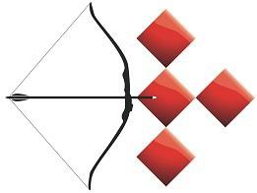

To all World Archery and World Archery Europe Member Associations

Dear President, Secretary General,

On behalf of the Local Organizing Committee I would like to invite your country to the European Grand Prix 2020, which will be held from 9-13 June in Porec, Croatia.

Year 2020 is very important for all sports and naturally for Archery as a very important Olympic sport. Tokyo 2020 Archery tournament is scheduled to take place from, 24 July to 1 August 2020.
All high-ranking archery events, like European Grand Prix, is very good opportunity for the final pre-Olympic setup, just five weeks prior to the Olympic tournament.
We would be happy to organize a training camp as well, for everyone who intends to come earlier and use the Porec as period of preparations for the Olympic Games and the adapting to the expected heat in Tokyo. Find more on page 13 of this letter.

The Prize money offered to the winners is not negligible and I hope it will attract many archers and specially the best among them.

Please find enclosed all the necessary information for registration, organization and participation for this event.
Please complete the necessary details in WAREOS before the following deadlines:

Summary of deadlines:

Preliminary Entries 9 March 2020
Final Entries 19 May 2020
Hotel Reservation 6 March 2020
Visa Support 7 April 2020
Transportation 17 April 2020
Final Hotel Reservation & Payment 17 April 2020

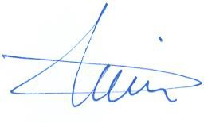
We are looking forward to welcoming you and your teams to Porec, Croatia.
Sincerely yours,

Mr. Darko Uidl
Organizing Committee President

PRELIMINARY PROGRAMME
Day |  | Date | Description
Day -1 | Sunday  7 June |  | Arrival of participants  Practice field and local transport available
DAY 0 | Monday  8 June |  | Arrival of Participants  Practice field and local transport available
DAY 1 | Tuesday  9 June |  | Official Practice Recurve & Compound (women and men) Equipment Inspection  Team Managers Meeting
DAY 2 | Wednesday  10 June |  | Qualification 70m Round Recurve and 50m Compound  (Practice Field open)
DAY 3 | Thursday  11 June |  | Individual Eliminations up to semi-finals and Mixed Team  (Practice Field open)
DAY 4 | Friday  12 June |  | Teams Elimination and Finals  (Practice Field open)
DAY 5 | Saturday  13 June |  | Individual Finals – Medal matches  Award Ceremony  Closing Party
DAY 6 | Sunday  14 June |  | Departure of teams

NOTE
This preliminary program could be changed slightly according to number of participants and TV requirements. All changes will be published and distributed to all participants in good time.

PRIZE MONEY

WAE will give total amount of 12.000 € to the winners as follows:

1st place 1.500 €
2nd place 1.000 €
3rd place 500 €

PRELIMINARY & FINAL REGISTRATION

All entries, accommodation reservations, transport needs, flight arrival/departure information and Visa invitation letter requests are to be completed using WAREOS.

The World Archery Online Registration System (WAREOS):
http://extranet.worldarchery.org has been updated to handle the entire registration process for this event. No entry forms, hotel reservations or transport forms will be accepted as all information is to be entered to WAREOS.

In order to use WAREOS, please login on http://extranet.worldarchery.org with your Username and Password assigned by World Archery. After entering WAREOS, please go to "Online Registration" and register your athletes and officials for this event. A "WAREOS User Manual" can be downloaded in PDF format (English) using the same web site link.

For any questions regarding WAREOS, please contact the World Archery office, Mr. JK LEE jklee@archery.org

A maximum number of 6 men and 6 women per country can be registered into each division of the event.
The host country may enter the maximum of 8 men and 8 women per division.

Start date for online registration using WAREOS: 20 January 2020
End of Preliminary registration using WAREOS: 9 March 2020
End of Final registration using WAREOS: 19 May 2020

Please respect the stated deadlines.

Club Archers are allowed to participate.
It is allowed also Individual registrations to the competitions. It means that not only National Team archers can participate in a Grand Prix, but also Club archers.
National teams will have priority during the preliminary entry phase.
Please find Club Archer Registration Form and Club Archer Regulation and Registration Procedure at the end of this Invitation and as Attachment of EGP Rules on WAE official web site.

Member Associations should only use WAREOS to make any changes/amendments to their entries and will be able to do so at any time. Any changes made in WAREOS an email will instantly be automatically sent to the Local Organizing Committee and Member Association with the updated information.

However, any changes that are made after the deadlines specified or if entries differ by more than 4 athletes from the preliminary entries, the following penalty fees will automatically be applied.

Penalty fees to be paid to Organising Committee | Cost €
Entries made after the preliminary and/or final entry deadline date | 45 per entry
If final entries differ from the preliminary entries by more than 4 athletes/officials | 140 per entry
When no preliminary entries were made before the deadline date but then submit final entries | 140 per entry

Any entries received less than 3 days before the Team Managers Meeting will be refused if no preliminary entry and/or final entry are made prior.

NOTE
Member Associations that have penalty fees outstanding from earlier events will need to pay these penalty fees and get good standing before being eligible to enter and compete.
Also, World Archery fee must have been paid prior the participation.

ACCOMMODATION & GENERAL INFORMATION

Important Note
Non-official accommodation is not allowed. Any team or individual accommodated in non-official hotel will not be accredited and participation in the event will be refused.

The official hotels are divided in five categories: Budget, Standard, Standard+ All Inclusive, Comfort and Superior. All hotels are especially selected by the organization for the event. Hotel allocations will be made on a 'first come, first serve' basis. Accommodation rates will offer full board and half board meal packages.

Reservations should be made before 6 March 2020
Final Hotel Reservation & Transportation Forms 17 April 2020

To confirm your hotel reservations, 60% deposit of the total amount is to be paid by a bank transfer to the Organizing Committee before 6 March 2020. Reservations received after this date will be considered only according to availability.

o Budget Hotel **
Half board (dinner at the hotel)
Single Room 108 € Double/Twin 92 €
Full board (lunch and dinner at the hotel) Single Room 123 €
Double/Twin 107 €

o Standard Hotels ***
Half board (dinner at the hotel) Single Room 126 € Double/Twin 113 €
Full board (lunch and dinner at the hotel) Single Room 141 €
Double/Twin 128 €

- Standard+Hotel ***
All inclusive (breakfast, lunch, dinner & drinks in restaurant) Single Room 126 €
Double/Twin 113 €

- Comfort Hotel ****
Half board (dinner at the hotel) Single Room 142 € Double/Single use 164 € Double/Twin 135 €
Full board (lunch and dinner at the hotel) Single Room 157 €
Double/Single use 179 € Double/Twin 150 €

- Superior Hotel *****+
Half board (dinner at the hotel) Single Room 165 € Double/Single use 187 € Double/Twin 157 €
Full board (lunch and dinner at the hotel) Single Room183 €
Double/Single use 205 € Double/Twin 175 €

The hotel room rates are per person, per night, including free internet. Additional purchases in the hotel bar, café and mini bar is at own expense. *
*All prices are including city tax.

One welcome package per person is included.

During the event there will be a tournament desk available in office on the FoP with all the relevant and latest information about the European Grand Prix 2020.

All information will be forwarded to the WhatsApp and Viber groups for everyone signed up for this mode of communication. Information will be shared through Twitter, Instagram and Facebook.

Important Note
Refer to the accommodation pages for detailed hotel information.
Please complete all the necessary sections in WAREOS and make full payment (entry fees, transport and accommodation, closing party) by the specified deadlines.
Bank transfers only, no credit cards or travel checks will be accepted.

- Budget hotel
Budget hotel Delfin is not typical budget hotel but very good** beach hotel. Rooms are suitable and well kept, with comfortable beds. They are cosy and basic but works well and offer great views. The hotel has all the services you need to make your stay as comfortable as possible

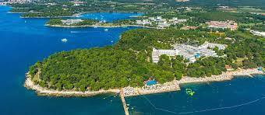
The Delfin hotel occupies a superb location in Zelena Resort, just outside Porec, on its own verdant peninsula offering ample shade and protection from the sun along a strip of beaches of all kinds. There are plenty of refreshment stalls selling fruit and snacks along the beach, as well as a restaurant, so you can stay there all day if you like.
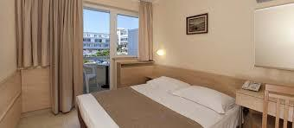

- Standard Hotels
We choose 3 standard hotels which are in close distance from each other and have the same service and amenities. Standard hotels are very good hotels with better service and facilities than budget hotel. Unfortunately, it is not possible to choose a hotel - Organizer will inform you two weeks before your arrival at which hotel you will be staying.

Hotel Plavi ***
Sitting right above a Blue Flag beach, Hotel Plavi was partially renovated in 2016 when the new, light and airy dining and reception area were created. Plenty of bars and restaurants along the coastline provide ample entertainment in the evening, but if you've spent your day outdoors you just might choose to stay in and relax.
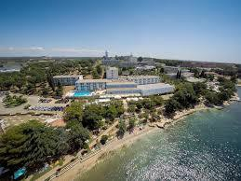
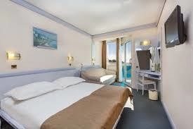

Hotel Istra ***
Located just outside of Porec, Hotel Istra overlooks a lovely cove and has everything you might need for a simple, relaxing holiday. The grounds are well kept, dominated by palm trees, colourful flowers and rose bushes. The beach is 100 m away, offering beach volley court, as well as mini golf, canoe rentals, and tennis. All rooms are air-conditioned, with a shower bathroom and a satellite TV.

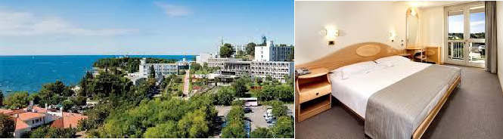

Hotel Gran Vista ***
Renewed for the breath-taking vista from the dining room over the pool, Hotel Gran Vista is a well-kept location just outside Porec. Situated on a slope, it offers daily exercise in the form of stairs you must take to the paved beach in front of the hotel and back. The pool area is well sized for guests, and you can easily find a spot-on deck after breakfast or lunch and enjoy the gorgeous views from the patio area. Rooms are cosy and clean and the sunset from the balcony is postcard stuff. Make sure to see it.
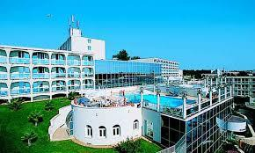
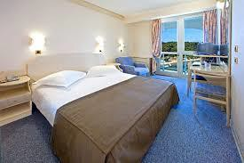

- Standard+Hotel - All inclusive
Very limited rooms in one standard+ hotel who is on all-inclusive basis. “First come, first served”.

Hotel Albatros ***+ (All inclusive)
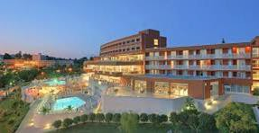
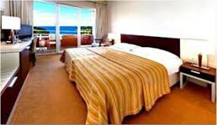
Set only 100 m from a beach, the All-Inclusive Hotel Laguna Albatros enjoys a pleasant location in the Zelena Laguna in Porec. It offers an on-site swimming pool, live music, fine cuisine and refreshing cocktails. Free WiFi is available in the entire property. All rooms are air-conditioned. Amenities in each room include a safe, satellite TV and a mini bar. Private bathrooms come with a hair dryer. The Hotel is only 70 m from FoP.

- Comfort Hotel

Hotel Molindrio ****
At Zelena Resort, hotel Molindrio takes the holiday experience to the next level, combining upscale amenities and elegance into one of the chicest Plava Laguna properties in Porec. The hotel grounds are all neatly trimmed grass if you want to take a barefoot walk. All rooms are appointed with sweet smelling linens, a plush robe and slippers. There's a private balcony too, so you can catch those dreamy Mediterranean views and sunsets and bask in the views of the Zelena Resort.

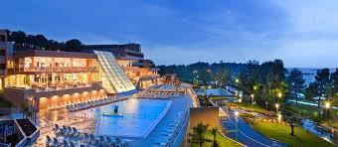
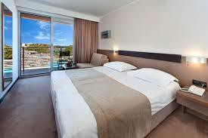

- Superior Hotel

Hotel Parentium ****+
Tucked away in the deep shade of pine trees within Zelena Resort, Hotel Parentium is a comfortable holiday sanctuary offering breath-taking views of the nearby lagoon. Pick between double rooms, suites and our palatial presidential suite and let us look after you for a few days or weeks, however you feel. Deepen the holiday relaxation with SPA experiences, sweat it out in one of our saunas, then relax in the whirlpool and doze off before dinner. Fill your solar batteries with an enchanting sunset. Sample all our dishes, starting with the show-cooking buffet, all the way to the a la carte restaurant Bacchus.

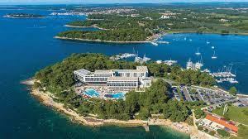
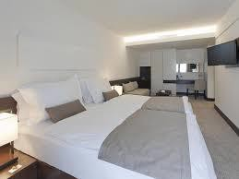

ENTRY FEE
Individual: | 150 € | per athlete
Teams: | 75 € | per team
Officials: | 50 € | per person
There is no entry fee for mix teams.

Temporary Upgrade: 30 € per accreditation (for athletes wishing to be a coach temporarily).

PAYMENT CONDITIONS
All fees should be paid in full before arrival.

Payment of accommodation and local transportation: a minimum deposit of 60% of the total amount owed should be made when booking by 6 March 2020.
The final outstanding balance shall be transferred 3 weeks before arrival. Accommodation cannot be guaranteed after this deadline. A balance invoice will be provided via WAREOS.
Entry fee should be paid by 6 March 2020 separately than Accommodation & Transportation due to Croatian Tax policy.

Bank information for ACCOMMODATION & TRANSPORTATION

BANK RAIFFEISEN BANK AUSTRIA d.d. BANK ACCOUNT HOLDER NAME UNILINE d.o.o.
ADRESS BOZE GUMPCA 38, 52100 PULA
ACCOUNT No HR3024840081500154861
BIC/SWIFT CODE RZBHHR2X

Bank information for ENTRY FEES
BANK PRIVREDNA BANKA ZAGREB d.d. BANK ACCOUNT HOLDER NAME HRVATSKI STRELICARSKI SAVEZ
ADDRESS HRVATSKOG PROLJECA 34, 10040 ZAGREB
ACCOUNT No HR6623400091110039202
BIC/SWIFT CODE PBZGHR2X

NOTE: All payments shall be made in EUR only by BANK TRANSFER.

Bank transfer fees are responsible on the sender.
Credit cards and Travel checks will not be accepted.

CANCELLATIONS & CHANGES
All cancellations and changes must be made through WAREOS:
- Cancellations received before 6 March 2020 a full refund of the deposit payment will be made.
- Cancellations received after 6 March 2020 no refund will be given.
- Refunds will be processed after the event.
- Name changes to team officials or athletes (same category and division) will be accepted up to 72 hours before the event without any additional charge.
- Should flight arrival details change last minute, please contact the Organizing Committee using the details indicated in the Team Managers Booklet.
- If a participant’s arrival is later than the original scheduled arrival date, the room charges will start from the dates of the original booking made by the Member Association.

ADDITIONAL INFORMATION

Transport:
As the Porec city is not in the close distance of a major international airport (except for the local Pula airport), you can choose one of these for your arrival airport, whichever suits you best.

CROATIA Zagreb Airport, Pula Airport, Rijeka Airport
SLOVENIA Ljubljana Airport
ITALY Trieste Airport, Venice Airport

Local transport to Porec from the above airports is very poor, so we advise you to book the private transfer options below. Price is per vehicle per one way.

Private Transfers  to/from Porec - one way | Standard car 1-3 pax | Van 4-7 pax
Pula Airport | 80 € | 100 €
Zagreb Airport | 350 € | 400 €
Ljubljana Airport | 250 € | 300 €
Trieste Airport | 180 € | 200 €
Venice Airport | 300 € | 350 €
Rijeka Airport | 170 € | 190 €

Group transfer with bus – fixed time departure - one way
If you choose this transfer, you will have to adapt to all other passengers and wait for the departure time.
Only one bus transfer available on arrival dates.
Minimum of 20 passengers to confirm the transfer departure. Organizer can cancel the transfer if there will not be 20 or more passengers booked per transfer.

One-way group transfer to/from Porec price per person:

Trieste Airport: | 30 €
Zagreb Airport: | 55 €
Ljubljana Airport: | 45 €
Venice Airport: | 50 €

Training –Training Camp
Training venues will be available starting from 5 June 2020. For those teams wishing to arrive earlier and practice at a practice field. We would be happy to organize a training camp for everyone who intends to come earlier. Please announce your arrival at the Training Camp by 7 April 2020. Find the details and contacts at the official event website www.egp2020.org

Internet
Free WiFi will be available in the official hotel (in hotel rooms and in the lobby).

Meals
The lunch is foreseen to be served at hotels. Team managers can request a lunchbox in Hotel where they are located to dine at FoP during the official days.

Water
Water will be available at the venues free of charge.

Media Registration
Media representatives can apply for registration by emailing infoegp2020@archery.hr

Weather
Average Temperature 22oC Low Temperature 17oC High Temperature 25oC Sunshine Hours 8 hours
Rainfall days 9 days Water Temperature 21oC Sunrise 05:30
Sunset 22:00

So, what to wear in June? Competitors traveling to Porec should plan on bringing a totally waterproof rain jacket since it will be raining some days. Also bring your shorts and or a skirt because it can be very nice and warm.

Dress regulations
WA & WAE dress regulations do apply.

Closing Party
Banquet or closing party will be organized in some of Hotels from above. Price for attendees at the party is 25 € per person.

VISA SUPPORT
All participants who need an entry visa to the Croatia, will be required to complete the Visa Support Form in WAREOS no later than 7 April 2020.

It is the applicants’ responsibility for supplying the necessary information, ensuring all details are up to date, correct and submitted by the deadlines specified.

In addition, all participants that require a visa are kindly requested to supply a copy of their latest, valid passport. Copies of each applications can be uploaded on WAREOS. All passport copies and personal details entered/uploaded to WAREOS will be held securely and in the strictest of confidence and will not be shared with other parties.

Please note that the Organizing Committee can provide invitation for the period of the European Grand Prix only.

LOC CONTACT
President Organizing Committee Darko Uidl
General Secretary –Entry Fee Kresimir Cadez
Transport, Accommodation
&Finances Hrvoje Mijic
Email egp2020@uniline.hr

Language English and Croatian

Email infoegp2020@archery.hr

Official website www.egp2020.org

CLUB ARCHERS PARTICIPATION
Not only National Team archers can participate in the Grand Prix, but also Club archers. National teams will have priority during the preliminary entry phase. After the Preliminary Entry deadline 9 March 2020. all Club members could register. The Club archers can participate only in the individual competition, not in team competition and not in mixed team. Registrations must be done through their National Federations and the entries can be accepted by the Organizing Committee until the total capacity of the field has been reached.

Please, also refer to the Club Archers Registration Form provided below the next page.
Please, send this form completed to the Local Organizing Committee and to your National Archery Federation/Association.

CLUB ARCHER REGISTRATION FORM

WA Member Association

Date: _____________ President/Secretary General: _______________________

Event: European Grand Prix 2020

Place: Porec, (Croatia)
Date: 9-13, June 2020

Country:
Family Name:
Name: |  |  |  |  |  |  |  |  | WA ID #  (if any)
Date of birth: |  |  |  |  |  | DIVISION |  |  |  | Recurve women
Club name: |  |  |  |  |  |  |  |  |  | Recurve men
 |  |  |  |  |  |  |  |  |  | Compound women
 |  |  |  |  |  |  |  |  |  | Compound men
Email address:
Postal address | Street:
 | City:
 | Postal code:
 | Phone#:
 | ALL cells must be completed
To be completed ONLY by THE LOC  Date the Form was received: |  |  |  | Day |  |  | Month |  |  |  | Year

- The Local Organizing Committee (LOC) will contact you to coordinate final registration, payment and any other information needed to complete your registration to the event.
- Your Federation will need to register your data in WAREOS
(WA Registration & Entry Online System) in order to include you into the results system and WA WAREOS data base.

REGULATION FOR CLUB ARCHERS
participating in EGP 2020

- The Club Archer is responsible to send the completed form to the LOC and his/her Federation. Sending the form does not guarantee his/her participation. The process of registration and inclusion must respect the Club Archers’ regulations and procedures in order to be able to participate to this event.

- As soon as the Club Archer will be registered in WAREOS (by his/her Federation) and the LOC has accepted his/her registration, the Club Archer will be informed by the LOC that he/she can officially take part in the event.

- Club Archers participating in WAE events must be members of a WA Member Association (therefore official members of the Archery Federation of his/her country).

- The LOC will work on a “first come, first serve” basis, to take into consideration the forms they will be receiving. However, in order to participate, the Club Archer must also fulfil all the requirements requested in terms of booking, payments and other information requested by the LOC.

- Club archers cannot have coaches or guest accredited to access the FoP (blue area). If guest or coaches will accompany a Club Archer, he will be treated as a spectator.

- DRESS REGULATIONS: Club Archers must respect WA rules (Book 1, point 3.22) in terms of uniform for the WA events. Club Archers cannot use any National Team uniform (neither of his country nor any other).

- Club Archer must be present in the Official Practice day when he will pick up his/her accreditation, confirm name and data given and pass the equipment inspection. The Club Archer is not allowed to miss the official practice and arrive directly to the qualification day. Travel plan should be arranged according to the schedule.

- Club archers could be Junior or Senior Categories. Cadet’s archers are not allowed to participate in the event as Club Archer.

CLUB ARCHER REGISTRATION PROCEDURE

- The Club Archer interested in participating in a European Grand Prix Porec 2020, has to read Invitation Package and study cost and conditions to participate.

- After the end of the Preliminary Registration, the Local Organizing Committee will calculate the available spaces for Club Arches per Division and inform WAE, which will advertise and publish the spots available for Club Archer on WAE Website.

- Max 30% of spots of the spots available (for Division) are for Club Archers from the host country, 70% are for International Club Archers.

- The Club Archer will visit the WAE Website and as soon as she/he knows the places available, completes the 'Club Archer Registration Form' and send it to the LOC and to her/his National Archery Federation.

- The belonging Federation, receiving the Club Archer Registration Form, has to check:
  - If she/he is a member of the Federation
  - If everything is in order, the Federation will register the data of the archer in WAREOS (WA Registration & Online System) in order to include her/him into the result system and WA WAREOS data base. If Club Archer is included in WAREOS, the Federation has to inform LOC that the archer is eligible for the event.

- The LOC will prepare a list of Club Archers forms ordered by date of arrival and inform the Club Archer that her/his form has been received and she/he is included in the Club Archers list. The LOC requests to start room booking and fees-cost payment as indicated in the Invitation Package.

- The Club Archer contacts LOC to arrange room booking, arranges payments and informs about travel plan.

